

**数据结构课程设计**

**题目：** 图书管理信息系统的设计与实现

**专业班级：** 计算机科学与技术 6班

**学 号：** 20204331

**姓 名：** 王博文

**指导教师：** 隋毅

**报告日期：** 2022年5月20日

计算机科学技术学院

**2022年5月20日**

一、课程设计内容

**设计要求：**图书信息表所表示的是一个数据库文件。图书管理一般包括：图书采编、图书编目、图书查询及图书流通（借、还书）等等。

具体设计要求如下：

1. **建立一个图书信息数据库文件，输入若干种书的记录，建立一个以书号为关键字的索引文件；在主数据库文件中建立书名、作者及出版社作为次关键字的索引以及对应的索引文件；**
2. **实现关于书号、书名、作者及出版社的图书查询；**
3. **实现图书的借还子系统，包括建立读者文件、借还文件、读者管理及图书借还等的处理。**

二、算法设计

**这次的实验虽然代码的长度不俗，但是还是比较简单的，代码中多处都为重复的。本次主要就是思路要清晰，首先要建三个表，分别为图书信息表、借阅信息表、读者信息表，再往后我采用的就是用链表来存储文件里的信息，链表更改的时候就把文件里的内容重写一遍。总结起来，就是链表和文件的应用**

三、核心代码实现

#include<iostream>

#include<stdlib.h>

#include<fstream>

using namespace std;

struct book{

string book_no;

string book_name;

string author;

string press;

int flag;

struct book *next;

};

struct borrow{

string book_no;

string reader_no;

float borrow_time;

float return_time;

int flag;

struct borrow *next;

};

struct reader{

string reader_no;

string name;

string sex;

string company;

int top;

int number;

int flag;

struct reader *next;

};

void insert_book(book *head){

ifstream fin;

fin.open("图书信息表.txt",ios::in);

if(!fin.is_open()) {

std::cerr<<"未打开文件"<<endl;

exit(0);

}

fin>>head->book_no>>head->book_name>>head->author>>head->press>>head->flag;

head->next=NULL;

book *q=head;

while(!fin.eof()) {

book *p=new book;

fin>>p->book_no>>p->book_name>>p->author>>p->press>>p->flag;

p->next=NULL;

q->next=p;

q=q->next;

}

fin.close();

}

void insert_borrow(borrow *head){

ifstream fin;

fin.open("借阅信息表.txt",ios::in);

if(!fin.is_open()) {

std::cerr<<"未打开文件"<<endl;

exit(0);

}

fin>>head->book_no>>head->reader_no>>head->borrow_time>>head->return_time>>head->flag;

head->next=NULL;

borrow *q=head;

while(!fin.eof()) {

borrow *p=new borrow;

fin>>p->book_no>>p->reader_no>>p->borrow_time>>p->return_time>>p->flag;

p->next=NULL;

q->next=p;

q=q->next;

}

fin.close();

}

void insert_reader(reader *head){

ifstream fin;

fin.open("读者信息表.txt",ios::in);

if(!fin.is_open()) {

std::cerr<<"未打开文件"<<endl;

exit(0);

}

fin>>head->reader_no>>head->name>>head->sex>>head->company>>head->top>>head->number>>head->flag;

head->next=NULL;

reader *q=head;

while(!fin.eof()) {

reader *p=new reader;

fin>>p->reader_no>>p->name>>p->sex>>p->company>>p->top>>p->number>>p->flag;

p->next=NULL;

q->next=p;

q=q->next;

}

fin.close();

}

void print_book(book *head){

cout<<"图书信息表："<<endl;

while(head!=NULL){

cout<<head->book_no<<" "<<head->book_name<<" "<<head->author<<" "<<head->press<<" ";

if(head->flag==0)

cout<<"可借"<<"\n";

else

cout<<"已借出"<<"\n";

head=head->next;

}

cout<<endl;

}

void print_borrow(borrow *head){

cout<<"借阅信息表："<<endl;

while(head!=NULL){

cout<<head->book_no<<" "<<head->reader_no<<" "<<head->borrow_time<<" ";

if(head->return_time!=0){

cout<<head->return_time<<"（已归还）"<<" ";

}

else cout<<"尚未归还"<<" ";

if(head->flag==0)

cout<<"完成"<<endl;

else if(head->flag==1)

cout<<"进行中"<<endl;

else

cout<<"超期"<<endl;

head=head->next;

}

cout<<endl;

}

void print_reader(reader *head){

cout<<"读者信息表："<<endl;

while(head!=NULL){

cout<<head->reader_no<<" "<<head->name<<" "<<head->sex<<" "<<head->company<<" "<<head->top<<" "<<head->number<<" ";

if(head->flag==0)

cout<<"正常可借"<<endl;

else

cout<<"异常"<<endl;

head=head->next;

}

cout<<endl;

}

void reader_borrow(borrow *borrow_head,book *book_head,reader *reader_head){

cout<<"输入借书的书号、读者号、借阅时间"<<endl;

int flag1=0;

int flag2=0;

string a,b;

float c;

cin>>a>>b>>c;

while(borrow_head->next!=NULL){

borrow_head=borrow_head->next;

}

borrow *p=new borrow;

p->book_no=a;

p->reader_no=b;

p->borrow_time=c;

p->return_time=0;

p->flag=1;

p->next=NULL;

borrow_head->next=p;

fstream f;

f.open("借阅信息表.txt",ios::out|ios::app);

f<<endl;

f<<a<<" "<<b<<" "<<c<<" "<<0<<" "<<1;

f.close();

book* q=book_head;

while(book_head->next!=NULL){

if(a==book_head->book_no){

break;

flag1=1;

}

book_head=book_head->next;

}

if(a==book_head->book_no)

flag1=1;

if(flag1=1){

book_head->flag=1;

}

fstream f1;

f1.open("图书信息表.txt",ios::out);

while(q->next!=NULL){

f1<<q->book_no<<" "<<q->book_name<<" "<<q->author<<" "<<q->press<<" "<<q->flag<<endl;

q=q->next;

}

f1<<q->book_no<<" "<<q->book_name<<" "<<q->author<<" "<<q->press<<" "<<q->flag;

f1.close();

reader* w=reader_head;

while(reader_head->next!=NULL){

if(b==reader_head->reader_no){

break;

flag2=1;

}

reader_head=reader_head->next;

}

if(b==reader_head->reader_no)

flag2=1;

if(flag2=1){

reader_head->number++;

}

if(reader_head->number>reader_head->top)

reader_head->flag=1;

fstream f2;

f2.open("读者信息表.txt",ios::out);

while(w->next!=NULL){

f2<<w->reader_no<<" "<<w->name<<" "<<w->sex<<" "<<w->company<<" "<<w->top<<" "<<w->number<<" "<<w->flag<<endl;

w=w->next;

}

f2<<w->reader_no<<" "<<w->name<<" "<<w->sex<<" "<<w->company<<" "<<w->top<<" "<<w->number<<" "<<w->flag;

f2.close();

}

void book_return(borrow *borrow_head,book *book_head,reader *reader_head){

cout<<"输入归还的书号、读者号、归还时间"<<endl;

int flag1=0;

int flag2=0;

int flag3=0;

string a,b;

float c;

cin>>a>>b>>c;

borrow *e=borrow_head;

while(borrow_head!=NULL){

if(borrow_head->book_no==a&&borrow_head->reader_no==b){

flag1=1;

break;

}

borrow_head=borrow_head->next;

}

if(flag1==1){

borrow_head->return_time=c;

if(c<borrow_head->borrow_time+2)

borrow_head->flag=0;

else

borrow_head->flag=2;

}

fstream f;

f.open("借阅信息表.txt",ios::out);

while(e->next!=NULL){

f<<e->book_no<<" "<<e->reader_no<<" "<<e->borrow_time<<" "<<e->return_time<<" "<<e->flag<<endl;

e=e->next;

}

f<<e->book_no<<" "<<e->reader_no<<" "<<e->borrow_time<<" "<<e->return_time<<" "<<e->flag;

f.close();

book* q=book_head;

while(book_head->next!=NULL){

if(a==book_head->book_no){

break;

flag3=1;

}

book_head=book_head->next;

}

if(a==book_head->book_no)

flag3=1;

if(flag3=1){

book_head->flag=0;

}

fstream f1;

f1.open("图书信息表.txt",ios::out);

while(q->next!=NULL){

f1<<q->book_no<<" "<<q->book_name<<" "<<q->author<<" "<<q->press<<" "<<q->flag<<endl;

q=q->next;

}

f1<<q->book_no<<" "<<q->book_name<<" "<<q->author<<" "<<q->press<<" "<<q->flag;

f1.close();

reader* w=reader_head;

while(reader_head->next!=NULL){

if(b==reader_head->reader_no){

break;

flag2=1;

}

reader_head=reader_head->next;

}

if(b==reader_head->reader_no)

flag2=1;

if(flag2=1){

reader_head->number--;

}

if(reader_head->number<reader_head->top)

reader_head->flag=0;

fstream f2;

f2.open("读者信息表.txt",ios::out);

while(w->next!=NULL){

f2<<w->reader_no<<" "<<w->name<<" "<<w->sex<<" "<<w->company<<" "<<w->top<<" "<<w->number<<" "<<w->flag<<endl;

w=w->next;

}

f2<<w->reader_no<<" "<<w->name<<" "<<w->sex<<" "<<w->company<<" "<<w->top<<" "<<w->number<<" "<<w->flag;

f2.close();

}

void Search_book_no(book *book_head){

cout<<"输入想要查询的书号："<<endl;

int flag=0;

string a;

cin>>a;

book *head=book_head;

while(head!=NULL){

if(head->book_no==a){

cout<<head->book_no<<" "<<head->book_name<<" "<<head->author<<" "<<head->press<<" ";

if(head->flag==0)

cout<<"可借"<<"\n";

else

cout<<"已借出"<<"\n";

cout<<endl;

flag++;

break;

}

head=head->next;

}

if(flag==0)

cout<<"查询失败"<<endl;

}

void Search_book_name(book *book_head){

cout<<"输入想要查询的书名："<<endl;

string a;

int flag=0;

cin>>a;

book *head=book_head;

while(head!=NULL){

if(head->book_name==a){

flag++;

cout<<head->book_no<<" "<<head->book_name<<" "<<head->author<<" "<<head->press<<" ";

if(head->flag==0)

cout<<"可借"<<"\n";

else

cout<<"已借出"<<"\n";

cout<<endl;

}

head=head->next;

}

if(flag==0)

cout<<"查询失败"<<endl;

}

void Search_book_author(book *book_head){

cout<<"输入想要查询的作者："<<endl;

string a;

int flag=0;

cin>>a;

book *head=book_head;

while(head!=NULL){

if(head->author==a){

flag++;

cout<<head->book_no<<" "<<head->book_name<<" "<<head->author<<" "<<head->press<<" ";

if(head->flag==0)

cout<<"可借"<<"\n";

else

cout<<"已借出"<<"\n";

cout<<endl;

}

head=head->next;

}

if(flag==0)

cout<<"查询失败"<<endl;

}

void Search_book_press(book *book_head){

cout<<"输入想要查询的出版社："<<endl;

string a;

int flag=0;

cin>>a;

book *head=book_head;

while(head!=NULL){

if(head->press==a){

flag++;

cout<<head->book_no<<" "<<head->book_name<<" "<<head->author<<" "<<head->press<<" ";

if(head->flag==0)

cout<<"可借"<<"\n";

else

cout<<"已借出"<<"\n";

cout<<endl;

}

head=head->next;

}

if(flag==0)

cout<<"查询失败"<<endl;

}

int main(){

book *book_head=new book;

borrow *borrow_head=new borrow;

reader *reader_head=new reader;

insert_book(book_head);

insert_borrow(borrow_head);

insert_reader(reader_head);

cout<<"1、查看文件内容"<<endl<<"2、插入借阅记录"<<endl<<"3、插入还书记录"<<endl;

cout<<"4、查询书号"<<endl<<"5、查询书名"<<endl<<"6、查询作者"<<endl<<"7、查询出版社"<<endl<<"8、退出系统"<<endl;

while(1) {

int z;

cin>>z;

switch(z) {

case 1:

print_book(book_head);

print_borrow(borrow_head);

print_reader(reader_head);

break;

case 2:

reader_borrow(borrow_head,book_head,reader_head);

break;

case 3:

book_return(borrow_head,book_head,reader_head);

break;

case 4:

Search_book_no(book_head);

break;

case 5:

Search_book_name(book_head);

break;

case 6:

Search_book_author(book_head);

break;

case 7:

Search_book_press(book_head);

break;

case 8:

exit(0);

}

}

return 0;

}

图书信息表：

213 Python编程从入门到实践 Eric.Matthes 人民邮电出版社 0

214 Python编程从入门到实践 Eric.Matthes 人民邮电出版社 1

110 计算机操作系统 汤小丹 西安电子科技大学出版社 0

011 数据库系统概论 王珊 高等教育出版社 0

1231 高等数学 佚名 高等教育出版社 0

借阅信息表：

110 250 5.4 6.1 0

111 2 2.2 12.1 2

213 1 4.1 5.1 0

读者信息表：

1 宋应杰 男 浩园搓澡工 2 1 0

2 张十三 男 青岛大学 1 2 1

250 李华 女 天堂 2 1 0

四、测试与分析

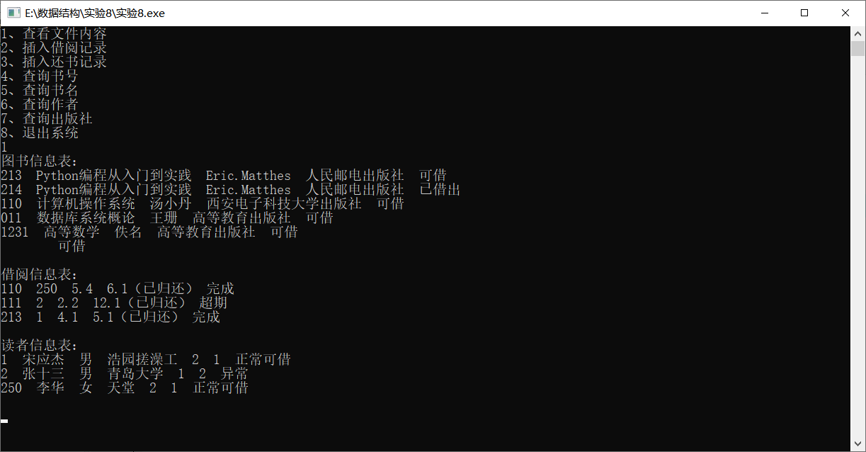

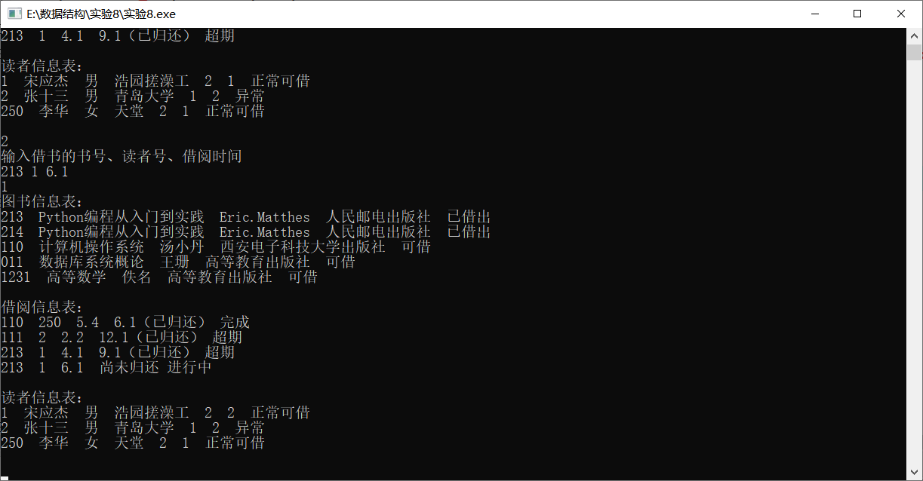

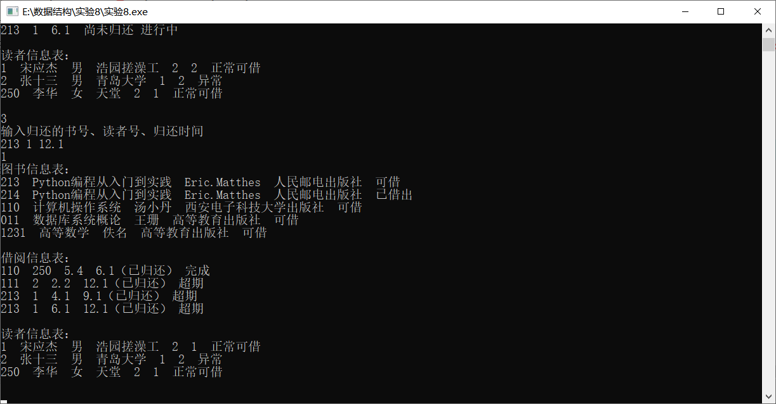

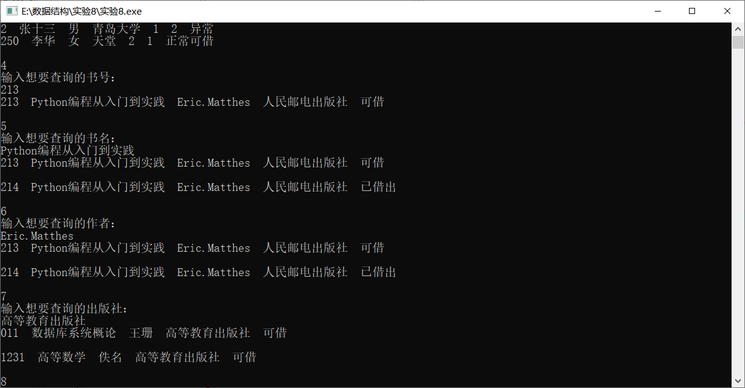

五、总结及体会

这是本学习最后一次的实验了，代码看起来是比较多的，但是其实并不是很难，无非就是一个对文件的取和写的操作，过程中采用合适的存储方式进行存储，并不是很难，经过一个学期的课程设计，让我体会到了编程不一定是要解那些多难得题，落实在应用方面也是很有成就感的。

1. 参考书目和网络资源

无