# Adsorption model generations for CO2RR C2 pathway

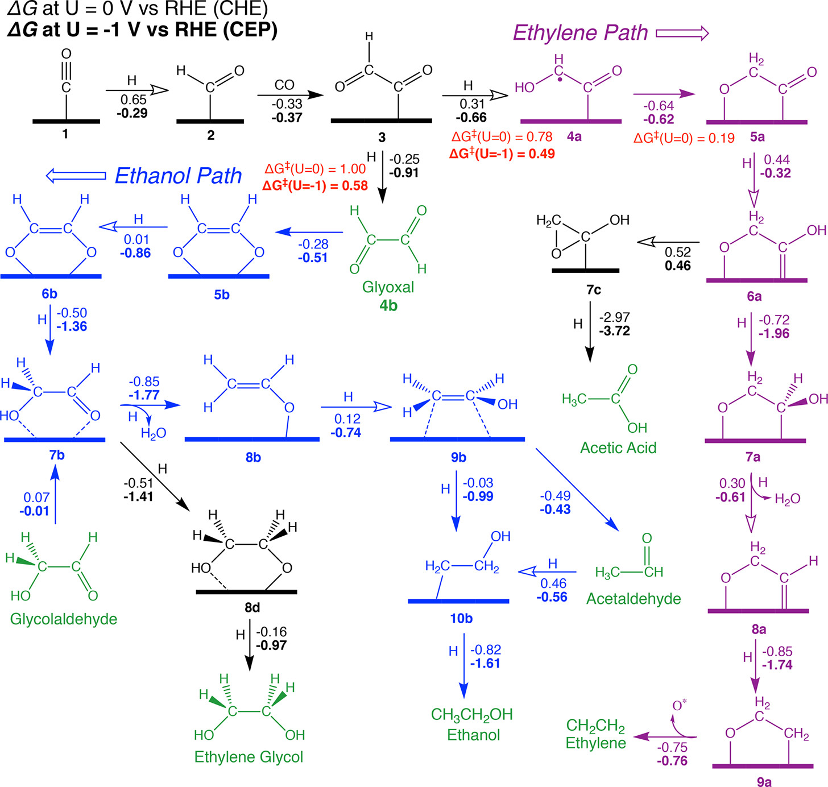

## Organizations of generated models

Pathways: 1. ethylene 2. acetic_acid 3. ethanol 4. ethanol_other

### ethylene

1. CO (1): single, 7 for each
2. CHO (2): single, 7 for each
3. COCHO (3): single, 7 for each
4. COCHOH (4a): single, 7 for each
5. OCH2CO (5a): double asymmetric, 14
6. OCH2COH (6a): double asymmetric, 14
7. OCH2CHOH (7a): double asymmetric, 14
8. OCH2CH (8a): double asymmetric, 14
9. OCH2CH2 (9a): double asymmetric, 14
10. C2H4: double symmetric, 7

35+70 = 105.

## acetic_acid

Derived from 6a

1. OCH2C_cyc_OH (7c): single, 7
2. CH3COOH: single, 7

14.

## ethanol

1. Glyoxal (4b): double asymmetric, 14
2. HOCCHO (5b): double symmetric, 7
3. HOHCCHO (6b): double asymmetric, 14
4. Glycolaldehyde (7b as well): double asymmetric, 14
5. CH2CHO (8b): single, 7
6. CH2CHOH (9b): double asymmetric, 14
7. CH2CH2OH (10b): single, 7
8. acetaldehyde: single, 7
9. CH3CH2OH : single, 7

35+56=91.

## ethanol_other

1. CH2OHCH2O (8d): double asymmetric, 14
2. ethylene_glycol: double symmetric, 7

Total: (105+14+91+21)*44 = 10164