Горяева Татьяна

Создание таблицы Faculties

SELECT TOP (1000) [fac_id]

,[fac_name_full]

,[fac_name_abbr]

FROM [DataGirdView].[dbo].[Faculties]

CREATE TABLE FacultiesTest1 (

fac_id INT IDENTITY (1,1) PRIMARY KEY, fac_name_full NVARCHAR (255),

fac_name_abbr NVARCHAR (50)

);

Form1.cs

using System;

using System.Collections.Generic;

using System.ComponentModel;

using System.Data;

using System.Data.Common;

using System.Data.SqlClient;

using System.Drawing;

using System.Linq;

using System.Text;

using System.Threading.Tasks;

using System.Windows.Forms;

using System.Windows.Input;

using System.Xml.Linq;

using static System.Windows.Forms.VisualStyles.VisualStyleElement.ProgressBar;

using static System.Windows.Forms.VisualStyles.VisualStyleElement.Status;

namespace DataGirdView

{

public partial class Form1 : Form

{

public Form1()

{

InitializeComponent();

LoadData();

}

private void Form1_Load(object sender, EventArgs e)

{

}

private void LoadData()

{

string connectString = @"Data Source=DARK\MSSQLSERVER01;Database = DataGirdView;Integrated Security = true;" +

"Integrated Security=true;";

SqlConnection myConnection = new SqlConnection(connectString);

myConnection.Open();

string query = "SELECT * FROM Faculties ORDER BY fac_id ";

SqlCommand command = new SqlCommand(query, myConnection);

SqlDataReader reader = command.ExecuteReader();

List<string[]> data = new List<string[]>();

while (reader.Read())

{

data.Add(new string[3]);

data[data.Count - 1][0] = reader[0].ToString();

data[data.Count - 1][1] = reader[1].ToString();

data[data.Count - 1][2] = reader[2].ToString();

}

reader.Close();

myConnection.Close();

foreach (string[] s in data)

dataGridView1.Rows.Add(s);

}

private void button1_Click(object sender, EventArgs e)

{

string facNameFull = textBox1.Text; // Полное название факультета

string facNameAbbr = textBox2.Text;

string connectString = @"Data Source=DARK\MSSQLSERVER01;Database = DataGirdView;Integrated Security = true;";

using (SqlConnection myConnection = new SqlConnection(connectString))

{

myConnection.Open();

// Запрос на вставку и получение нового fac_id

string query = "INSERT INTO FacultiesTest1(fac_name_full, fac_name_abbr) VALUES (@fullName, @abbr); SELECT SCOPE_IDENTITY();";

using (SqlCommand command = new SqlCommand(query, myConnection))

{

command.Parameters.AddWithValue("@fullName", facNameFull);

command.Parameters.AddWithValue("@abbr", facNameAbbr);

// Получаем последний добавленный идентификатор

int nowId = Convert.ToInt32(command.ExecuteScalar());

dataGridView1.Rows.Add(new object[] { nowId, facNameFull, facNameAbbr });

}

}

textBox1.Clear();

textBox2.Clear();

}

} }

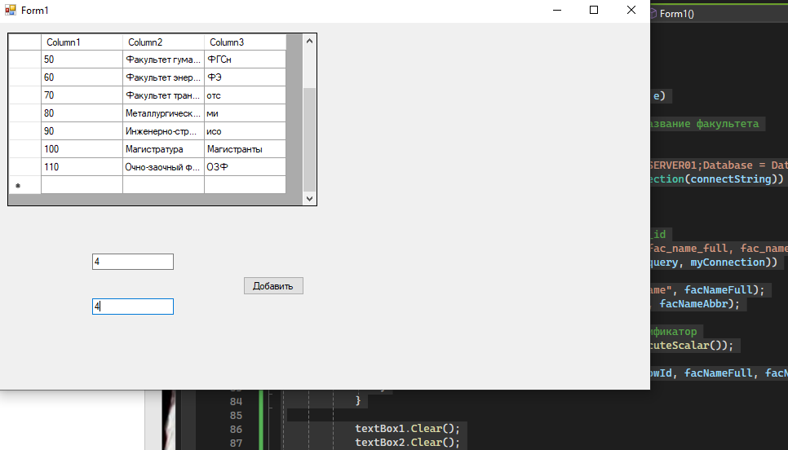

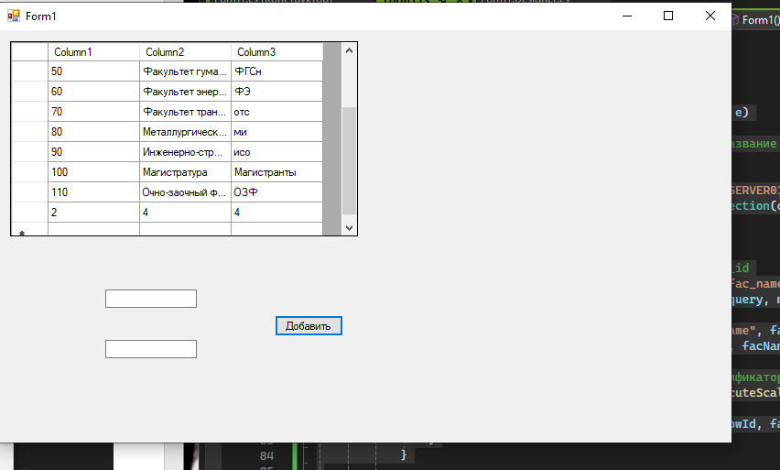

ЗАДАНИЕ: Нужно создать самими новую таблицу, с названием "Group IS" (Номер вашей группы), столбцы id, Фио и имя студента

CREATE TABLE GROUPIS213 (

fac_id INT PRIMARY KEY,

fac_name_full NVARCHAR(255),

fac_name_abbr NVARCHAR(50)

);

INSERT INTO GROUPIS213(fac_id,fac_name_full,fac_name_abbr) VALUES

(1, 'Горяева' ,'Татьяна'),

(2, 'Пискун' ,'Полина'),

(3, 'Самарина' ,'Алина'),

(4, 'Самко' ,'Анастасия');

SELECT TOP (1000) [fac_id]

,[fac_name_full]

,[fac_name_abbr]

FROM [GroupIS213].[dbo].[GROUPIS213]

CREATE TABLE GR (

fac_id INT IDENTITY (1,1) PRIMARY KEY, fac_name_full NVARCHAR (255),

fac_name_abbr NVARCHAR (50)

);

Form1.cs

using System;

using System.Collections.Generic;

using System.ComponentModel;

using System.Data;

using System.Data.SqlClient;

using System.Drawing;

using System.Linq;

using System.Text;

using System.Threading.Tasks;

using System.Windows.Forms;

namespace GROUP

{

public partial class Form1 : Form

{

public Form1()

{

InitializeComponent();

LoadData();

}

private void Form1_Load(object sender, EventArgs e)

{

}

private void LoadData()

{

string connectString = @"Data Source=DARK\MSSQLSERVER01;Database =GroupIS213 ;Integrated Security = true;" +

"Integrated Security=true;";

SqlConnection myConnection = new SqlConnection(connectString);

myConnection.Open();

string query = "SELECT * FROM GroupIS213 ORDER BY fac_id ";

SqlCommand command = new SqlCommand(query, myConnection);

SqlDataReader reader = command.ExecuteReader();

List<string[]> data = new List<string[]>();

while (reader.Read())

{

data.Add(new string[3]);

data[data.Count - 1][0] = reader[0].ToString();

data[data.Count - 1][1] = reader[1].ToString();

data[data.Count - 1][2] = reader[2].ToString();

}

reader.Close();

myConnection.Close();

foreach (string[] s in data)

dataGridView1.Rows.Add(s);

}

private void button1_Click(object sender, EventArgs e)

{

string facNameFull = textBox1.Text; // Полное название факультета

string facNameAbbr = textBox2.Text;

string connectString = @"Data Source=DARK\MSSQLSERVER01;Database = GroupIS213;Integrated Security = true;";

using (SqlConnection myConnection = new SqlConnection(connectString))

{

myConnection.Open();

// Запрос на вставку и получение нового fac_id

string query = "INSERT INTO GR(fac_name_full, fac_name_abbr) VALUES (@fullName, @abbr); SELECT SCOPE_IDENTITY();";

using (SqlCommand command = new SqlCommand(query, myConnection))

{

command.Parameters.AddWithValue("@fullName", facNameFull);

command.Parameters.AddWithValue("@abbr", facNameAbbr);

// Получаем последний добавленный идентификатор

int nowId = Convert.ToInt32(command.ExecuteScalar());

dataGridView1.Rows.Add(new object[] { nowId, facNameFull, facNameAbbr });

}

}

textBox1.Clear();

textBox2.Clear();

}

}

}

РЕЗУЛЬТАТ

