- Almost all Intel Core i7 processors support Intel VT-x.
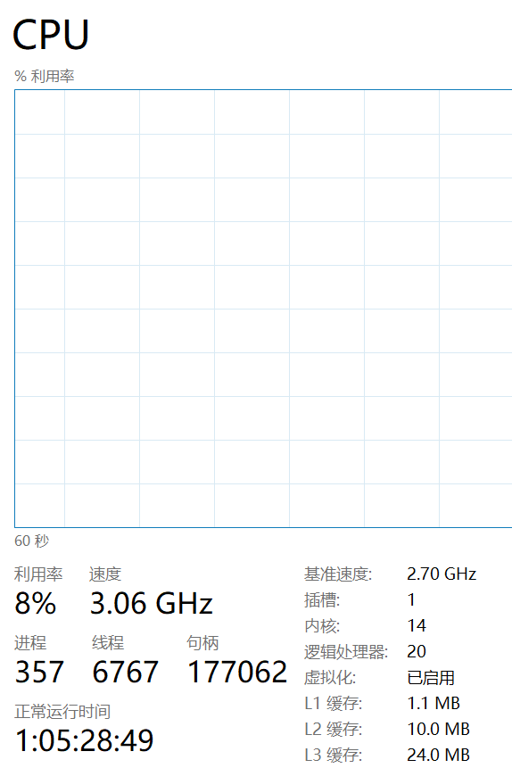

2. The fundamental reasons for Cloud's success, its three major advantages, and its three major disadvantages
The underlying cause:
Economy: Transitioning from capital expenditure (CapEx) to operational expenditure (OpEx), enterprises no longer need to make significant upfront hardware investments.
Scalability: Dynamically scale resources as needed to adapt to business fluctuations.
Maintenance simplification: Cloud providers are responsible for hardware maintenance, updates, and security patches.
Global deployment: Quickly deploy services globally to reduce latency
Three major advantages:
Cost-effectiveness: Pay based on usage, avoiding resource idleness
High availability and disaster recovery: Built-in redundancy and data backup mechanisms
Quick deployment and innovation acceleration: Minute-level resource allocation, supporting agile development and testing
Three major drawbacks:
The long-term cost may be higher: The cumulative subscription fees may exceed the cost of self-building.
Supplier lock-in risk: May encounter technical and data migration difficulties when migrating to other cloud platforms
Security and privacy concerns: The data is stored with a third party, which may be subject to regulatory restrictions or vulnerable to cross-tenant attacks.

3. The main functions of Hypervisor
The main function of Hypervisor (Virtual Machine Monitor) is to create, run and manage virtual machines on physical hardware, abstracting and allocating physical resources (CPU, memory, storage) to multiple virtual machines, enabling them to operate independently.

4. What is a virtual machine
A virtual machine is a complete computer system simulated by software. It has its own virtual hardware (such as CPU, memory, hard disk, etc.) and can install and run operating systems and applications just like on a physical computer.

5. Benefits of Using Virtual Machines
Server consolidation: Reducing the number of physical servers
Isolation: Issues with one virtual machine do not affect other virtual machines or the host machine.
Snapshot and Recovery: Save the state and quickly restore.
Testing and Development: Conducting security tests on new software or system configurations
Legacy system support: Running old operating systems on new hardware

6. Five Use Cases of Virtual Machines
Server virtualization (data center consolidation)
Desktop Virtualization (VDI)
Software Testing and Quality Assurance (Multiple Environment Testing)
Disaster recovery (rapid restoration of virtual machines from backup)
Cloud computing services (IaaS such as AWS EC2, Azure VM)
7. What is Guest OS? The operating system installed on a virtual machine

8. The meaning of virtual machine isolation Virtual machines run independently and are isolated from each other and the host system

9. The benefits of virtual machine portability It allows virtual machines to be moved between different physical machines with compatible hypervisors

10. The purpose of cloning virtual machines
To quickly replicate the configured virtual machine environment for the following purposes:
Create multiple instances with the same configuration
Backup or templated deployment
Quickly replicating the test environment

