Confirm that the Kubernetes control plane and related services are operating normally, and prepare for the subsequent installation of KServe.
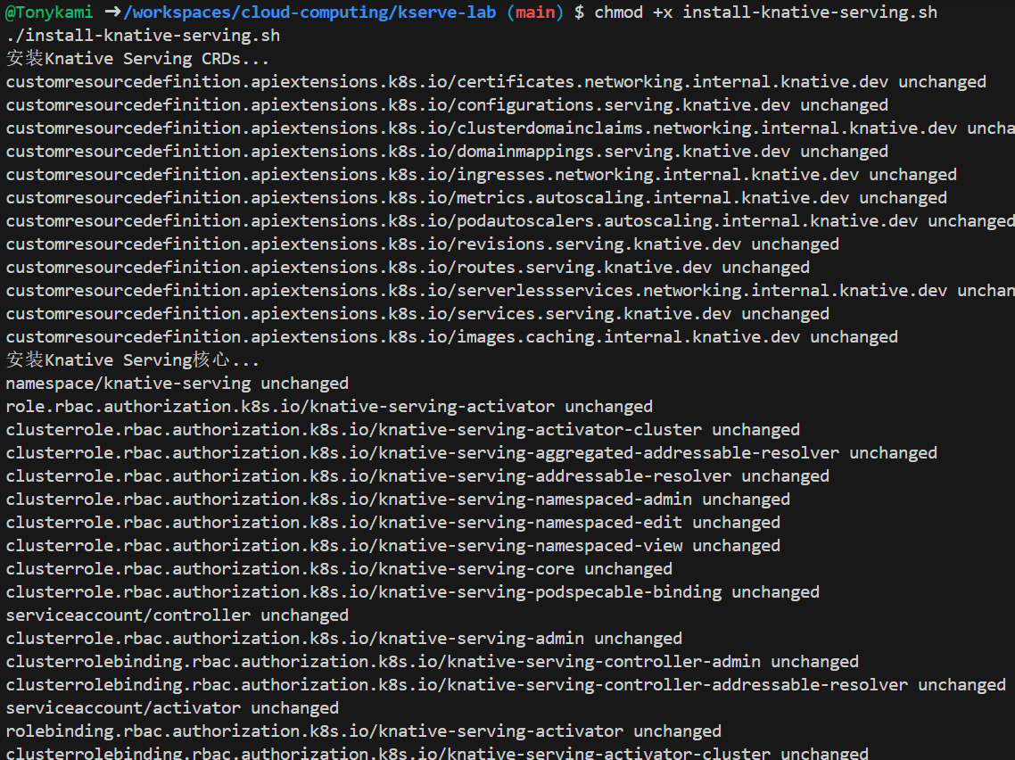
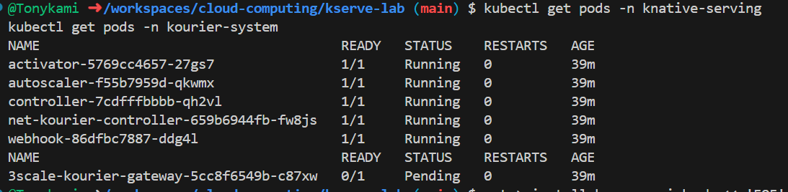
KServe was successfully installed, including core components such as namespaces, CRD, RBAC permissions, configuration mapping, service and controller deployment.
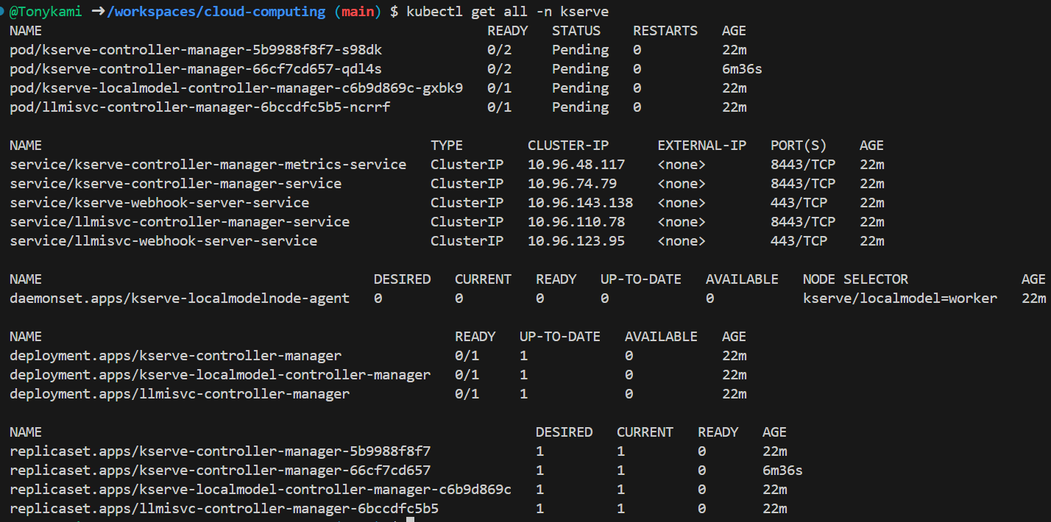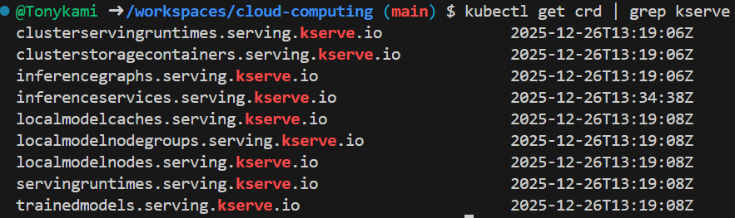
Create the sklearn-iris.yaml deployment file
Monitoring deployment status
The InferenceService was successfully created, and the system automatically generated the corresponding Deployment and Pod. The Pod consists of two containers: the storage initializer and the model server.
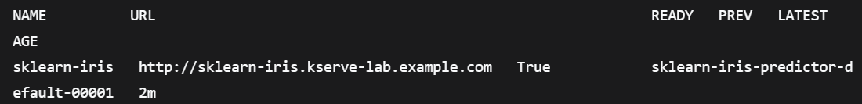
The storage initializer successfully downloaded the model file from Google Cloud Storage to the local path /mnt/models, and then the sklearn model server started and began to listen on port 8080.
Model inference and verification
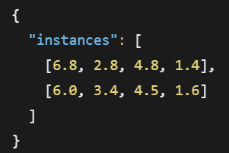

Related links:
