My computer encountered an error when installing Docker and the problem couldn't be resolved. I also reported this to you during the class. Therefore, for future experiments, I will use the GitHub Codespaces to solve the issue. It can complete almost all the tasks of this course, so it is an alternative solution.
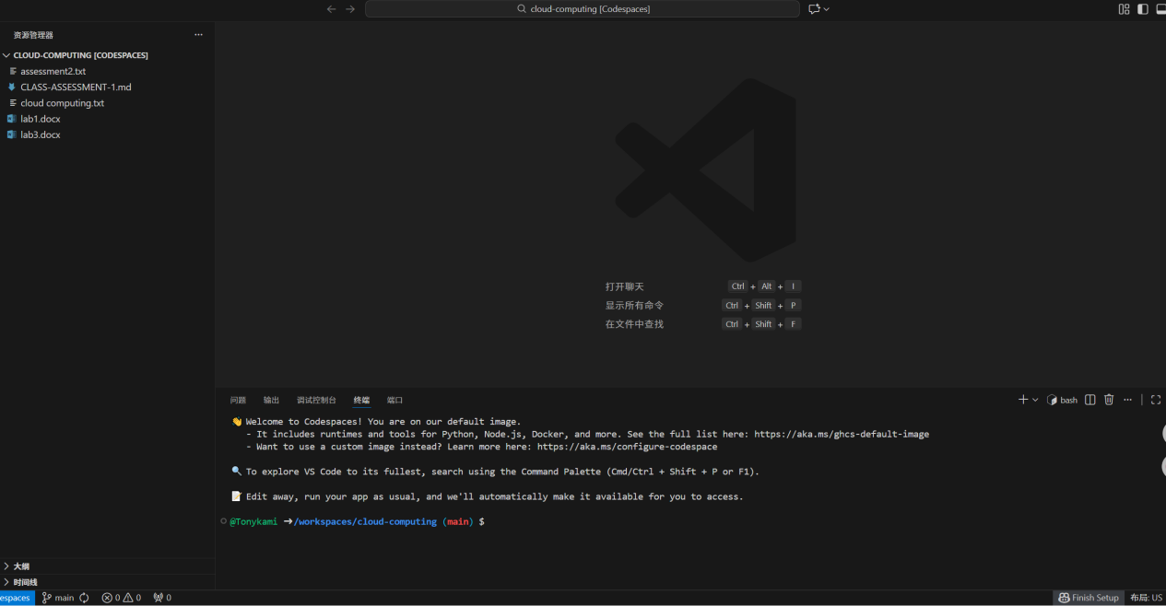
Download and install Gitea：
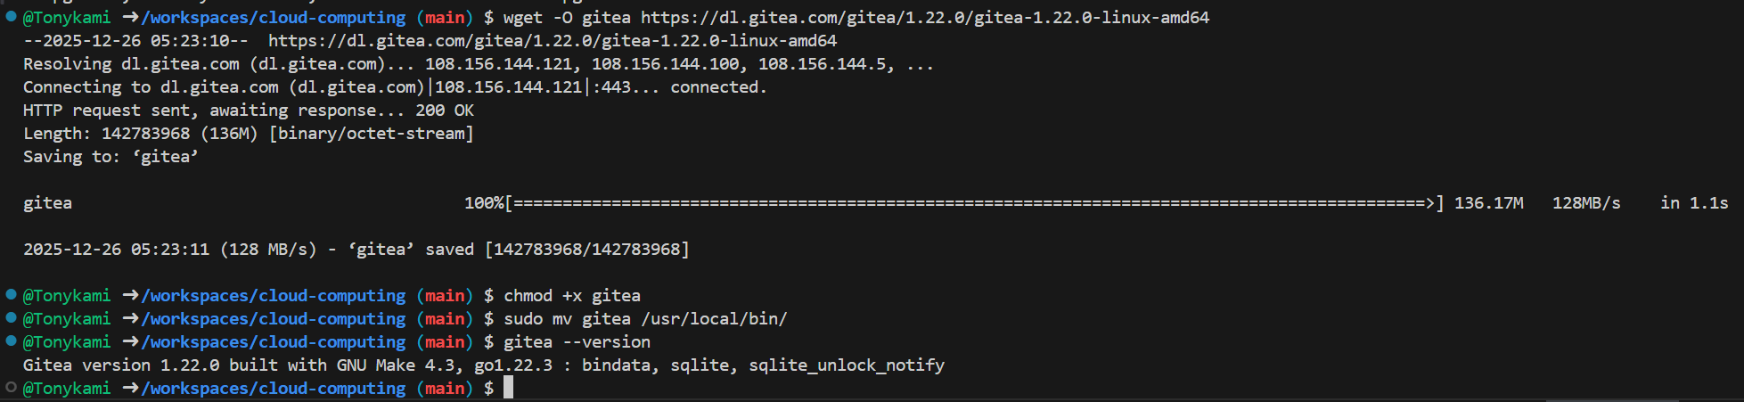
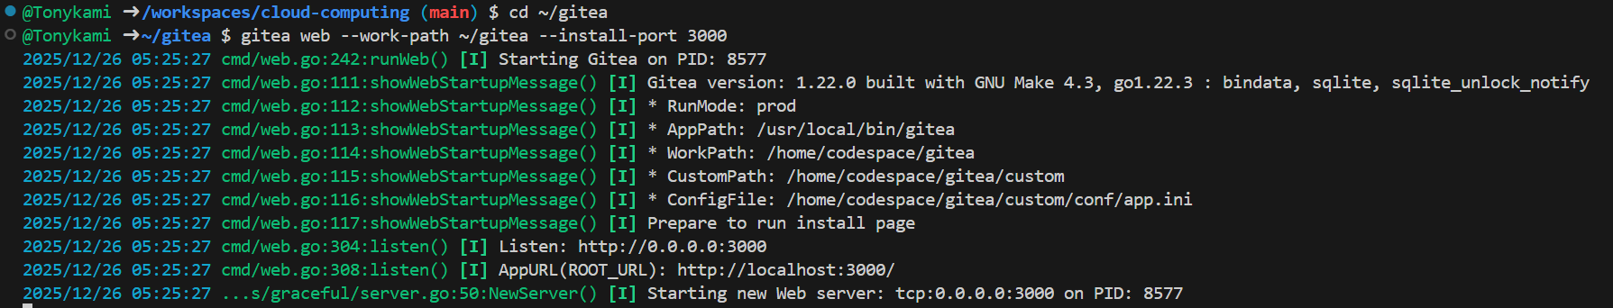
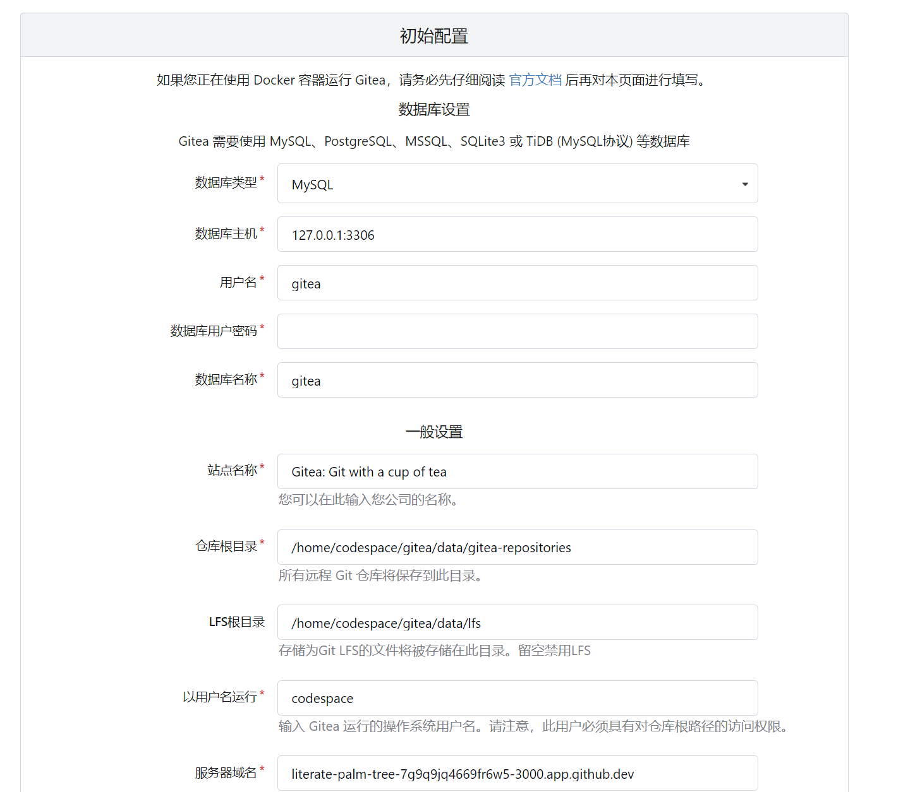
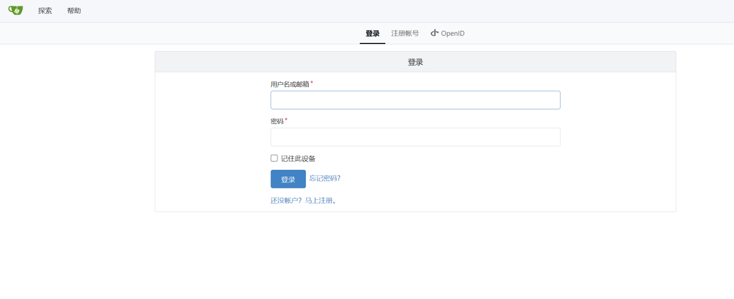
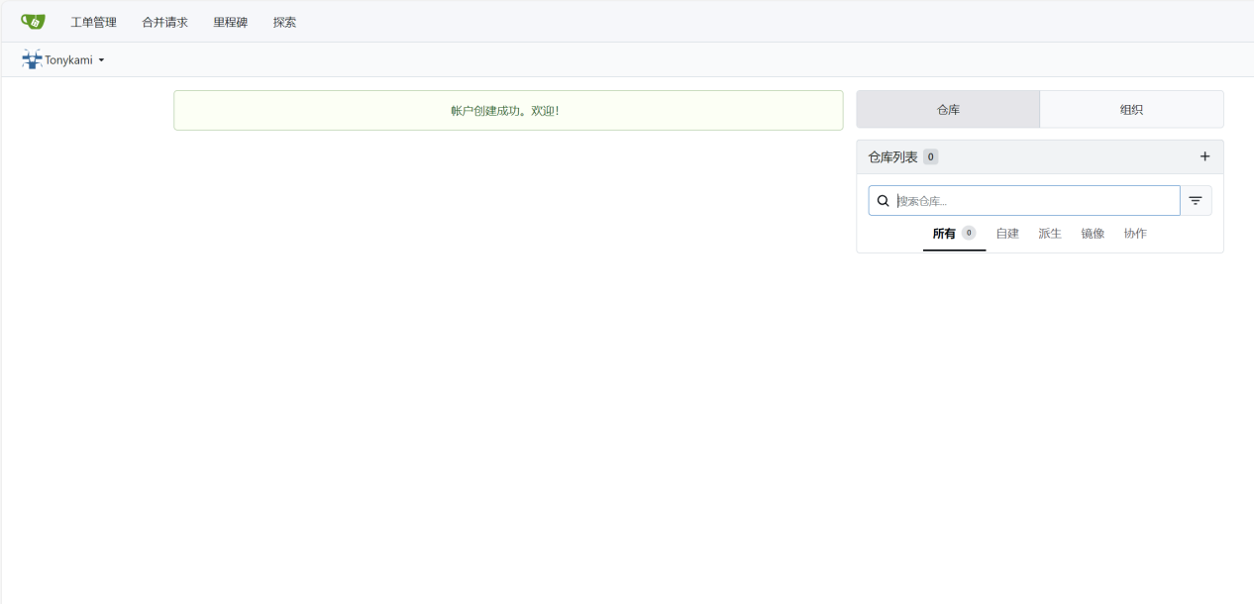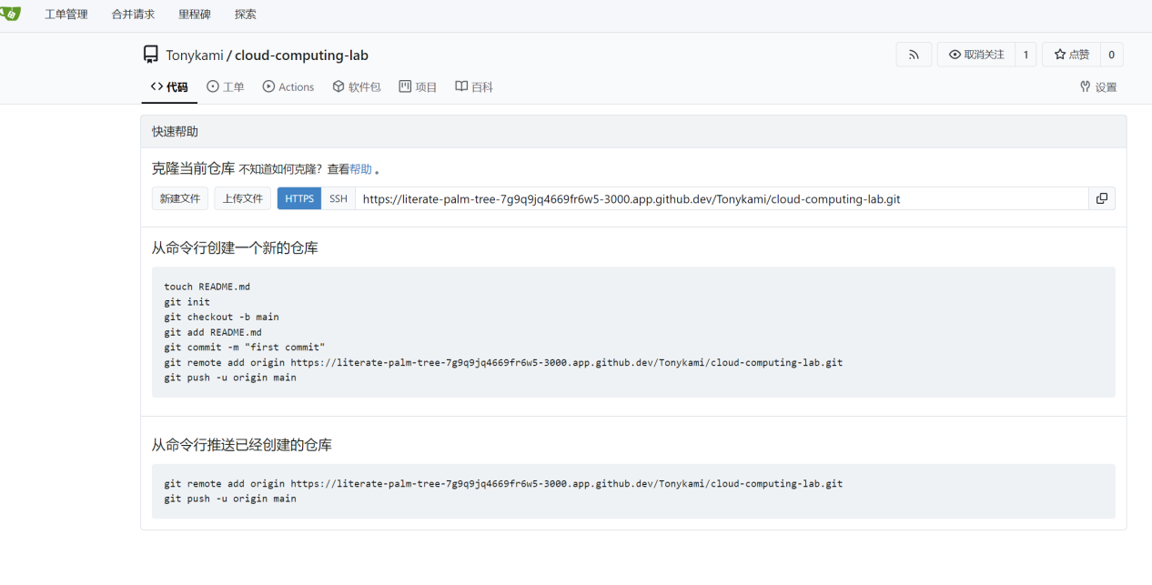

The management interface shows that LFS support has been enabled.
