Display the Docker version and confirm that the hello-world container has been successfully run.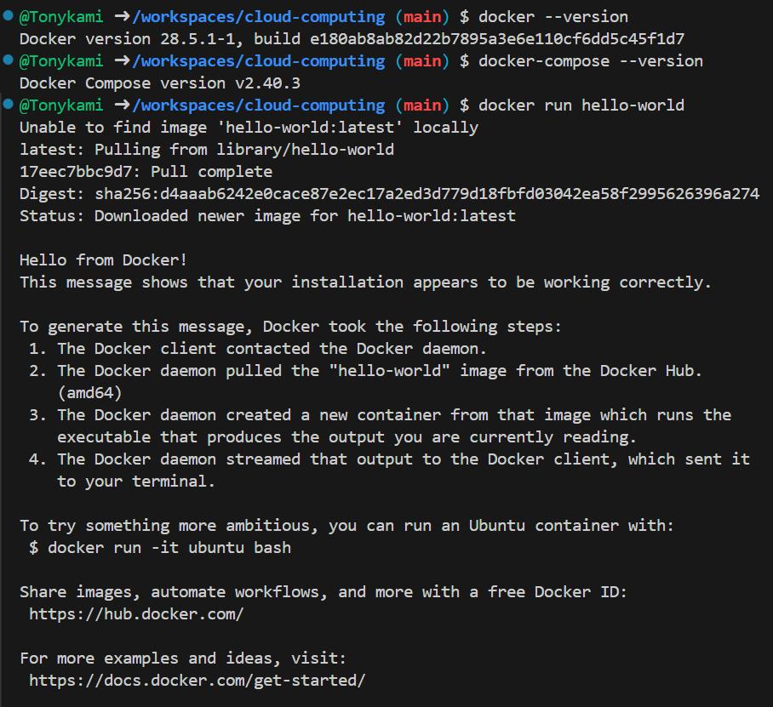
Create a file inside the container and exit.
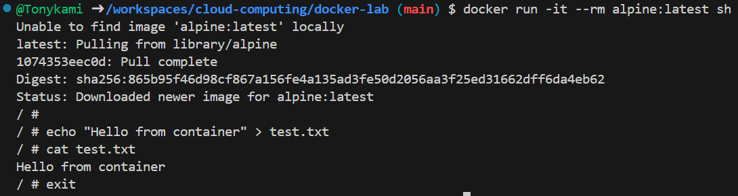

Display the pulled images and image details
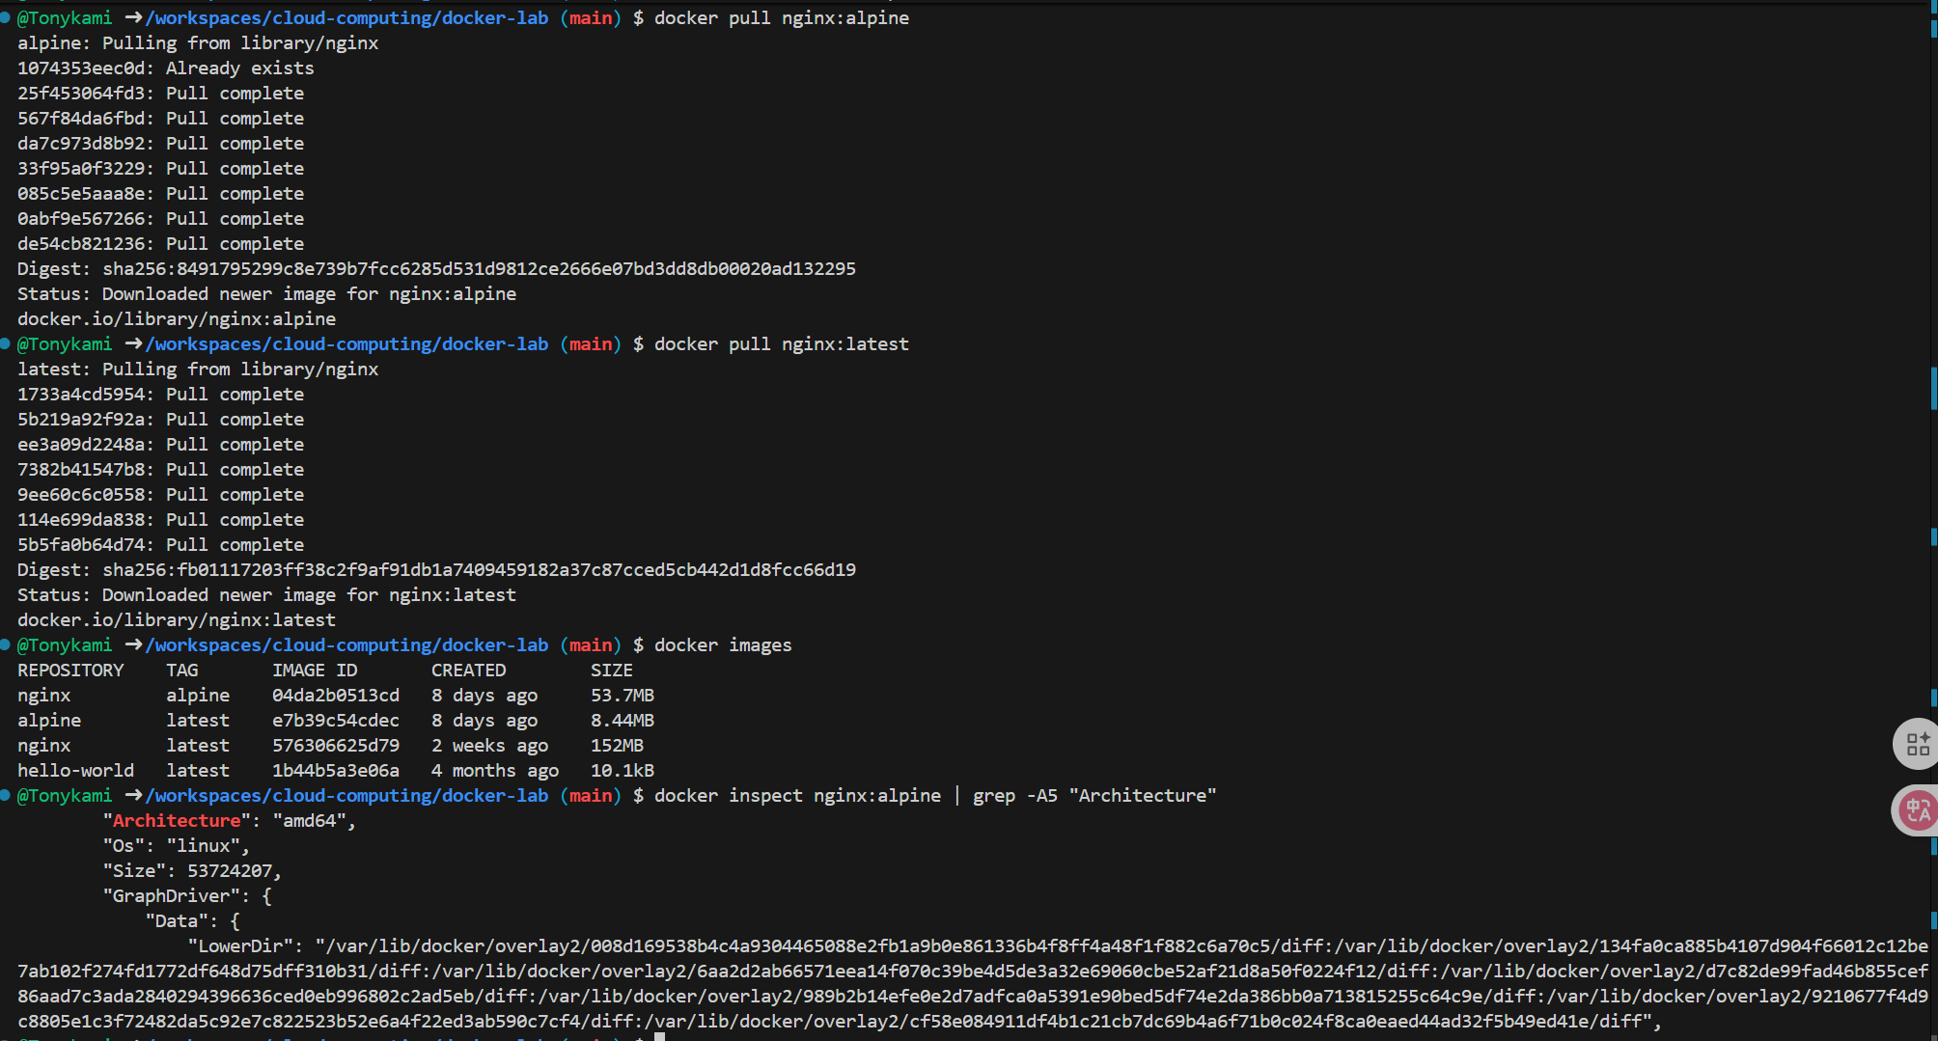
Port mapping test
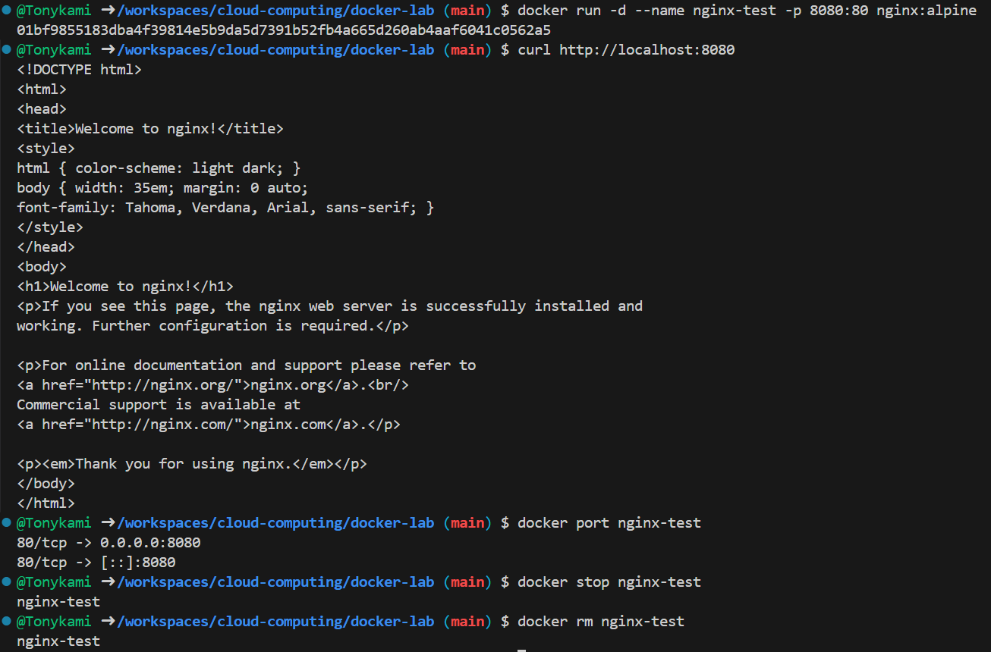
Examples of covering commands, environment variables and working directories
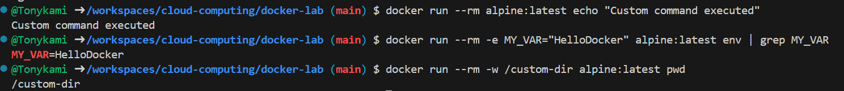
Creation of the volume and verification of data persistence
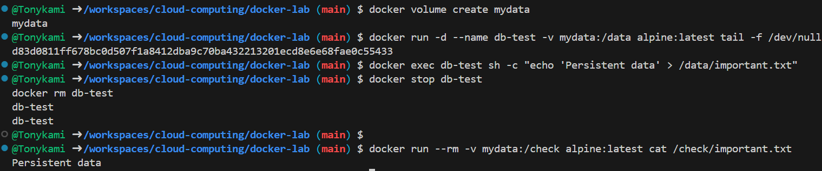
Local file mounting and bidirectional synchronization
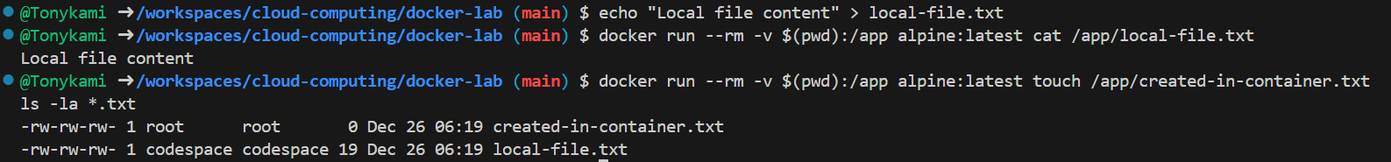
Docker Compose configuration file, starting services and verification
