The successful installation output of the istioctl install command
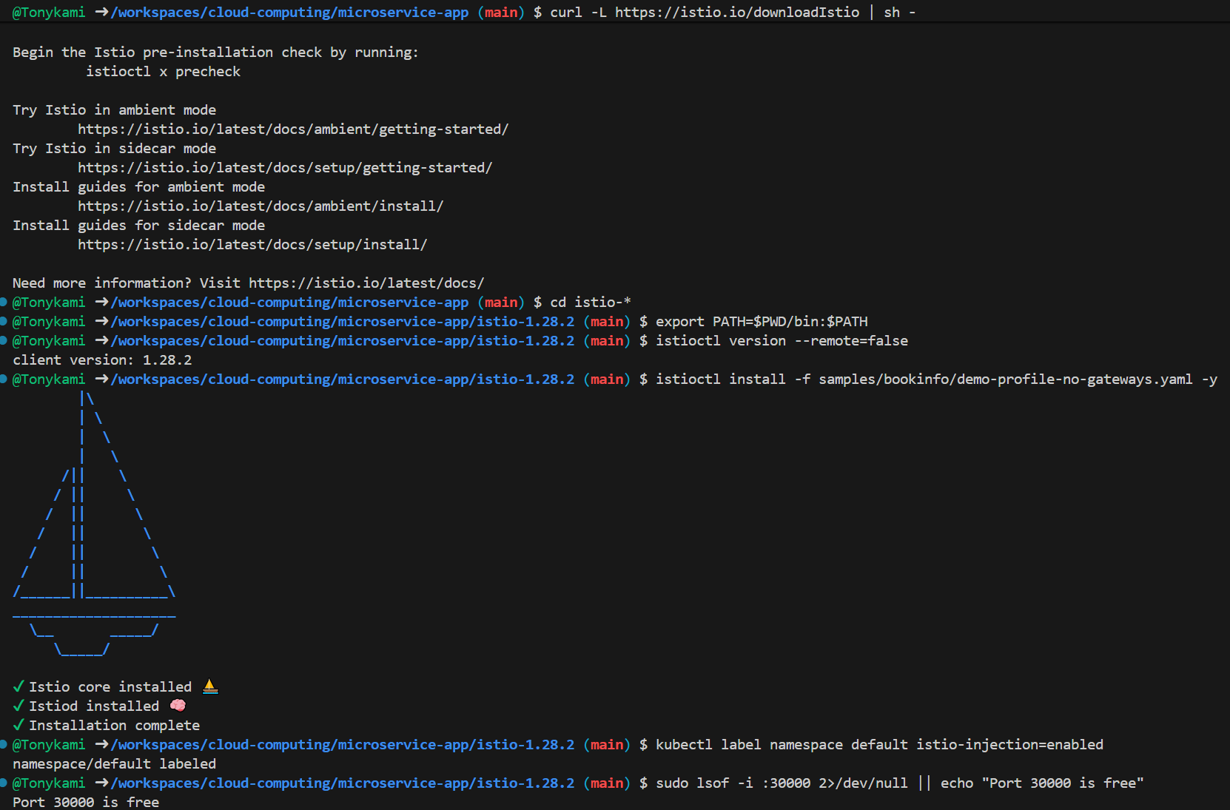
The output of "kubectl get pods" and the verification command returns the <title>Simple Bookstore App</title>
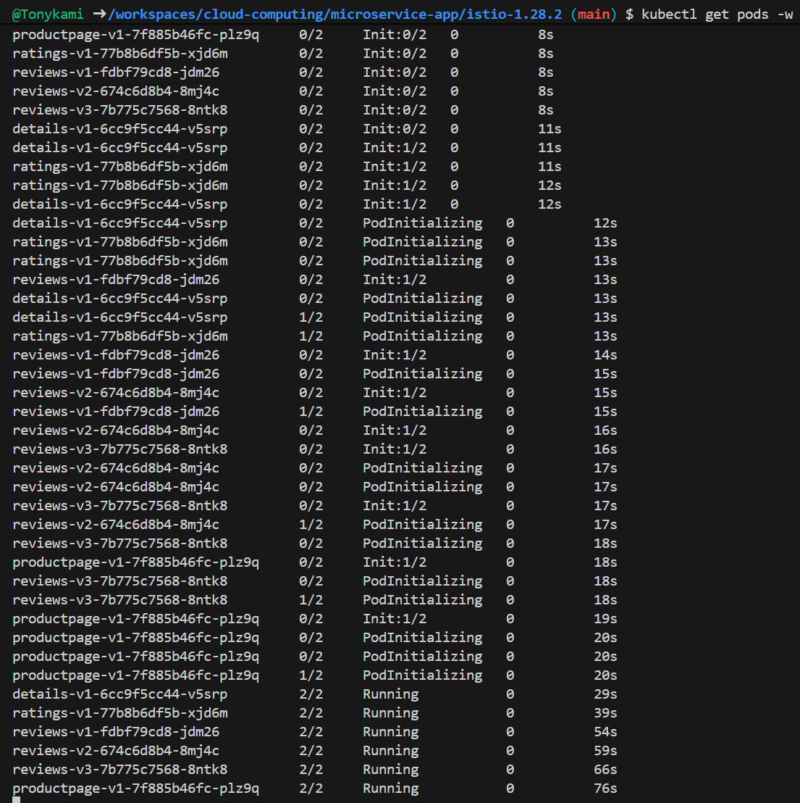

The output of "kubectl get gateway" confirms that the gateway has been created and its status is True.
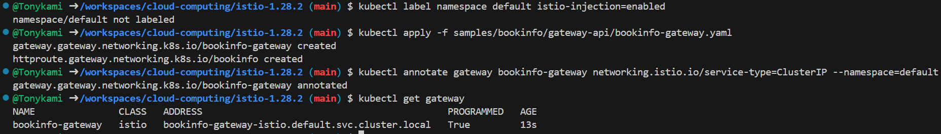
The browser successfully displayed a screenshot of the Bookinfo application page.
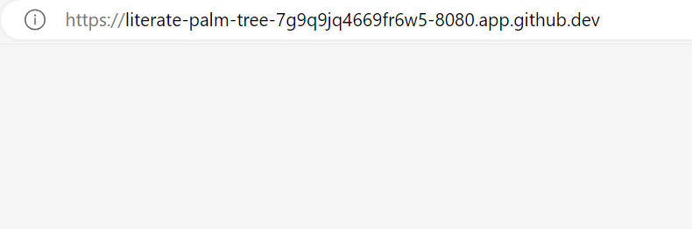
Screenshot of the Graph page on the Kiali dashboard
