1.The configuration of "virtual-service-reviews-50-v3.yaml" has taken effect.
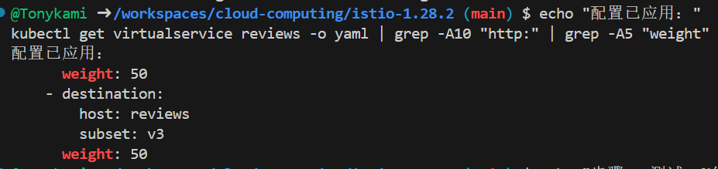
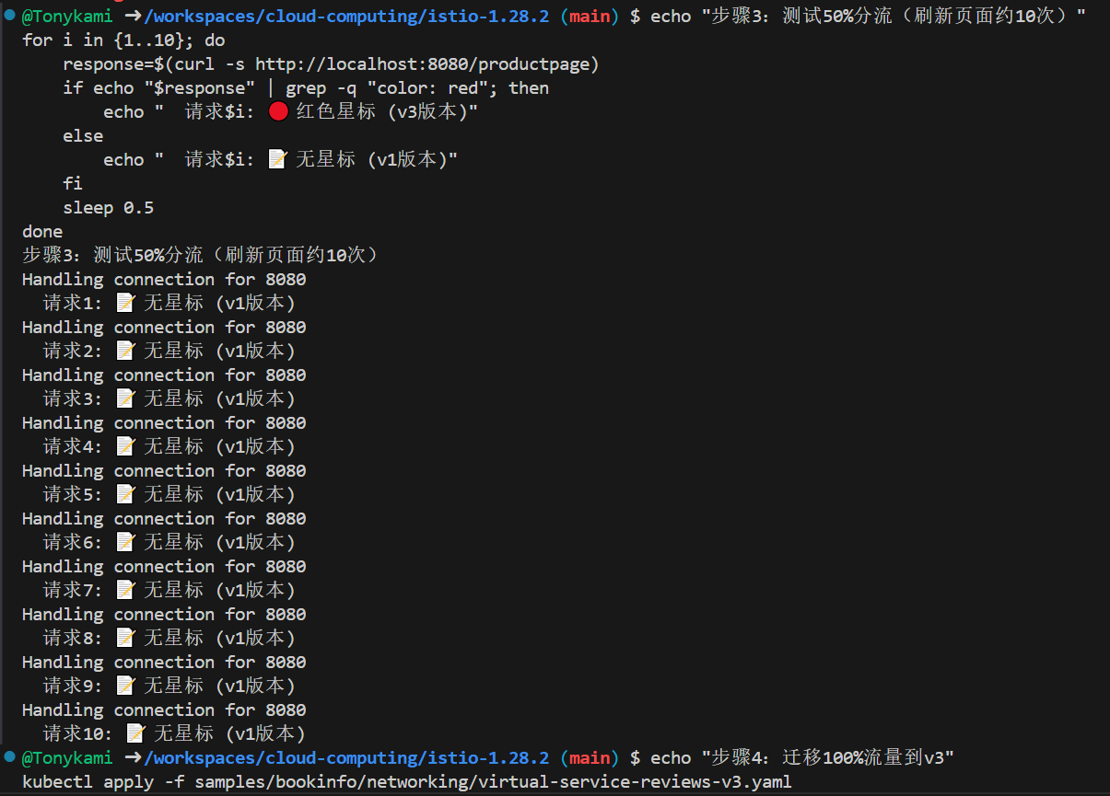
By configuring the "weight" field in the VirtualService, it is possible to finely adjust the traffic distribution for different service versions at the traffic layer without restarting any application instances. This enables risk control during the release process.

2.The VirtualService configuration shows routing rules based on headers.
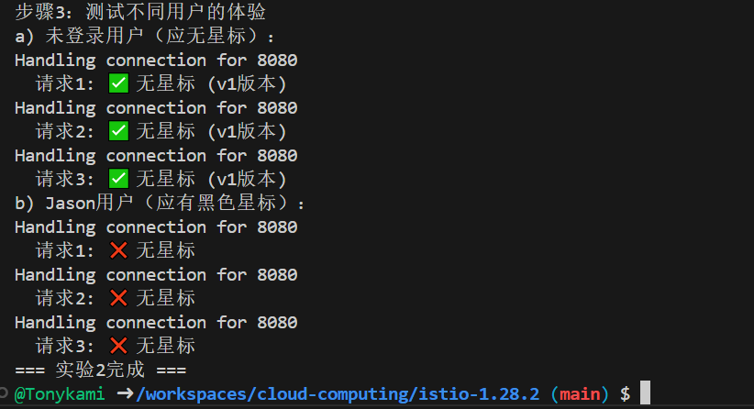

Comparison of pages before and after logging in as jason
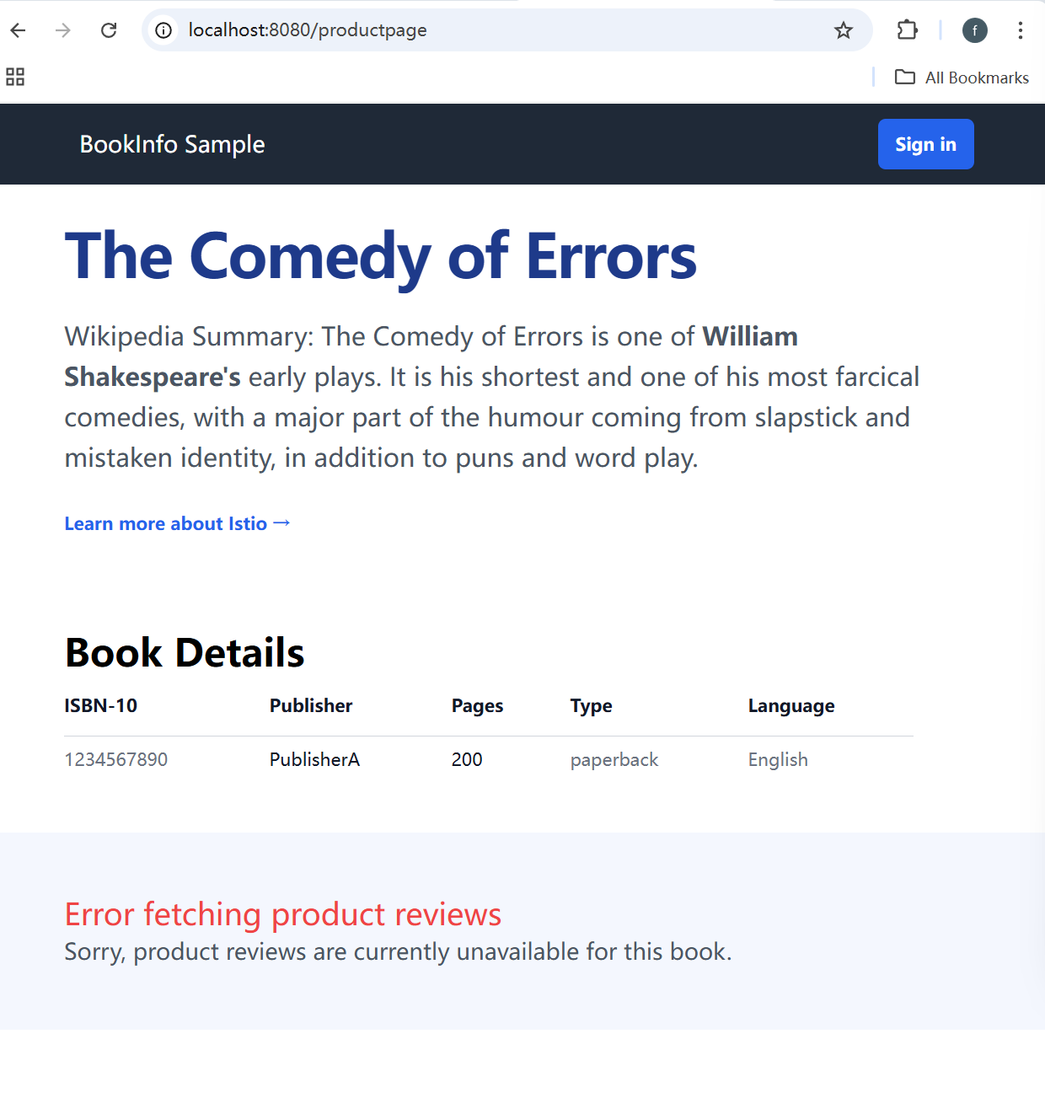
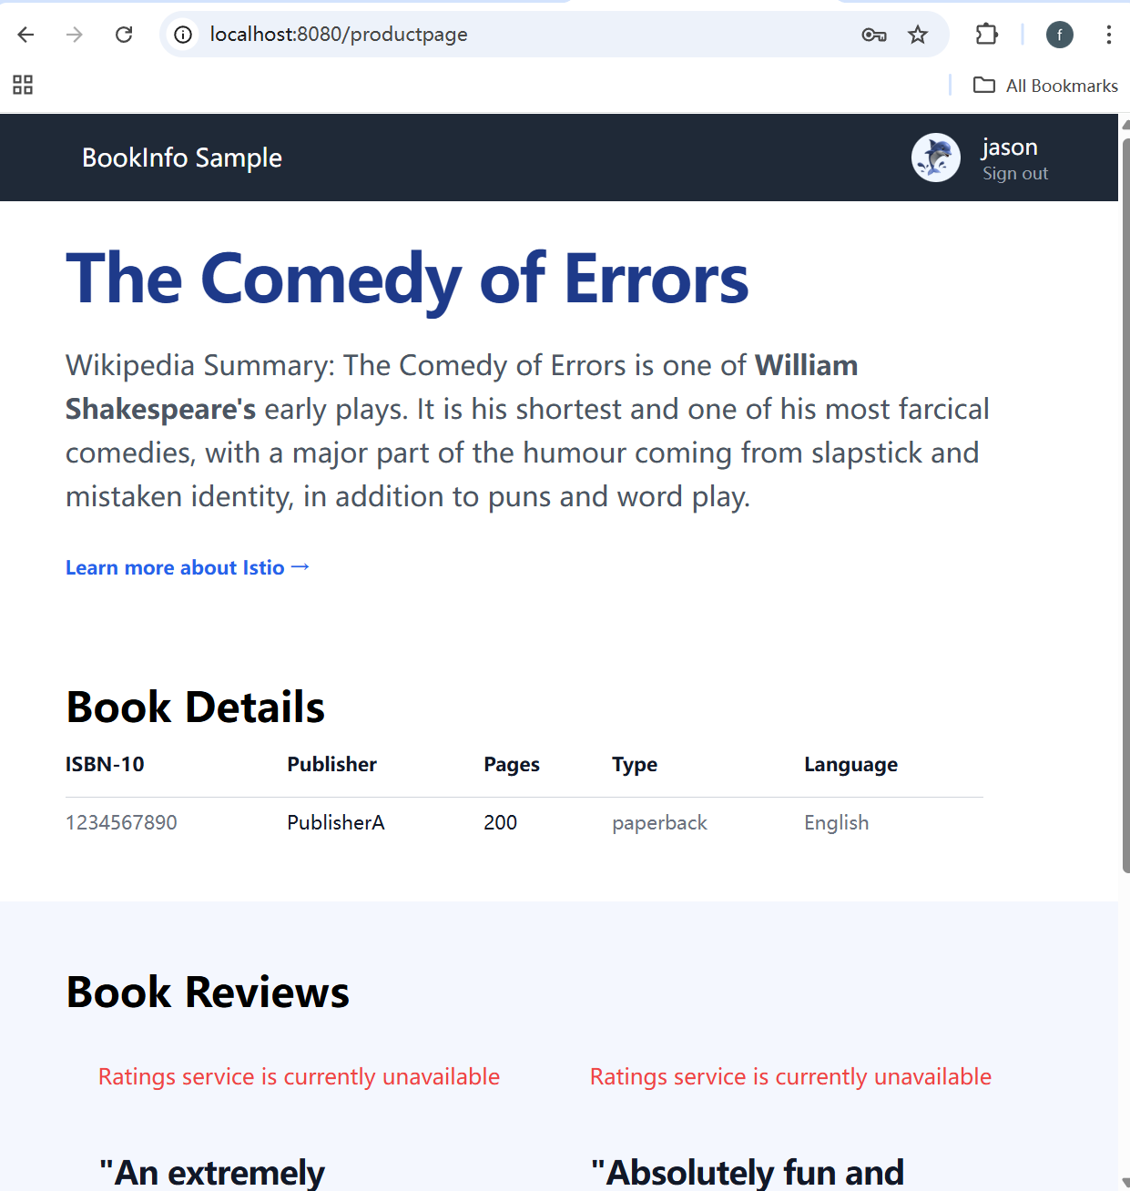

3.The timeout error page that the Jason user saw
The "Ratings service is unavailable" message that Jason user saw
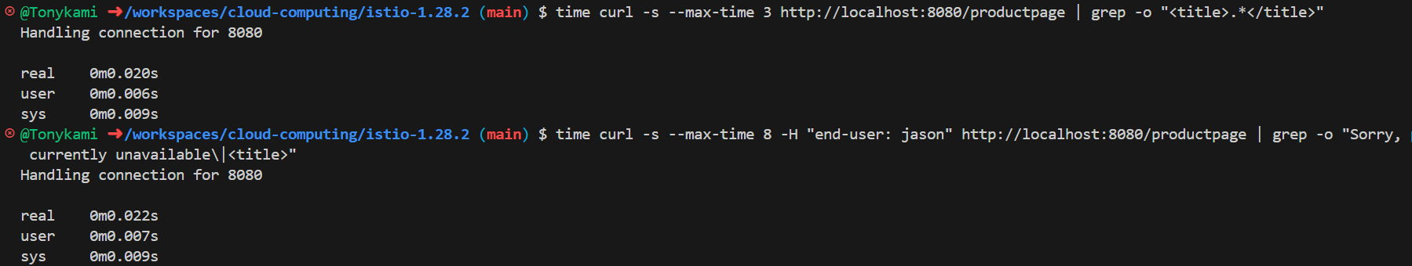
Fault injection is a powerful tool for chaos engineering practices. It enables the proactive triggering of faults in a controlled environment, allowing for the early detection of system weaknesses (such as unreasonable timeout configurations, fragile error handling logic), without requiring any physical disruption to the upstream services.

4.Configure circuit breaker rules: Create a DestinationRule for the httpbin service and set strict circuit breaker thresholds (for example, maxConnections: 1).
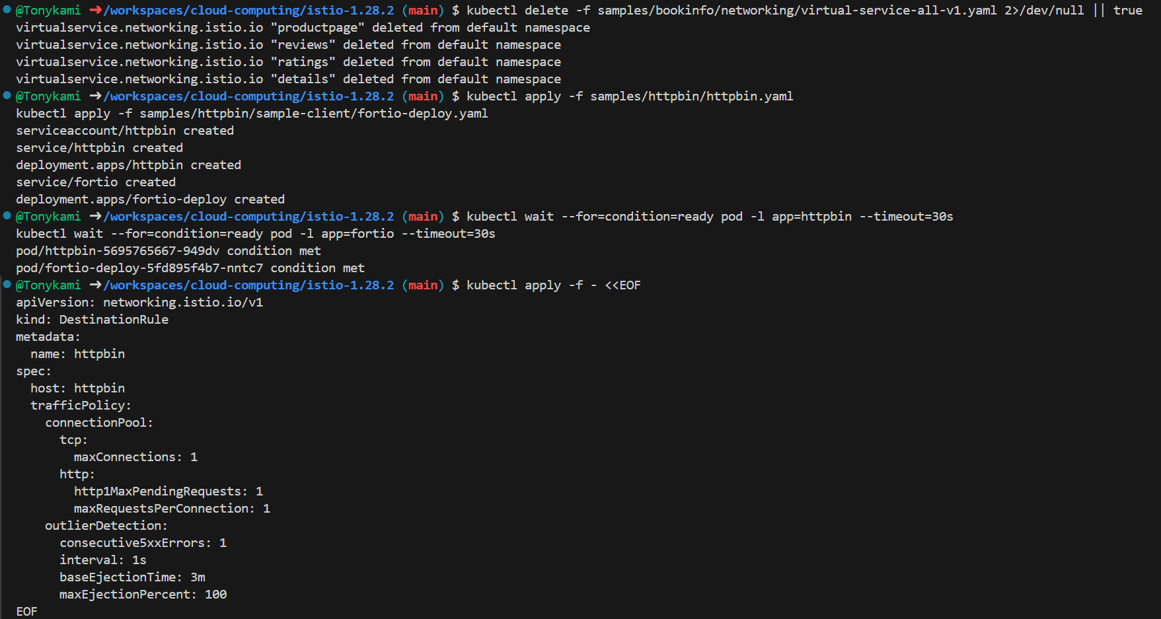
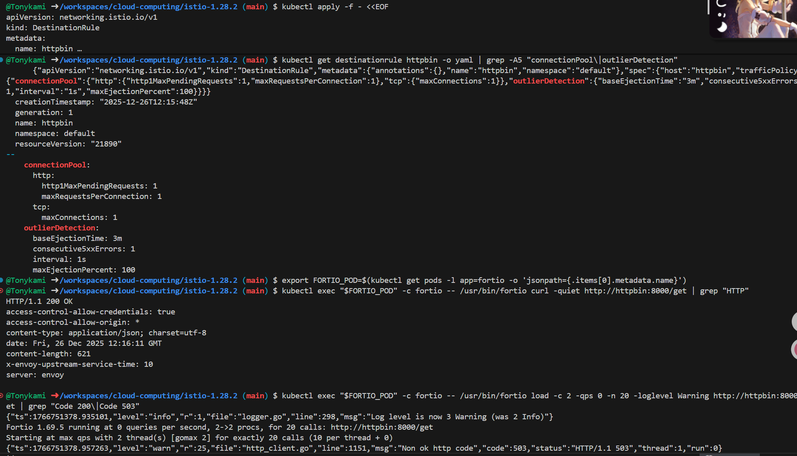
Pressure test triggers the circuit breaker: Using the load testing tool Fortio, multiple requests are initiated concurrently. When the number of concurrent requests exceeds the fuse threshold, some requests immediately receive an HTTP 503 (Service Unavailable) response, indicating that the circuit has been "fused" and the requests are quickly rejected.
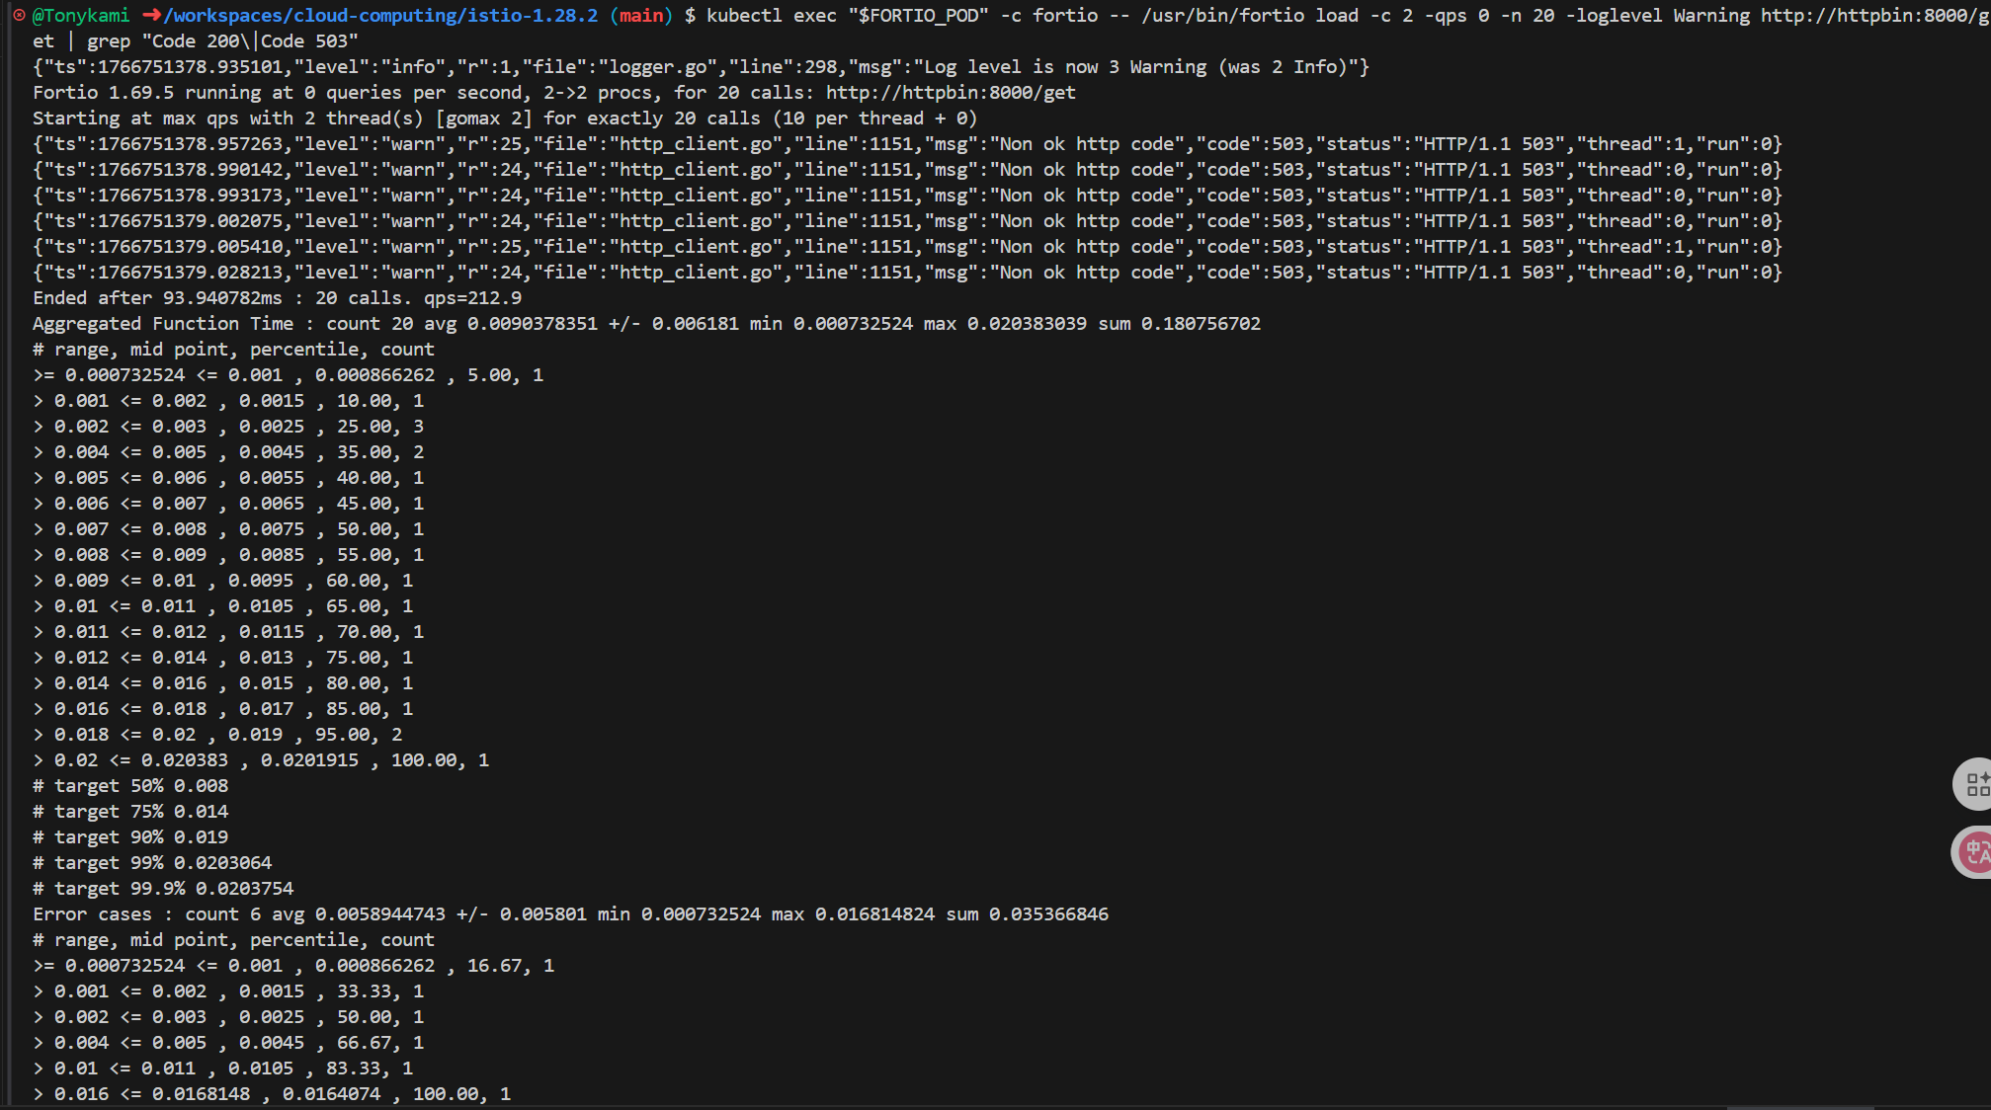
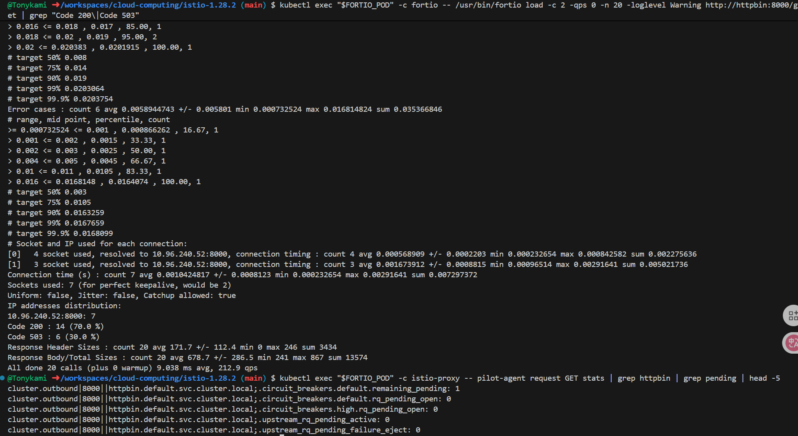
By using the statistical indicators provided by istio-proxy, one can observe the counts of connection pool overflows and rejected requests.

