Docker status: Output of "docker info" command
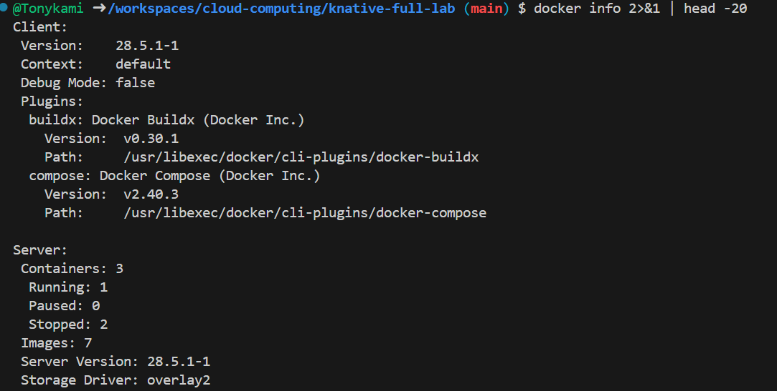
Check the output of the "kn version" and "func version" commands to confirm that the Knative command-line tool has been installed successfully.
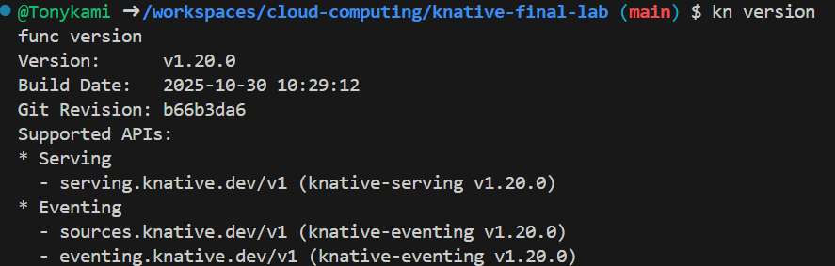
The status of the Knative Serving component
The command "kubectl get pods -n knative-serving" shows that all the core controllers (such as controller, autoscaler, activator, etc.) are in the "Running" state.
The command "kubectl get pods -n kourier-system" displays the Pod status of the Kourier gateway and the controller.
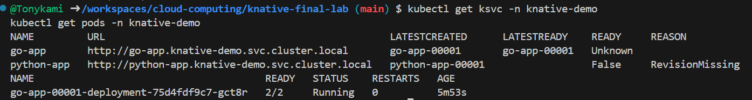

The file "EXPERIMENT_REPORT.md" of the cat shows the header and key sections of the final generated experimental report document.
