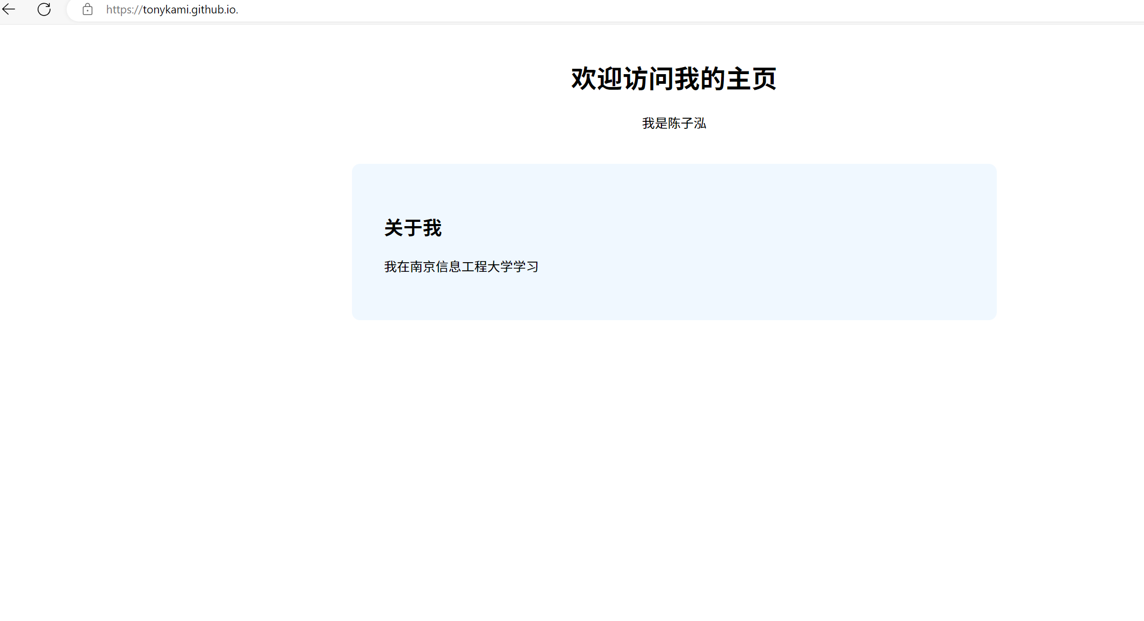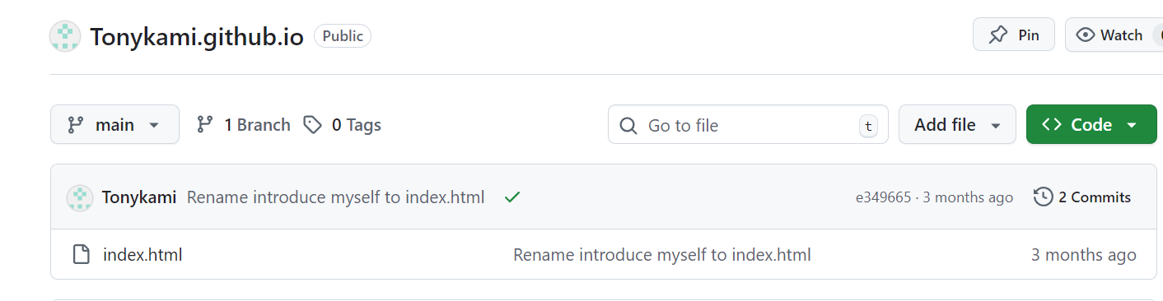

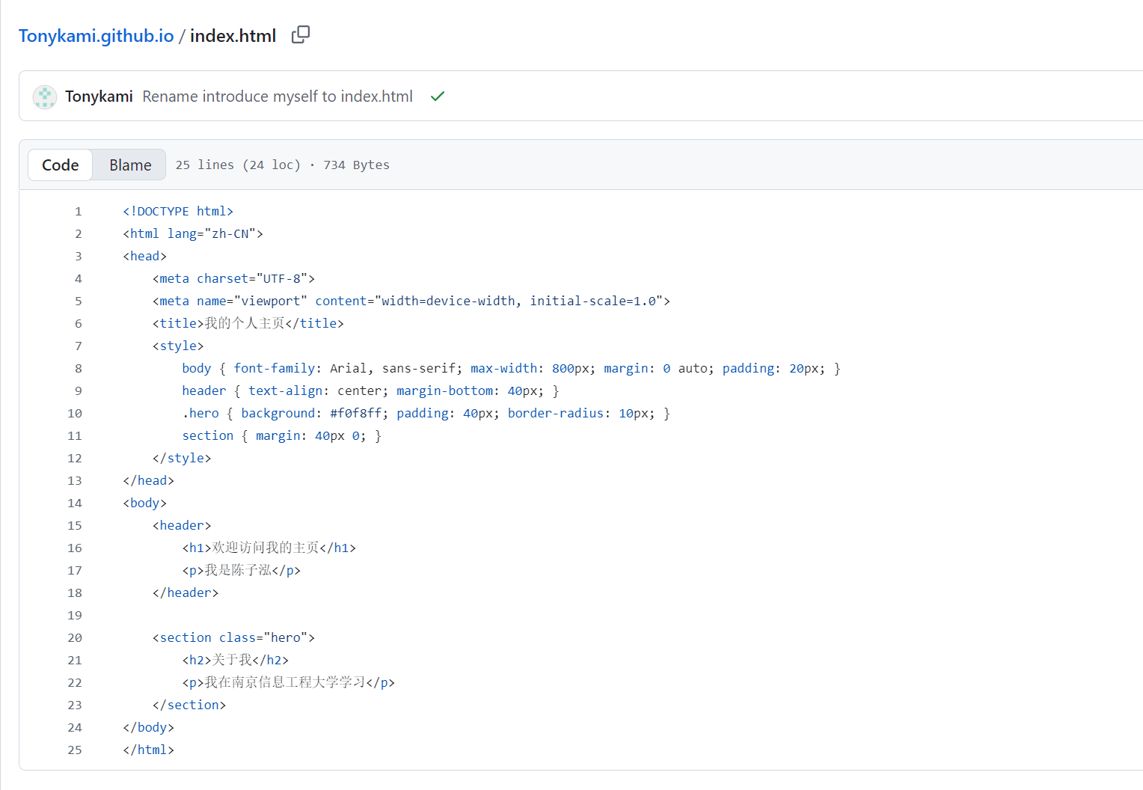
My personal website： https://tonykami.github.io.
The GitHub repository：https://github.com/Tonykami/Tonykami.github.io

