KajoRecSys System Flowchart
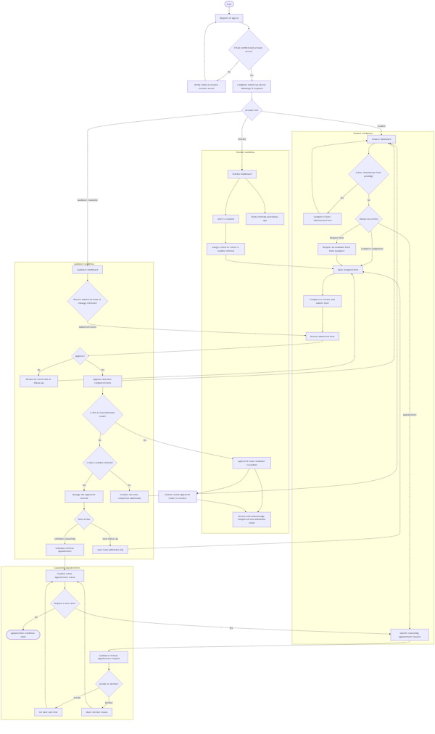
The flowchart focuses on the primary student, teacher, and Guidance Office workflows. Access to dashboards and actions is restricted by account role.

