**Вариант 5.2**

|  |  |
| --- | --- |
| 2 pattern | **192\.168\.1\.\d{1,3}** |

**Автоматная грамматика**:

L(pattern) = L("192\.168\.1\.\d{1,3}") = {"192.168.1.0", ..., "192.168.1.255"}

G(T, V, P, S0) = G({0, 1, 2, ..., 9, «.»}, {S0, A, B,…, L}, {p1, …, p13}, S0)

*Правила регулярной грамматики:*

p1: S0 → 1A

p2: A → 9B

p3: B → 2C

p4: C → .D

p5: D → 1E

p6: E → 6F

p7: F → 8G

p8: G → .H

p9: H → 1I

p10: I → .J

p11: J → 0 | 1 |…| 9 | 1K | 2K

p12: K → 0 | 1 |…| 9 | 0L |1L | 2L | 3L | 4L | 5L

p13: L → 0 | 1 | 2 | 3 | 4 | 5

*Пример цепочек:*

S0 =>1 1A =>2 19B =>3 192C =>4 192.D =>5 192.1E =>6 192.16F =>7 192.168G =>8 192.168.H =>9 192.168.1I =>10 192.168.1.J =>11 192.168.1.5

S0 =>1 1A =>2 19B =>3 192C =>4 192.D =>5 192.1E =>6 192.16F =>7 192.168G =>8 192.168.H =>9 192.168.1I =>10 192.168.1.J =>11 192.168.1.2K =>12 192.168.1.23

S0 =>1 1A =>2 19B =>3 192C =>4 192.D =>5 192.1E =>6 192.16F =>7 192.168G =>8 192.168.H =>9 192.168.1I =>10 192.168.1.J =>11 192.168.1.2K =>12 192.168.1.23L =>13 192.168.1.234

**Конечный автомат:**

L(КА) = L(G)

КА = (**Q**, **Σ**, **δ**, **S0**, **F**), где

**Q** = { **S0**, **A**, ..., **L**, **qf** }, **Σ** = {0, 1, 2, ..., 9, «.» }, **S0** = S0, **F** = qf,

**δ** = { 1. δ(**S0**, 1) = {**A**},

2. δ(**A**, 9) = {**B**},

3. δ(**B**, 2) = {**C**},

4. δ(**C**, .) = {**D**},

5. δ(**D**, 1) = {**E**},

6. δ(**E**, 6) = {**F**},

7. δ(**F**, 8) = {**G**},

8. δ(**G**, .) = {**H**},

9. δ(**H**, 1) = {**I**},

10. δ(**I**, .) = {**J**},

11. δ(**J**, 0) = {**qf**},

12. δ(**J**, 1) = {**qf**},

13. δ(**J**, 2) = {**qf**},

…

20. δ(**J**, 9) = {**qf**},

21. δ(**J**, 1) = {**K**},

22. δ(**J**, 2) = {**K**},

23. δ(**K**, 0) = {**qf**},

…

31.. δ(**K**, 9) = {**qf**},

32.. δ(**K**, 0) = {**L**},

…

36. δ(**L**, 0) = {**qf**},

…

40. δ(**L**,5) = {**qf**},

}

*Примеры конфигурации КА:*

1. (**S0**, 192.168.1.8) ⸠1 (**A**, 92.168.1.8) ⸠2 (**B**, 2.168.1.8) ⸠3 (**C**, .168.1.8) ⸠4 (**D**, 168.1.8) ⸠5 (**E**, 68.1.8) ⸠6 (**F**, 8.1.8) ⸠7 (**G**, .1.8) ⸠8 (**H**, 1.8)⸠9 (**I**, .8) ⸠10(**J**, 8)⸠19 (**qf**, ε)

2.(**S0**, 192.168.1.20) ⸠1 (**A**, 92.168.1.20) ⸠2 (**B**, 2.168.1.20) ⸠3 (**C**, .168.1.20) ⸠4 (**D**, 168.1.20) ⸠5 (**E**, 68.1.20) ⸠6 (**F**, 8.1.20) ⸠7 (**G**, .1.20) ⸠8 (**H**, 1.20)⸠9 (**I**, .20) ⸠10(**J**, 20)⸠22 (**K**, 0) ⸠32 (**qf**, ε)

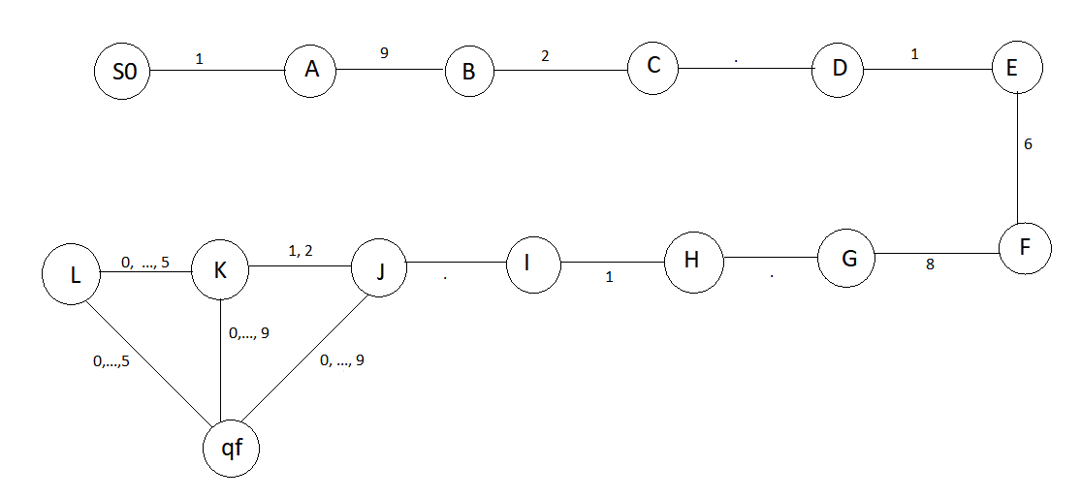

**Вариант 2.**

|  |  |
| --- | --- |
| pattern | **(?i)(\W|^)(baloney|darn|drat|fooey|gosh\sdarnit|heck)(\W|$)** |

**Автоматная грамматика**:

L(pattern) = L("(?i)(\W|^)(baloney|darn|drat|fooey|gosh\sdarnit|heck)(\W|$)") = {"baloney", “Baloney”, “BAloney” ..., “baloney darn”, “…”}

G(T, V, P, S0) = G({b, a, l, o, n, e, y, B, A, L, …, k, K}, {S0, }, {p1, …, p13}, S0)

*Правила регулярной грамматики:*

p1: S0 → bA’ | BA’ | dB’ | DB’ | fC’ | FC’ | gD’ | GD’ | hE’ | HE’

p2: A’ → aF’| AF’

p3: B’ → aG’| AG’ | rH’ | RH’

p4: C’ → oI’ | OI’

p5: D’ → oJ’ | OJ’

p6: E’ → eK’ | EK’

p7: F’ → lL’ | LL’

p8: G’ → rM’ | RM’

p9: H’ → aN’ | AN’

p10: I’ → sO’ | SO’

…