If we use a larger terms, let’s say 40, the result:

The results are much more accurate now.

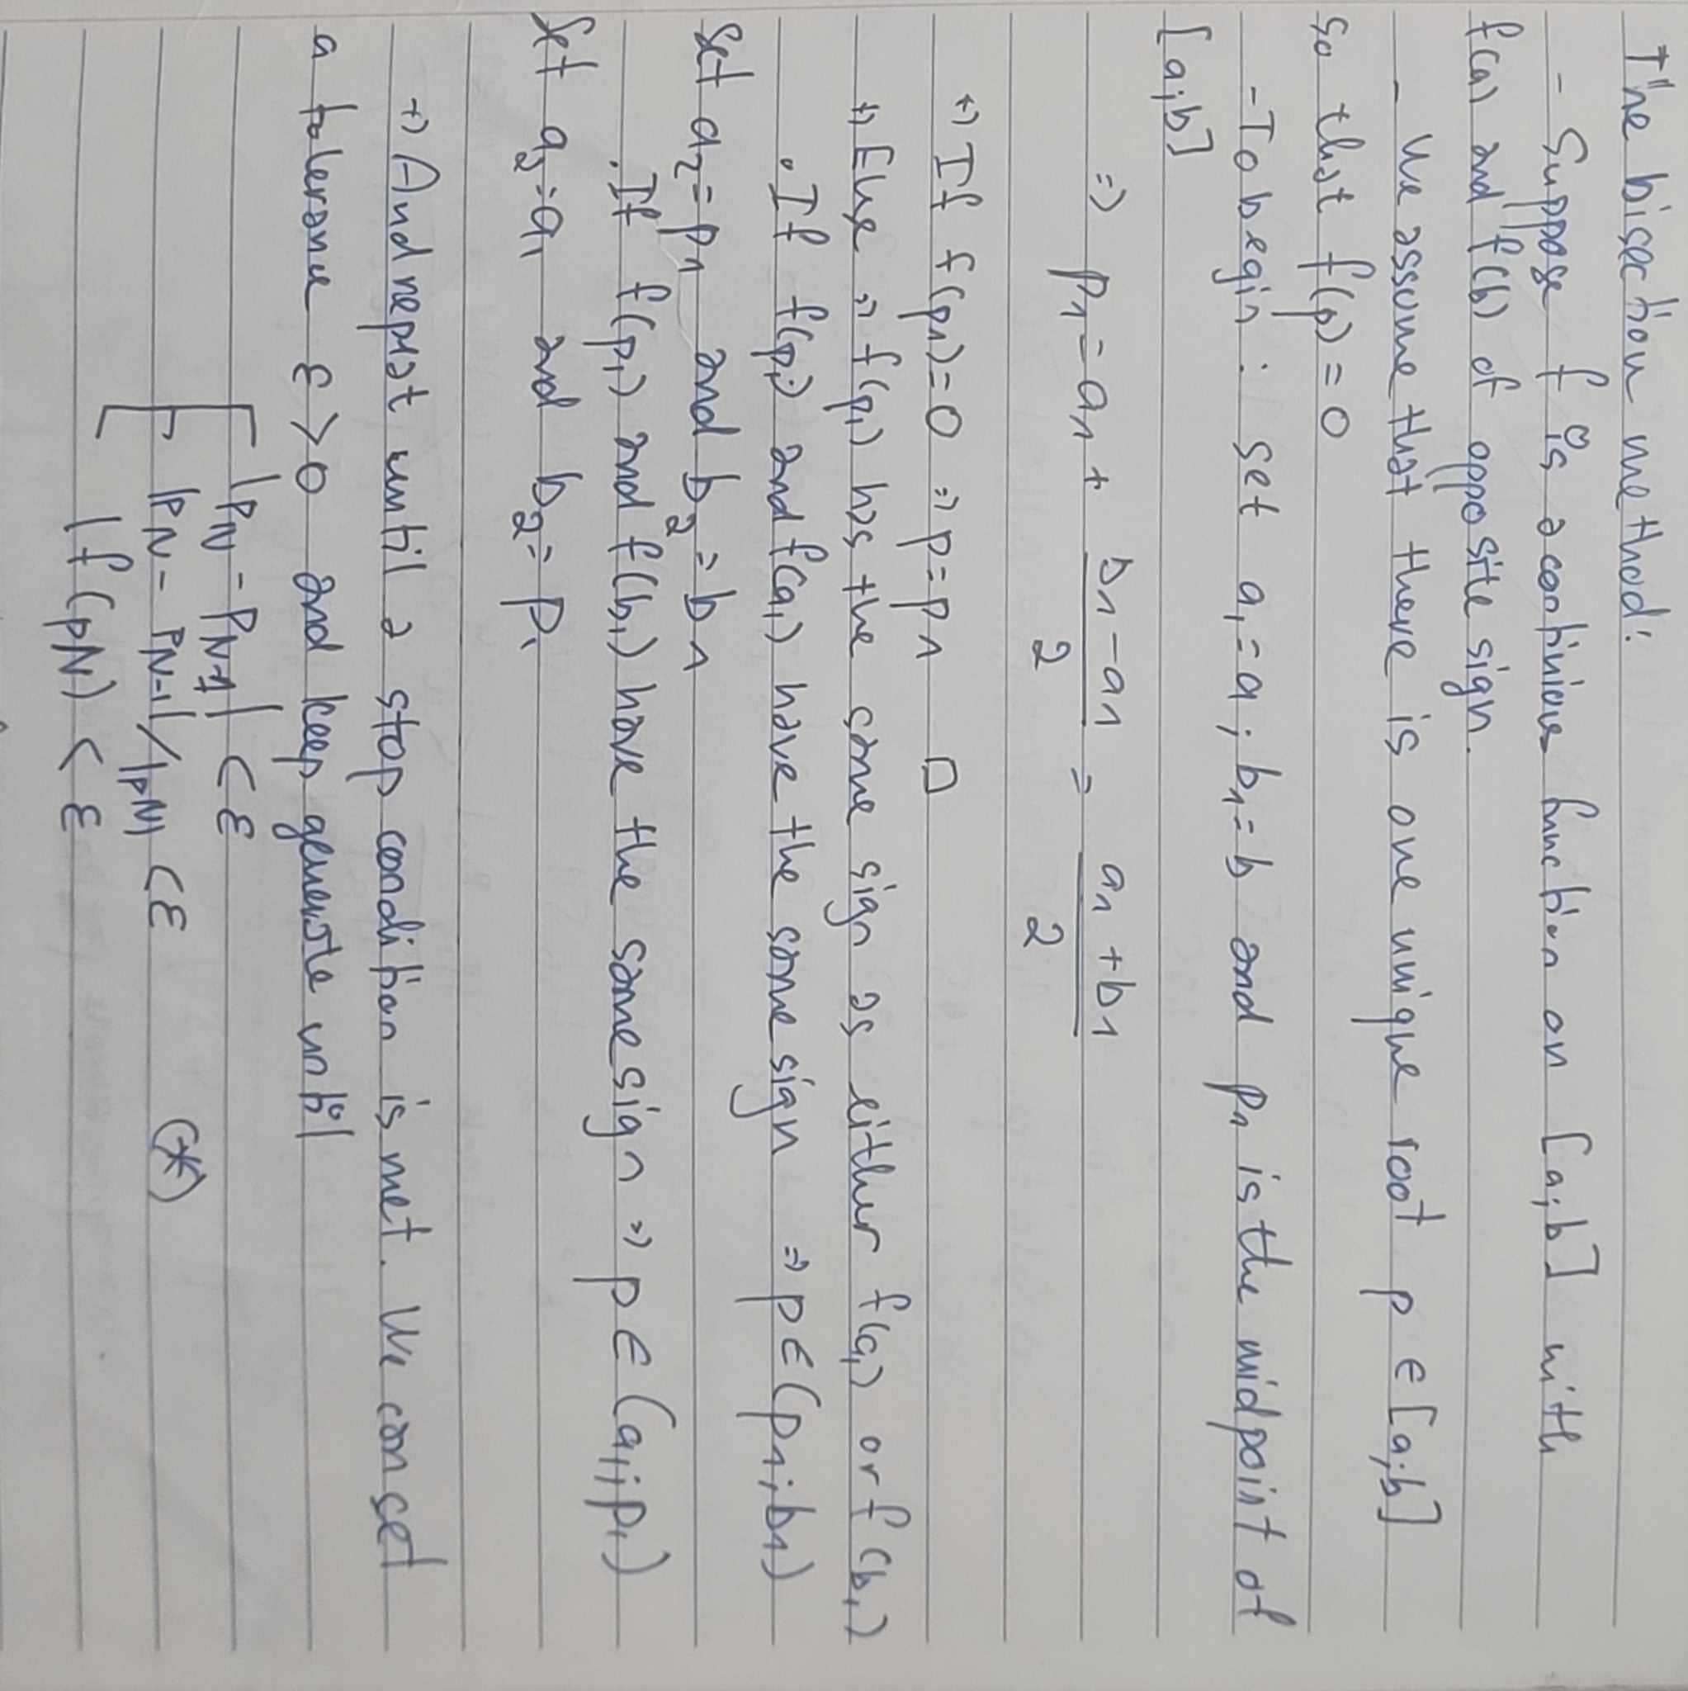

Perform the algorithm on all the given ranges, we result:

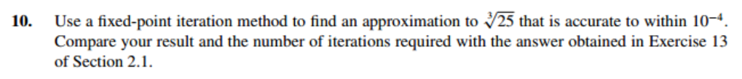

The code will randomly choose a number and start iterating till the final value:

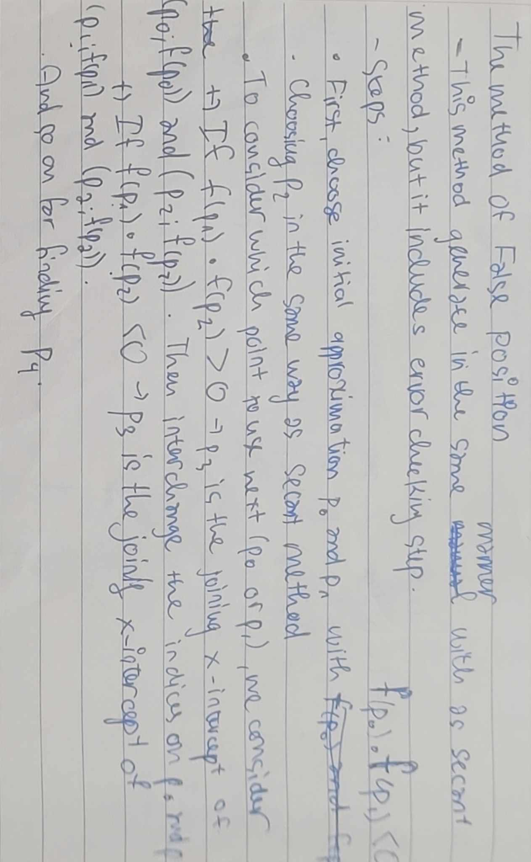

Calculating by hand:

Use code:

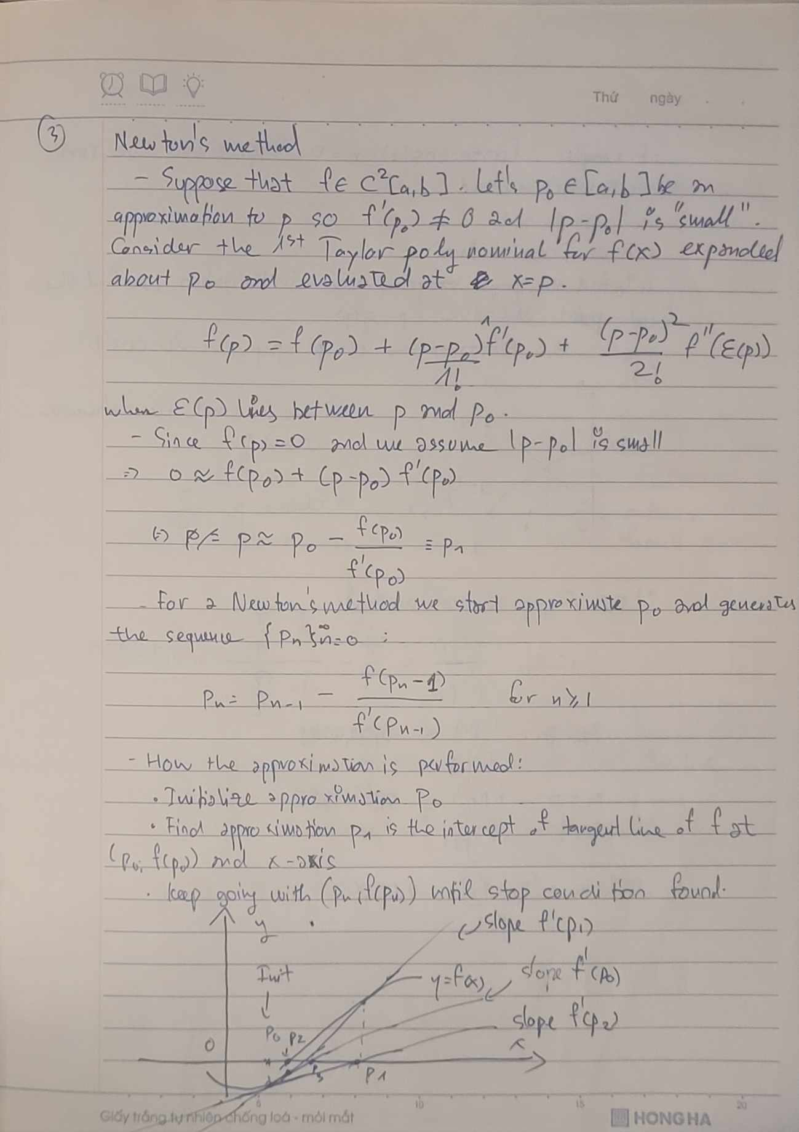

Calculating by hand:

Calculating by code with some other p0:

We next write A into a Lower matrix multiply to the Transposed of that Lower matrix:

Perform calculating and result in the coefficents on the left

Finally, we calculate A = L \* L^T and L\*y = B, giving the result:

Runnign the code yeilding the same result:

Using code, we find a = 13.146500, and b = -0.002255

To determine whether to use 3 points endpoint, 3 points midpoint, or the 5 points fomula, we should look at the index of the value in the table.

End point fomula suits value at the start or end (if the case is at the end, simply lets h<0) of the table, while mid points is for the middle ones.

Applying the code on table (a), we yield:

Midpoint rule (rectangular rule but we take the middle points instead of the starting ones), is a method to calculate the intergration by calculating the rectangulars’s size. The following figure illustrates how this method works.

The theory:

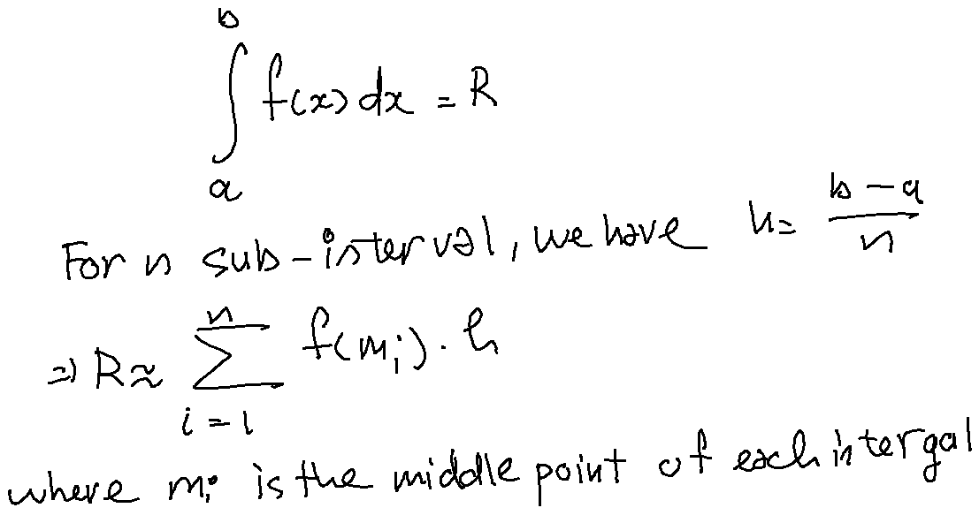

For (a) and (b) the code (n = 10) yields resspectively:

The truth value of (a) and (b) are 0.489971 and 0.0525, as we can see the errors are quite large.

Heun’s method is a method to approx the differential equations. This method will predict a value (predictor) beforehand, then use that prediction to approximate a better (corrector) value.

In general:

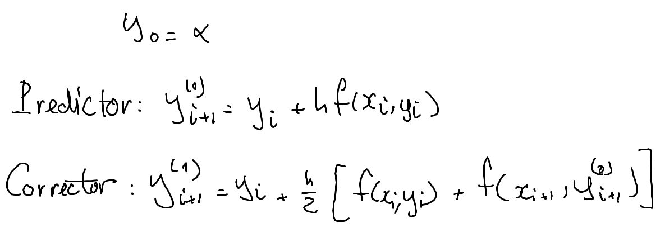

Applying code for exercise (a), we have:



Try with a smaller h (let’s say, h = 0.05)

The error doesn’t noticably decrease.

Euler method is defined:

Which is simple. Use code to solve the (a):

Now, apply Lagrange interpolation into the aboves data set, we have:

* f(1.052) = -0.9480945175525641
* f(1.555) = -0.6241495493175295
* f(1.978) = -0.4776453139246011

Taylor method high order is defined:

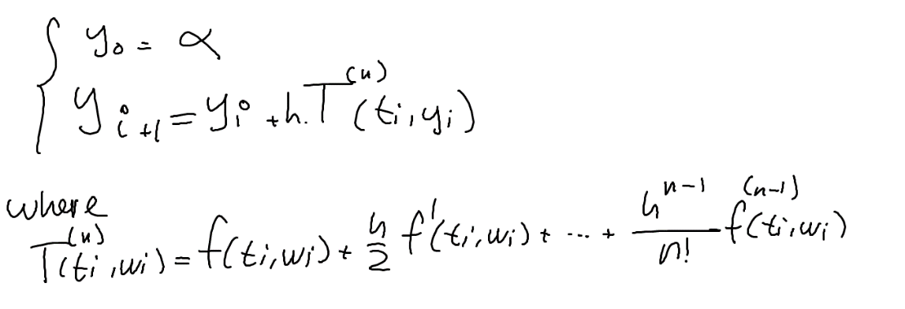

Applying into the function:

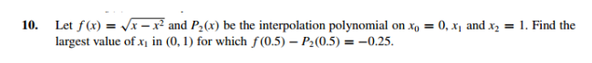

To do this exercise, first we archive a Lagrange polynomial.Ththan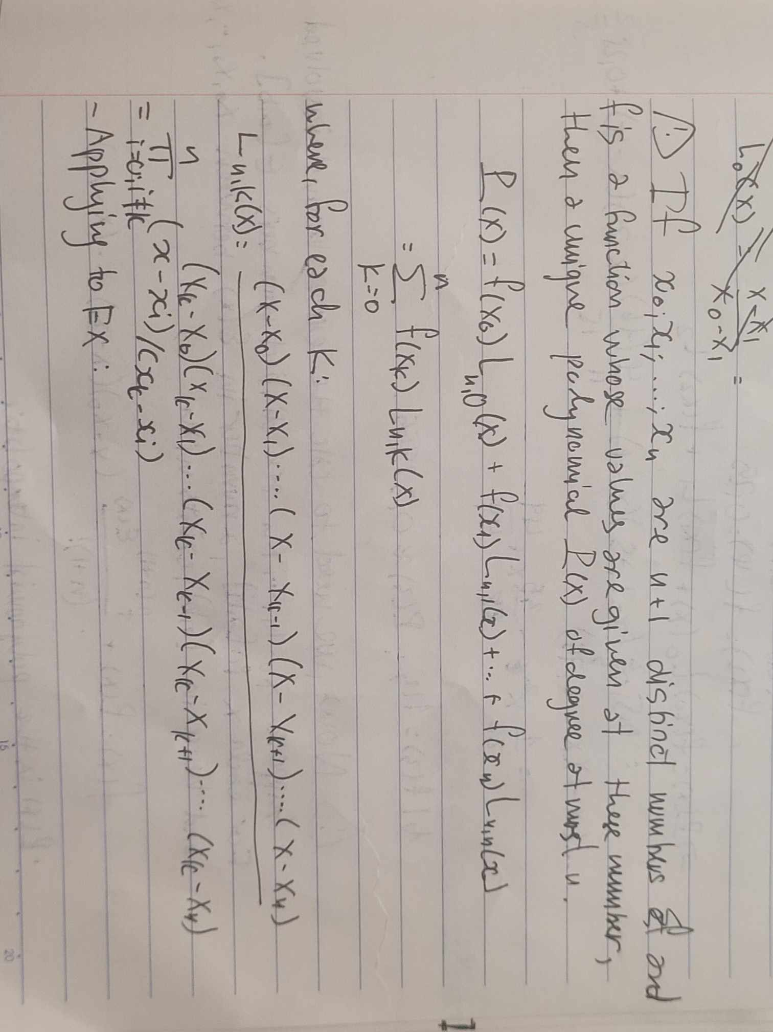

Next, we will do some coding trick to guess and choose the t1 value so that it is as correct as possible. After 100000 steps, the program concludes the following value.

More detail about how we handle the task can be seen in the code file.