LAB-03

Activity 01

using System;

using System.Collections.Generic;

using System.ComponentModel;

using System.Data;

using System.Drawing;

using System.Linq;

using System.Text;

using System.Text.RegularExpressions;

using System.Threading.Tasks;

using System.Windows.Forms;

namespace WindowsFormsApp5

{

public partial class Form1 : Form

{

public Form1()

{

InitializeComponent();

}

private void btn_Click_Click(object sender, EventArgs e)

{

String var = richTextBox1.Text;

// split the input on the basis of space

String[] words = var.Split(' ');

// Regular Expression for variables

Regex regex1 = new Regex(@"^[0-9][0-9]*(([\.][0-9][0-9]*)?([e][+|-][0-9][0-9]*)?)?$");

for (int i = 0; i < words.Length; i++)

{

Match match1 = regex1.Match(words[i]);

if (match1.Success)

{

richTextBox2.Text += words[i] + " ";

}

else

{

MessageBox.Show("invalid " + words[i]);

}

}

}

}

}

OUTPUT:

When input is invalid

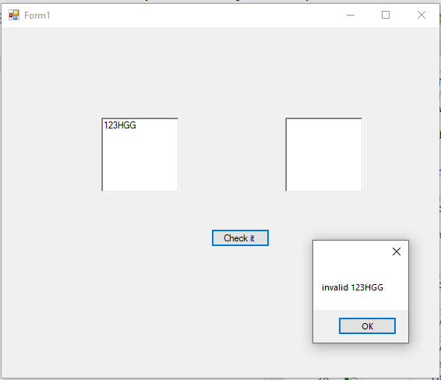

When input is valid

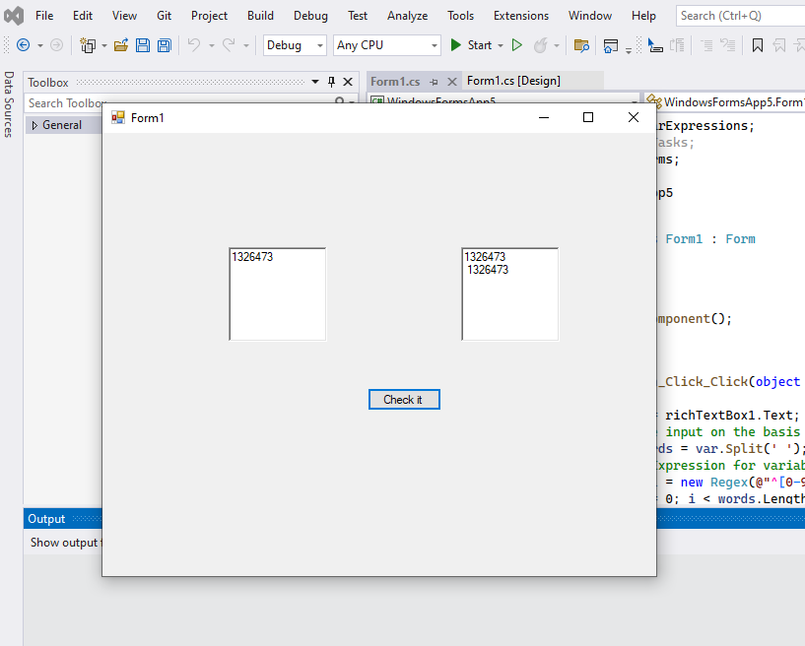

Activity 02

CODE

namespace RE_FOR_KEYWORDS

{

public partial class Form1 : Form

{

public Form1()

{

InitializeComponent();

}

private void btn_check_Click(object sender, EventArgs e)

{

String var = richTextBox1.Text;

// split the input on the basis of space

String[] words = var.Split(' ');

// Regular Expression for variables

Regex regex1 = new Regex(@"^[int | float | char]*$");

for (int i = 0; i < words.Length; i++)

{

Match match1 = regex1.Match(words[i]);

if (match1.Success)

{

richTextBox2.Text += words[i] + " ";

}

else

{

MessageBox.Show("invalid " + words[i]);

}

}

}

}

}

OUTPUT:

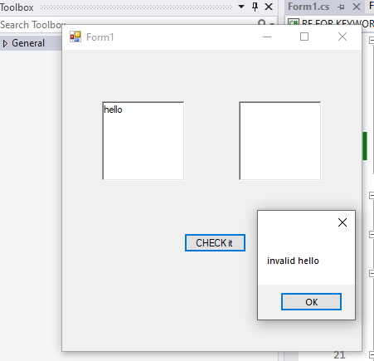

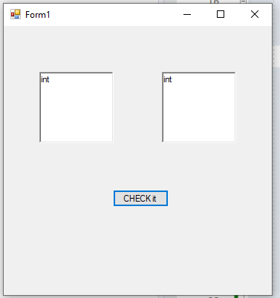

LAB_TASK_01

CODE:

namespace LAB3_task1

{

public partial class Form1 : Form

{

public Form1()

{

InitializeComponent();

}

private void button1_Click(object sender, EventArgs e)

{

String var = richTextBox1.Text;

// split the input on the basis of space

String[] words = var.Split(' ');

// Regular Expression for variables

Regex regex1 = new Regex(@"^[+-]?([0-9]*[.])?[0-9]+$");

for (int i = 0; i < words.Length; i++)

{

Match match1 = regex1.Match(words[i]);

if (match1.Success)

{

richTextBox2.Text += words[i] + " ";

}

else

{

MessageBox.Show("invalid " + words[i]);

}

}

}

}

}

OUTPUT:

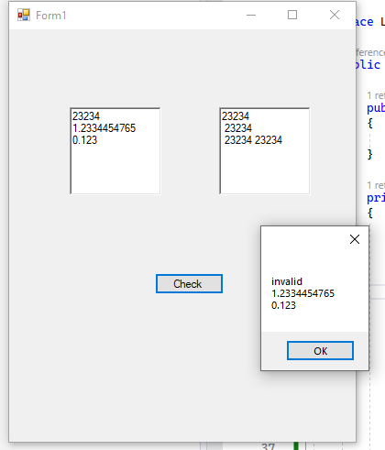

LAB TASK 02:

CODE:

String var = richTextBox1.Text;

// split the input on the basis of space

String[] words = var.Split(' ');

// Regular Expression for variables

Regex regex1 = new Regex(@"[+-]?[0-9]*\.?[0-9]+([eE][+-]?[0-9]+)?");

for (int i = 0; i < words.Length; i++)

{

Match match1 = regex1.Match(words[i]);

if (match1.Success)

{

richTextBox2.Text += words[i] + " ";

}

else

{

MessageBox.Show("invalid " + words[i]);

}

}

LAB_TASK_03

CODE:

namespace word_start_with_t_m

{

public partial class Form1 : Form

{

public Form1()

{

InitializeComponent();

}

private void button1_Click(object sender, EventArgs e)

{

String var = richTextBox1.Text;

// split the input on the basis of space

String[] words = var.Split(' ');

// Regular Expression for variables

Regex regex1 = new Regex(@"\b[tmTm]\w+");

for (int i = 0; i < words.Length; i++)

{

Match match1 = regex1.Match(words[i]);

if (match1.Success)

{

richTextBox2.Text += words[i] + " ";

}

else

{

MessageBox.Show("invalid " + words[i]);

}

}

}

}

}

OUTPUT: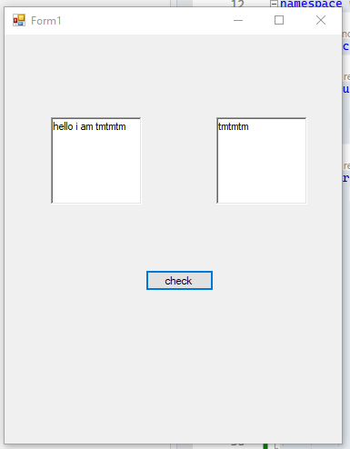

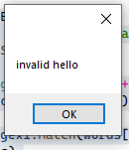

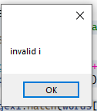

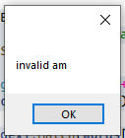

Forms inside form:

using System;

using System.Collections.Generic;

using System.ComponentModel;

using System.Data;

using System.Drawing;

using System.Linq;

using System.Text;

using System.Text.RegularExpressions;

using System.Threading.Tasks;

using System.Windows.Forms;

namespace WindowsFormsApp5

{

public partial class Form1 : Form

{

public Form1()

{

InitializeComponent();

}

private void btn_Click_Click(object sender, EventArgs e)

{

String var = richTextBox1.Text;

// split the input on the basis of space

String[] words = var.Split(' ');

// Regular Expression for variables

Regex regex1 = new Regex(@"^[0-9][0-9]*(([\.][0-9][0-9]*)?([e][+|-][0-9][0-9]*)?)?$");

for (int i = 0; i < words.Length; i++)

{

Match match1 = regex1.Match(words[i]);

if (match1.Success)

{

richTextBox2.Text += words[i] + " ";

}

else

{

MessageBox.Show("invalid " + words[i]);

}

}

}

private void btn_gotoTask2_Click(object sender, EventArgs e)

{

Form2 frm2 = new Form2() { TopLevel = false, TopMost = true };

frm2.FormBorderStyle = FormBorderStyle.Sizable;

this.Controls.Add(frm2);

frm2.Show();

}

private void btn_gotoTask3_Click(object sender, EventArgs e)

{

Form3 frm3 = new Form3() { TopLevel = false, TopMost = true };

frm3.FormBorderStyle = FormBorderStyle.Sizable;

this.Controls.Add(frm3);

frm3.Show();

}

}

}