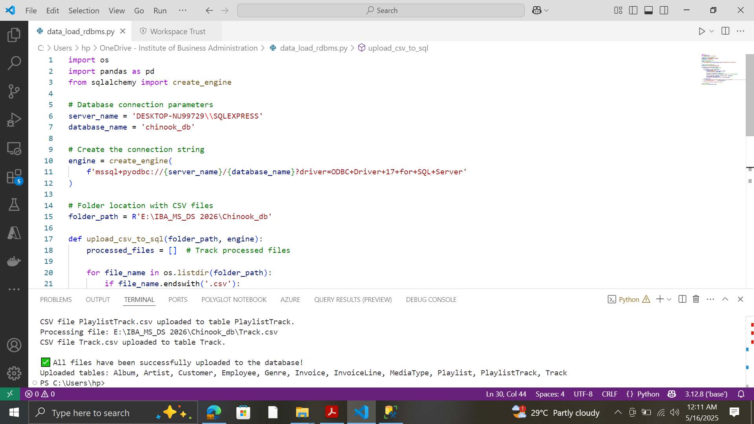

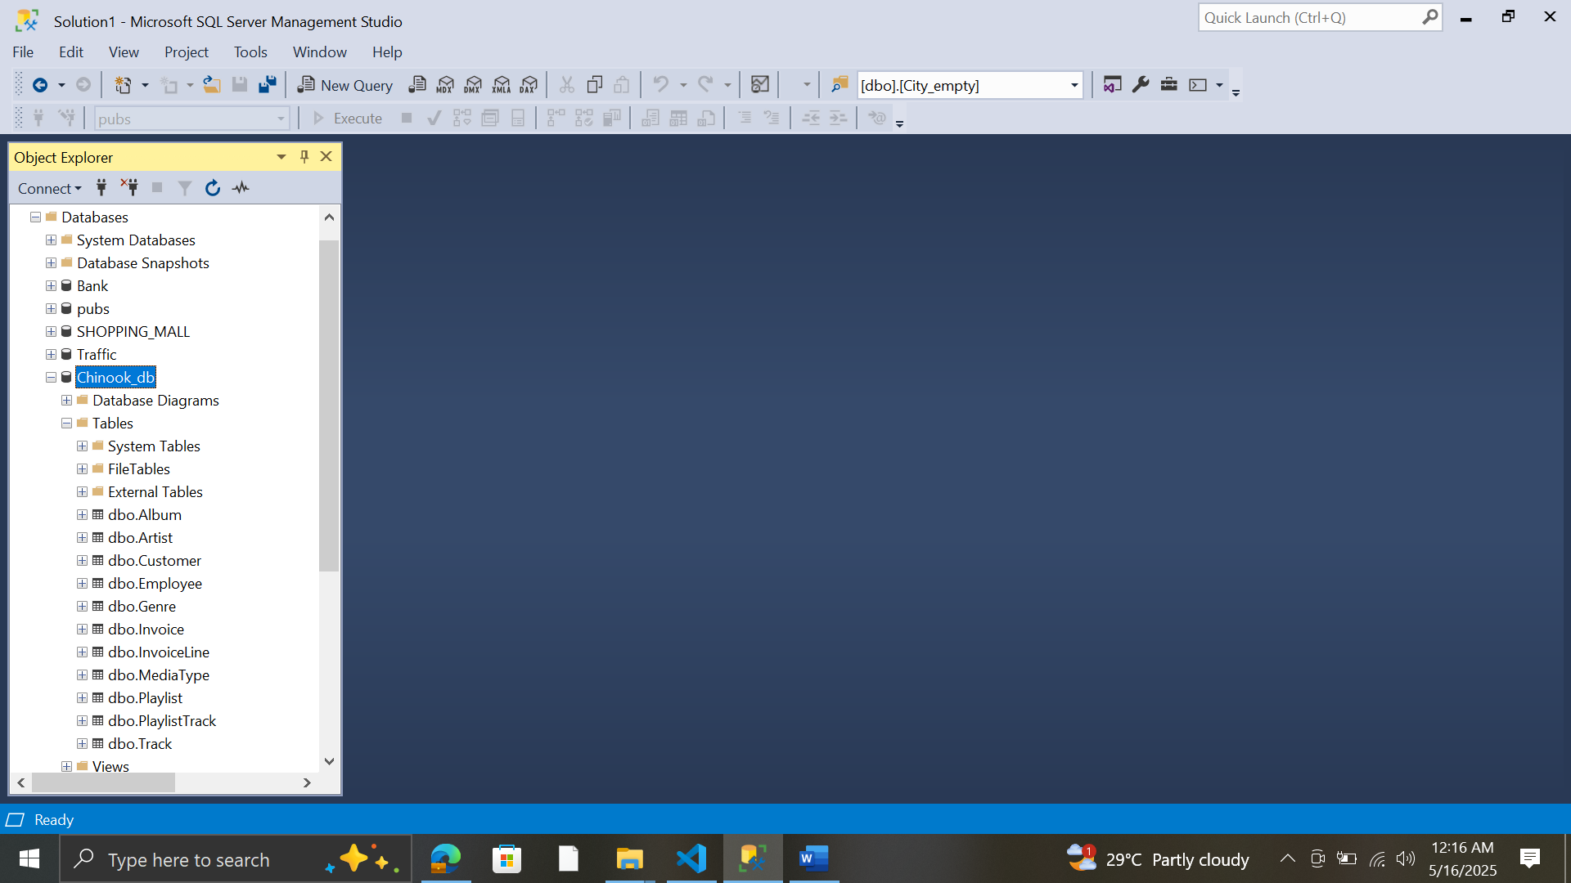

5MkSkbc7tnV3nbwa

nano ~/airflow/airflow.cfg

