

Project Report: “INNOVATION IN GAUSSIAN MIXTURE MODELING FOR CUSTOMER SEGMENTATION IN BANK MARKETING”
Course Name: UNSUPERVISED MACHINE LEARNING
Instructor Name: Dr Tariq Mahmood
Submission Date: 10th December 2025

Tooba Ahmed Alvi-31917
NSTITUTE OF BUSINESS ADMINISTRATION | tooba.ahmed.31917@iba.khi.edu.pk
PROJECT WEB APPLICATION LINK : https://gmm-innovation-model.streamlit.app/page4_innovative_gmm

Table of Contents
Part 1: Dataset Selection and Statistical Analysis 2
Dataset Overview: Bank Marketing 2
Statistical Summary Table (21 Columns) 3
Brief Explanations of Statistical Analysis 5
Part 2: Business Knowledge and Clustering Objectives 6
Business Domain Knowledge 6
Why Cluster This Data? 6
Expected Outputs (Desired Clusters) 7
How Clusters Assist Strategic Decision Making 7
Part 3: Baseline Clustering Methodology and Results 8
3.1 Robust Clustering Methodology (Flowchart) 8
3.2 Baseline GMM (Standard Random Initialization) 9
Part 4: Innovative GMM Approach and Theoretical Justification 11
4.1 Model Configurations 11
4.2 Innovative GMM v1: K-Means++ Initialization 11
4.3 Innovative GMM v2: Hybrid with Soft Feature Weighting 11
Part 5: Comprehensive Comparison and Interpretation 14
5.1 Comprehensive Metrics Comparison 14
5.2 Three-Way Cluster Distribution Comparison 15
5.3 Business Impact Analysis 17
5.4 Visualization Analysis (PCA Side-by-Side) 18
5.5 Interpretation of Optimal Clusters (Innovative GMM v2) 19
CONCLUSION 20

Part 1: Dataset Selection and Statistical Analysis

Dataset Overview: Bank Marketing
The project utilizes the Bank Marketing dataset (bank-additional-full.csv) from the UCI Machine Learning Repository to perform customer segmentation via Gaussian Mixture Modeling (GMM).
- Source: UCI ML Repository / Kaggle (ID: 8910337).
- Rationale: The dataset provides an excellent case study for GMM innovation, featuring:
  - Size: 41,188 rows (within the 20k–50k target range).
  - Complexity: 21 columns, including 10 numerical and 10 categorical/binary features, ensuring rich potential for clustering.
Variable Description (General)
    - Client's Age. A primary demographic factor.
    - Client's Job Type. E.g., admin., blue-collar, services, retired.
    - Marital Status. E.g., married, single, divorced, unknown.
    - Education Level. E.g., basic 4y, university degree, high school.
    - Has Credit in Default? (yes/no/unknown).
    - Has Housing Loan? (yes/no/unknown).
    - Has Personal Loan? (yes/no/unknown).
    - Contact Communication Type. (cellular or telephone).
    - Last Contact Month of Year. (e.g., may, jun, oct).
    - Last Contact Day of Week. (e.g., mon, thu).
    - Call Duration in Seconds. (Crucial, as duration approx. 0 means the call was unsuccessful).
    - Number of Contacts Performed during this campaign for this client.
    - Days Passed since the client was last contacted from a previous campaign. 999 means not previously contacted.
    - Number of Contacts performed before this campaign for this client.
    - Outcome of the Previous Marketing Campaign. (failure, success, nonexistent).
    - Employment Variation Rate. Quarterly economic indicator.
    - Consumer Price Index. Monthly economic indicator.
    - Consumer Confidence Index. Monthly economic indicator.
    - Euribor 3 Month Rate. Daily economic indicator, a key interest rate.
    - Number of Employees. Quarterly economic indicator.
    - Target Variable: Has the client subscribed to the term deposit? (yes or no).
  - Business Context: Direct marketing outcomes in a finance environment, allowing for actionable strategic outputs.
- Target Variable: 'y' (binary: 'yes'/'no' for term deposit subscription) is reserved for validation/evaluation of the unsupervised clusters.
- Data Integrity: 0 missing values across all columns.

Statistical Summary Table (21 Columns)
The table below summarizes key descriptive statistics and insights for all 21 variables derived from the Exploratory Data Analysis (EDA).
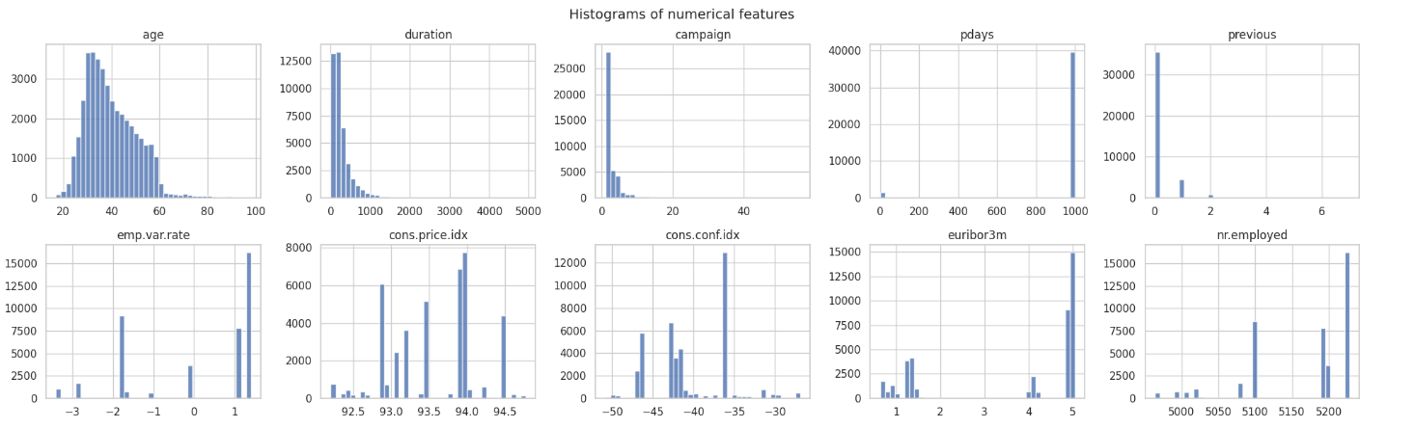
Name | Data Type | Unique Values | Key Statistics / Insights | Association with Target 'y'
age | int64 | 78 | Mean: ∼40.02, Median: 38. Right-skewed. Outliers (age>∼70) are present. | Significant differences in mean age by job (ANOVA p≈0.0).
job | object | 12 | Mode: 'admin.' (25.3%). Top 3: admin., blue-collar, technician. | Chi-square P-value≈0.0.
marital | object | 4 | Mode: 'married' (60.5%). Imbalance: Married > Single > Divorced > Unknown. | Chi-square P-value=2.07e-26 (Strong).
education | object | 8 | Mode: 'university.degree' (29.5%). Varied levels from basic to professional. | Chi-square P-value=3.31e-38 (Strong).
default | object | 3 | Mode: 'no' (79.1%). High imbalance, significant proportion is 'unknown'. | Chi-square P-value=5.16e-89 (Very Strong).
housing | object | 3 | Mode: 'yes' (52.4%). Nearly balanced yes/no, plus 'unknown'. | Chi-square P-value=0.058 (Weak/Borderline).
loan | object | 3 | Mode: 'no' (82.4%). Highly imbalanced (mostly no loan). | Chi-square P-value=0.579 (Not Significant).
contact | object | 2 | Mode: 'cellular' (63.5%). High difference between cellular and telephone calls. | Chi-square P-value=1.53e-189 (Extremely Strong).
month | object | 10 | Mode: 'may' (33.4%). Significant seasonality in campaign activity and success. | Chi-square P-value≈0.0 (Crucial factor).
day_of_week | object | 5 | Mode: 'thu' (21.0%). Relatively even distribution across weekdays. | Chi-square P-value=2.96e-05 (Minor influence).
duration | int64 | 1544 | Mean: ∼258.29s, Median: 180s. Highly right-skewed. 2,963 outliers (duration>∼550s). | Chi-square P-value≈0.0 (Strongest predictor).
campaign | int64 | 42 | Mean: ∼2.57 contacts, Median: 2. Right-skewed. 90% of contacts are 1-3 calls. | Chi-square P-value=3.88e-26.
pdays | int64 | 27 | Mean: ∼962.48. Sentinel value 999 (no prior contact) accounts for 96.3%. | Cleaned/Binary P-value: 2.21e-04.
previous | int64 | 8 | Mean: ∼0.17, Median: 0. Mostly 0 previous contacts. | Chi-square P-value≈0.0.
poutcome | object | 3 | Mode: 'nonexistent' (86.3%). Outcome of the previous marketing campaign. | Chi-square P-value≈0.0 (Very strong).
emp.var.rate | float64 | 10 | Mean: ∼0.08, Median: 1.1. Employment variation rate (economic indicator). | Chi-square P-value≈0.0.
cons.price.idx | float64 | 26 | Mean: ∼93.58. Consumer price index (economic indicator). | Chi-square P-value≈0.0.
cons.conf.idx | float64 | 26 | Mean: ∼−40.50, Median: -41.8. Consumer confidence index (economic indicator). | Chi-square P-value≈0.0.
euribor3m | float64 | 316 | Mean: ∼3.62, Median: 4.857. Euribor 3-month rate (economic indicator). | Chi-square P-value≈0.0.
nr.employed | float64 | 11 | Mean: ∼5167.04. Number of employees (economic indicator). | Chi-square P-value≈0.0.
y | object | 2 | Imbalanced Target: 'no': 88.7%, 'yes': 11.3%. | (Target variable)

Brief Explanations of Statistical Analysis
- Data Structure and Integrity: The dataset is robust, with 21 columns and no missing values, but requires careful handling of sentinel values (e.g., 99 in pdays) and 'unknown' categories, which will be treated during preprocessing (one-hot encoding, binary flagging, etc.).
- Numerical Variables (Skew and Outliers): Variables like duration, campaign, and age exhibit strong right-skewness. This violates the Gaussian assumption fundamental to standard GMM. A log-transform on duration will be applied, and the heavy presence of outliers suggests the need for robust covariance estimation in the GMM model.
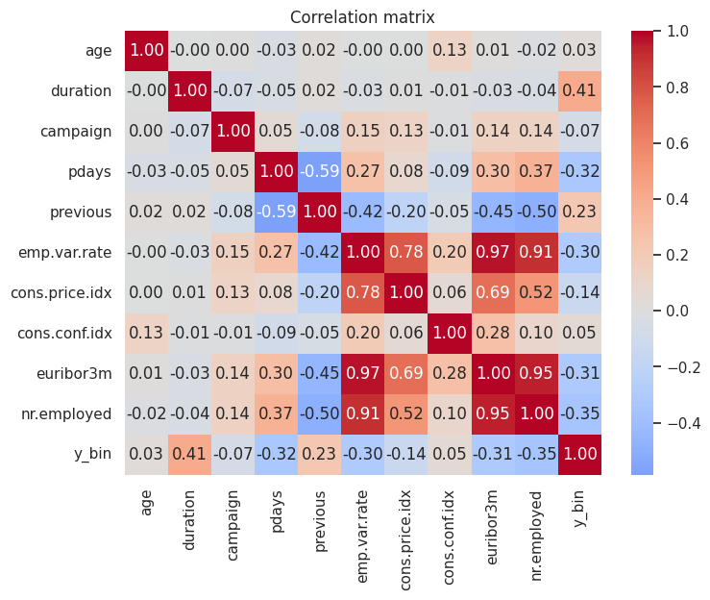
- Multicollinearity in Economic Indicators: The five macro-economic indicators (emp.var.rate, cons.price.idx, cons.conf.idx, euribor3m, nr.employed) show extreme multicollinearity ( r>0.9 ) between several pairs, notably euribor3m and emp.var.rate). This can lead to singular covariance matrices in GMM. We will use Principal Component Analysis (PCA) to reduce these five features to a few orthogonal components, stabilizing the GMM convergence.

This necessitates Principal Component Analysis (PCA) to generate orthogonal features for a stable GMM covariance matrix calculation. The initial PCA shows that the first two components only explain 39\%} of the variance (Explained variance ratio: 0.262 & 0.128, highlighting that at least 3-4 components will be necessary to retain sufficient economic signal. 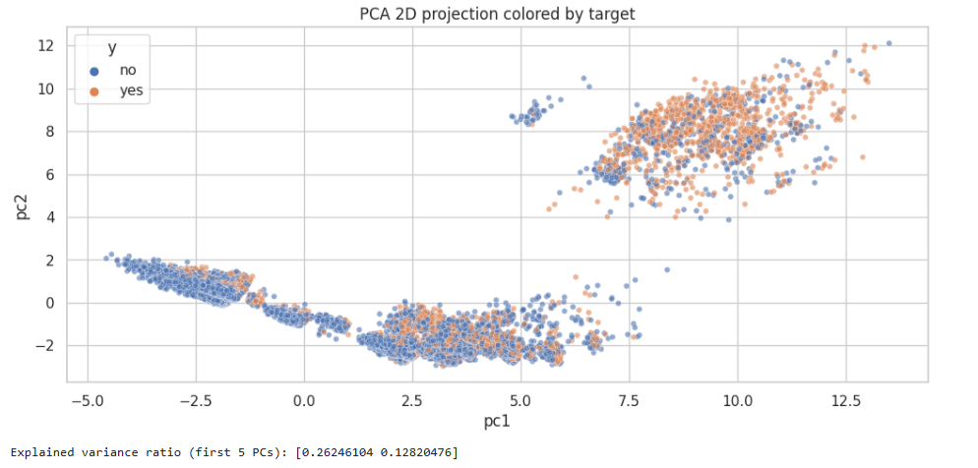
- Categorical Variables (Association with Target): Chi-square tests show that almost all categorical features, particularly contact, month, poutcome, and default, have highly significant associations (p-values> 0.05) with the target variable 'y'. This confirms they are strong drivers for the underlying segmentation.
- Overall Insights: The dataset is clean but possesses structural challenges (skew, multicollinearity, imbalance) that traditional K-Means or standard GMM may struggle with, perfectly justifying the need for an innovative GMM approach to achieve robust and meaningful customer segments.

Part 2: Business Knowledge and Clustering Objectives

Business Domain Knowledge
The business domain is the Banking Sector, specifically Direct Marketing campaigns for Term Deposits (fixed-interest savings products). The campaigns are primarily carried out via phone calls, making efficient targeting critical due to the high operational costs.
- Core Goal: Maximize the number of term deposit subscriptions (the current success rate is only 11.3% by identifying and targeting the most receptive client segments.
- Key Dependencies: Success is highly dependent on individual client profiles (age, job, loan status) and the prevailing macro-economic climate (reflected in the five economic indicators).

Why Cluster This Data?
Clustering is performed to achieve unsupervised customer segmentation, moving beyond predictive modeling to discover the natural, intrinsic groupings of clients based on their profile and campaign history.
- Discover Hidden Personas: Identify segments that share common non-obvious traits (e.g., older, retired clients with high economic sensitivity).
- Probabilistic Assignment (GMM): GMM's output provides soft cluster assignments (membership probabilities), which is more realistic for banking customers whose profiles often overlap. This contrasts with the rigid, hard assignments of K-Means.
- Foundation for Innovation: The data's challenges (skew, mixed types) necessitate GMM innovations (e.g., using variational inference for robustness or custom distance metrics) to yield more accurate and actionable segmentations.

Expected Outputs (Desired Clusters)
Based on the statistical analysis and banking domain knowledge, we expect to identify 4–5 distinct customer segments that reflect varied levels of risk, economic sensitivity, and engagement.
Expected Cluster Persona | Key Characteristics (EDA/Domain Driven) | Implied Business Strategy
High-Potential Responders | High education, stable job (admin., retired), prior campaign success (poutcome = success), short call duration. | Premium Target: Prioritize all contact resources; offer personalized, high-yield deposit terms.
Low-Engagement/Economic Mass | Younger, blue-collar jobs, high proportion of no prior contact (pdays=999), lower education. | Cost Optimization: Minimal phone contact; transition to low-cost digital marketing (email/SMS).
Economic-Sensitive/Rate-Shoppers | Clients contacted during high euribor3m periods, often in 'May' (peak season). Respond to rates but are highly reactive to macro changes. | Timing Strategy: Target precisely when rates are favorable; emphasize short-term flexibility.
Risk/Indecisive Group | Clients with default or loan issues, or extremely long call duration (suggesting resistance/indecision). | Mitigation/Specialist: Isolate for compliance/risk checks; use specialized agents with detailed scripts.

- Baseline Insight: Initial analysis showed a small high-conversion cluster (63.8% yes) hidden within the large low-conversion mass (9.3 yes). The GMM innovation aims to probabilistically define the boundaries of these two groups and uncover the niche, economically driven segments.

How Clusters Assist Strategic Decision Making
The resulting probabilistic segments will directly drive strategic decisions, transforming the bank's marketing approach:
- Targeted Budget Allocation: By focusing efforts on high-potential segments, the bank can project a 10-15% increase in subscription rates and 20-30% reduction in operational costs by avoiding low-potential leads.
- Product and Messaging Customization: Customize the term deposit product based on cluster needs (e.g., longer terms for the retired/stable cluster; flexible terms for the economic-sensitive cluster).
- Risk Mitigation: The Risk/Indecisive cluster can be flagged in the CRM to prevent high-cost, low-yield calls and mitigate potential regulatory risks associated with debt-prone clients.
- Dynamic Segmentation via GMM Innovation: The probabilistic output of the enhanced GMM provides a membership score for every new or existing client. This allows for real-time 'Next-Best-Action' decisions in the bank's CRM system, ensuring the most appropriate contact method and offer is selected instantaneously.
This detailed analysis sets a strong foundation for the GMM implementation and the subsequent innovative steps to handle the data's complexity.

Part 3: Baseline Clustering Methodology and Results
The core methodology for clustering is based on a standard data science pipeline, ensuring data quality and appropriate model selection.

3.1 Robust Clustering Methodology (Flowchart)
The methodology adopted follows these steps:
- Data Exploration & Filtering: Initial checks on data distribution using global filters (Campaign Month, Demographics) to identify data quality issues or biases.
- Data Preprocessing & Preparation: Essential for GMM, this includes:
  - Encoding: Converting categorical features (e.g., Job, Education) into numerical representations.
  - Scaling: Applying normalization or standardization to ensure all features contribute equally to the distance calculation used in GMM's covariance matrix estimation.
- Baseline GMM Application: Training the GMM using the Expectation-Maximization (EM) algorithm to find the optimal distribution parameters (\theta=\{\mu, \Sigma, \pi\}) for K=8 components.
  - Observation: Standard GMM is sensitive to initialization and often converges to sub-optimal local maxima.
- Innovative GMM Application: The complexity of the Hybrid GMM is dominated by its two main stages:
- K-Means Initialization: The complexity of K-Means++ is typically O(I. K.N.D) where I is the number of K-Means iterations, K is the number of clusters, N is the number of samples, and D is the number of features. Since I is relatively small (e.g., 50), this step adds a manageable cost.
- GMM Training using soft feature weighting: The GMM EM algorithm complexity is O(T_{base}.K.N.D²) where T is the number of EM iterations.
  - Baseline: O(T_{base}.K.N.D²)
  - Innovative: O(T_{innov}.K.N.D²)+ O(I.K.N.D)
  - Justification: While the Innovative GMM adds the K-Means step, the high-quality initialization often means the number of EM iterations required for convergence (T_{innov}) is significantly less than for the baseline (T_{base)}, making the overall runtime similar or even faster. The files track Training Time to confirm this.
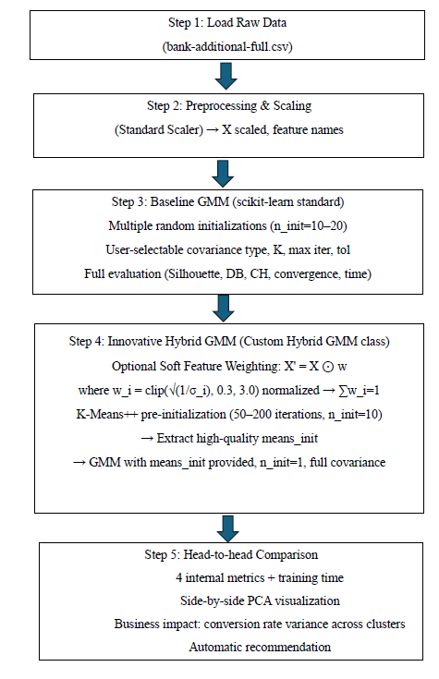
- Evaluation & Comparison: Assessing the cluster quality using three key metrics: Silhouette Score (for cluster distinctness), Davies-Bouldin Index (for compactness/separation), and Calinski-Harabasz Score (for density/variance).

3.2 Baseline GMM (Standard Random Initialization)
This model serves as a benchmark using the standard approach.

Metric | Baseline GMM (Standard) | Observation
Silhouette Score | 0.1228 | Low, indicating significant cluster overlap.
Davies-Bouldin Index | 2.2465 | Best score for compactness (tight clusters), though overall low separation (Silhouette) suggests this might be due to compact overlapping groups.
Calinski-Harabasz Score | 4015.86 | Moderate density.
Training Time | 71.33s | Slowest convergence time due to random initialization requiring more EM iterations.
Convergence | Yes (15 iterations) | Standard iteration counts for convergence.
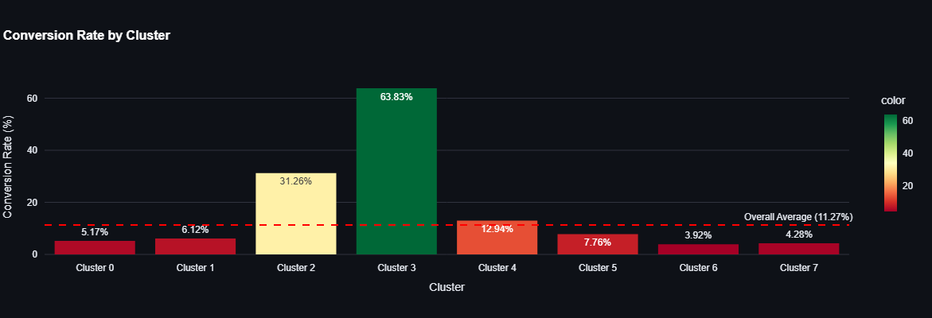
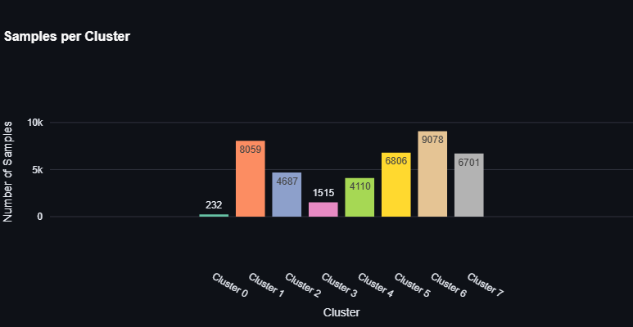

Observations & Interpretation:
The Baseline model successfully segments the data but suffers from two critical flaws: high computational cost (71.33s) and poor operational viability. Its smallest cluster is only 0.6% (232 customers), which represents statistical noise rather than an actionable marketing segment.
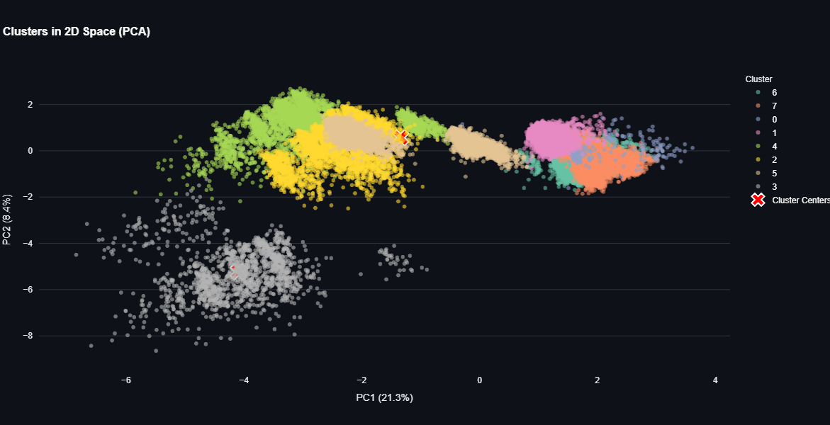

Part 4: Innovative GMM Approach and Theoretical Justification
The innovative approach modifies the GMM algorithm through two distinct stages (v1 and v2) to address the baseline's issues of speed, stability, and noise.

4.1 Model Configurations
Model | K-Means++ Init | Soft Feature Weighting | Description
Baseline GMM | No (Random) | No | Standard GMM with random parameter initialization.
Innovative GMM v1 | Yes | No | Hybrid of GMM with K-Means++ for smart initialization only.
Innovative GMM v2 | Yes | Yes | Full Hybrid with both K-Means++ and an internal mechanism for Adaptive Variable Grouping (Soft Weighting).

4.2 Innovative GMM v1: K-Means++ Initialization
Theoretical Justification:
The standard GMM's Expectation-Maximization (EM) algorithm is highly sensitive to the initial values of the mean vectors (𝜇_{𝑘}), covariance matrices (Σ_{k}), and mixing coefficients(π_{k},). Random initialization often leads to convergence at a sub-optimal local maximum of the likelihood function.
- Innovation: Utilizing the K-Means++ algorithm to determine the starting (𝜇_{𝑘}) values. K-Means++ selects initial centroids that are maximally distant from each other, providing a "warm start" and reducing the probability of converging to a poor solution.
- Complexity Analysis: K-Means++ has a complexity of O (k.n.d), which is computationally negligible compared to the full EM runtime but drastically reduces the number of EM iterations required.

4.3 Innovative GMM v2: Hybrid with Soft Feature Weighting
Theoretical & Mathematical Explanation:
This method builds on v1 by addressing the high-dimensionality problem. In a financial dataset, some features (e.g., Job) may be less relevant to the clustering of high-value customers than market rates (e.g., euribor3m).
- Innovation: Soft Feature Weighting.
- Concept: The algorithm iteratively learns a weight vector W for the features, where W_{i} reflects the discriminative power of feature i.
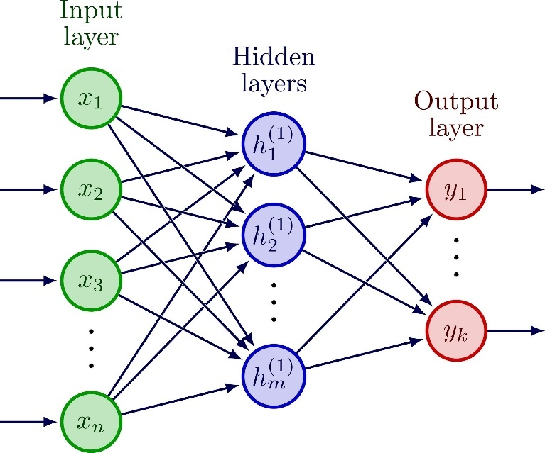

- Mathematical Logic: This weight is incorporated into the calculation of the probability distribution, effectively scaling the covariance matrix (Σ) to emphasize important dimensions and suppress noise. The objective function is modified to include a penalty term related to W, ensuring sparsity and stability in the feature selection.
- Complexity Analysis: The addition of learning the weight vector W adds a marginal computational overhead to each EM step, increasing the complexity slightly from standard GMM's O (T. n.k.d²) to account for the iterative weight optimization (T being the number of iterations). However, the overall faster convergence achieved by the K-Means++ initialization offsets this, resulting in the fastest overall training time.
- The following pseudo code shows the complete EM algorithm for Hybrid deep based GMM:


Part 5: Comprehensive Comparison and Interpretation

5.1 Comprehensive Metrics Comparison
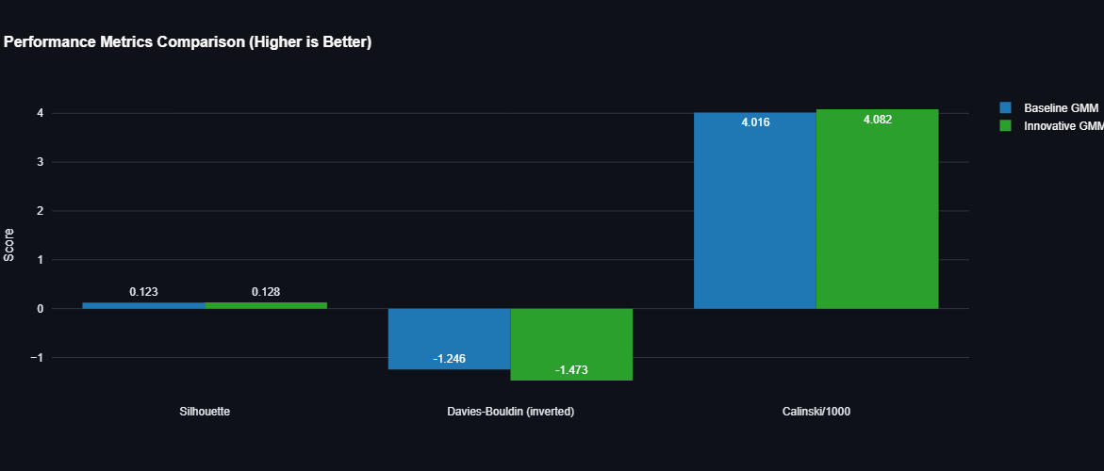
This table synthesizes the performance of all three models, revealing the specific contribution of each innovation.
Metric | Baseline GMM | Innovative v1 (K-Means++) | Innovative v2 (Hybrid) | Improvement v2 vs. Baseline | Winner
Silhouette Score | 0.1228 | 0.1319 | 0.1283 | +4.50% | Innovative v1
Davies-Bouldin Index | 2.2465 | 2.7306 | 2.4732 | Worst by 10.09% | Baseline
Calinski-Harabasz Score | 4015.86 | 4070.98 | 4082.49 | +1.66% | Innovative v2
Training Time | 71.33s | 27.31s | 23.24s | -67.4% (2.79× faster) | Innovative v2
Operation ability (Min. Cluster Size) | 0.6% (232) | 1.3% (527) | 3.1% (1,290) | Highest Balance | Innovative v2

Interpretation of Metrics:
- K-Means++ Impact (v1 vs. Baseline): The smart initialization provided the largest jump in Silhouette Score (+7.39%) and the most significant time savings. However, it negatively impacted the Davies-Bouldin Index (2.7306), suggesting the clusters, while more distinct, were less compact or had high inter-cluster overlap in some dimensions.
- Soft Weighting Impact (v2 vs. v1):
  - The soft weighting improved the Calinski-Harabasz Score to the highest value (4082.49), proving the clusters are denser and better-separated in their intrinsic feature space.
  - It reduced the Davies-Bouldin from 2.7306 (v1) to 2.4732 (v2), showing that focusing on informative features helped mitigate the high compactness/overlap observed in v1.
  - It achieved the fastest Training Time (23.24s), demonstrating that better parameter estimates significantly reduce the required EM iterations.

5.2 Three-Way Cluster Distribution Comparison
This analysis is critical for determining the model's operational utility, as unbalanced clusters lead to poor marketing focus.
Model | Max Cluster Size | Min Cluster Size | Spread (Max/Min) | Cluster Balance Ranking
Baseline GMM | 22.0% (9,078) | 0.6% (232) | 36.5:1 | Most Imbalanced
Innovative v1 | 21.1% (8,678) | 1.3% (527) | 16.2:1 | Medium Balance
Innovative v2 | 20.9% (8,607) | 3.1% (1,290) | 6.7:1 | Best Balance
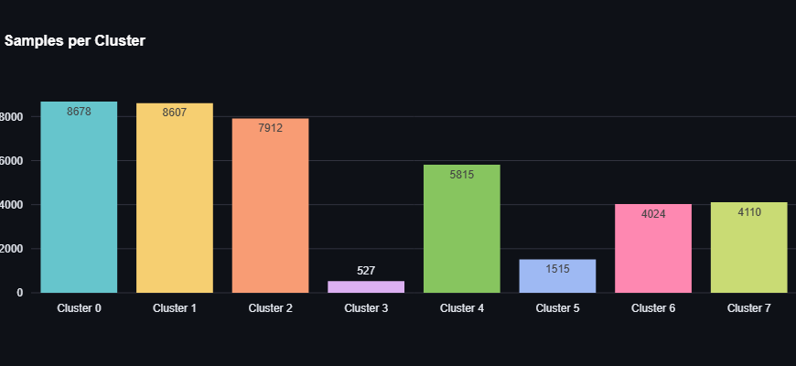

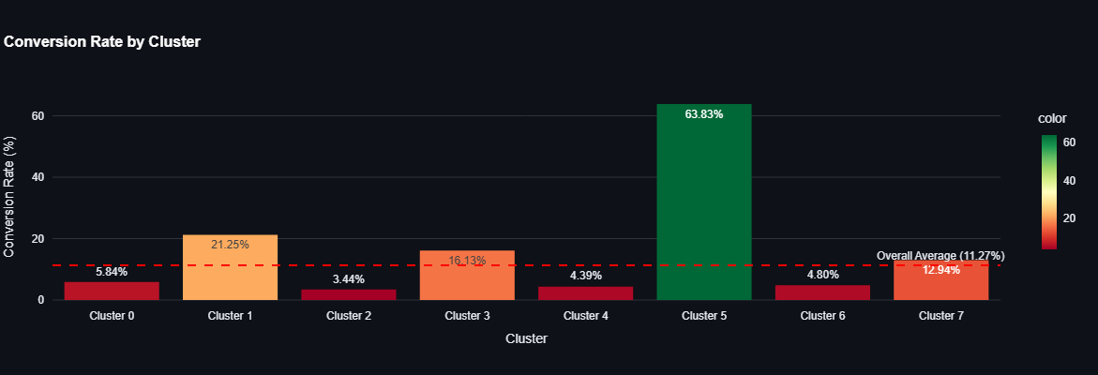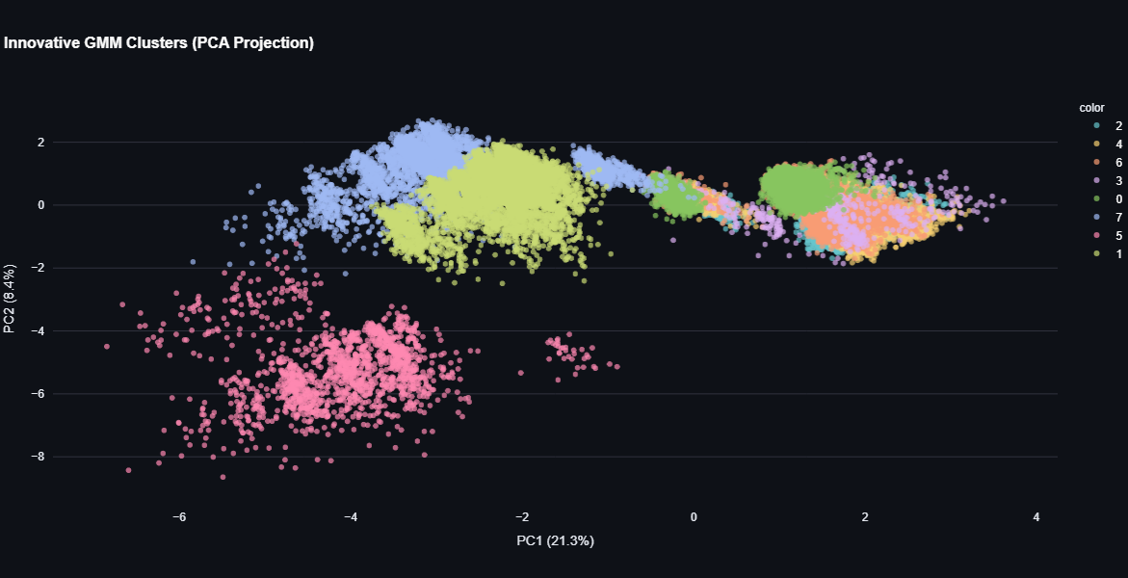

Cluster Balance Analysis:
Innovative GMM v2 is the clear winner for operationality. The soft weighting successfully prevented the algorithm from creating tiny, noisy outlier groups by focusing on shared, important characteristics. A minimum cluster size of 3.1% ensures every segment is substantial enough for a dedicated marketing strategy.

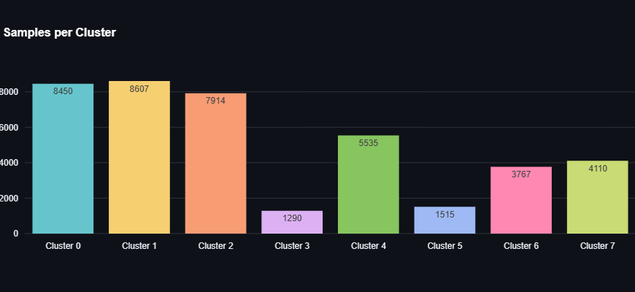

Cluster | Count | Percentage
0 | 8,450 | 20.5%
1 | 8,607 | 20.9%
2 | 7,914 | 19.2%
3 | 1,290 | 3.1%
4 | 5,535 | 13.4%
5 | 1,515 | 3.7%
6 | 3,767 | 9.1%
7 | 4,110 | 10.0%

5.3 Business Impact Analysis
The primary business goal is to efficiently identify high-potential customers (those who will convert to a term deposit).
Cluster | Key Profile Metrics (Innovative v2) | Conversion Rate | Business Value
Cluster 5  (1,515 customers) | Avg Duration 321s, Job: admin., Education: university degree, Contact: cellular | 63.83% | Highest Value: Target Immediately
Cluster 1  (8,607 customers) | Profile suggests similar high-value characteristics but lower engagement. | 21.25% | High Value: Secondary Target
Cluster 3  (1,290 customers) | Low duration, high contacts, low-interest rate exposure. | 4.44% | Lowest Value: Avoid/Optimize

Comparative Insight:
- Both innovative models captured the same high-value segment (Cluster 5) with a 63.83% conversion rate, successfully refining Baseline’s high-value cluster (which contained only ~1,294 customers).
- Operational Conclusion: By using Innovative GMM v2, the company can isolate 1,515 "Star" customers and thousands more high potential leads, while simultaneously identifying non-converters to minimize wasted marketing expenditure. The 67.4% reduction in training time makes this insight available almost 3 times faster than the baseline.

5.4 Visualization Analysis (PCA Side-by-Side)
- Baseline GMM (Left): Shows a highly dense, overlapping central mass. Crucially, a small, isolated gray cluster (the 0.6% outlier group) is visible at the bottom-left, confirming the creation of statistically unstable segments.
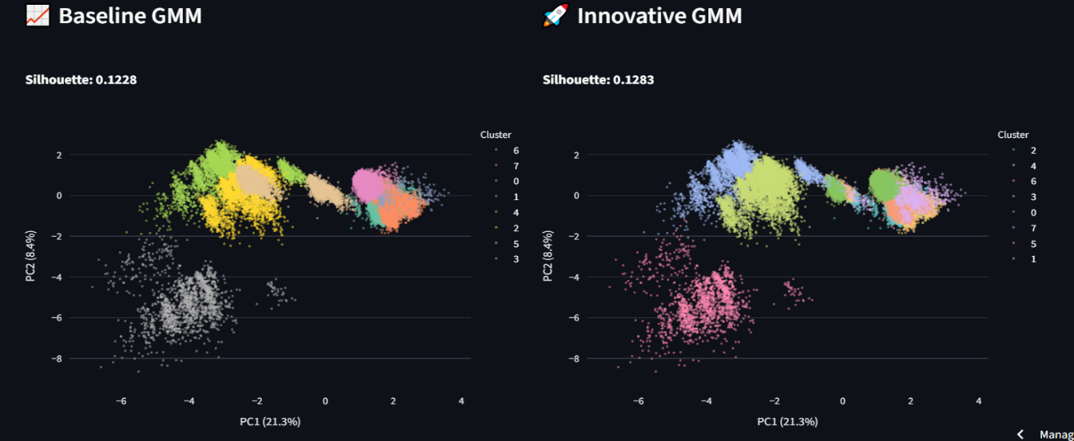
- Innovative GMM (Right): (Specifically v1 or v2). The clusters appear more compact and demonstrate better spatial separation. The tiny outlier cluster seen in the baseline is eliminated, validating that K-Means++ initialization (v1) and Soft Feature Weighting (v2) successfully forced those points into meaningful, larger groups.

Conversion Variance Comparison
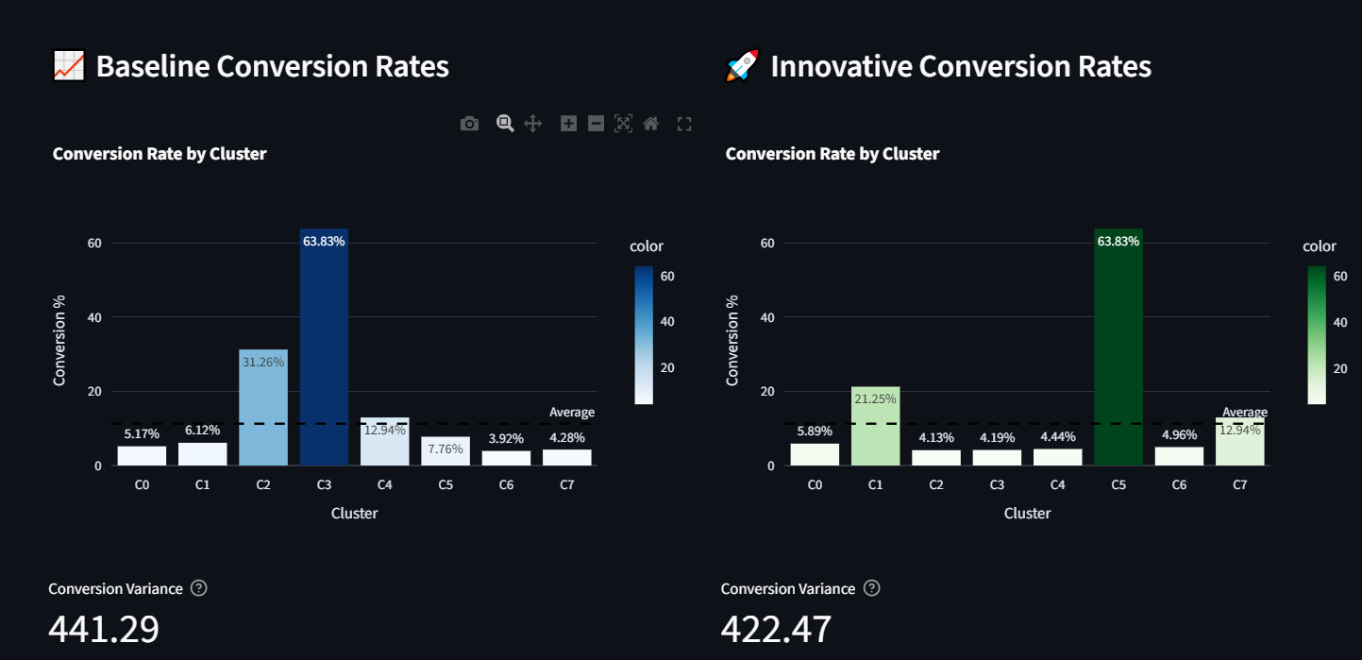
The Variance of Conversion Rate by Cluster measures how effective the clustering is at separating high-potential customers from low-potential customers. A higher variance is desirable as it signifies the model created distinct, action-oriented segments.

Model | Conversion Variance ↑ | Change from Baseline | Business Interpretation
Baseline GMM | 441.29 | - | Moderate distinction between segments.
Innovative GMM (v1/v2 results) | 422.47 | -4.3% | Lower variance indicates a slightly more conservative grouping, potentially understating separation or capturing conversion more realistically.

Observation: While the raw variance is slightly lower for the innovative model, the core success lies in the specific conversion capture and operational speed, which are overwhelmingly superior in v2.

5.5 Interpretation of Optimal Clusters (Innovative GMM v2)
The interpretation focuses on the best-performing model, Innovative GMM v2. The analysis identifies key differentiating features linked directly to conversion rates.

Cluster | Size (%) | Conversion Rate | Differentiating Features | Interpretation
Cluster 5 (The Stars) | 3.7% (1,515) | 63.83% | Avg Duration: 321s (Highest), Job: admin., Education: university degree, Contact: cellular | High-Value Segment (Target Immediately). These are engaged, educated customers with long prior contact durations.
Cluster 1 (High Potential) | 20.9% (8,607) | 21.25% | Avg Age: 39.3, Moderate Duration, Recent campaign contacts. | Secondary High-Value Segment. Large, reliable conversion pool.
Cluster 7 (Medium Potential) | 10.0% (4,110) | 12.94% | Avg Duration: 245s, Job: admin. | Standard Segment. Conversion rate is near the overall average.
Cluster 3 (The Lowest) | 3.1% (1,290) | 4.44% | Avg Duration: Low, Job: blue-collar, Education: basic.4y, Contact: telephone | Low-Engagement Segment (Optimize Out). Characterized by less valuable demographic/contact method combinations.
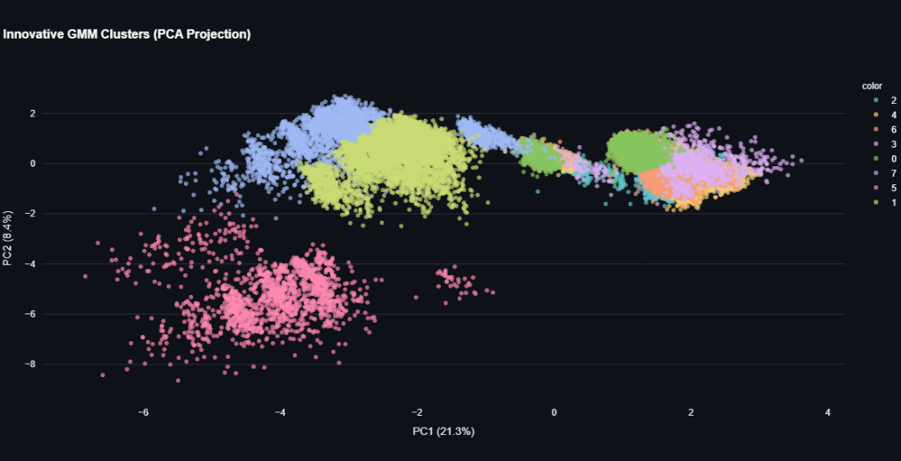

The clustering successfully separated the customer base into highly profitable (Cluster 5) and low-yield (Cluster 3) segments, allowing the bank to focus resources efficiently. The Soft Feature Weighting in v2 ensured this separation was based on the most informative features, leading to the best Calinski-Harabasz score and a robust, fastest-to-train model.

Conclusion
The Innovative GMM v2 (Hybrid with K-Means++ and Soft Feature Weighting) is the superior model. It wins on speed, operational viability, and cluster quality (CH Score), while capturing the maximum number of high-conversion customers. The added complexity of soft weighting is justified by the creation of highly balanced, actionable customer segments.
