**LOAN MANAGEMENT SYSTEM**

**Project Description:**

Loan Management System will help the organization to manage loan of the employees. The target of the project is to manage loans of a software house. The loans will be granted to the employees on the basis of employee’s designation and salary. Loans will be interest free. The more the salary, the higher the designation, more loan will be granted. Loan money will be deducted from the salary automatically on the day salary is given to the employees. Number of installments will be decided by the employee within the loan return time. Loans approval or rejection with reason will be granted by HR director.

**Business Rules:**

There will be two loan categories:

* Against Provident Fund
* General Loan

The loan policies for the categories listed above are given below:

**Against Provident Fund:**

* Loans will be interest free.
* Number of installments for loan return must be chosen in a way that loan should be returned within 4 years.
* Minimum installment will be of two thousand rupees.
* The loan limit taken against Provident fund must not exceed deposited provident fund of specific employee.
* Provident fund will only be granted for purchase of property or automobile.
* Installments will be automatically deducted from the salary.
* If employee left without paying installments, it would depend on senior management to confiscate provident fund or to grant him fund by deducting remaining loan money or to grant him provident fund without any deduction if only few installments are left by acknowledging the employee’s services.
* Agreement document template will be provided which contains terms regarding employee will pay the loan completely. Without paying loan, employee will not leave company. If employee left or some serious consequences occur, it will depend on senior management whether to confiscate provident fund or to grant him fund by deducting remaining loan money or to grant him provident fund without any deduction if only few installments are left by acknowledging the employee’s services.
* Signed agreement document must be uploaded at time of applying for loan and the signed document must match the template provided.
* Documents regarding purchased automobile or property must be provided within 30 days from loan acceptance.
* If documents regarding purchased automobile or property are not provided within 30 days from loan acceptance, then the employee will be added to defaulters. The employee will be notified to submit the documents as soon as possible.
* If employee is defaulter, it would depend on senior management to grant him with provident fund with or without deduction depending upon his services.

**General Loan:**

* Loans will be interest free.
* Maximum Loan granted will be ten times of the employee’s salary.
* Number of installments for loan return must be chosen in a way that loan should be returned within 4 years.
* Minimum installment will be of two thousand rupees.
* Installments will be automatically deducted from the salary.
* Installments should not exceed salary.
* Agreement document template will be provided which contains terms regarding employee will pay the loan completely. Without paying loan, employee will not leave company. If employee left or some serious consequences occur and employee has opted provident fund, it will depend on senior management whether to confiscate provident fund or to grant him fund by deducting remaining loan money or to grant him provident fund without any deduction if only few installments are left by acknowledging the employee’s services. . If employee left or some serious consequences occur and employee has not opted provident fund, it would depend on senior management to take any legal action or not
* Signed agreement document must be uploaded at time of applying for loan and the signed document must match the template provided.

**Conceptual Design:**

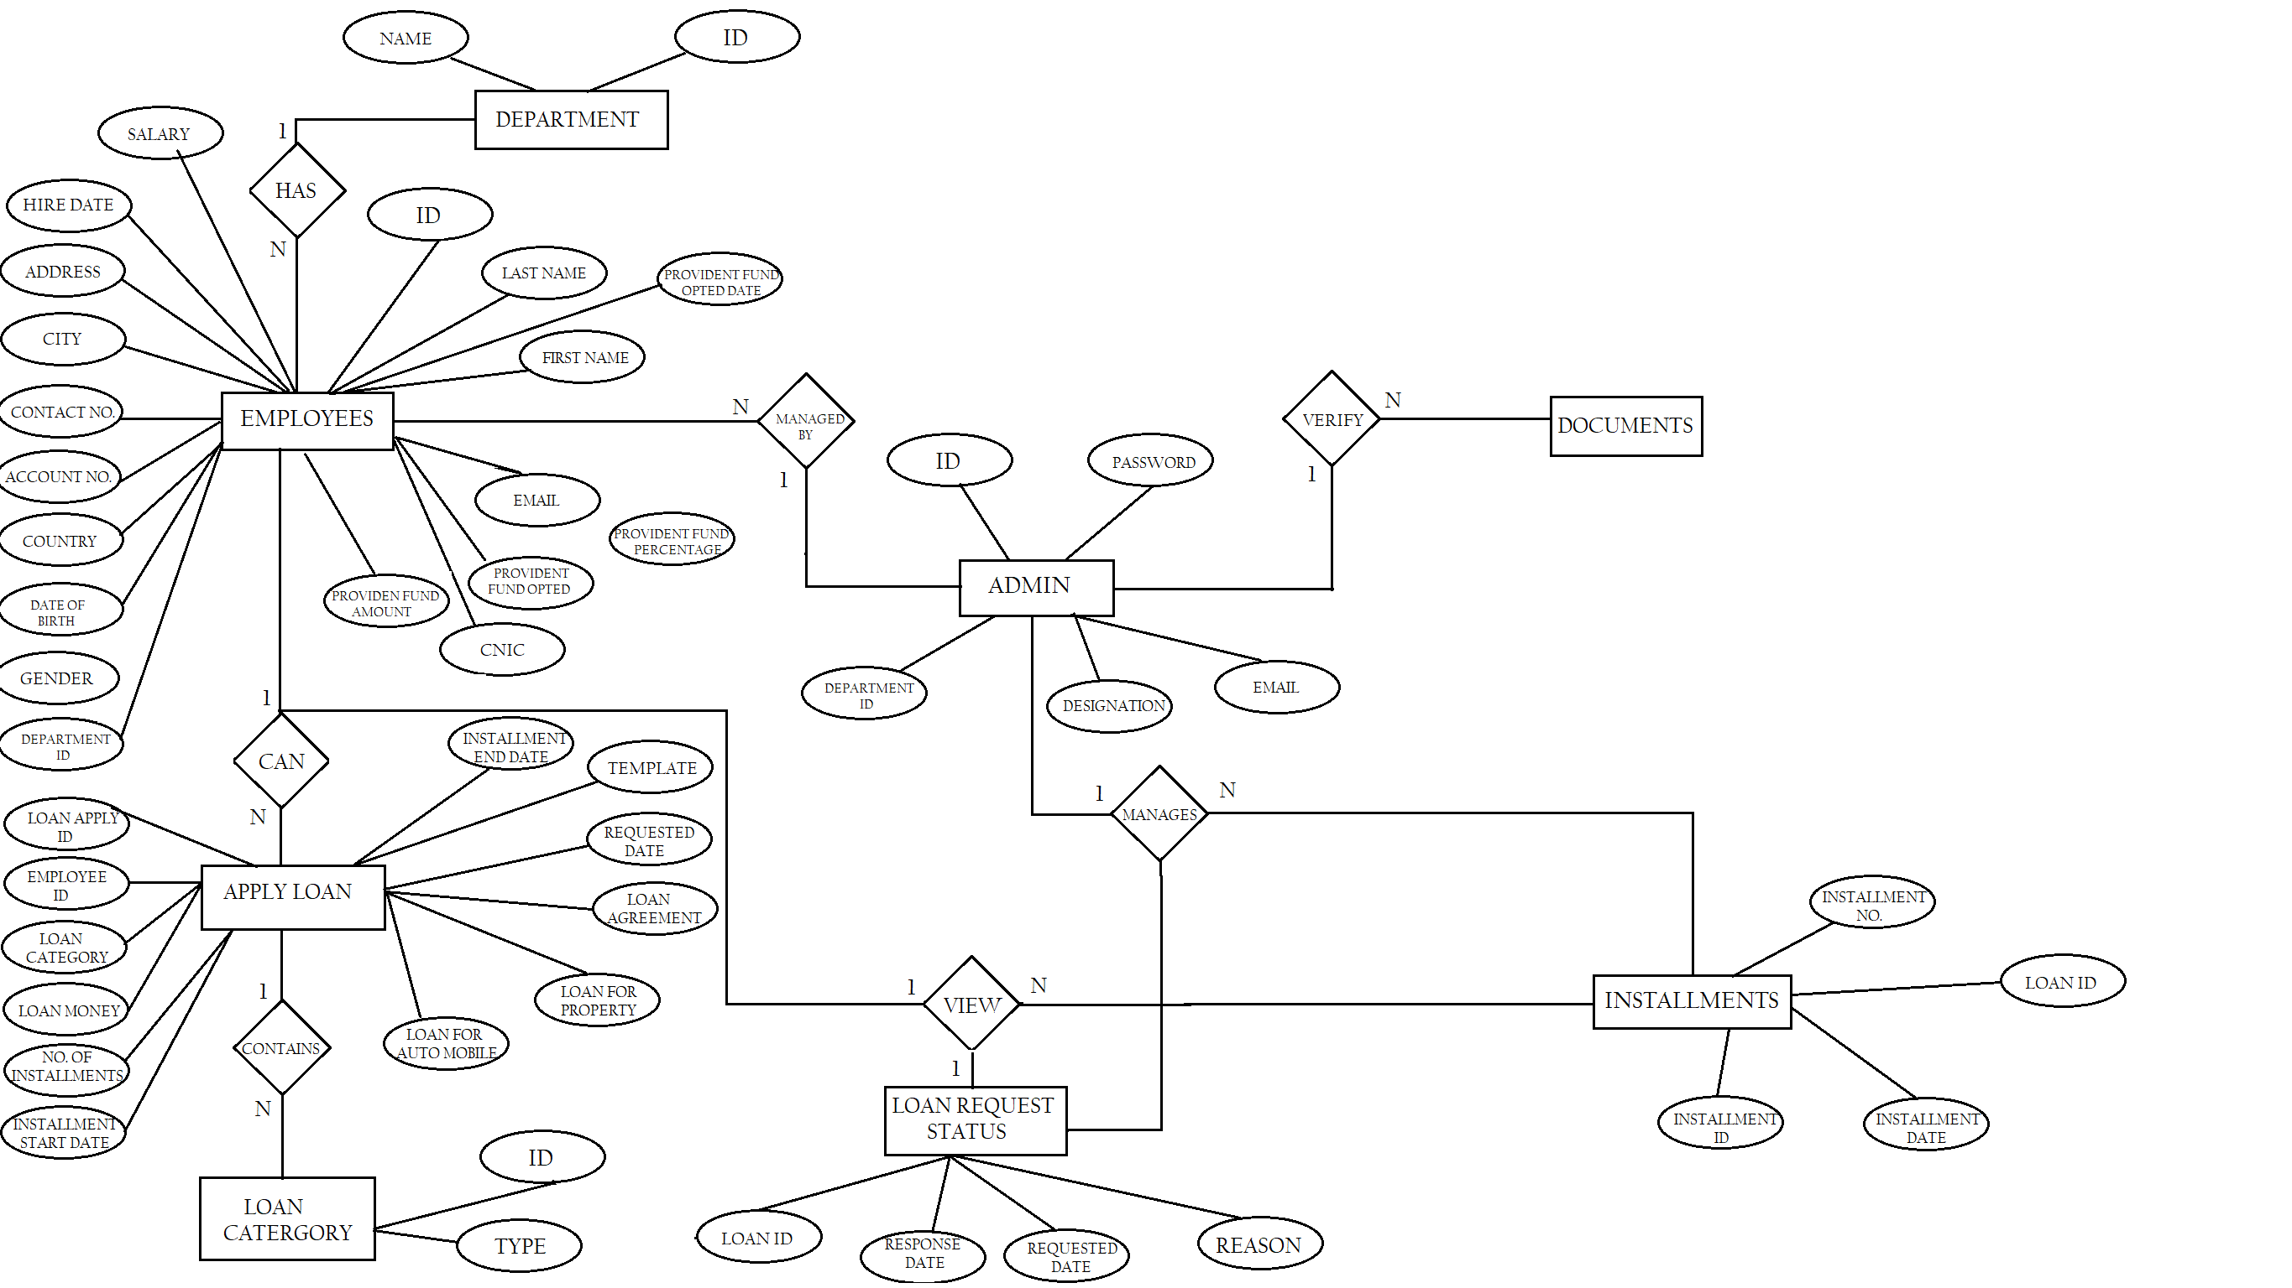

**Logical Database Design:**



**List of Reports:**

The reports which will be generated are listed below:

* Employees loan requests which are still pending.
* Employees loan requests which are accepted.
* Employees loan requests which are rejected.
* Defaulter Employees.
* Employees who have taken loan against Provident Fund.
* Employees who have taken loan against Provident Fund for property.
* Employees who have taken loan against Provident Fund for automobile.
* Employees who have taken general loan.
* Installments which will be paid by employee.
* Paid installments of employee.
* Specific employee’s loan history.

**Technology:**

* MVC (.NET FRAMEWORK)
* Visual Studio
* MS Sql