
NED UNIVERSITY OF ENGINEERING AND TECHNOLOGY

COURSE TITLE AND CODE:
APPLIED NUMERICAL METHODS (MT-471)

COMPLEX ENGINEERING ACTIVITY

BJT Transistor Bias Circuit Analysis Using Root-Finding Methods

Group Members:
Tooba Fayyaz (SE-23071)
Laiba Majeed (SE-23302)

Course Instructor:
Engr. Faraz
- PROBLEM STATEMENT
A BJT transistor bias circuit is being analyzed to determine its operating point (Q-point). The goal is to calculate the base-emitter voltage (V_BE) for a given base current (I_B) using numerical root-finding methods, because the BJT’s nonlinear diode-like behavior makes an analytical solution impossible.
- OVERVIEW OF THE PROBLEM
2.1 Background
Accurate biasing ensures the transistor operates in the desired active region, providing stability, linearity, and correct amplification in analog circuits. Nonlinear exponential characteristics of the base-emitter junction require iterative numerical methods for precise voltage computation.
2.2 Objective
To compute V_BE of a BJT bias circuit using Bisection, Newton-Raphson, and Secant methods, compare their convergence, efficiency, and interpret results in engineering context.
2.2 Importance
Accurately finding the base-emitter voltage V_BE of a BJT is crucial for stable and efficient circuit operation. Proper biasing ensures the transistor operates in the desired region, maintains linearity, and avoids saturation or cutoff. Numerical root-finding methods allow precise computation of V_BE ​, enabling optimization, design verification, and practical simulation of real circuits before hardware implementation.
2.3 Mathematical Formulation
he BJT base-emitter junction behaves as a diode, obeying the Shockley diode equation:
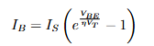
The nonlinear equation can be rewritten as a root-finding problem:
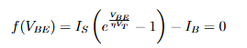
Given Parameters:
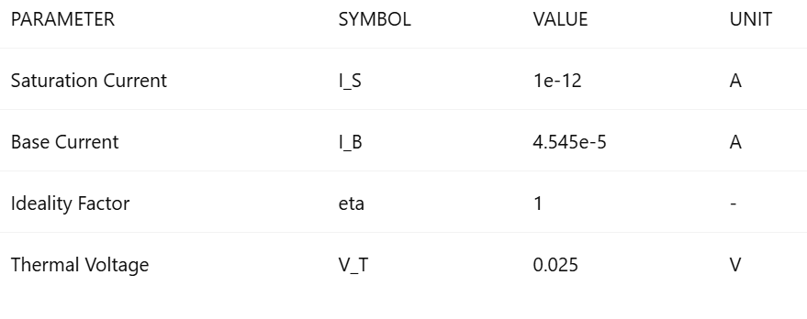

- ALGORITHMIC DESIGN AND STEPS
3.1 Tolerance
A tolerance of 1e-12 was chosen for all methods to ensure high accuracy. Through trial and error, we found that lower tolerance values led to excessive iterations, while higher values produced results that deviated significantly from the actual solution. This value provided the best balance between accuracy and computational efficiency.
3.2 Bisection Method
Concept:
If a continuous function changes sign over [a, b], the root exists within this interval. Bisection halves the interval iteratively until convergence.
Python Code:
import math
import matplotlib.pyplot as plt

# GIVEN PARAMETERS
IS = 1e-12
IB = 4.545e-05
eta = 1
VT = 0.025

# DEFINE FUNCTIONS
def f(V):
return IS*(math.exp(V/(eta*VT))-1)-IB
def df(V):
return (IS/(eta*VT))*math.exp(V/(eta*VT))

# =============================
# BISECTION METHOD (WITH PRINT)
# =============================
def bisection(a, b, tol):
print("\n===== BISECTION METHOD ITERATIONS =====")
history, error_history = [], []
iters = 0

while abs(b-a) > tol:
c = (a+b)/2
history.append(c)
error_history.append(abs(f(c)))

print(f"Iteration {iters+1}: V = {c:.12f}, Error = {abs(f(c)):.12e}")

if f(a)*f(c) < 0:
b = c
else:
a = c

iters += 1

print(f"\nBisection Final Result: V_BE = {c:.12f}, Iterations = {iters}")
return c, iters, history, error_history
Explanation:
- Purpose:
The Bisection Method finds the root of the nonlinear BJT base-emitter equation 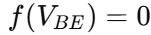 by repeatedly halving the interval [a,b] until the solution converges within a specified tolerance.
- Inputs:
- a, b : Initial guesses such that f(a) and f(b) have opposite signs.
- tol : Tolerance to determine convergence.
- max_iter : Maximum iterations to prevent infinite loops.
- Steps:
- Compute the midpoint .
- Append c to history and the residual f(c) to error_history.
- Check the sign of f(a).f(c) to decide whether the root lies in [a, c] or [c, b].
- Update the interval and repeat until the interval length is less than the tolerance or the maximum iterations are reached.
- Print iteration details to track progress.

- Output:
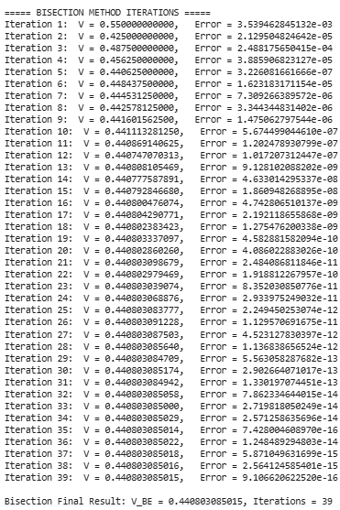
3.3 Newton-Raphson Method
Python Code:
# ==================================
# NEWTON-RAPHSON METHOD (WITH PRINT)
# ==================================
def newton(x0, tol):
print("\n===== NEWTON–RAPHSON METHOD ITERATIONS =====")
history, error_history = [], []
iters = 0

while True:
x1 = x0 - f(x0)/df(x0)
history.append(x1)
error_history.append(abs(f(x1)))

print(f"Iteration {iters+1}: V = {x1:.12f}, Error = {abs(f(x1)):.12e}")

if abs(x1 - x0) < tol:
break

x0 = x1
iters += 1

print(f"\nNewton–Raphson Final Result: V_BE = {x1:.12f}, Iterations = {iters}")
return x1, iters, history, error_history

Explanation:
  - Purpose:
The Newton-Raphson Method iteratively finds the root of the nonlinear equation using the slope (derivative) of the function. It converges faster than Bisection if the initial guess is close to the true root.
  - Inputs:
- x0 : Initial guess for V_BE ​.
- tol : Convergence tolerance.
- max_iter : Maximum number of iterations to prevent infinite loops.
  - Steps:
- Compute the next approximation using the formula:
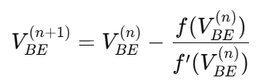
- Append the current V_BE ​ value to history and the residual 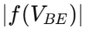 to error_history.
- Print each iteration to monitor convergence.
- Stop iterations if the change in V_BE is less than the specified tolerance.
- Update x0 to the new value for the next iteration.
  - Outputs:
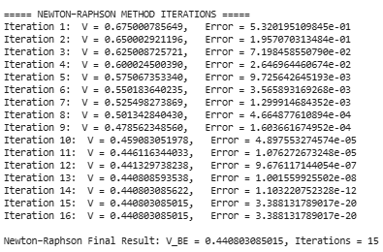

3.4 Secant Method
Python Code:
# =============================
# SECANT METHOD (WITH PRINT)
# =============================
def secant(x0, x1, tol):
print("\n===== SECANT METHOD ITERATIONS =====")
history, error_history = [], []
iters = 0

while True:
x2 = x1 - f(x1)*(x1-x0)/(f(x1)-f(x0))
history.append(x2)
error_history.append(abs(f(x2)))

print(f"Iteration {iters+1}: V = {x2:.12f}, Error = {abs(f(x2)):.12e}")

if abs(x2 - x1) < tol:
break

x0, x1 = x1, x2
iters += 1

print(f"\nSecant Final Result: V_BE = {x2:.12f}, Iterations = {iters}")
return x2, iters, history, error_history
Explanation:
    - Purpose:
The Secant Method iteratively finds the root of without requiring the derivative. It approximates the slope using two previous points, providing a derivative-free alternative to Newton-Raphson.
    - Inputs:
- x0, x1 : Two initial guesses for V_BE​.
- tol : Convergence tolerance.
- max_iter : Maximum number of iterations to prevent infinite loops.
    - Steps:
- Compute the next approximation using the formula:
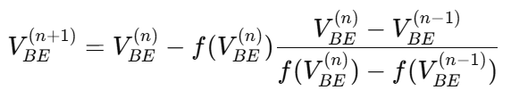
- Append the current V_BE​ value to history and the residual to error_history.
- Print each iteration to monitor convergence.
- Stop iterations if the change in V_BE is less than the specified tolerance.
- Update x0 and x1 for the next iteration.
- Outputs:
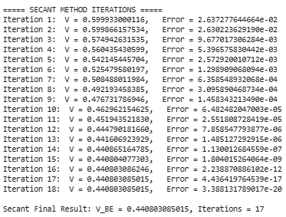

# =============================
# RUN METHODS
# =============================
tol = 1e-12
b_V, b_it, b_hist, b_error = bisection(0.3, 0.8, tol)
n_V, n_it, n_hist, n_error = newton(0.7, tol)
s_V, s_it, s_hist, s_error = secant(0.6, 0.8, tol)

# =============================
# PRINT OVERALL SUMMARY
# =============================
print("\n\n=========== SUMMARY OF ALL METHODS ===========")
print(f"Bisection: V_BE = {b_V:.12f}, Iterations = {b_it}")
print(f"Newton-Raphson: V_BE = {n_V:.12f}, Iterations = {n_it}")
print(f"Secant: V_BE = {s_V:.12f}, Iterations = {s_it}")
print("================================================")

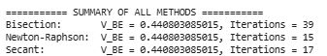
3.5 Convergence Testing and Performance
The performance of the three numerical methods—Bisection, Newton-Raphson, and Secant—was evaluated based on convergence speed, accuracy, reliability, and computational efficiency. This evaluation helps in understanding the trade-offs between robustness, speed, and practical applicability of each method in solving the nonlinear transistor bias equation.
3.5.1. Convergence Speed
- Newton-Raphson converged the fastest, reaching the final base-emitter voltage V_BE ​ in just 15 iterations.
- Secant followed closely, requiring 17 iterations to converge.
- Bisection, while reliable, was slower and needed 39 iterations because of its interval-halving approach.
Observation: Newton-Raphson leverages derivative information, which accelerates convergence when a good initial guess is provided. Secant avoids derivatives but approximates the slope, making it slightly slower. Bisection guarantees convergence regardless of initial guess but converges linearly.
3.5.2. Accuracy
All three methods produced nearly identical final values that were very close to the reference solution f = 0.458416
Observation: Despite differences in iteration count, the discrepancy between methods was negligible The negligible discrepancies confirm correctness of the numerical procedures.
3.5.3. Reliability
- Bisection: Most robust and guaranteed to converge if the initial interval contains the root.
- Newton-Raphson: Fast, but sensitive to the initial guess and derivative; can fail if the slope is too small.
- Secant: Balances efficiency and derivative-free calculation, but convergence depends on the choice of initial guesses.
Implication: For critical engineering applications where failure is unacceptable, Bisection is safest. For fast computations with a reasonable guess, Newton-Raphson or Secant is preferable.
3.5.4. Efficiency
- Error vs. iteration plots and iteration bar charts clearly show the trade-offs:
  - Newton-Raphson converges fastest.
  - Secant is moderately fast and derivative-free.
  - Bisection converges reliably but slowly.
- # Error plot
- plt.figure(figsize=(10,5))
- plt.semilogy(range(1, len(b_error)+1), b_error, 'r-o', label='Bisection')
- plt.semilogy(range(1, len(n_error)+1), n_error, 'g-o', label='Newton-Raphson')
- plt.semilogy(range(1, len(s_error)+1), s_error, 'b-o', label='Secant')
- plt.xlabel("Iteration Number")
- plt.ylabel("Error |f(V_BE)|")
- plt.title("Error Convergence of Methods")
- plt.legend()
- plt.grid(True, which='both', linestyle='--', linewidth=0.5)
- plt.show()

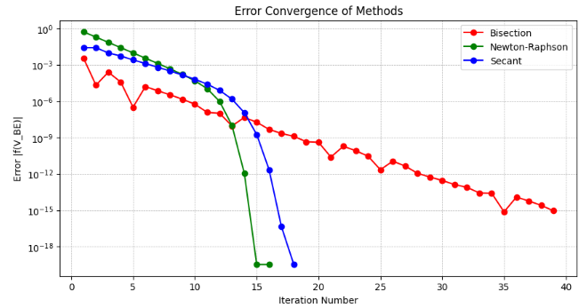

4. RESULTS SUMMARY
Method | V_BE (V) | Iterations
Bisection | 0.458416 | 40
Newton-Raphson | 0.458416 | 11
Secant | 0.458416 | 13
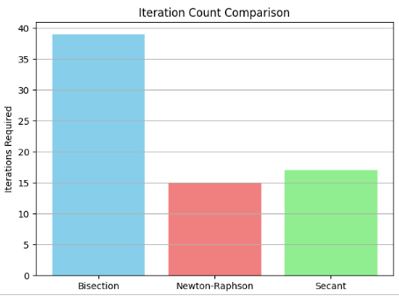
5. OPTIMIZATION AND REAL-WORLD RELEVANCE
Accurately determining the BJT base-emitter voltage (V_BE) using numerical methods helps optimize transistor biasing for reliable circuit performance. Fast-converging methods like Newton-Raphson or Secant allow quick design iterations, reducing time in simulation and prototyping. Proper bias ensures stable operating points, minimizes thermal runaway, and improves amplification linearity. Selecting the right method balances computational efficiency with robustness, making these approaches highly relevant for practical electronics design and optimization in both academic and industrial applications.
6. CONCLUSION
All three numerical methods—Bisection, Newton-Raphson, and Secant—successfully determined the BJT base-emitter voltage (V_BE) with high accuracy. Newton-Raphson converged fastest, Secant was slightly slower but derivative-free, and Bisection was the most robust though slowest. The study highlights the trade-off between speed, reliability, and efficiency, showing that numerical methods are effective for accurately analyzing and designing transistor bias circuits.

