LAB SESSION 2
QUESTION 1:
Code:
. # Name: Tooba Fayyaz
2. # Section: B
3. # Roll No. SE-23071
4. # QUESTION 1:
5. def sum_of_num(n):
6. total = 0
7. for i in range(1, n+1):
8. total += i
9.
10. return total
11.
12. print(sum_of_num(10))
13

QUESTION 2:
Code:
. # QUESTION 2:
14. import math
15.
16. def approx_pi(n):
17. pi_app = 0
18. for k in range(n):
19. pi_app += ((-1)**k) / (2*k + 1)
20. pi_app *= 4
21. return pi_app
22.
23. n = 1000
24. estimate = approx_pi(n)
25. print(f'Approximation of pi using {n} terms', estimate)
26.
27. print("Error: ", abs(math.pi - estimate))
28.
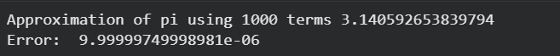
QUESTION 3:
Code:
. # QUESTION 3:
30.
31. def smallest_factorial(threshold):
32. m = 1
33. fact = 1
34. while fact <= threshold:
35. m += 1
36. fact *= m
37. return m
38.
39. t1 = 1000
40. t2 = 1e6
41.
42. print(f"Smallest m such that m! > {t1}: {smallest_factorial(t1)}")
43. print(f"Smallest m such that m! > {t2}: {smallest_factorial(t2)}")

