LAB SESSION 4
QUESTION 1:
CODE:
1. # Name : Tooba Fayyaz
2. # Roll No: SE-23071
3.
4. #Problem 1: Solve Quadratic Equation and Make a Plot
5. #Function to solve the quadratic equ
6. import numpy as np
7. import matplotlib.pyplot as plt
8. def equation(a,b,c):
9. discriminant = b**2 - 4*a*c
10. if(discriminant > 0):
11. x1 = int (-b + np.sqrt(discriminant)) / 2*a
12. x2 = int (-b - np.sqrt(discriminant)) / 2*a
13. return x1,x2
14.
15. a = 1
16. b = -3
17. c = 2
18. roots = equation(a,b,c)
19. print("The roots for the given equation are:",roots)
20.
21. #Plotting the graph for the Equ over x[-1,4]
22. x = np.linspace(-1, 4, 400)
23. y = a*x**2 + b*x + c #using a,b,c from the above function
24.
25. for r in roots :
26. plt.plot(r, 0, "ro")
27.
28. plt.plot(x,y)
29. plt.xlabel("x")
30. plt.ylabel("y")
31. plt.title("Quadratic Function and Its Roots")
32. plt.grid(True)
33. plt.show()
34.
OUTPUT:
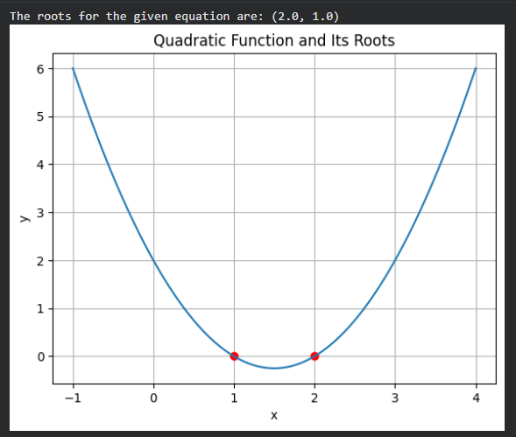
QUESTION 2:
CODE:
1. # Problem 2: Vector Geometry in 3D
2.
3. # Part 1 : u + v and 3u - 2v
4. import numpy as np
5. u = np.array([3, -1, 4])
6. v = np.array([2, 5, -2])
7.
8. addition = u + v
9. multiplication = 3*u - 2*v
10.
11. print("u + v: " , addition)
12. print('3u - 2v: ', multiplication)
13. #----------------------------------------------
14.
15. # Part 2 : Dot Product of u and v
16. dot_product = np.dot(u,v)
17. print('Dot product of u and v:', dot_product)
18. #----------------------------------------------
19.
20. # Part 3 : Magnitude of u and v
21. u_ = np.linalg.norm(u)
22. v_ = np.linalg.norm(v)
23.
24. print('Magnitude of u:', u_)
25. print('Magnitude of v:', v_)
26. #----------------------------------------------
27.
28. # Part 4 : Angle between u and v
29. # formula : Cos(theta) = (u · v) / (|u| |v|)
30.
31. cos = dot_product / (u_ * v_)
32. angle = np.arccos(cos)
33. angle_degree = np.degrees(angle)
34.
35. print('Angle between u and v:' , angle_degree)
36.
OUTPUT:
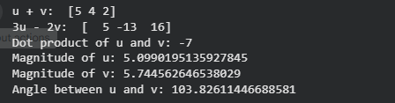
QUESTION 3:
CODE:
1. #Problem 3: Solving Linear System
2. import numpy as np
3.
4. # Part 1
5. A = np.array([[5, -2], [1, 6]])
6. B = np.array([12, -7])
7.
8. result1, result2 = np.linalg.solve(A,B)
9. print(f"I1 : {result1} and I2 : {result2}")
10. #----------------------------------------------
11.
12. #Part 2
13. power = 4 * result1**2
14. print(f"Power in 4 ohm resistor : {power}")
15.
OUTPUT:

QUESTION 4:
CODE:
1. # Problem 4: Polynomial Comparison Plot
2. import numpy as np
3. import matplotlib.pyplot as plt
4.
5. x = np.linspace(-2,3,400)
6. #Defining Functions
7. f1 = x
8. f2 = x**2
9. f3 = x**3
10.
11. #Plotting Functions
12. plt.plot(x, f1, 'g-', label = "f(x) = x")
13. plt.plot(x, f2, 'b--', label = "f(x) = x^2")
14. plt.plot(x, f3, 'r-.', label = "f(x) = x^3")
15.
16. #Adding Labels
17. plt.title("Polynomial omparison Plot")
18. plt.xlabel("x")
19. plt.ylabel("f(x)")
20. plt.legend()
21. plt.grid(True)
22.
23. plt.show()
24.
25. plt.savefig('polynomials.png')
26.
OUTPUT:
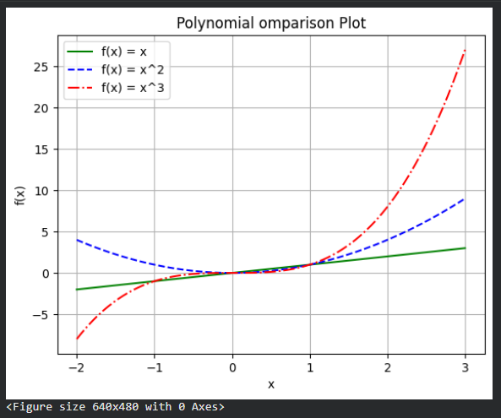
QUESTION 5:
CODE:
1. #Problem 5: Approximation of Pi using Series and Convergence Plot
2.
3. # Part 1 : Function for approximation
4. # The given series is Leibniz and pi can be converged as follows
5.
6. def approx_pi(n):
7. sum = 0
8. for k in range(n):
9. sum += ((-1)**k) / (2*k + 1)
10. return 4 * sum
11. #----------------------------------------------
12.
13. # Part 2 : Approximation for n = 10, 100, 1000, 10000.
14.
15. for n in [10, 100, 1000, 10000]:
16. print(f"For n={n}, π ≈ {approx_pi(n)}")
17.
18. n_values = np.logspace(1, 4, 50, dtype=int) # gives 50 integers between and including 10^1 and 10^4
19.
20. pi_approx = [approx_pi(n) for n in n_values] # has the calculated approx_pi for all 50 n values
21.
22. errors = [abs(np.pi - val) for val in pi_approx] # gets approximation error |π−πn| for all calculated values
23. #----------------------------------------------
24.
25. # Part 3 : Plotting Error
26.
27. plt.plot(n_values, errors, ':', label='Error')
28.
29. plt.xscale('log')
30. plt.yscale('log')
31. plt.xlabel('n (number of terms)')
32. plt.ylabel('|π - πₙ| (error)')
33. plt.title('Convergence of π Approximation')
34. plt.legend()
35. plt.grid(True, which='both')
36. plt.show()
37. #----------------------------------------------
38.
39. # Part 4 : Discussion
40. #The error decreases very slowly that even at n = 10,000 the approximation is only correct upto 4 decimal place
41. # Thus, we can conclude that the series converges very slowly
42.

OUTPUT:
