LAB SESSION 6
QUESTION 1 AND 2:
1. import numpy as np
2. import matplotlib.pyplot as plt
3.
4. # Gaussian Elimination
5. def gaussian_elimination(A, b):
6. print('GAUSSIAN ELIMINATION: ')
7.
8. Ab = np.column_stack((A.copy(), b.copy()))
9. print("Augmented Matrix: ")
10. print(Ab)
11.
12. n = len(b)
13.
14. for i in range(n):
15. if Ab[i,i] == 0:
16. print('Zero at diagonal')
17. break
18. for j in range(i+1, n):
19. factor = Ab[j][i] / Ab[i][i]
20. Ab[j, :] -= factor * Ab[i, :]
21.
22. print("\nAfter Forward Elimination: ")
23. print(np.round(Ab,3))
24.
25. def backward_sub(Ub):
26. n = len(Ub)
27. x = np.zeros(n)
28. for i in range(n-1, -1, -1):
29. x[i] = (Ub[i, -1] - np.sum(Ub[i, i+1:n] * x[i+1: n])) / Ub[i,i]
30. return x
31.
32. solution = backward_sub(Ab)
33. print("Solution: ", np.round(solution, 3))
34. return solution
35.
36. # Function: Gauss-Jordan Elimination
37. def gauss_jordan(A, b):
38. print("\nGAUSS–JORDAN ELIMINATION:")
39.
40. Ab = np.column_stack((A.astype(float), b.astype(float)))
41. n = len(b)
42.
43. for i in range(n):
44. Ab[i] = Ab[i] / Ab[i, i]
45. for j in range(i + 1, n):
46. factor = Ab[j, i]
47. Ab[j] = Ab[j] - factor * Ab[i]
48.
49. print("After forward elimination:")
50. print(np.round(Ab, 3))
51.
52. # Backward elimination
53. for i in range(n - 1, -1, -1):
54. for j in range(i - 1, -1, -1):
55. factor = Ab[j, i]
56. Ab[j] = Ab[j] - factor * Ab[i]
57.
58. print("After backward elimination (RREF):")
59. print(np.round(Ab, 3))
60.
61. solution = Ab[:, -1]
62. print("Solution:", solution)
63.
64. return solution
65.
66. # SOLTUION FOR QUESTION 1:
67. # Solve using Gaussian Elimination
68.
69. A = np.array([[2,1,1,], [1,3,1], [1,1,4]], dtype=float)
70. b = np.array([6,9,11], dtype=float)
71. gaussian_elimination(A, b)
72.
73. # SOLUTION FOR QUESTION 2:
74. # Solve using Gauss-Jordan Elimination
75. gauss_jordan(A, b)
76.
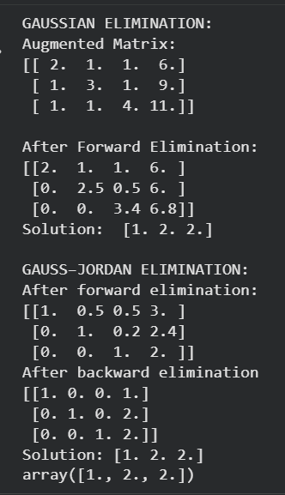
QUESTION 3:
1. # SOLUTION FOR QUESTION 3:
2. A = np.array([[2.0, 3.0],
3. [4.0, -1.0]])
4. b = np.array([7.0, 5.0])
5.
6. x, y = gaussian_elimination(A, b)
7. print("Solution : x =", x, ", y =", y)
8.
9. xs = np.linspace(-2, 4, 400)
10.
11. line1 = (7 - 2*xs) / 3
12. line2 = 4*xs - 5
13.
14. plt.figure(figsize=(6,4))
15. plt.plot(xs, line1, label="2x + 3y = 7")
16. plt.plot(xs, line2, label="4x - y = 5")
17.
18. plt.scatter([x], [y], color='red', s=80, label="Intersection")
19.
20. plt.xlabel("x")
21. plt.ylabel("y")
22. plt.title("Solution of 2x2 System (Using Gaussian Elimination Function)")
23. plt.legend()
24. plt.grid()
25.
26. plt.savefig("system_plot.png", dpi=200)
27. plt.show()
28. 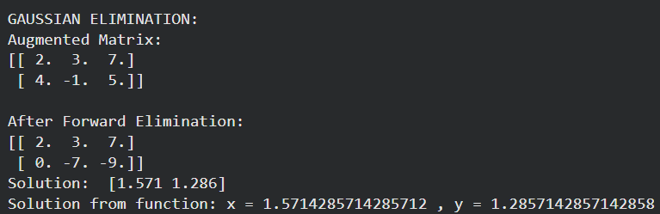
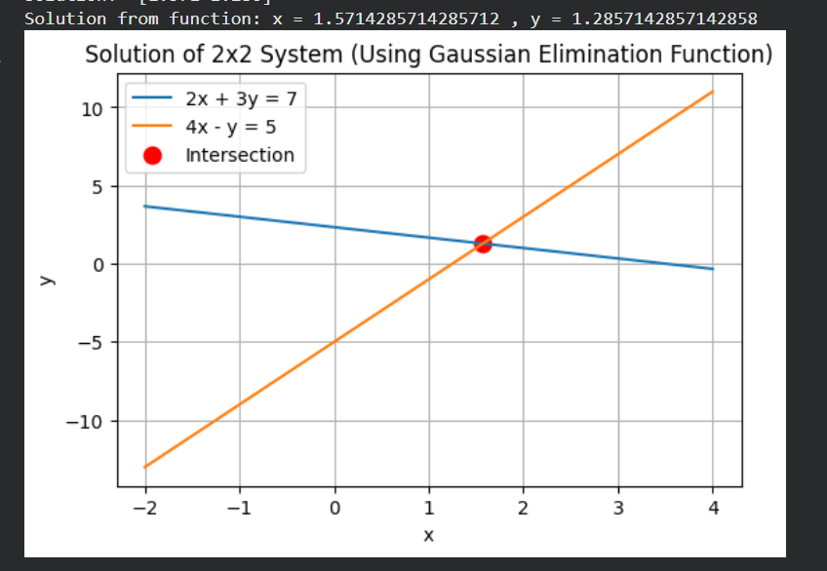
EXPLANATION:
The gaussian elimination function first performs the formation of Augmented Matrix. It then performs forward elimination over the augmented matrix, till we get an upper triangular matrix. This transforms the matrix into Echelon Form. Once the matrix is triangular, it uses back-substitution to find the variables starting from the last equation.
The gauss-jordan elimination also performs the same operations, but it normalizes the augmented matrix and makes every pivot 1, and the rest of the entries zero. This transforms the matrix into Reduced Echelon Form. Then it performs backward elimination to get the final answers for each variable.
The code then checks both methods on the provided system of equation.
In the last question, end of the code, the gaussian elimination method is applied for another system of equation and the graph is plotted to show that the method provides the correct roots.

