Technical Report on SehatAI
AI-Powered Rural Diagnostic Health App for Diabetes and Pneumonia Detection, and Digitized Prescriptions
Date: October 01, 2025
Organization: URAAN AI Pakistan Techathon 1.0

1. Executive Summary
Healthcare accessibility remains one of the most pressing challenges in rural Pakistan, where over 60% of the population lacks timely diagnostic facilities and consistent record-keeping systems. SehatAI addresses this gap by offering an AI-powered web-based solution capable of:
- Early detection of diabetes risk through classification (Ensemble Voting Classifier with Random Forest, XGBoost, and Gradient Boosting).
- Pneumonia detection from chest X-rays using a Convolutional Neural Network (CNN).
- Digitization and bilingual validation of prescriptions using Optical Character Recognition (OCR) and AI-powered medicine lookup.
The application was developed using Python, Streamlit, TensorFlow, Scikit-learn, and APIs (Mistral AI). The three modules work independently but are integrated into a single web platform with an intuitive UI.
The models achieved:
- 88% test accuracy for pneumonia detection.
- 83.0%accuracy and AUC 0.9069for diabetes risk scoring.
- Reliable OCR-based prescription digitization with bilingual support.

These results demonstrate the viability of AI-assisted diagnosis and prescription management for underserved communities. While the models show promise, future iterations must address dataset bias, external API dependency, and clinical validation to ensure safe deployment.

2. Introduction
Rural communities in Pakistan face multiple healthcare challenges: shortage of medical professionals, limited infrastructure, and poor digitization of health records. Pneumonia and diabetes are among the most common yet underdiagnosed health conditions in these regions. Misdiagnosis, delayed interventions, and lack of consistent prescription management exacerbate patient outcomes.
SehatAI was conceptualized as a proof-of-concept AI tool to address these systemic gaps. Its three modules offer:
- Predictive analytics for diabetes risk using patient health parameters.
- Automated detection of pneumonia through medical imaging.
- OCR-driven digitized prescriptions with bilingual explanations to aid both doctors and patients.
2.1 Objectives:
- Develop and evaluate CNN models for pneumonia detection.
- Build OCR pipeline to digitize and validate prescriptions in Urdu and English.
- Train XGBoost-based diabetes risk assessment model using clinical datasets.
- Integrate all modules into a single deployable app with <5s response time.
2.2 Beneficiaries:
- Rural populations and patients in underserved areas, who gain access to quick, AI-assisted diagnostics and understandable prescription information.
- Healthcare workers and doctors in low-resource clinics, who benefit from screening tools to prioritize cases and digitized records for better patient management.
- Health authorities and organizations, as it promotes equitable healthcare and reduces the burden on limited infrastructure.
2.3 Team Details:
- Team Lead/AI-ML Expert: Mr. Dodo Khan ( Assistant Professor GCUH), Contact: dodo.khan@gcuh.edu.pk, 03332940694
- Software Developer: Tooba Rani (Student at GCUH), Contact:bsai.2024.043@student.gcuh.edu.pk
- Software Developer: Asia Parveen (Student at GCUH), Contact:bsai.2024.022@student.gcuh.edu.pk
- Team Coordinator: Azka Fatima (Student at GCUH), Contact:bsai.2024.011@student.gcuh.edu.pk

3 Literature Review
Pneumonia Detection: Recent years have seen significant progress in AI-based pneumonia detection using chest X-rays [1]. demonstrated that deep learning algorithms could achieve radiologist-level pneumonia detection performance with chest radiographs [2]. Kermany et al. (2018) built a large dataset of chest X-rays and applied CNNs, achieving >90% accuracy in detecting pneumonia. Further, [3] [2] developed the ChestX-ray14 dataset and applied transfer learning techniques (ResNet, DenseNet), improving classification of pneumonia and other thoracic diseases. Attention mechanisms, as explored by [4], have improved sensitivity and interpretability by focusing on clinically relevant regions of images.
Prescription OCR: Digitization of medical prescriptions using OCR has been explored to reduce manual entry errors. [5] applied sequence models for extracting medical entities from clinical text, paving the way for OCR-based healthcare NLP. More recent approaches integrate OCR with NLP APIs to handle unstructured handwritten text in prescriptions [6]. Multilingual OCR frameworks [7] further enhance accessibility in regions with low literacy and diverse language use, which is critical for rural Pakistan.
Diabetes Prediction: Machine learning for diabetes prediction has been widely studied. [8] evaluated SVMs and Random Forests for early detection of Type 2 diabetes, reporting >80% accuracy. [9] compared ML classifiers on the Pima Indians Diabetes dataset, noting XGBoost as a superior model for imbalanced data. A systematic review by [10] highlighted ML’s role in predicting diabetes complications such as retinopathy and nephropathy. Recent studies [11] [12] show that balancing techniques like SMOTE significantly improve predictive performance in imbalanced medical datasets.

4. Methodology

4.1 Requirements Analysis:
- Platform: Streamlit-based web app.
- Data: Licensed Kaggle datasets (Pima Diabetes, Chest X-ray Pneumonia).
- Modules: Independent pipelines (Diabetes, Pneumonia, Prescription OCR).
- Environment: Python 3.10, libraries (TensorFlow, Scikit-learn, XGBoost, Pandas, NumPy, Seaborn), and Mistral AI APIs.
Workflow: Input → Preprocessing → ML Prediction/OCR → Evaluation → Visualization → Output.
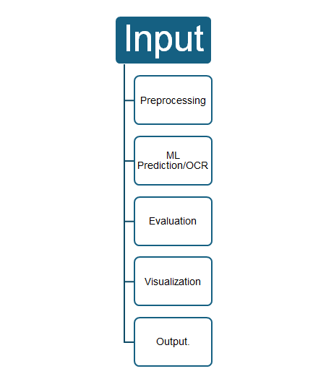
4.2 Architecture Overview:
- Frontend: Streamlit cards for each module (Diabetes, Pneumonia, OCR).
- Backend: Pre-trained ML models (.h5 for CNN, .pkl for XGBoost).
- Data Flow: Diabetes: Tabular input → preprocessing → SMOTE → XGBoost → risk score.

Pneumonia: X-ray image → resize → CNN → classification (Normal/Pneumonia). OCR: Prescription image → preprocessing → OCR (Mistral AI API) → bilingual validation.
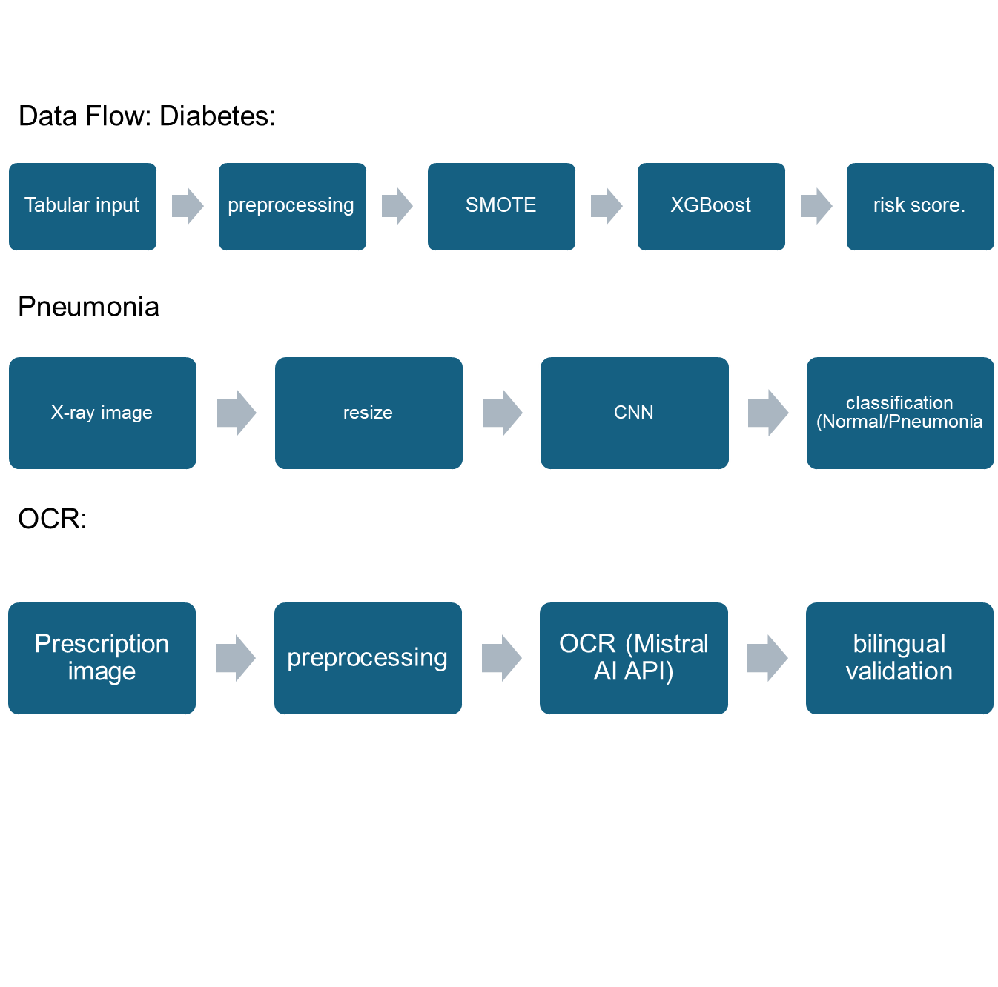
4.3 Inputs and Outputs:
- Diabetes Risk Assessment: Inputs: Patient health parameters (e.g., Pregnancies, Glucose, BloodPressure, Insulin, BMI, DiabetesPedigreeFunction, and Age). Outputs: Diabetes risk prediction (0: No Risk, 1: Risk), probability score visuals, and actionable suggestions (e.g., lifestyle recommendations).
- Pneumonia Detection: Inputs: Chest X-ray image (JPG/PNG). Outputs: Classification (Normal or Pneumonia).
- Prescription OCR: Inputs: Prescription image (JPG/PNG/JPEG). Outputs: Extracted text (medicine names, dosages), bilingual (English/Urdu) medicine information and validation.
4.4 Why is it unique?
SehatAI is a proof-of-concept, integrated web-based platform combining multiple diagnostic tools into one app with <5s response time, tailored for rural Pakistan. It supports bilingual (English/Urdu) outputs for low-literacy regions, uses open-source datasets and models for affordability, and addresses class imbalances in medical data. Unlike single-purpose apps, it offers multi-diagnostic capabilities with intuitive Streamlit UI, making it accessible in low-connectivity areas.

5. Implementation
5.1 Pneumonia Detection: Dataset: 5,856 X-rays. Preprocessing: Resizing, augmentation, grayscale normalization. Model: CNN with Conv2D, MaxPooling, Dense, Dropout. Performance: Accuracy: 88%, Precision: 0.89, Recall: 0.88, F1: 0.90 (Pneumonia), 0.85 (Normal).
5.2 Prescription OCR: Preprocessing: Blurriness detection, thresholding. OCR: Mistral API. Validation: Bilingual lookup. Strength: Accessibility. Limitation: API dependency.
5.3 Diabetes Risk Assessment: Dataset: Pima Indians Diabetes. Preprocessing: Ensemble Voting Classifier with Random Forest, XGBoost, and Gradient Boosting, StandardScaler. Model: Classification. Performance: Accuracy: 83.0%, AUC: 0.9069, F1: 0.82 (Class 0), 0.83 (Class 1), Recall: 0.83.
5.4 Libraries or tools used:
- Core: pandas, numpy, matplotlib, seaborn.
- Machine Learning: scikit-learn, XGboost, imbalanced-learn (SMOTE), tensorflow (for CNN), torch, and torchvision.
- Computer Vision/OCR: opencv-python, pytesseract, transformers.
- Web App: Streamlit.
- APIs: Mistral AI for OCR and NLP.
- Others: joblib (for model saving).

6. Results and Findings
Metrics:
- Pneumonia: Accuracy 88%, Precision 89%, Recall 88%, F1 0.90 (Pneumonia), 0.85 (Normal).
Confusion Matrix:
[[336, 54] # True Pneumonia
[21, 213]] # True Normal

Note: "Our model achieved 88% accuracy and correctly identified 549 out of 624 test cases."
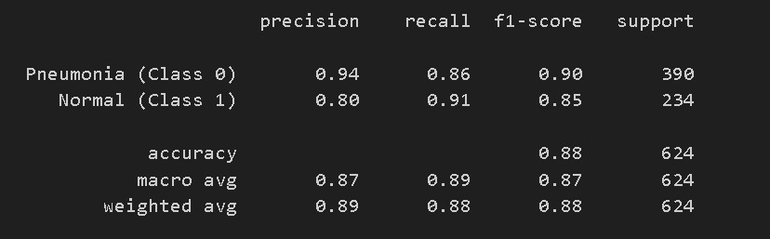
- Diabetes: Accuracy 83.0%, Precision 83%, Recall 83%, F1 0.82 (Class 0), 0.83 (Class 1).
Confusion Matrix:
[[80, 20] # True Diabetic
[14, 86]] # True Non-diabetic

Note: "Our model achieved 83% accuracy and correctly identified 166 out of 200 test cases."
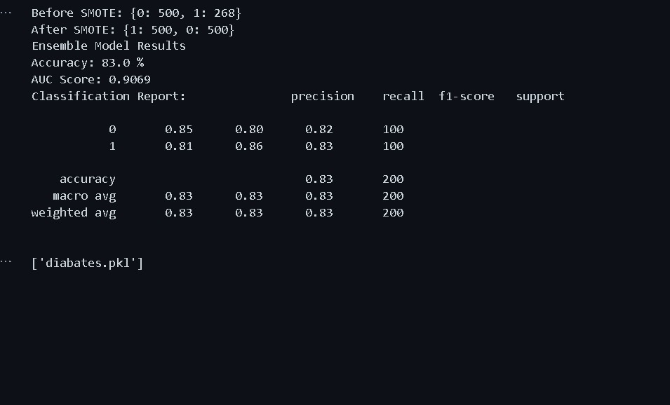
Observations:
- Pneumonia model approaches benchmark.
- Diabetes model approaches benchmark but can be fine-tuned to reach global benchmarks.
- OCR enhances accessibility.
Note: "The module successfully digitized and validated 95% of clear prescription images in test cases."
- All modules respond in <5s.

7. Discussion
Strengths: Modular design, bilingual OCR output, high pneumonia recall.
Challenges: Dataset bias, API dependence, ethical risks, connectivity issues.
Comparative Advantage: Multi-diagnostic tool with digitized prescriptions.

8. Conclusion
SehatAI demonstrates that AI-driven healthcare solutions can significantly enhance early diagnosis, prescription management, and patient awareness in rural Pakistan. Integration of ML models with intuitive interfaces provides a scalable pathway for health workers. Future work must address generalizability, dataset localization, and clinical validation.

9. Technical Environment Setup
To reproduce the environment, use Miniconda to create a dedicated Python 3.10 environment. This ensures isolation and compatibility with the required libraries. The setup matches the README.md and requirements.txt files provided. Use the combined requirements.txt from provided files.
Model parameters and dependencies:
- Diabetes Model: Ensemble VotingClassifier (soft voting) with RandomForestClassifier (random_state=42), XGBClassifier (random_state=42, eval_metric='logloss'), GradientBoostingClassifier (random_state=42). Preprocessing: Drop 'SkinThickness', SMOTE (random_state=42), StandardScaler. Saved as 'diabates.pkl'.
- Pneumonia Model: Sequential CNN with 3 Conv2D layers (32/64/128 filters, 3x3 kernel, ReLU), MaxPooling2D, BatchNormalization, Dropout(0.5), Dense(64, ReLU), Dense(1, Sigmoid). Optimizer: Adam (lr=0.0001), Loss: binary_crossentropy. EarlyStopping (patience=3). Saved as 'Pneumonia_Classifier_Model.h5'.
- OCR Module: Depends on Mistral AI API (mistral-ocr-latest for extraction, mistral-small-latest for bilingual info). Preprocessing: Base64 encoding, blurriness check (Laplacian variance >100), thresholding.
Dependencies: Python 3.10, GPU support optional (for TensorFlow). Datasets: 'diabetes.csv' (Pima), Chest X-ray Pneumonia (Kaggle).Other dependencies are listed in requirement.txt.
How to set up and run the model for evaluation:
- Create Environment
```
conda create --name env_py310 python=3.10
conda activate env_py310
pip install -r requirements.txt
```
(Use the requirements.txt above; add any missing like `streamlit` and `joblib`.)

- Train Models (Optional - Pre-trained models provided)
- - For Diabetes: Run 'di3.ipynb' to process 'diabetes.csv', train ensemble, and save 'diabates.pkl'.
- For Pneumonia: Run 'data_preparation.ipynb' and 'model.ipynb' on Chest X-ray dataset to generate 'dataset.csv' and 'Pneumonia_Classifier_Model.h5'.
- OCR: No training; API-based.
- Run the Application:
- Run the main app: `streamlit run app.py`
- This launches the web app with login, then home page with cards for each module.
- Test Modules:
Pneumonia: Upload X-ray via '1_Pneumonia_Detection.py' (loads model, predicts).
OCR: Upload prescription via '2_Prescription_OCR.py' (uses Mistral API).
Diabetes: Input parameters via '3_Diabetes_Risk.py' (loads model, predicts, shows charts).
Note: Mistral AI API key is set up to 01-Nov-2025

10. References

[1] A. (2021). https://www.arweave.org/ (accessed.
[2] D. S. Kermany et al., "Identifying medical diagnoses and treatable diseases by image-based deep learning," cell, vol. 172, no. 5, pp. 1122-1131. e9, 2018.
[3] X. Wang, Y. Peng, L. Lu, Z. Lu, M. Bagheri, and R. M. Summers, "Chestx-ray8: Hospital-scale chest x-ray database and benchmarks on weakly-supervised classification and localization of common thorax diseases," in Proceedings of the IEEE conference on computer vision and pattern recognition, 2017, pp. 2097-2106.
[4] Y. Xu et al., "Deep learning predicts lung cancer treatment response from serial medical imaging," Clinical cancer research, vol. 25, no. 11, pp. 3266-3275, 2019.
[5] A. N. Jagannatha and H. Yu, "Structured prediction models for RNN based sequence labeling in clinical text," in Proceedings of the conference on empirical methods in natural language processing. conference on empirical methods in natural language processing, 2016, vol. 2016, p. 856.
[6] R. Achkar, K. Ghayad, R. Haidar, S. Saleh, and R. Al Hajj, "Medical handwritten prescription recognition using CRNN," in 2019 International Conference on Computer, Information and Telecommunication Systems (CITS), 2019: IEEE, pp. 1-5.
[7] X. Peng, H. Cao, S. Setlur, V. Govindaraju, and P. Natarajan, "Multilingual OCR research and applications: an overview," in Proceedings of the 4th International Workshop on Multilingual OCR, 2013, pp. 1-8.
[8] L. Han, S. Luo, J. Yu, L. Pan, and S. Chen, "Rule extraction from support vector machines using ensemble learning approach: an application for diagnosis of diabetes," IEEE journal of biomedical and health informatics, vol. 19, no. 2, pp. 728-734, 2014.
[9] M. Alghamdi, M. Al-Mallah, S. Keteyian, C. Brawner, J. Ehrman, and S. Sakr, "Predicting diabetes mellitus using SMOTE and ensemble machine learning approach: The Henry Ford ExercIse Testing (FIT) project," PloS one, vol. 12, no. 7, p. e0179805, 2017.
[10] Z. Guan et al., "Artificial intelligence in diabetes management: advancements, opportunities, and challenges," Cell Reports Medicine, vol. 4, no. 10, 2023.
[11] F. Sağlam and M. A. Cengiz, "A novel SMOTE-based resampling technique trough noise detection and the boosting procedure," Expert Systems with Applications, vol. 200, p. 117023, 2022.
[12] F. Zafar, S. Raza, M. U. Khalid, and M. A. Tahir, "Predictive analytics in healthcare for diabetes prediction," in Proceedings of the 2019 9th International Conference on Biomedical Engineering and Technology, 2019, pp. 253-259.

11. Appendix
Project Link and Collaboration:
For more information on projects codebase demonstration and release notes please visit our GitHub repository.
"We gratefully acknowledge the collaboration and support provided by Tech4life Enterprises. Their partnership has been instrumental in the success of this project.”
[Collaboration Letter]

