
PUCIT
Punjab University College of Information Technology

First Deliverable
Planning, Scope and Estimation
Version 1.0



Project Title: GLADTOUCH
Session: MCS(CS) 2017-2019
Project Supervisor: Sir Muhammad Usman Malik
Signature:

Table of Contents

First Deliverable 3
1 Introduction 3
1.1 Project/Product Feasibility Report 3
1.1.1 Technical Feasibility 4
1.1.2 Operational Feasibility 4
1.1.3 Economic Feasibility 4
1.1.4 Schedule Feasibility 4
1.1.5 Specification Feasibility 5
1.1.6 Information Feasibility 5
1.1.7 Motivational Feasibility 5
1.1.8 Legal & Ethical Feasibility 5
1.2 Project/Product Scope 5
1.3 Project/Product Costing 5
1.3.1 Project Cost Estimation By Function Point Analysis 6
1.3.2 Project Cost Estimation by using COCOMO’81 (Constructive Cost Model) 8
1.4 CPM - Critical Path Method 9
1.5 Gantt chart 12
1.6 Introduction to Team member and their skill set 13
1.7 Tools and Technology with reasoning 13
1.8 Vision Document 13
1.9 Risk List 14
2 Introduction 15
2.1 Systems Specifications 16
2.2 Identifying External Entities 17
2.3 Context Level Data Flow Diagram 17
2.4 Capture "shall" Statements 17
2.5 Allocate Requirements 18
2.6 Prioritize Requirements 18
2.7 Requirements Trace-ability Matrix 18
2.8 High Level Usecase Diagram 30

First Deliverable

1 Introduction
Gladtouch is dynamic web and app-based marketplace for hiring home and local services. Our vision is to use technology and smart processes to structure the highly organized service market in Pakistan. Gladtouch aspires to hire trusted professionals as easy and straightforward as companies has made buying products. It provides all their services customers need with an interactive interface having services menu (APPLIED FILTERS BY USER) to choose any needed service and then can place by using MyOrder option. Application provides benefits as user can also place an appointment at their any available convenient time. Our website will provide staffed with young, passionate people working tirelessly to make a difference in the lives of people by catering to their service needs at their doorsteps. It provides housekeeping services which consist of Plumbers, Electricians, Carpenters, Cleaning and Pest Control. We also provide personal services like beauty, spa, mobile and other appliance repairs etc. Be it getting a plumbing job done, improving your fitness through yoga, learning to play the guitar, decorating your home or getting candid photos of your wedding clicked, it assures shot destination for your service needs.

Project/Product Feasibility Report

For the evaluation of the effectiveness of the project Economic Analysis, we are not using any costly hardware for our project. Anyone can use our services just by registering themselves. If the user has fast internet connection it will be a plus point for him. Otherwise it is not too much necessary. During the development of the project new things will be learnt.
This might impact our project schedule but we will consider this thing while designing the scope of the project. Our team members have resources and technical expertise which are capable enough to complete the work on time. Gantt chart and CPM contains the details of the activities throughout the completion of the project. So we try our best to complete this project on time.

1.1.1 Technical Feasibility
The requirement of our project is to develop the interface for the user. So, we will be doing our job with the tools which we have already used and are familiar with the adjacent tools if required. We will study the new tools side by side and we are very much confident and hopeful that we will provide a low risk, optimal cost solution for meeting the varied requirements. All Other OS having compatibility with XAMP. We will be using Entity framework for model binding, MVC model used for developing three tier applications, HTML, CSS, Bootstrap will be used for interface designing. Back end coding will be done using c# and php/asp.net and the concept of restful or adaptability will be used for communication between server and clients. As android version is optional so we will use XML for developing user interface.

1.1.2 Operational Feasibility
Currently the interface we are designing will meet the requirements of our users. We are working hard to provide the solution that will be highly interactive, usable and user friendly interface. Our basic purpose is to provide the basic online services like saloon, chef, maid, plumber etc. to our designated clients.

1.1.3 Economic Feasibility
The project specifications are fully analyzed. These specifications are realistic and the cost factors are calculated. No heavy hardware specifications are required for the project. The main benefit of this project is that user doesn’t have to go in search of a chef, maid, saloon or plumber as they will have online facility to hire. Economic feasibility can be divided into two parts; cost estimates and benefit estimates. If the user cancels the order after hiring someone even then he will have to compensate the base charges. Cost estimates can further be alienated into development or acquisition costs (one time) and maintenance and operation costs (ongoing). In order to find development costs, the project is broken into tasks and the lifecycle cost models are used. Experienced costs gained from similar projects are then be used to make estimates.

1.1.4 Schedule Feasibility
During development things will be learnt. This can impact our project schedule but we will consider this thing while designing scope of the project. Our team members have resources and technical expertise, which are capable enough to complete the work on time. Gantt chart and CPM contain the duration details of the activities throughout the completion of the project. So project will likely be completed in time. The design of the project time line has been planned keeping in view the delivery dates and a quality product in the end.

1.1.5 Specification Feasibility
This is basically an online system which will help people to hire the basic online services provider from anywhere and anytime within the city. We understand the specifications and functional requirements based on the input provided to develop the web application.

1.1.6 Information Feasibility
Information required for the development of this project is available on web but no such application exists around the corner so it is the first application in its own. Necessary information will be collected from different sources and help will be taken from different teachers and seniors.

1.1.7 Motivational Feasibility
We are preparing an online application and website. It does not need to install any extra device for use. One can easily use it from anywhere using the internet service. This will save heaps of time and money.

The project has been initiated like how a good project should be started like gathering the project requirements, doing analysis and research and it will be moving ahead according to its development lifecycle.
Some motivational aspects are as follows:
- Easy to use
- Friendly interface
- Less ambiguity
- Reliability
- Decreased cost and increased performance

1.1.8 Legal & Ethical Feasibility
Our project meets the entire legal and ethical requirement. An ethical behavior for a website during its developments means not to use pirated versions of software, as we are using open source tools and technologies so there no chance of illegal activity in this project, also we provide a complete assurance of user security for their pictures/password/emails etc. Moreover, it will fulfill ethical values of our society like female service providers will be hired only by female users. It will also follow the terms and conditions of our Government rules and regulations and it will not contain any type of illegal activity in it. All rights are reserved by PUCIT.

Project/Product Scope

The Gladtouch, being a local service website, it performs all such functions as are attributed to commercial institution both in the area of resources utilization, investment and business growth which is manually maintained. From providing local services online to users- ordering a desired service at home in respective budgets, legitimate professionals criteria; allowing all at a local platform. To take interest of stake holders and the investors, benefits are given in their perspectives way to enhance the reliability and the strength of this app.
Budgets fit of choices, Trusted Professionals Ideal for last movement requirement are in the scope of our project. Both employee and customers can view each other profiles as both will be rating will be given by both ends. The most important feature that is to be taken into consideration is maintenance of verified account holders’ details, for such purpose database will be integrated.
Not just that, in order of any certainty about the professionals that they hire we will have a system of background check and police verification, and at user end feedback system will also be meld and will be updated to the service provider profile. The profile controls will not be accessible to any user for security purposes.

1.3 Project/Product Costing
A metric is a measurement tool that is used in process development
process. Metrics are divided into two wide categories:

- Knowledge oriented metrics: these are oriented to tracking the process to evaluate, predict or monitor some part of the process.
- Achievement oriented metrics: these are often oriented to measuring some product aspect, often related to some overall measure of quality of the product.
Cost estimation can be done by just one methodology.

1.3.1 Project Cost Estimation By Function Point Analysis
Function point allows the measurement of software size in standard units, independent of the underlying language in which the software is developed. Instead of counting the line of code that make up a system, count the number of external (inputs, outputs, inquires and interfaces) that make the system.

Number of User Inputs
Serial No | Inputs | Complexity
1 | Signup | High
2 | login | Low
3 | Logout | Low
4 | Local Service order | Low
5 | Luxury services order | Low
6 | Filters | Low
7 | Charges of services | High
8 | Authorize NIC | Average
9 | Bills of customers | low
10 | History of services | Average
11 | History of order services | Average
12 | New employee Data | High
13 | Extra Expenses | Average
14 | Complains | Average
15 | Other Utility Bills | Average
16 | All commercial Taxes | Average
17 | Appointments schedule | Average
18 | Location | Average

Number of Outputs
Serial No | Outputs | Complexity
1 | Main menus | Low
2 | Bills | High
3 | Help Menu | Low
4 | Special offers | Average
5 | No. Of Available services | Average
6 | Order Status | High
7 | services Menus | Average
8 | filtered offers | Average
9 | No. Of register customers | High
10 | No. of employees | High
11 | Expenses & Enring | Average

Number of Inquiries
Serial No | Inquiries | Complexity
1 | Sign In | High
2 | Available services | Low
3 | Available employees | Low
4 | Order Status | Average
5 | Current Bills | High
6 | Total Employee Working | Average
7 | Table customers | Average
8 | Previous Expenses | Average
9 | Special Offers | Average

Number Of Interfaces
Serial No | Interfaces | Complexity
1 | User Interface | High
2 | Management Interface | Average
3 | Employee Interface | Average

Types Of Component | Count |  | Weight |  | Total
 |  | Low | Avg. | High
External Inputs | 18 | 6*3 = 18 | 9*4 = 36 | 3*6 = 18 | 72
External Outputs | 11 | 2*4 = 8 | 5*5 = 25 | 4*7 = 28 | 61
External Inquiry | 9 | 2*3 = 6 | 5*4 = 20 | 2*6 = 12 | 38
Internal Logical file | 5 | 2*7 = 14 | 2*10 = 20 | 1*15 = 15 | 49
External Interfaces | 3 | 1*5 = 5 | 1*7 = 7 | 1*10 = 10 | 22
 | Count Total |  |  |  | 242

Global Factors:
Data Communication | 5
Distributed-Data Processing | 4
Performance | 5
Heavily-Used Configuration | 3
Transaction rate | 4
On Line Data Entry | 1
End user Efficiency | 5
On Line Update | 1
Complex Processing | 3
Reusability | 5
Installation ease | 5
Operational Ease | 5
Multiple sites | 1
Facilitate changes | 4
Total = ∑Fj | 51

Calculate Function Point:

FP est. = Count Total * [0.65 + 0.01 * (Fj)]
= 242 * [0.65 + 0.01 * (51)]
= 242*[1.16]
FP est. = 282.72
Productivity = 60FP / month
Labor Rate =RS. 50,000 / month
Function Point = 282.72 FP

Cost/FP = Labor Rate / Productivity Parameter
Cost/FP =50,000/ 60
Cost/FP = 833 RS. / FP

Total Project Cost = FP est.* (Cost / FP)
Total Project Cost = 282.72 * 833
Total Project Cost = RS. 235,506

Total Estimated Effort = FP est. / Productivity Parameter
Total Estimated Effort = 282.72/ 60
Total Estimated Effort = 4.712 PM

1.3.2 Project Cost Estimation by using COCOMO’81

(Constructive Cost Model)

- Calculate LOC
MODULES | LOC
CUSTOMERS | 1283.33
ADMIN | 1000
EMPLOYEE | 1100
PRODUCTS | 900
ORDERS | 708.33
FEEDBACK | 600
UPDATION | 683.33
Total LOC=6274.99

2) Calculate KLOC
TLOC/1000=KLOC
6274.99/1000=6.27499

3) Select Nature of Project
Basic COCOMO Model values
Software project | a | B | c | D
Organic | 2.4 | 1.05 | 2.5 | 0.38
Semi-detached | 3.0 | 1.12 | 2.5 | 0.35
Embedded | 3.6 | 1.20 | 2.5 | 0.32

Organic: This project is Organic type because, no research involved in it.

- Initial Effort
Initial effort of Organic project can be find using this formula:
Ei = 3.2(KDSI)^{1.05}
Ei=3.2 x (6.27499)^{1.05} =22.011

- Cost Drivers
There are Fifteen Cost Drivers:
Cost ratings and multipliers for the attributes

Ratings
Cost Drivers | Very Low | Low |  | Nominal |  | High |  | Very High |  |  |  | Extra High
Product attributes
Required software reliability | 0.75 | 0.88 |  | 1.00 |  | 1.15 |  | 1.40
Size of application database |  | 0.94 |  | 1.00 |  | 1.08 |  | 1.16
Complexity of the product | 0.70 | 0.85 |  | 1.00 |  | 1.15 |  | 1.30 |  |  |  | 1.65
Hardware attributes
Run-time performance constraints |  |  |  | 1.00 |  | 1.11 |  | 1.30 |  |  |  | 1.66
Memory constraints |  |  |  | 1.00 |  | 1.06 |  | 1.21 |  |  |  | 1.56
Volatility of the virtual machine environment |  | 0.87 |  | 1.00 |  | 1.15 |  | 1.30
Required turnabout time |  | 0.87 |  | 1.00 |  | 1.07 |  | 1.15
Personnel attributes
Analyst capability | 1.46 | 1.19 |  | 1.00 |  | 0.86 |  | 0.71
Software engineer capability | 1.29 | 1.13 |  | 1.00 |  | 0.91 |  | 0.82
Applications experience | 1.42 | 1.17 |  | 1.00 |  | 0.86 |  | 0.70
Virtuel machine experience | 1.21 | 1.10 |  | 1.00 |  | 0.90
Programming Language experience | 1.14 | 1.07 |  | 1.00 |  | 0.95
Project attributes
Use of software tools | 1.24 | 1.10 |  | 1.00 |  | 0.91 |  | 0.82
Application of software engineering methods | 1.24 | 1.10 |  | 1.00 |  | 0.91 |  | 0.83
Required development schedule | 1.23 | 1.08 |  | 1.00 |  | 1.04 |  | 1.10

- Effort Adjustment Factor
(Choosing HIGH rating cost driver)
EAF=CD1 x CD2 x CD3 x CD4 x CD5 x CD6 x CD7 x CD8 x CD9 x CD10 x CD11 x CD12 x CD12 x CD14 x CD15xCD16
EAF= 1.02483

- Final Effort
The final effort estimate E is estimated by:
E = EAF * Ei
E=1.02483 * 11.950
Final effort
E=12.2468 pm

- Cost
Cost = E * labor rate
= 12.2468 *15000
=183702.34 Rs.
- Duration:

Duration= 2.5 (E) ^ 0.35
= 2.5(12.2468) ^0.35
= 3.31 (approx 4 ) months
- Staff Size
Staff Size= E/duration
= 12.2468 /3.31
= 3.69 (approx. 4 persons)

1.4 CPM - Critical Path Method

Phases
Information gathering & planning phase | Planning
Information gathering & planning phase | Idea generation
Information gathering & planning phase | Conduct Meeting
Information gathering & planning phase | Project Scope
Information gathering & planning phase | Proposal submitted
Information gathering & planning phase | Proposal Accepted
Information gathering & planning phase | Requirement Planning
Information gathering & planning phase | Feasibility Report
Analysis Phase | Risk Analysis
Analysis Phase | Cost Analysis
Analysis Phase | System Specification
Analysis Phase | Deliverable 1 Submitted
Designing Phase | Identify Identities
Designing Phase | Creating DFD
Designing Phase | Creating Shall statements
Designing Phase | Creating ERD
Designing Phase | Define Usecase
Designing Phase | Domain Modeling
Designing Phase | Draw DCD
Designing Phase | Defining Modules
Designing Phase | Deliverable 2 Submitted
Development Phase | Application Layout
Development Phase | Design Level Interfaces
Development Phase | Design Menu Interfaces
Development Phase | Bonus Level Interfaces
Development Phase | Implementing Levels
Development Phase | Level Integration
Development Phase | Connecting to DB
Development Phase | Combining the Modules
Testing Phase | Black Box testing
Testing Phase | White Box testing
Deployment Phase | Final Evaluation
Deployment Phase | Final Document preparation
Deployment Phase | Deployment
Deployment Phase | Feedback

Sequence of the Activities
NAME | TASK | PREDECESSOR | DURATION  (Days)
A | Planning | None | 1
B | Idea generation | A | 2
C | Conduct Meeting | B | 1
D | Project Scope | C | 2
E | Proposal submitted | D | 1
F | Proposal Accepted | E | 10
G | Requirement Planning | F | 15
H | Feasibility Report | G | 17
I | Risk Analysis | H | 4
J | Cost Analysis | H | 4
K | System Specification | I,J | 6
L | Deliverable 1 Submitted | K | 1
M | Identify Identities | L | 2
N | Creating DFD | M | 2
O | Capturing Shall statements | N | 1
P | Creating ERD | O | 3
Q | Define Usecases | M | 3
R | Domain Modeling | Q | 2
S | Draw DCD | R | 3
T | Defining Modules | S | 3
U | Deliverable 2 Submission | P,T | 1
V | Application Layout | U | 1
W | Design Level Interfaces | V | 2
X | Bonus Level Interfaces | V | 2
Y | Design Menu Interfaces | V | 2
Z | Implementing Level | W,X,Y | 21
AA | Level Integration | Z | 3
AB | Connecting to DB | AA | 2
AC | Combining the Modules | AB | 2
AD | Black Box Testing | AC | 1
AE | White Box testing | AC | 3
AF | Final Evaluation | AD,AE | 1
AG | Final Document preparation | AF | 7
AH | Deploy on Google Playstore | AF | 3
AI | Feedback | AG,AH | 1

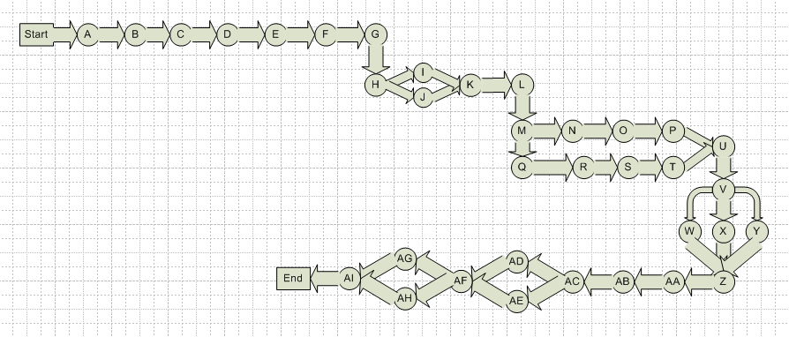

Activity |  | Duration |  | ES |  | EF |  | LS |  | LF |  | TS |  | FS
Start | -- |  | 0 |  | 0 |  | 0 |  | 0 |  | 0 |  | 0
A | 2 days |  | 0 |  | 2 |  | 0 |  | 2 |  | 0 |  | 0
B | 1 days |  | 2 |  | 3 |  | 2 |  | 3 |  | 0 |  | 0
C | 2 days |  | 3 |  | 5 |  | 3 |  | 5 |  | 0 |  | 0
D | 5 days |  | 5 |  | 10 |  | 5 |  | 10 |  | 0 |  | 0
E | 1 day |  | 10 |  | 11 |  | 14 |  | 15 |  | 4 |  | 4
F | 2 days |  | 10 |  | 12 |  | 10 |  | 12 |  | 0 |  | 0
G | 3 days |  | 12 |  | 15 |  | 12 |  | 15 |  | 0 |  | 0
H | 5 days |  | 15 |  | 20 |  | 15 |  | 20 |  | 0 |  | 0
I | 5 days |  | 20 |  | 25 |  | 20 |  | 25 |  | 0 |  | 0
J | 10 days |  | 25 |  | 35 |  | 25 |  | 35 |  | 0 |  | 0
K | 10 days |  | 35 |  | 45 |  | 35 |  | 45 |  | 0 |  | 0
L | 5 days |  | 45 |  | 50 |  | 45 |  | 50 |  | 0 |  | 0
M | 5 days |  | 50 |  | 55 |  | 50 |  | 55 |  | 0 |  | 0
N | 10 days |  | 55 |  | 65 |  | 55 |  | 65 |  | 0 |  | 0
O | 10 days |  | 65 |  | 75 |  | 65 |  | 75 |  | 0 |  | 0
P | 10 days |  | 75 |  | 85 |  | 75 |  | 85 |  | 0 |  | 0
Q | 5 days |  | 85 |  | 90 |  | 85 |  | 90 |  | 0 |  | 0
R | 5 days |  | 90 |  | 95 |  | 90 |  | 95 |  | 0 |  | 0
S | 5 days |  | 90 |  | 95 |  | 90 |  | 95 |  | 0 |  | 0
T | 5 days |  | 90 |  | 95 |  | 90 |  | 95 |  | 0 |  | 0
U | 2 days |  | 95 |  | 97 |  | 95 |  | 97 |  | 0 |  | 0
V | 20 days |  | 97 |  | 117 |  | 97 |  | 117 |  | 0 |  | 0
W | 15 days |  | 97 |  | 112 |  | 97 |  | 112 |  | 5 |  | 5
X | 20days |  | 97 |  | 117 |  | 97 |  | 117 |  | 0 |  | 0
Y | 10 days |  | 117 |  | 127 |  | 117 |  | 127 |  | 0 |  | 0
Z | 5 days |  | 127 |  | 132 |  | 127 |  | 132 |  | 0 |  | 0
1 | 5 days |  | 132 |  | 137 |  | 132 |  | 137 |  | 0 |  | 0
2 | 10 days |  | 137 |  | 147 |  | 137 |  | 147 |  | 0 |  | 0
3 | 5 days |  | 147 |  | 152 |  | 147 |  | 152 |  | 0 |  | 0
4 | 5 days |  | 152 |  | 157 |  | 152 |  | 157 |  | 0 |  | 0
5 | 3 days |  | 157 |  | 160 |  | 157 |  | 160 |  | 0 |  | 0
6 | 2 days |  | 160 |  | 162 |  | 160 |  | 162 |  | 0 |  | 0
7 | 2 days |  | 162 |  | 164 |  | 162 |  | 164 |  | 0 |  | 0

Critical Path
Start -> A -> B -> C ->D-> F -> G -> H -> I -> J -> K -> L -> M -> N -> O ->
P->Q->R->U->V ->Y->Z->1->2->3->4->5->6->7-> End

1.5 Gantt chart
We have Use MS Project to develop gantt chart.

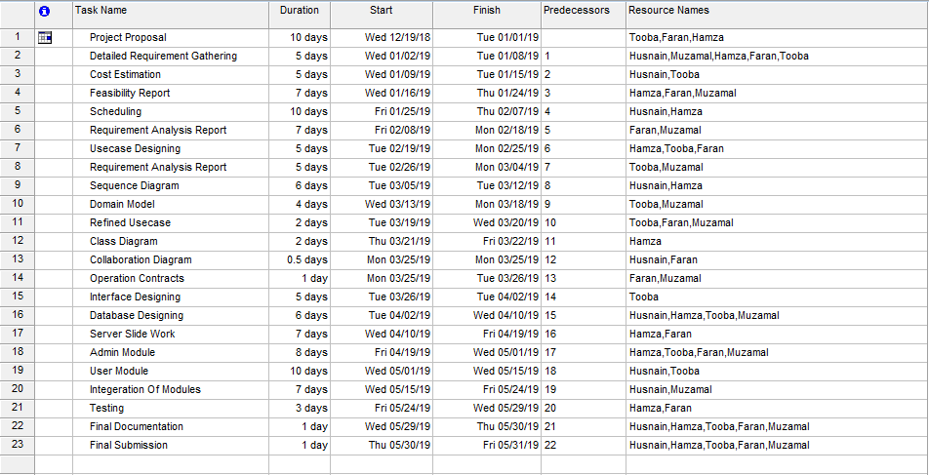
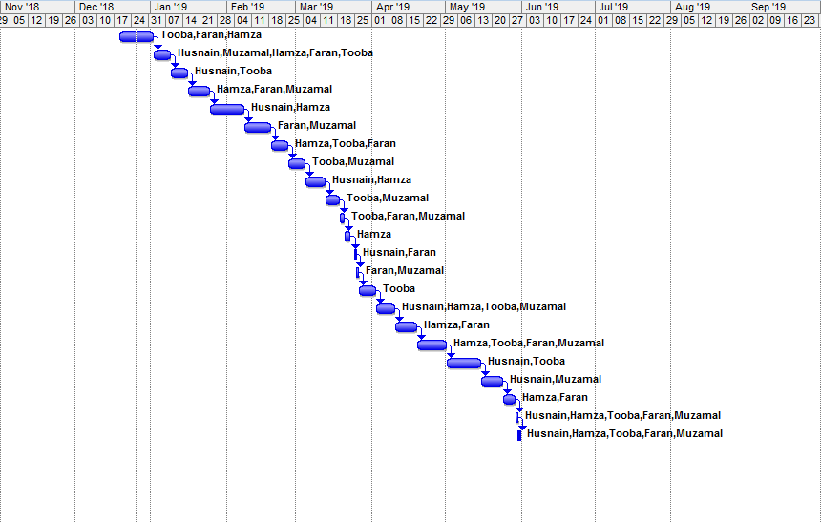

1.6 Introduction to Team member and their skill set:

Our Team consists of four members. The team members have some sound skills that are required to fulfill and take our project to the success. As a team we are very much collaborative and supportive to each other. The individual skills of the team members are written below:

1.6.1 Tooba Rashid (Team Lead):

Tooba possesses great leader ship qualities, good managerial, good communication skills. She knows how to handle and tackle team. She is good at programming task, can handle almost all network related task and likes to ponder over different software design and
technical development issues. Her skills are as follows
Programming in C++, C#, JAVA, .NET.
- Website development using HTML, ASP.NET, AJAX and various Microsoft Technologies.
- Database development and management using MySQL, SQL Server , Oracle Server
and MS Access
- Software engineering expertise using Object Oriented approach
- Project management expertise
- Research expertise over the internet and through books
- Requirement engineering expertise
Tasks:
- Back end development
- Design pattern
- Database and Server deployment
- Documentation
- Review
- Testing

1.6.2 Hamza Maqbool (Coordinator):
Hamza has good communication skills; even he is good in programming. He can handle all programming related task he loves to explore new things related to anything. He is logically and technically sound person.
His skills are as following.
- Programming in C/C++, C# and .NET
- Website designing using HTML, CSS, Bootstrap
- Database management and development
- Software Engineering expertise using OOP
Task:
- Back end development
- Database deployment and management
- Documentation
- Testing

1.6.3 Husnain Tariq(Coordinator):

One of our important person in our team is husnain. He is a good learner and learns new things quickly. He has good managerial skills. He has the ability to complete work with in specific time. He has the following skills
- Programming in C/C++, C# and .NET
- Website designing using HTML, CSS,Js,Jquery
- Database management and development management using MySQL, SQL Server, Oracle Server and Microsoft Access
- Good understanding in object oriented analysis and design.
- Project management expertise
Task:
- Backend development
- Database designing
- Documentation
- Testing and Review

1.6.4 Muhammad Faran Butt(Coordinator):

Another important part of our team is faran. He is excellent in problem solving. He is
logically and technically very strong person who loves to try and research new things.
He has the following skills
  - Programming in C/C++, Java, C# and .NET
  - Website designing using HTML, CSS, Bootstrap, Ajax
  - Database management and development management using MySQL, SQL Server, Oracle Server and Microsoft Access
  - Good understanding in object oriented analysis and design.
  - Project management expertise
  - Requirement engineering expertise
Task:
- Backend and front end development
- Database deployment
- Documentation (Cost and Scheduling)
- Testing and Review

1.6.5 Muhammad Muzammal (Coordinator):

Muzammal have good communication skills and great learning skills. He is good in database designing and implementation. He can complete the assigned task with dedication.

He has the following skills
- Programming in C/C++, C# and .NET
- Database management, deployment and development
- Good understanding in object oriented analysis and design.
- Project management expertise
- Requirement engineering expertise
Task:
- Backend and Front-end development
- Database handling
- Documentation
- Review

1.7 Tools and Technology with reasoning

Technology / Tools | Reason to use
C#.Net | For secure and robust behavior of our application we will use C# in our project. We will use it for Web application and for database applications. Furthermore it provides a code editor for interface design and for integrated debugging, that will help in our project development.
MVC Framework (model, view,  controller) | MVC is a framework provided by ASP.NET, used for creating web applications. It is highly testable and very light framework.We have divided project into different layers so that efficiency may increase
Microsoft Visual Studio 2012/2013/2015 | We will use it for designing graphical user interface of our website. It provides built in tools like database schema designer. It accepts plug-in that enhance the functionality at almost every level. So we will use it for our project development as it fulfills our requirements.
SQL Server Database | To fulfill our need of storing, processing  and securing our database we will be using SQL Server Database for our project. It provides a complete control and rapid transaction of data on demand.
Web API | Provide an efficient way to create restful Services
Microsoft Project and Microsoft Visio | We will be using these for creating UML diagrams like Gantt chart and work breakdown structure (WBS) for our project deliverables. As easy to use.
Microsoft Word. | Microsoft Word is a very efficient and reliable word processor. We’ll be using this tool for our documentation purposes.

.Net Framework | We will use .Net framework in our project for web page design, page design features, code editing, testing, debugging and deployment
Html | This language will be used for static pages on website.
Java Script. | We have used these languages for scripting process. The validation of client side will be done through java Script, which is a scripting language.
A computer | A Computer with an OS and enough memory to run all the above tools.
Web Browser | We needed a good web browser for surfing on net and many other searching problems.
Java (Optional) | Java is a general-purpose computer programming language that is concurrent, class-based, object-oriented, and specifically designed to have as few implementation dependencies as possible.  We will be using adaptability to connect server with the client.
CSS/Bootstrap | We will be using CSS and Bootstrap for styling of webpages.

1.8 Vision Document

The purpose of this document is to collect analyses and define online local services to the customer. This application when completed will be available on the internet and all the users can use this according their needs and the services provided. This project is unique in the sense that the services provided by our website do not exist on a single platform. This web based application will provide the options to create account of customers and employees and only registered employee can be provide services to the registered customers. The admin have all the rights to use the website and have complete access of all the contents exist on the website. All the information regarding this application will under the rules and regulations of university and will not follow any information which violates the security and privacy issues. There will be a proper checking for the verification of users so that only verified users can access the inside data. The interface of website will be easy to use and reliable for managing and registration purpose. We are living in the pool of technology, where every person is dependent on technology. In matter of fact, people who need any kind of services must have to sacrificed their precious time from their busy lives; so while analyzing how to save their time we are providing them the facility to save their time by using our website instead of going to market or door by door. The employees can also upload all their hand-come services to entertain the customers so that the customers will be select their desired and can also use filters and location based services too.

Assumptions:

- When more devices will connect with each other it will reduce the connection speed as it will increase the traffic.
- All the users have a good internet connection
- Users are well aware of how to use the website

1.9 Risk List
Our project has following risks. These all risks are listed in a “risk list” in decreasing order
according to priority

- Effects of changes in requirements of project.
- Effects of restructuring in organization.
- Server may crash.
- Business logic may differ at presentation layer.
- When more devices will connect with application it will reduce the connection speed as it will increase the traffic.
- Database Security risk.
- Financial issues.

REQUIREMENTS ENGINEERING

Introduction

Requirement Engineering is very important and somehow critical phase of SDLC because gathering correct, complete and valid requirement is a tiresome work to do. Requirements engineering process provides the appropriate mechanism for understanding what we wants, analyzing need, assessing feasibility, negotiating a reasonable solution, specifying the solution unambiguously, validating the specification and managing the requirements as they are transformed into an operational system. This document will provide the requirements of the end users and the system we are developing.
- Requirements elicitation
- Requirements analysis and negotiation
- Requirements specification
- System modeling
- Requirements validation
- Requirements management

Requirements specification:
Here, requirements specification is to be discussed. Requirements specification would lead to the following four steps:
- Identify external interfaces.
- Development of context diagram.
- Capture “shall statements.
- Allocate requirements.
- Prioritize requirements.
- Development of requirements traceability matrix.
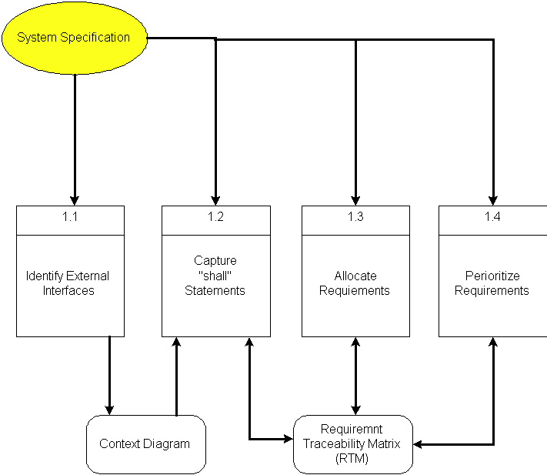

2.1 Systems Specifications
The following are the clauses that must be included while describing the system specifications.

Introduction
Our project is an android based application. This application is named as GladTouch Application. This application is been developed for the users around the world to provide different services. If anyone want to use this, he/she just download this application. It is an Android Based Application which is a customers and our company interactive application for providing different services to customers. Our main target is to facilitate the customers who are in difficult situation about some services. Our Interface is one of the main attractive features for our customers. As whole we are providing some package for our regular users.

Existing System
As we are developing the application which provides many services to our customers is a good application. Services like if anyone wants to need a plumber then he/she can download this application and our company provide a plumber for the customer through this application. Some applications had many problems like security, expensiveness and some other problems. Our application covers all these problems. As its mobile application it doesn’t broken or get in bad shape. It’s not so much costly and the best of them all its within your device you don’t have to keep the application separately. Our application will not only provides services but also entertaining for the customers because they will get these services by sitting at their home.

Organizational_Chart 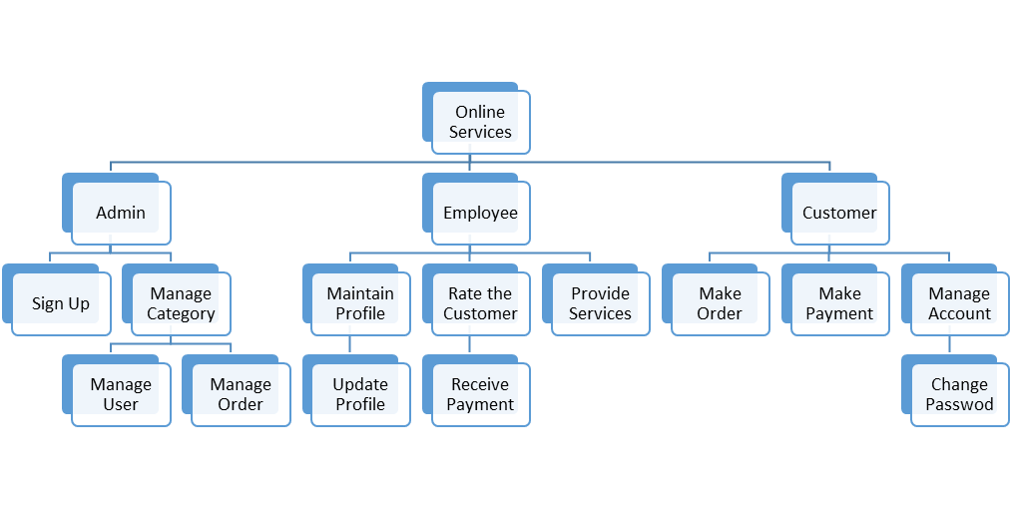

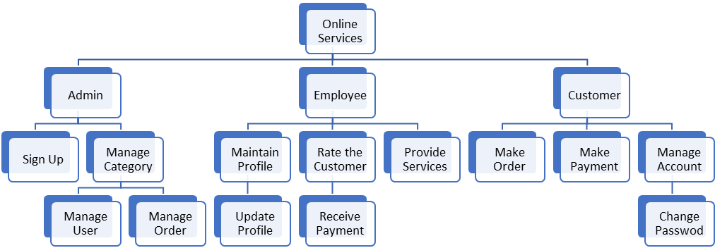Scope of the System
The scope can be defined in the following phases:

Phase I: Analysis and Design
- Analyze the requirements for the application
- Designing the architecture for the application
- Division of the architecture into small components or modules to specify the design with the functionalities performed
- Design the interface
- Analyze the backend development completely

Phase II: Implementation
- Implement the components of the system.
- Develop the Database.
- Maintaining consistency of components with the database.

Phase III: Testing
- Development of test plans for testing the complete project.
- Unit testing of each component.
- Perform System/application testing

Our scope can also be defined as:
Our system will handle all the information uploaded by the admin. Anybody who is connected to the internet can access our website but he is allowed to use the website only when he/she has a valid user name and password. Our system provide online employee and customer management in an efficient way. User can seek help or can read about Developers.

Summary of Requirements (Initial Requirements)

- Customers Access
Customers should be able to access the application and all type of information should be there and they will get an easy access to the available content of the application.
For example a customer can make his/her account on GladTouch and maintain his/her profile moreover he/she can make order cancel order and contact to the nearest Employees.
- Employee Access
Employee should be able to access the application and all type of information should be there and they will get an easy access to the available content of the application.
There is need to make trusted profile for the employee by uploading their portfolio on the profile to attract the customers.
- Admin Access
Admin have access of the application with registration. Admin are able to manage customer orders and update their services.
Admin have the access to remove reported customers by the employees and employees by the customers as well .admin can also take feedback from the customers and the employees about GladTouch application.
- Sign up
For a customer and admin to use our services he/she must get register to our application. For this the user has to fill a form providing his/her details.
Signup will be made on the valid Mobile Number of any network and validity will be checked by sending confirmation code to the provided mobile numbers.
- Login
Any customer and admin with a valid username and password will be allowed to use the services provided by our application.
- Service
The service can be of two types white collared and blue collared. Blue collared contains filters.

2.2Identifying External Entities

The Identification of External Entities is done in two phases.

a) Over Specify Entities from Abstract
On the basis of Abstract, there are the following entities:

- Admin
- Customers
- Employees
- Login Account
- User comments
- Sign up
- Validation
- Rating system
b) Perform Refinement
- Admin
- User
- Employee
- Client
- Server

2.3 Context Level Data Flow Diagram

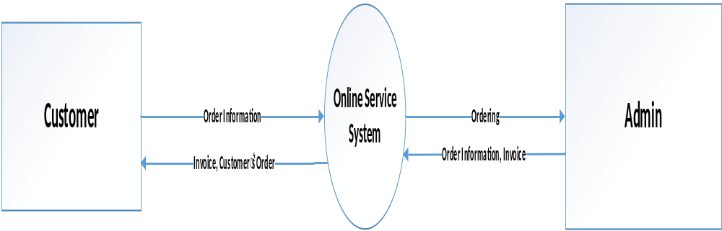

2.4 Capture "shall" Statements
There are only two main actors in our system is:
Employee and Customer
 | Sr. no |  |  | External Entities |  |  | Initial Requirements
 | 1. |  |  | Employee |  |  | Employee “shall” connect to Internet Connection.
 | 2 |  |  | Customer |  |  | Customer “shall” connect to Internet Connection.
 | 3. |  |  | Employee |  |  | Employee “shall” Sign Up in this application.
 | 4. |  |  | Customer |  |  | Customer “shall” provide an accurate Email/Password to Sign In to the application.
 | 5. |  |  | Employee |  |  | Employee “shall” press login button to continue as Employee.
 | 6. |  |  | Customer |  |  | Customer “shall” be able to view all registered Employees and their uploaded services.
 | 7. |  |  | Employee |  |  | Employee “shall” able to see the profile.
 | 8. |  |  | Customer |  |  | Customer “shall” be able to place orders.
 | 9. |  |  | Employee |  |  | Employee “shall” be able to register with different other services.
 | 10. |  |  | Customer |  |  | Customer “shall” be logout when he/she press logout button.
 | 11. |  |  | Employee |  |  | Employee “shall” be able to logout when he/she wants. | .
 | 12. |  |  | Customer |  |  | Customer “shall” be able to visit Employee’s profile and rated them according to their work quality.

2.5 Allocate Requirements

 | Sr. no |  |  | UseCase Name |  |  | Initial Requirements
 | 1. |  |  | UC_E_Connect_Internet |  |  | Employee “shall” connect to Internet Connection.
 | 2 |  |  | UC_C_Connect_Internet |  |  | Customer “shall” connect to Internet Connection.
 | 3. |  |  | UC_E_Request_to_Sign_Up |  |  | Employee “shall” Sign Up in this application.
 | 4. |  |  | UC_C_Request_to_Sign _In |  |  | Customer “shall” provide an accurate Email/Password to Sign In to the application.
 | 5. |  |  | UC_E_Request_to_Continue |  |  | Employee “shall” press login button to continue as Employee.
 | 6. |  |  | UC_C_Request_to_View_Employee |  |  | Customer “shall” be able to view all registered Employees and their uploaded services.
 | 7. |  |  | UC_E_Search_Employee |  |  | Employee “shall” able to see the profile.
 | 8. |  |  | UC_C_Place_Orders |  |  | Customer “shall” be able to place orders.
 | 9. |  |  | UC_E_Upload_Services |  |  | Employee “shall” be able to register with different other services.
 | 10. |  |  | UC_C_Request_Logout |  |  | Customer “shall” be logout when he/she press logout button.
 | 11. |  |  | UC_E_Request_Logout |  |  | Employee “shall” be able to logout when he/she wants.
 | 12. |  |  | UC_C_View_Employee |  |  | Customer “shall” be able to visit Employee’s profile and rated them according to their work quality.

2.6 Prioritize Requirements

Sr.no | Rank | Initial Requirements | UC  Id | UC_Name
 | Highest | Employee “shall” connect to Internet Connection. | UC_1 | UC_E_Connect_Internet
 | Highest | Customer “shall” connect to Internet Connection. | UC_2 | UC_C_Connect_Internet
 | Highest | Employee “shall” Sign Up in this application. | UC_3 | UC_E_Request_to_Sign_Up
 | Highest | Customer “shall” provide an accurate Email/Password to Sign In to the application. | UC_4 | UC_C_Request_to_Sign _In
 | Highest | Employee “shall” press login button to continue as Employee. | UC_5 | UC_E_Request_to_Continue
 | Medium | Customer “shall” be able to view all registered Employees and their uploaded services. | UC_6 | UC_C_Request_to_View_Employee
 | Medium | Employee “shall” able to see the profile. | UC_7 | UC_E_Search_Employee
 | Highest | Customer “shall” be able to place orders. | UC_8 | UC_C_Place_Orders
 | Medium | Employee “shall” be able to register with different other services. | UC_9 | UC_E_Upload_Services
 | Medium | Customer “shall” be logout when he/she press logout button. | UC_10 | UC_C_Request_Logout
 | Highest | Employee “shall” be able to logout when he/she wants. | UC_11 | UC_E_Request_Logout
 | Medium | Customer “shall” be able to visit Employee’s profile and rated them according to their work quality. | UC_12 | UC_C_View_Employee

2.7 Requirements Trace-ability Matrix

Sr.no | Rank | Initial Requirements | UC_Name | Build | Category
 | Highest | Employee “shall” connect to Internet Connection. | UC_E_Connect_Internet | B1 | Business
 | Highest | Customer “shall” connect to Internet Connection. | UC_C_Connect_Internet | B1 | Business
 | Highest | Employee “shall” Sign Up in this application. | UC_E_Request_to_Sign_Up | B1 | Business
 | Highest | Customer “shall” provide an accurate Email/Password to Sign In to the application. | UC_C_Request_to_Sign _In | B1 | Business
 | Highest | Employee “shall” press login button to continue as Employee. | UC_E_Request_to_Continue | B1 | Business
 | Medium | Customer “shall” be able to view all registered Employees and their uploaded services. | UC_C_Request_to_View_Employee | B1 | Business
 | Medium | Employee “shall” able to see the profile. | UC_E_Search_Employee | B1 | Business
 | Highest | Customer “shall” be able to place orders. | UC_C_Place_Orders | B1 | Business
 | Medium | Employee “shall” be able to register with different other services. | UC_E_Upload_Services | B1 | Business
 | Medium | Customer “shall” be logout when he/she press logout button. | UC_C_Request_Logout | B1 | Business
 | Highest | Employee “shall” be able to logout when he/she wants. | UC_E_Request_Logout | B1 | Business
 | Medium | Customer “shall” be able to visit Employee’s profile and rated them according to their work quality. | UC_C_View_Employee | B1 | Business

2.9 High Level Use-case Diagram

