
PUCIT
Punjab University College of Information Technology

Second Deliverable for Object Oriented Approach
Version 1.0



Project Title: GLADTOUCH
Session: MCS(CS) 2017-2019
Project Supervisor: Sir Muhammad Usman Malik
Signature:

Table of Contents

1 Introduction 3
1.1 Usecase descriptions 3
1.2 Use Case Diagram (Refined) 4
1.3 Domain Model 4
1.4 Sequence Diagram 6
1.5 Collaboration Diagram 13
1.6 Operation Contracts 15
1.7 Design Class Diagram 16
1.7.11 Design Class Relationships 23
1.8 Data Model 27

1 Introduction
Gladtouch is dynamic web and app-based marketplace for hiring home and local services. Our vision is to use technology and smart processes to structure the highly organized service market in Pakistan. Gladtouch aspires to hire trusted professionals as easy and straightforward as companies has made buying products. It provides all their services customers need with an interactive interface having services menu (APPLIED FILTERS BY USER) to choose any needed service and then can place by using MyOrder option and also have the cancel option too for cancellation of order. Application provides benefits as user can also place an appointment at their any available convenient time. Our website will provide staffed with young, passionate people working tirelessly to make a difference in the lives of people by catering to their service needs at their doorsteps. It provides housekeeping services which consist of Plumbers, Electricians, Carpenters, Cleaning and Pest Control. We also provide personal services like beauty, spa, mobile and other appliance repairs etc. Be it getting a plumbing job done, improving your fitness through yoga, learning to play the guitar, decorating your home or getting candid photos of your wedding clicked, it assures shot destination for your service needs.
Third deliverable is all about the use case modeling and software design. In the previous deliverable, analysis of the system is completed. So we understand the current situation of the problem domain. Now we are ready to strive for a solution for the problem domain by using object-oriented approach. Following artifacts must be included in this deliverable.

- Use case description
- Use case diagram refined
- Domain Model
- Sequence Diagram
- Collaboration Diagram
- Operation Contracts
- Design Class Diagram
- Data Model

Now we discuss these artifacts one by one as follows:

Usecase Description

Use Case Name: Request to Connect the Internet
Scope: Online Services
Level: User-Goal level
Primary Actors: Admin, Employee, Customer

Stakeholders and Interest:

Admin is responsible to run the whole system. Admin can add, delete, update all information related to system. Admin have access of the application with registration. Admin are able to manage customer orders and update their services.
Employee Employee should be able to access the application and all type of information should be there and they will get an easy access to the available content of the application.
Customer is a visitor, who visit the site and order something from our application.
Brief Description: Present the administrator, employee and customer to connect the internet and install this online services application.
Pre-Conditions: Admin, employee and customer has to connect to the internet on their devices.
Main Scenario:
- Admin, employee and customer connect with the internet connection.
- After successfully connected the internet, install this online services application.
Alternative Flows:
- If the internet connection is not successfully connected, then check it first and then install the application.
- If the application does not install then re-install it.
Post-Conditions: Admin, employee and customer connected with the internet connection and install the application.

Use Case Name: Request to Sign Up
Scope: Online Services
Level: User-Goal level
Primary Actors: Employee
Stakeholders and Interest:
Employee Employee should be able to access the application and all type of information should be there and they will get an easy access to the available content of the application.
Brief Description: Present the employee to sign up with this application. Resources will be acquired, data will be loaded and display screen will be shown.
Pre-Conditions: Employee has to sign up with this application for registration by giving his/her name, CNIC, address, e-mail etc.
Main Scenario:
- Employee and customer connect with the internet connection.
- After successfully connected the internet, install this online services application.
- After installed this application, employee has to sign up for registration.
- After registration, employee is registered on this online services application.
Alternative Flows:
- If the internet connection is not successfully connected, then check it first and then install the application.
- If the application does not install then re-install it.
- If sign up is not successfully registered, then re-register it.
Post-Conditions: Employee is registered on this application.

Use Case Name: Request to Register and Login
Scope: Online Services
Level: User-Goal level
Primary Actors: Customer
Stakeholders and Interest:
Customer is a visitor, who visit the site and order something from our application.
Brief Description: Present the customer to register with this application. Resources will be acquired, data will be loaded and display screen will be shown.
Pre-Conditions: Customer has to give the username and password to register with this application and then login.
Main Scenario:
- Customer connect with the internet connection.
- After successfully connected the internet, install this online services application.
- After installed this application, customer has to login.
- After login, customer has to place order for any services he/she needed.
Alternative Flows:
- If the internet connection is not successfully connected, then check it first and then install the application.
- If the application does not install then re-install it.
- If login is not successfully, then retry.
Post-Conditions: Customer is registered on this application and has to place the order when he/she wants.

Use Case Name: Request to Manage Category
Scope: Online Services
Level: User-Goal level
Primary Actors: Admin
Stakeholders and Interest:
Admin is responsible to run the whole system. Admin can add, delete, update all information related to system. Admin have access of the application with registration. Admin are able to manage customer orders and update their services.
Brief Description: Present the admin to manage the category which means to update the services in this application for the customers.
Pre-Conditions: Admin has to open the application and update the services.
Main Scenario:
- Admin connect with the internet connection.
- After successfully connected the internet, now open this application and then admin has to change the services which the customers wants more.
Alternative Flows:
- If the internet connection is not successfully connected, then check it first.
- If updates is not successfully works, then try again.
Post-Conditions: Provides the updated services for the customers.

Use Case Name: Request to Manage User and Employee
Scope: Online Services
Level: User-Goal level
Primary Actors: Admin
Stakeholders and Interest:
Admin is responsible to run the whole system. Admin can add, delete, update all information related to system. Admin have access of the application with registration. Admin are able to manage customer orders and update their services.
Brief Description: Present the admin to manage the users and employees for this application to provide better services to customers.
Pre-Conditions: Admin has to manage the different types of users and employees to maintain all of this.
Main Scenario:
- Admin connect with the internet connection.
- After successfully connected the internet, now open this application and then admin has to change the services which the customers wants more.
- Admin has the right to manage all the user and employees and maintain them.
Alternative Flows:
- If the internet connection is not successfully connected, then check it first.
- If updates is not successfully works, then try again.
- If admin does not manage the users and employees then make it manageable.
Post-Conditions: Maintain more than one user and employee by the admin.

Use Case Name: Request to Manage Order
Scope: Online Services
Level: User-Goal level
Primary Actors: Admin
Stakeholders and Interest:
Admin is responsible to run the whole system. Admin can add, delete, update all information related to system. Admin have access of the application with registration. Admin are able to manage customer orders and update their services.
Brief Description: Present the admin to manage the order for which the customer placed.
Pre-Conditions: Admin has to manage the order of customers.
Main Scenario:
- Admin connect with the internet connection.
- After successfully connected the internet, now open this application and then admin has to change the services which the customers wants more.
- Admin has the right to manage all the user and employees and maintain them.
- Admin has the right to manage the order of customers and provide the services to the customers on time which they order.
Alternative Flows:
- If the internet connection is not successfully connected, then check it first.
- If updates is not successfully works, then try again.
- If admin does not manage the users and employees then make it manageable.
- If admin does not manage the order then make sure to manage the order.
Post-Conditions: Provide the services to the customers on time.

Use Case Name: Request to Manage Both User and Employee Profile
Scope: Online Services
Level: User-Goal level
Primary Actors: Admin
Stakeholders and Interest:
Admin is responsible to run the whole system. Admin can add, delete, update all information related to system. Admin have access of the application with registration. Admin are able to manage customer orders and update their services.
Brief Description: Present the admin to manage and check the profile of both the user and the employees for the security and maintain it.
Pre-Conditions: Admin has to manage the profile of user and employee.
Main Scenario:
- Admin connect with the internet connection.
- After successfully connected the internet, now open this application and then admin has to change the services which the customers wants more.
- Admin has the right to manage all the user and employees and maintain them.
- Admin has the right to manage the order of customers and provide the services to the customers on time which they order.
- Admin has the right to manage the profile of both the user and the employee.
Alternative Flows:
- If the internet connection is not successfully connected, then check it first.
- If updates is not successfully works, then try again.
- If admin does not manage the users and employees then make it manageable.
- If admin does not manage the order then make sure to manage the order.
- If admin does not manage then check the error.
Post-Conditions: Make sure for security after managing the profile of both the user and employee.

Use Case Name: Request to Block the User and Employee
Scope: Online Services
Level: User-Goal level
Primary Actors: Admin
Stakeholders and Interest:
Admin is responsible to run the whole system. Admin can add, delete, update all information related to system. Admin have access of the application with registration. Admin are able to manage customer orders and update their services.
Brief Description: Present the admin to block the user and employee for security risks and for misbehaving and for different other issues.
Pre-Conditions: Admin has to take action against the misbehaving person.
Main Scenario:
- Admin connect with the internet connection.
- After successfully connected the internet, now open this application and then admin has to change the services which the customers wants more.
- Admin has the right to manage all the user and employees and maintain them.
- Admin has the right to manage the order of customers and provide the services to the customers on time which they order.
- Admin has the right to manage the profile of both the user and the employee.
- Admin has the right to block the user and employee for different security purposes.
Alternative Flows:
- If the internet connection is not successfully connected, then check it first.
- If updates is not successfully works, then try again.
- If admin does not manage the users and employees then make it manageable.
- If admin does not manage the order then make sure to manage the order.
- If admin does not manage then check the error.
- If block option does not works then check the connection first and then make it sure.
Post-Conditions: Block both the user and employee for security purposes.

Use Case Name: Request to Place Order
Scope: Online Services
Level: User-Goal level
Primary Actors: Customer
Stakeholders and Interest:
Customer is a visitor, who visit the site and order something from our application.
Brief Description: Present the customer to open this application and place the order which they want and cancel the order which is mistaken placed by customers.
Pre-Conditions: Customer place the order which they want.
Main Scenario:
- Customer connect with the internet connection.
- After successfully connected the internet, open this online services application.
- After open the application, customer has to place order for any services he/she needed.
- Customer manage the order by open this application which means to place order and cancel order.
Alternative Flows:
- If the internet connection is not successfully connected, then check it first and then install the application.
- If order is not successfully managed, then check the internet connection.
Post-Conditions: Booked the order and wait for the service which you need and if mistaken place the order then cancel it.

Use Case Name: Request to Make Payment
Scope: Online Services
Level: User-Goal level
Primary Actors: Customer
Stakeholders and Interest:
Customer is a visitor, who visit the site and order something from our application.
Brief Description: Present the customer to open this application and place the order which they want and after the service is provided, the customer paid the amount according to the service.
Pre-Conditions: Customer is provided with the services they want and satisfy with this.
Main Scenario:
- Customer connect with the internet connection.
- After successfully connected the internet, open this online services application.
- After open this application, customer has to place order for any services he/she needed.
- Customer manage the order by open this application which means to place order and cancel order.
- Customer satisfy with the services and after take these services, the customer paid the amount according to their service.
Alternative Flows:
- If the internet connection is not successfully connected, then check it first and then install the application.
- If order is not successfully managed, then check the internet connection.
- If customer is not satisfy about these services then admin make it satisfy for the customer.
Post-Conditions: Paid the cash to the service provider after the service is provided to the customer.

Use Case Name: Request to Manage Account
Scope: Online Services
Level: User-Goal level
Primary Actors: Employee, Customer
Stakeholders and Interest:
Employee Employee should be able to access the application and all type of information should be there and they will get an easy access to the available content of the application.
Customer is a visitor, who visit the site and order something from our application.
Brief Description: Present the employee and customer to manage their account. Employee and customer can logout their account when they want and use their account when they want.
Pre-Conditions: Employee and Customer use their account when they want.
Main Scenario:
- Employee and customer connect with the internet connection.
- After successfully connected the internet, open this online services application.
- Customer manage their account according to their needs and can logout when they want.
Alternative Flows:
- If the internet connection is not successfully connected, then check it first and then install the application.
- If employee and customer is not manage their account then check the internet connection first and if problem is in application then contact helpline.
Post-Conditions: Employee and customer can logout their account when they want by opening this application.

Use Case Name: Request to Give Feedback
Scope: Online Services
Level: User-Goal level
Primary Actors: Employee, Customer
Stakeholders and Interest:
Employee Employee should be able to access the application and all type of information should be there and they will get an easy access to the available content of the application.
Customer is a visitor, who visit the site and order something from our application.
Brief Description: Present the employee and customer to open this application and after receiving services, customer give feedback to employee and after providing services, employee give feedback to customers.

Pre-Conditions: Employee provides the services and customer receives the services.
Main Scenario:
- Employee and customer connect with the internet connection.
- After successfully connected the internet, open this online services application.
- After open this application, customer has to place order for any services he/she needed.
- Employee accept the request for place the order by customer.
- After providing service to customer, employee give the feedback to customer.
- After receiving service from employee, customer also give the feedback to customer.
Alternative Flows:
- If the internet connection is not successfully connected, then check it first and then install the application.
- If providing and receiving service does not works then re-check it.
- If feedback does not works then check the internet connection.
Post-Conditions: Both employee and customer give the feedback to each other.

Use Case Name: Request to Receive Order
Scope: Online Services
Level: User-Goal level
Primary Actors: Employee
Stakeholders and Interest:
Employee Employee should be able to access the application and all type of information should be there and they will get an easy access to the available content of the application.
Brief Description: Present the employee to open this application and receive the order which the customer placed.
Pre-Conditions: Employee open the application and wait for the order which customer placed.
Main Scenario:
- Employee connect with the internet connection.
- After successfully connected the internet, open this online services application.
- After open the application, if customer place any order then employee receive that order.
Alternative Flows:
- If the internet connection is not successfully connected, then check it first and then install the application.
- If order is not successfully managed, then check the internet connection.
Post-Conditions: Employee receive the order which the customer placed.

Use Case Name: Request to Receive Payment

Scope: Online Services
Level: User-Goal level
Primary Actors: Employee
Stakeholders and Interest:
Employee Employee should be able to access the application and all type of information should be there and they will get an easy access to the available content of the application.
Brief Description: Present the employee to receive the payment after providing the service to customer.
Pre-Conditions: Employee wait for the charges made after the service provide.
Main Scenario:
- Employee connect with the internet connection.
- After successfully connected the internet, open this online services application.
- After open the application, if customer place any order then employee receive that order.
- After providing the service, employee receive the amount from the customer and add the amount in this application.
Alternative Flows:
- If the internet connection is not successfully connected, then check it first and then install the application.
- If order is not successfully managed, then check the internet connection.
- If the amount is not added in this application, then contact to the admin.
Post-Conditions: Employee receives the amount after providing the service and add the amount in this application.

Usecase Diagram (refined and updated)

The use case (refined and updated) of our application is given below. It includes all the operations, actions and events of our application Gladtouch.
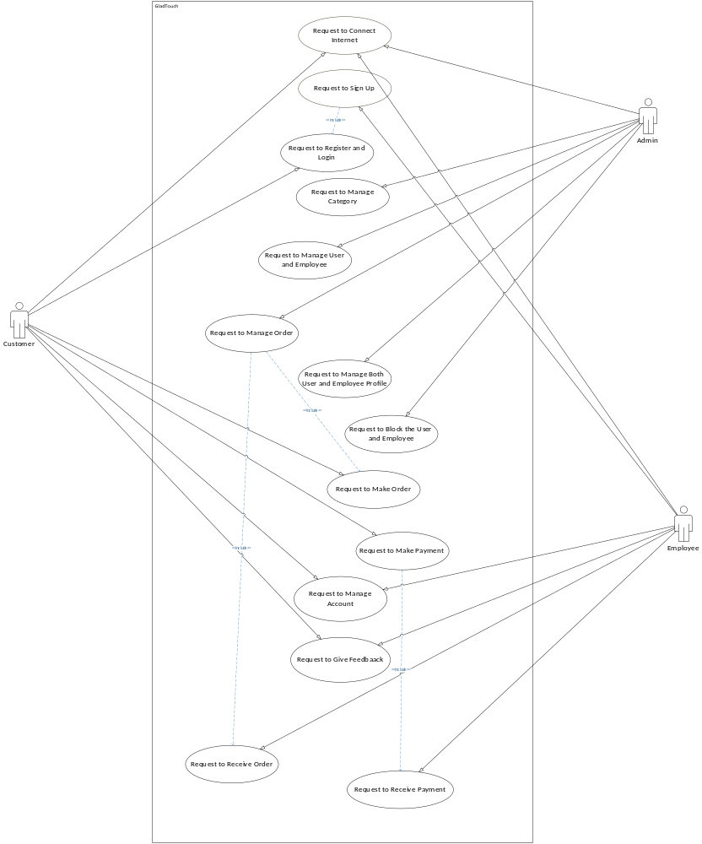

Domain Model
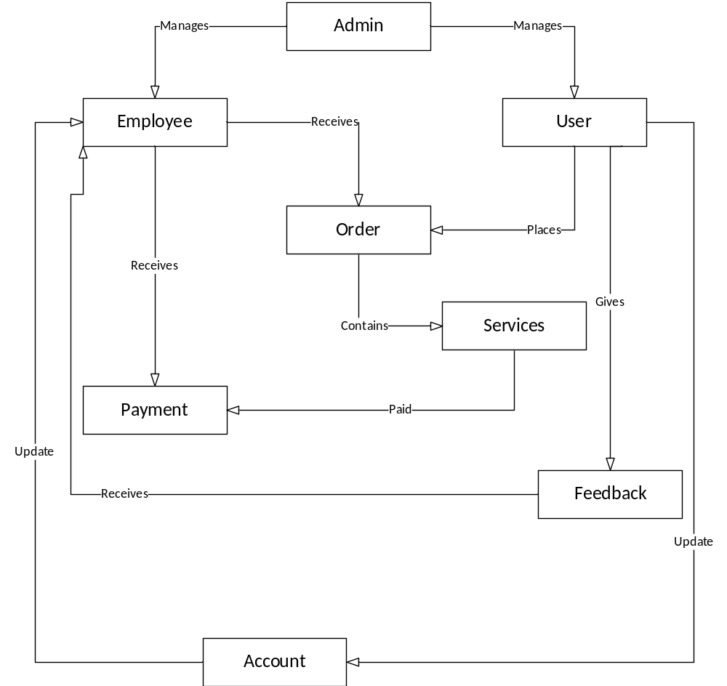

1.4 Sequence Diagram
Sequence diagrams describe interactions among classes in terms of an exchange
of messages over time. They're also called event diagrams. A sequence diagram is
a good way to visualize and validate various runtime scenarios. These can help to
predict how a system will behave and to discover responsibilities a class may
need to have in the process of modeling a new system.

Start Application
: user

MainMenu

startUsing()

<<gui>>

Sign in:
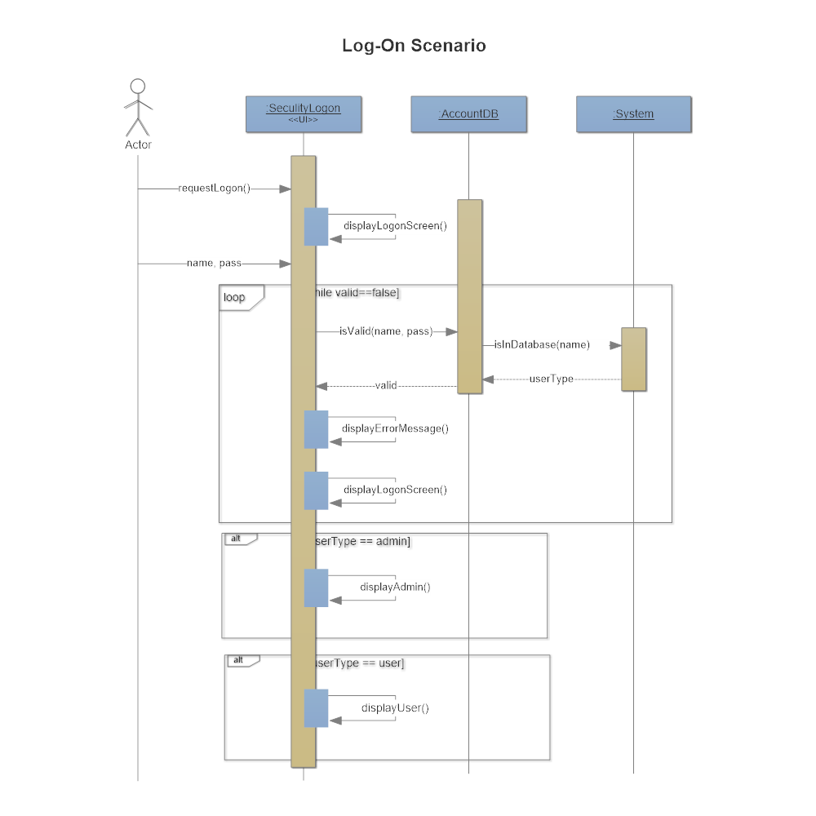

Sign Up
: user

Sign Up

Form Filling

GatherDetails()

<<GUI>>

gotoSignUp()

Saving Profile toDB

SaveProfile()

<<acknowledgement>>

<<acknowledgement>>

4. Category Selection

Main Menu
Service Type
: user

ShowMainMenu

Select Category

Selected

GUI

Claim Base Charges
: user

MainMenu

Claim Base Charges

BaseCharges()

<<acknowledgement>>

<<menu>>

goToClaimCharges()

Give Feedback
: user

MainMenu

AboutService

RatingTheService()

<<acknowledgement>>

<<menu>>

goToRatings()

Ordering

s
: user

MainMenu

OrderPlacementMenu

PlaceOrder()

<<acknowledgement>>

<<GUI>>

GotoMainMenu()

Cancel Order

: user

MainMenu

Current Orders

gotoOrders()

<<acknowledgement>>

<<GUI>>

GotoMainMenu()

Cancellation

CancelOrderI()

<<acknowledgement>>

Update Profile
: user

MainMenu

My Profie

ChangesToProfile()

<<GUI>>

gotoMainMenu()

Saving toDB

SaveChanges()

<<acknowledgement>>

<<acknowledgement>>

Instruction
: user

MainMenu

Intructing Demo

PlayDemo()

<<acknowledgement>>

<<GUI>>

goToMainMenu()

Quit Application
: user

MainMenu

Quit Application

ClosingApp()

<<menu>>

gotoMainMenu()

Saving toDB

SaveChanges()

<<acknowledgement>>

1.5 Collaboration Diagram

Initialization

Start application

: Customer/Emp
MainMenu

1: StartApplication()
2: <<gui>>

Choose Service Category
: Customer
MainMenu

1: GetServiceCategory()
4: <<Menu>>
Service_Category
2:SelectServiceCategory()
4: <<Selected>>
Place Order
Customer
ServiceTypes

1: selectServiceType
2: <<gui>>
3:SearchService_Emp()
4: <<acknowledgement>>
Found
EnlargeArea
T
Service_Emp

5:SelectService_Emp()
6:<<Selected>>
Order
Cart
7:PlaceOrder()
8: <<Placed>>
10: <<SavedToCart>>
9:SaveOrder()
F

Pin Employee

: Customer
MainMenul

1: StartApp()
2: <<MainMenu>>
ServiceTypes

Service_Emp
3:SelectServiceType
4:<<Selected>>
5:Select_Service_Emp()
6:<<Selected>>
Service_Emp
7:Pin_Service_Emp()
8:<<Pinned>>

Receive Order

: Emp
MainMenul

1: StartApp()
2: <<MainMenu>>
Order_Recieved
3:Get_Order()
6: <<Got>>
Cart
4:SaveOrder()
5:<<SavedtoCart>>

Cancle Order

:Customer/Emp
MainMenul

1: StartApp()
2: <<MainMenu>>
Cart

Order
3:CancleOrder()
6: <<Cancled>>
4:GetOrder_Info()
5: <<Got>>
FeedBack To Employee
:Customer/Emp
MainMenul

1: StartApp()
2: <<MainMenu>>
Service_Type

Service_Emp
3:SelecetServiceType()
4: <<Selected>>
5:selectService_Emp()
6: <<Selected>>
FeedBack
7:GiveFeedBack()
8: <<Given>>

Update Profile
: Customer/Emp
MainMenu

Profile
1:GotoProfile()
6: <<menu>>
5: <<acknowledgement>>
Profile_Setting
3:Make_Changes()
4:<<changes-made>>
2:Open_Profile()

Verify_user/Remove_User/BanUser by Admin
:Admin
MainMenu

User_Profile
1:GotoMainMenu()
4: <<menu>>
3: <<acknowledgement>>
2:Verify_User_Profile()
Profile
User_Profile

2:Remove_User_Profile()
3: <<acknowledgement>>
2:Ban_User_Profile()
3: <<acknowledgement>>

1.6 Operation Contracts

Name: startApplication( )
Responsibilities: To launch the Application and instantiate application object.
Cross References: Use Case: Request to connect to the internet.
Exceptions: Application can crash due to some error.
Preconditions: Application must be installed.
Post conditions: Application object is instantiated

Name: Initializedisplay ( )
Responsibilities: Initialize the Application object by getting data from database which was saved or by default values.
Cross References: Use Cases: request to signup.
Exceptions: None.
Preconditions: Application must be installed and launched.
Post conditions: All essential data is loaded in memory.

Name: orderService()
Responsibilities: To check the available services that can b ordered by user.
Cross References: Use Cases: Request to place order
Exceptions: None
Preconditions: Application must be initialized and user have made some progress in application.
Post conditions: All important data is saved in secandary storage .

Name: performedlocationSetting( )
Responsibilities: To track location from google map and saved in secondry storage.
Cross References: Use Cases: Request to manage customer and employee accounts
Exceptions: None
Preconditions: Application must be installed and launched.
Post conditions: location is updated .

Name: filter( )
Responsibilities: To filter the all data according to user needs.
Cross References: Use Cases: Request to manage customer and employee accounts
Exceptions: None
Preconditions: Application must be installed and launched.
Post conditions: filtered data showed.

Name: orderdone( )
Responsibilities: To save all important data and leave all resource used my application.
Cross References: Use Cases: Request to place order
Exceptions: None
Preconditions: Application must be running.
Post conditions: All important data is save in database and user move to his home screen.

Name: orderlist( )
Responsibilities: To load the data about the service which is order by user.
Cross References: Use Cases: Request to place order
Exceptions: None
Preconditions: Application must be running.
Post conditions: All data about the order service data is loaded.

Name: feedback( )
Responsibilities: To get the feedback after using the service.
Cross References: Use Cases: Request for feedback
Exceptions: None
Preconditions: Application must be running.
Post conditions: load the data from database which is saved as feedback about employee.

Name: updateprofile( )
Responsibilities: To get data from user and update in database.
Cross References: Use Cases: Request to manage account
Exceptions: None
Preconditions: Application must be running.
Post conditions: load the data from user and saved in database.

Name: cancelorder( )
Responsibilities: To cancel the order which is ordered by user.
Cross References: Use Cases: Request to cancel_order
Exceptions: None
Preconditions: Application must be running and user also place a order of a service.
Post conditions: order cancel.

Name: varietyofservices( )
Responsibilities: To get the data from database about the services which is available.
Cross References: Use Cases: Request for services
Exceptions: None
Preconditions: Application must be running.
Post conditions: load the data from database which is saved.

Name: goToReadInstruction( )
Responsibilities: To show the instruction of Application on screen.
Cross References: Use Cases: Request to manage account
Exceptions: None
Preconditions: Application must be running.
Post conditions: Instruction screen is shown to the player.

Name: goToAboutUsInstruction( )
Responsibilities: To show the about us of application on screen on which a brief detail about developers.
Cross References: Use Cases:Request for settings
Exceptions: None
Preconditions: Application must be running.
Post conditions: About us screen is shown to the player.

Name: quitApplication( )
Responsibilities: To leave all the resources used my game.
Cross References: Use Cases: Request for Quit_Application
Exceptions: None
Preconditions: Application must be running.
Post conditions: Application will be close and user move to his home screen.

1.7 Design Class Diagram
The design contains all appObjects, their components and data files. It has access to the appObject's renderers.

The design renders the applications and is mainly managed by the admin.

1.7.11 Design Class Relationships

Composition Relationship

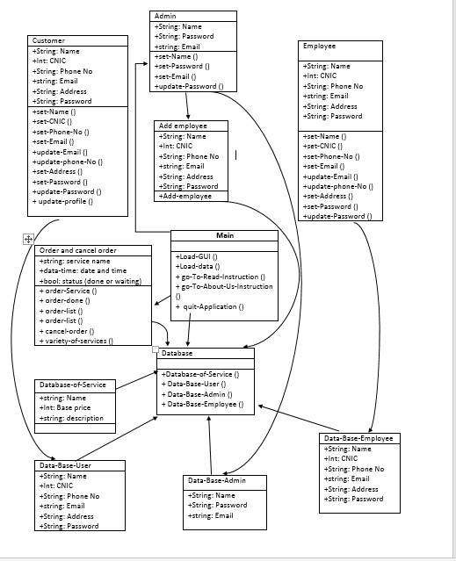

1.8 Data Model
The data model is a subset of the implementation model, which describes the logical and physical representation of persistent data in the system.

The Relational Data Model

