CWB205 Project 6 – Objects
(10 pts)

Extract the files for Project 6
There is one HTML file :
- html5doctype.txt: the HTML5 Doctype declaration.
The Body mass index (BMI) is a key index for relating a person's body weight to their height. Since the BMI describes the body weight relative to height, it correlates strongly (in adults) with the total body fat content.
Create a web page, bmass.html and a corresponding script file, bmass.js, that will take input from a visitor(see Figure 1), convert the input to the Body Mass Index, and output that information on the web page (see Figure 2).
Details:
- Create a JavaScript object, Bmi, that will contain all attributes, and methods necessary for the project using Object Literal Syntax.
  - Use Bmi properties for weight and height.
  - Create two Bmi methods for the project.
    - The first will retrieve the height of the user in inches and the weight in pounds. This method should run when the page loads.
    - The second will convert the inputs to the proper measurement units (kilograms and meters), perform the calculation to obtain the BMI, and produce formatted output for the page (see Figure 2). This method should be triggered using a button <input type=”button” /> and its click event after the input from the user has been entered. Use the innerHTML attribute of the a <div> to output the data to the page.

Figure 1.
When the page loads, retrieve height and weight in inches and pounds respectively from the page visitor. Controlled by the first Bmi Object method.
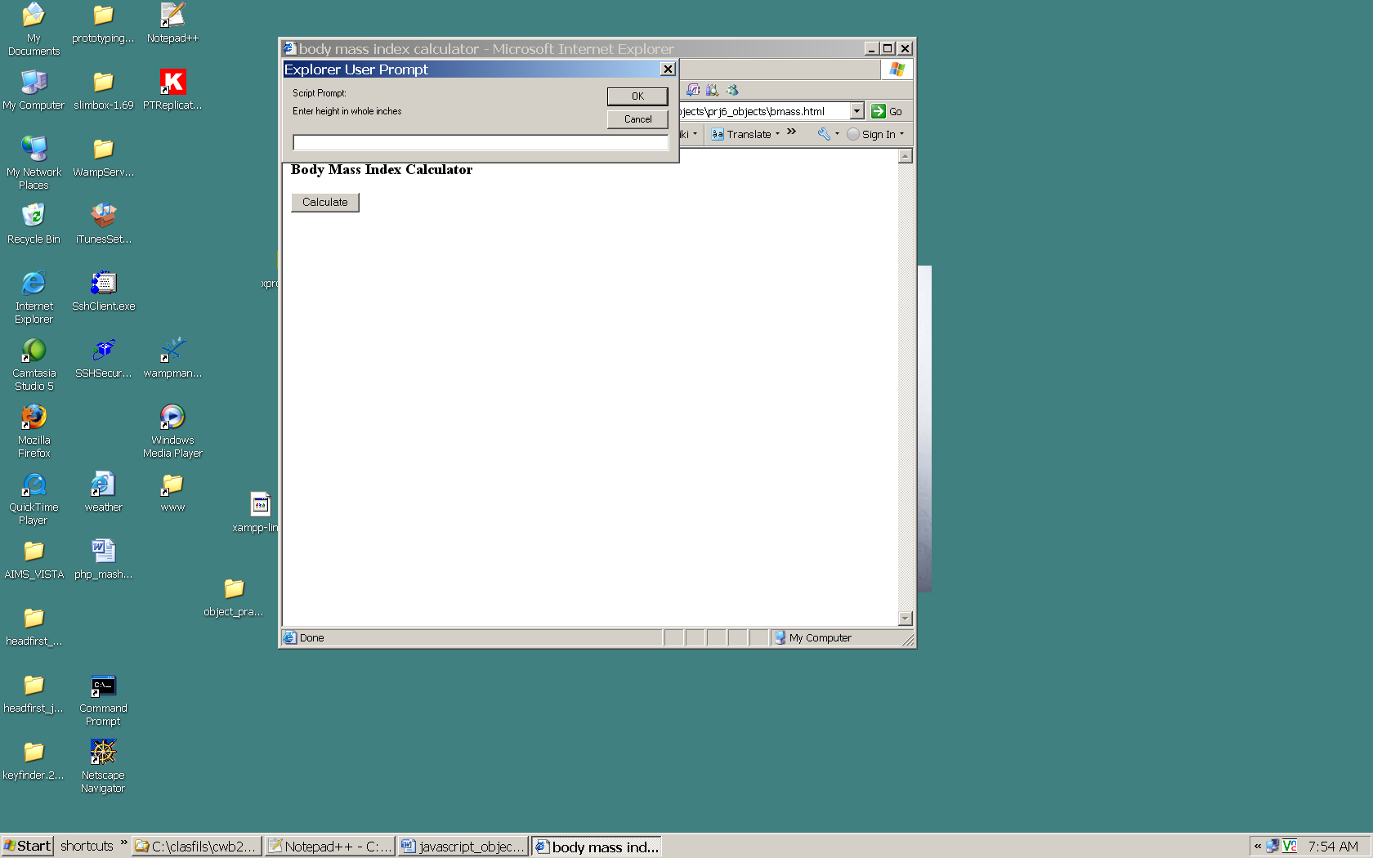
Page contains a heading and a button which will trigger the second Bmi Object method that calculates and outputs the BMI. Create an empty <div> with an id to output the result to the page using its innerHTML property.

Figure 2.
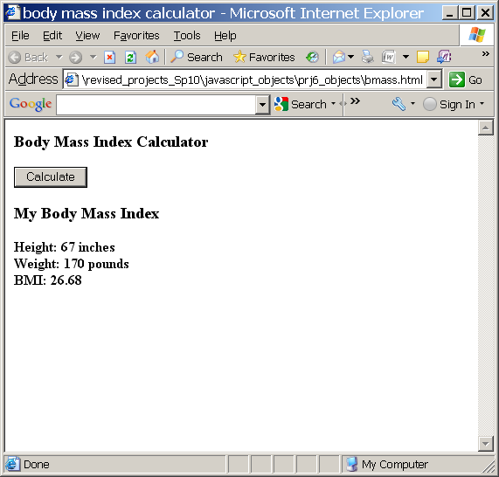
Output produced by the second Bmi Object method on the existing page.

Note:
- Include only the absolutely essential script code in bmass.html…bmass.js should contain nearly all scripts for this project.
- Validate your completed page with the W3C validation service. Fix any warnings or errors you encounter.

Publish all necessary Project 6 files to your web server account…be sure to test the project and include a link to it from your navigation page.
Submit itsup.txt to the appropriate Dropbox on the Aims Online location for CWB205 to insure you receive full credit for this project.

