CWB205 Project 7 - Objects
(5 pts)

Extract the files for Project 7
The project is composed of:
- An images folder - containing the graphics for the project.
- bmass.css (the .css file for the page)
- generic_bmass.html (the web page you will use for the project).
Revise the Bmi Object, created in Project 6 so it can be added to any page and apply it to generic_bmass.html. Name your revised .js file: generic_bmass.js. You will use this page again in your final project.
The revised application details are as follows:
- Encode this application as a separate part of a web page concerning bike tour training so that clicking a button, “Get BMI”, will trigger the application (Figure 1). Project 6 triggered the application when the page loaded.
- The application should run completely and result in output to the page with the visitor’s BMI (Figure 2) after the height and weight are entered.
- The basic structure of the Bmi Object should not change:
  - Bmi properties for weight and height.
  - Two Bmi methods
    - The first will retrieve the height of the user in inches and the weight in pounds. It is initiated with the Get BMI button.
    - The second will convert the inputs to the proper measurement units (kilograms and meters), perform the calculation to obtain the BMI, and produce formatted output for the page. Unlike project 6 where the second method is assigned to a button, in this case, the second function will be called by the first method that gathers the data.

Figure 1.
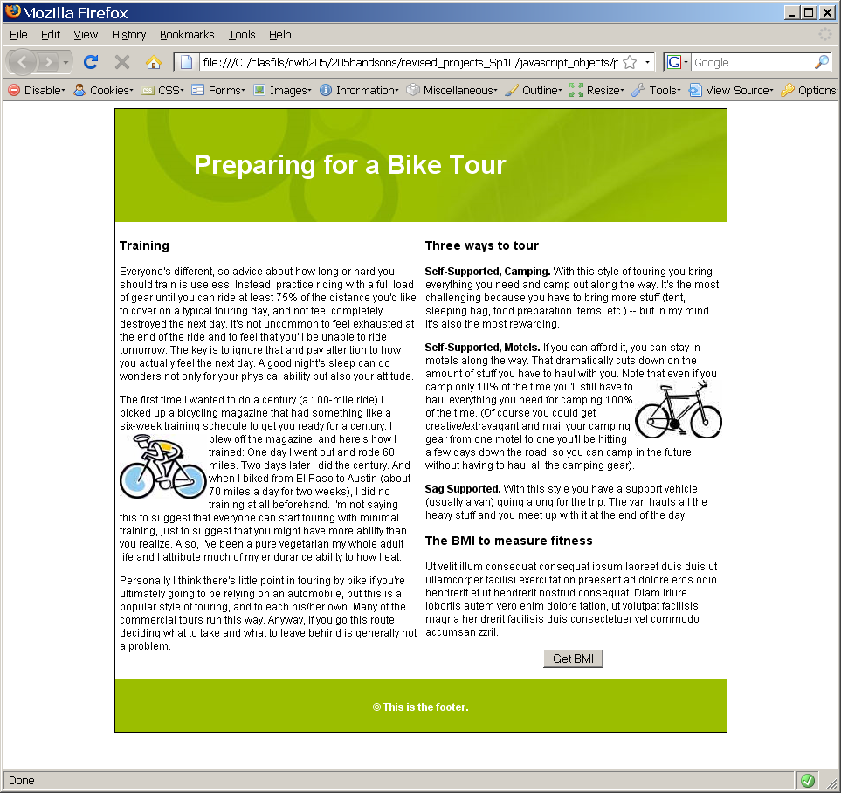
Page does not display any script output when loaded.
Add a button where indicated to execute method that gathers data and then outputs the BMI.

Figure 2.
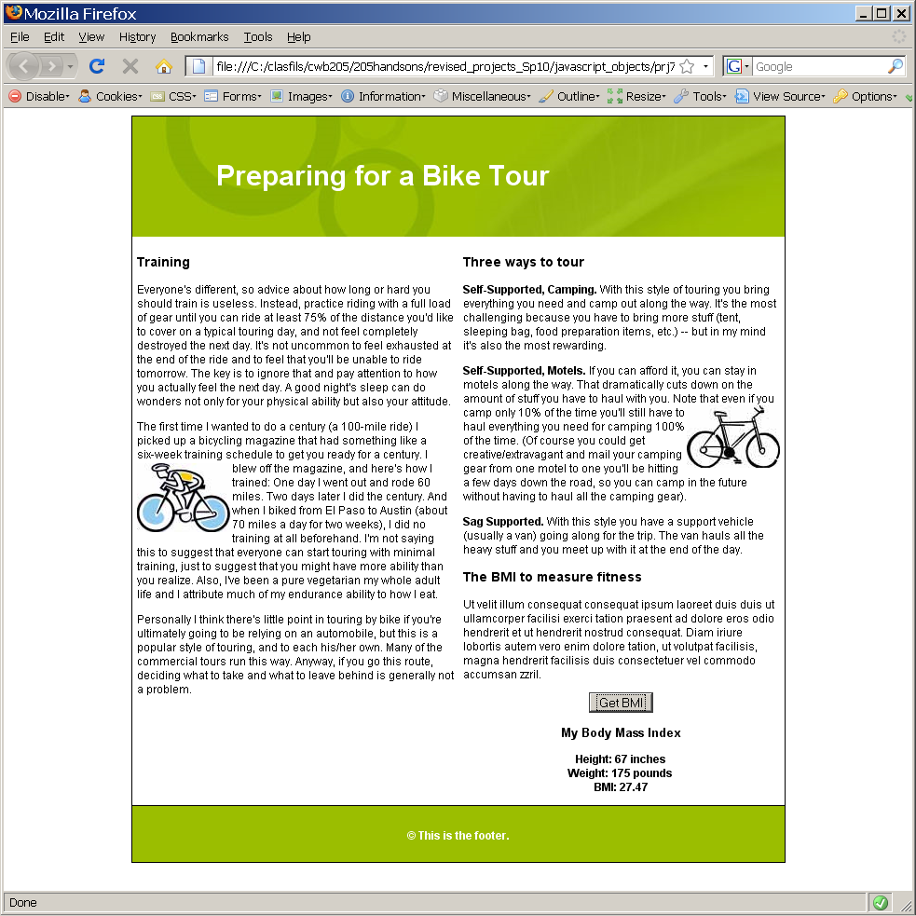
Format the script output area appropriately. The styles should be added to bmass.css. Use a <div> and its innerHTML property to fill in this area with the data.

Note:
- The file, generic_bmass.js, should contain javascript for this project.

Publish all necessary Project 7 files to your web server account…be sure to test the project and include a link to it from your navigation page.
Submit itsup.txt to the appropriate Assignment on the Aims Online location for CWB205 to insure you receive full credit for this project.

