**CWB205 jQuery Menus**

(15 pts.)

Download and extract the files for the Menus project (**menus.zip**). The files included are:

* **images** directory - contains the images needed for the template page and the project.
* **anim_menus.html** - the web page you will use for the project.

Use the jQuery Navigation plug-in to create a drop down menu system for **anim_menus.html**.

You will need to include a link to the appropriatefiles to include the functionality necessary for the project. This project follows the animated menu tutorial from Chapter 8 of the 2nd edition of the Missing Manual textbook. A pdf file of that chapter 8 is included in the downloadable materials. The 3rd edition of the book has a similar tutorial, but it's based on a responsive menu plugin called SmartMenu but that plugin doesn't lend itself to easy customization, so we will use the one from the 2nd edition of the book to implement this project.

The javascript you add to **anim_menus.html** should:

* Encapsulate all code within the $(document).ready()function.
* Be sure the proper image is included in your files to insure that indicator arrow graphics are included in the menus.(Figure 1)

**Figure 1:**

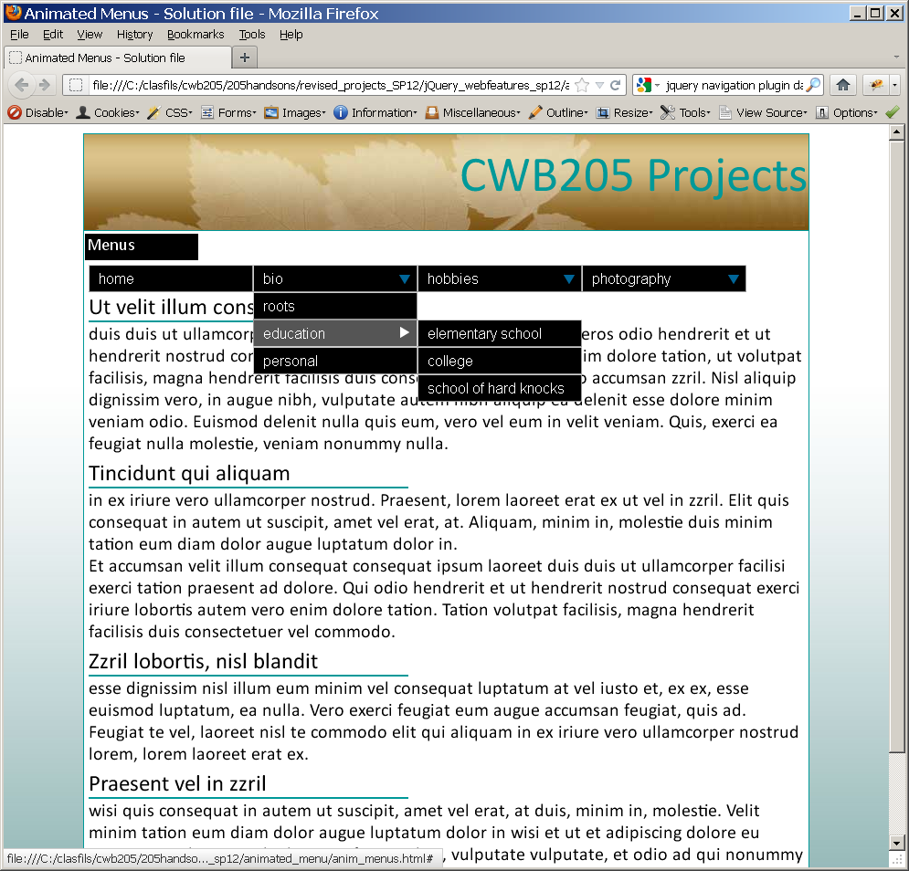

arrow.png used to indicate that there are hidden menus. Be sure this image is included in your files.

**Styles -**

* Include the .css styles necessary for the Navigation functionality in a separate external style sheet, **extra_anim.css**. The background and text color of the links in that file have been modified for you to match this assignment (namely to black and white, respectively).
* Be sure the widths of your menus are wide enough to accommodate the entire text of the longest link (avoid wrapping the links).
* Set the menus so they slide into view using a timing factor of .3 seconds.

**The markup-**

* You will have to modify **anim_menus.html** to make it work correctly with the Navigation menu system. Hint: *Look closely at the lists on the page and modify as necessary it's related to the way that the submenus are constructed with the <li> tags. Refer to the Chapter 8 tutorial (the pdf of the 2nd edition of the textbook) for more information on the proper construction of the unordered lists.*

Submit the completed project to your web server account on cislinux. Be sure to link to **anim_menus.html** from your navigation page.

* Make sure to test your submission on the server and correct errors.
* Submit the “**itsup.txt**” file to the Aims Online Drop box area for this assignment.