**CWB2005 jQuery Form Validation**

(15pts.)

Download and extract the files for the Form Validation project (**formval.zip**). The files included are:

* **images** directory - contains the images needed for the template page.
* **tempcss** directory -
  + **2005temp.css** - css page for the template
  + **formval.css** - css page for the form you will validate.
* **formval_std.html** - the web page you will use for the project.
* **thanks.html** - a dummy page to be used to check form submission. You will need to use this as the destination of the “action” attribute of the form.

Use the jQuery Validate plug-in to set up form validation for the form on the page, **order_form**.

You will need to include a link to **jquery-1.11.0.min.js,** and the necessary **validation plug-in** file to include the functionality necessary for the project. (This file is called ***jquery.validate.min.js*** and can be found in the Chapter 8 files from the book or Chapter 9 of the second edition).

***Note: These files will have to be uploaded to the server along with your completed project when you submit it.***

The script should:

* Encapsulate all code within the $(document).ready()function.
* Set the cursor in the “First Name” field textbox when the form loads using the focus function.
* set up form validation to be ***required*** on all fields on the form and in addition add the following checks for these fields.
  + email - provide format checking for a valid email address using advanced rules
  + price, slstax, and total - these fields should be programmatically filled in with JavaScript when the quant field (quantity of reservations) is completed by the user - *see below*.
* Use advanced validation techniques with custom messages for email and phone. When the email is missing, display the message, "Please supply your e-mail address.", when it's not valid, show the message, "Please enter a valid e-mail address." Similarly, if the phone number is missing, show the message, "Please give us your phone number." Rather than the generic, "This field is required". This is done by passing several object literals (rules and messages) into the validate() function. It's covered in the book.
* Use advanced validation on the quantity of registrants, with a maximum of 4 allowed (i.e., add a rule for the quant field of max:4) - If the quant field is greater than 4, then fill the fields that would normally contain calculated values with blanks instead.
* When a quantity is entered into the Quantity (quant) field write the javascript that will calculate the various charges (subtotal - registration price ($25) x quantity, sales tax (use 6.5%), grand total)
  + You will need to use a blur event to trigger the calculations. That means when the user exits the quant field, the calculation should take place.
  + Round your output to two places using the .toFixed(2) function.
  + ***Be sure to disable these three fields (price,slstax,and total) so users can’t modify them.***

**Styles -**

Modify the formval.css style sheet to provide the error message formatting indicated.

* Format your error text output appropriately:
  + bold the text
  + cut the font-size down to .7em
  + change the color to red
* Format the input boxes to further insure the user realizes something is amiss by putting a red border around the element.
* You can do that by adding these lines to the end of the formval.css file:

/*styles for error messages */

label.error{

font-weight:bold;

font-size:.7em;

color:#f00;

margin-left:.3em;

}

/*styles for input boxes with errors */

input.error{

border:2px solid #900;

}

Figure 1:

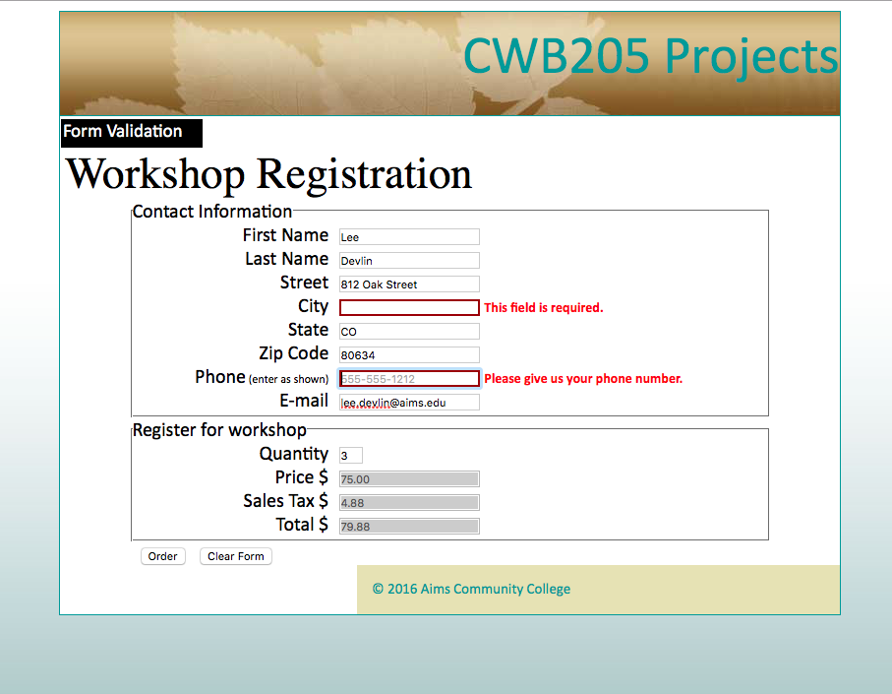

Error message sized, bolded, colored, text box has border applied.

Custom error messages for phone and email

Calculated form fields are disabled. Add background color of #CCC to the disabled text boxes.

A successful submission will show the thanks.html page like this when the Order button is clicked on when there are no validation errors:

