**Potpourri IDs Project**

CWB205 (5 points)

Open **ids_stdnt.html** and save it as **ids.html**. Save another copy of **ids_stdnt.html** as **ids_select.html because this project as 2 parts.**

**IDs -**

Create a script file, **ids.js**, that will contain the script for this project. Link this to **ids.html**.

Create a function that will:

* Select only the <li> tags that are part of the “eventsList” id.
* Color the text in the <li>s orange and bold the text (the li containing the hyperlink will exhibit the default link color and underline but will be bolded –that’s ok – not necessary to modify). See Figure 1.

**Figure 1.**

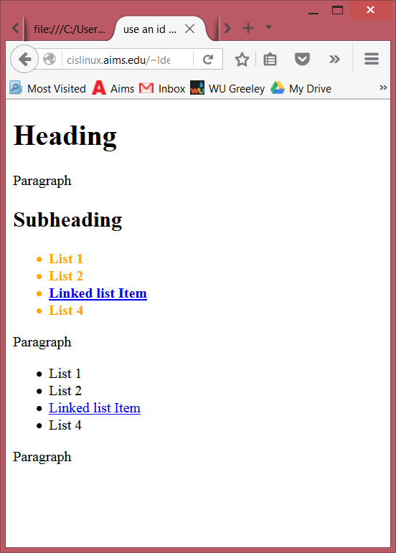

Note: Only the list items in “eventsList” are formatted

Text in <li> elements is orange and bolded. Text in hyperlink is the default color blue because it is overridden by the 'a' tag.

**IDs_select –**

Create a script file **ids_select.js,** that will contain the script for the second part of the exercise. Link this to **ids_select.html**.

Create a function that will:

* select the last <li> element on the page.
* change the text color to #900.
* bold the text. See Figure 2.

**Figure 2.**

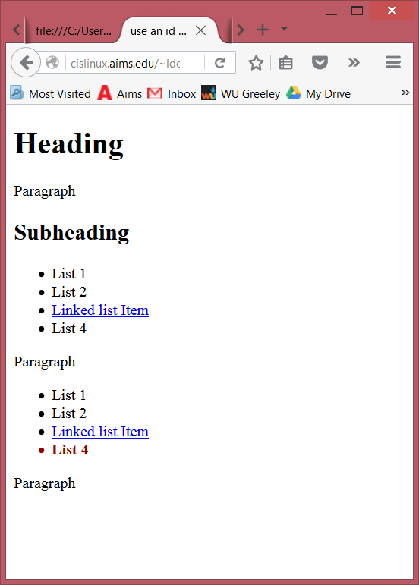

Last <li> selected. The text is bolded and colored #900.

All JavaScript code will reside in the .js files and the scripts need to execute when the page has loaded.

Upload these files to your web server account and include links to the two projects. . Submit **itsup.txt** to the appropriate Dropbox on the Aims Online location for CWB205 to insure you receive full credit for these projects.