**Potpourri Node Values Project**

CWB205 (5 points)

Open **nvalues_stdnt.html** and save two copies, **nvalues_output.html** and **nvalues_change.html.**

**Node value output –**

Create a script file, **output.js** and link to it from **nvalues_output.html**.

Create a function that will:

* Select the second list item in the second list on the page.
* Apply a color of #900, and bold the text.
* Output the nodeValue of the contents of this list item to the page using the innerHTML property. See Figure 1.

**Figure 1.**

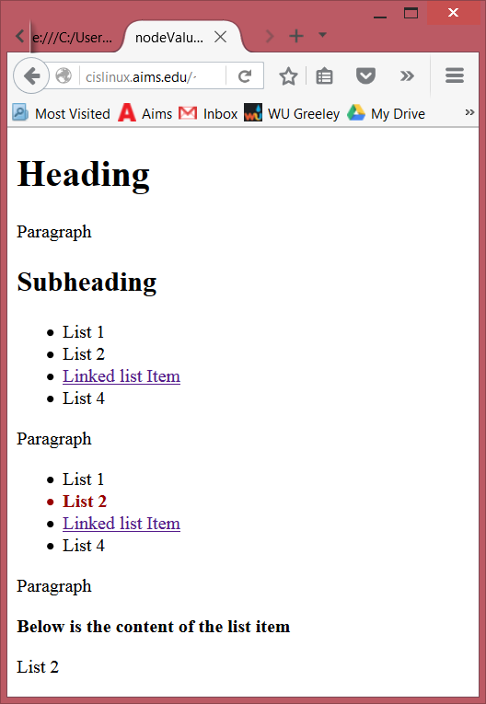

Second list item in second list formatted.

nodeValue of Second list item in second list output to page.

**Change Node Values-**

Create a script file, **changenv.js**, and link to it from **nvalues_change.html**.

Create a function that will:

* Select the3rd list item in the second list
* Change the link text to “NFL Website”.
* Change the URL to [www.nfl.com](http://www.nfl.com/). Test your changed link to be sure it works.

Figure 2.

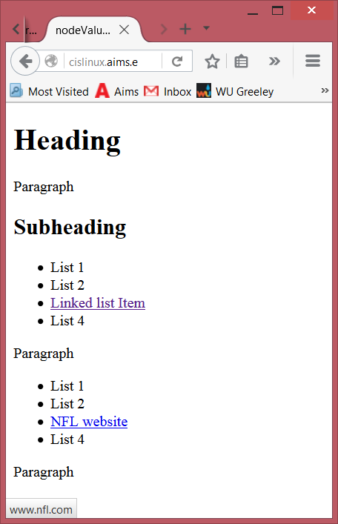

Change text of link to “NFL Website

Change URL to nfl.com

All JavaScript code must reside in the .js file and these scripts need to execute when the page has loaded. Validate both pages with the W3C.

Publish both projects to your web server account…be sure to test them and include a links to them from your navigation page. Submit **itsup.txt** to the appropriate Dropbox on the Aims Online location for CWB205 to insure you receive full credit for these projects.