**Potpourri Simple Project**

CWB205 (5 points)

Open **basic.html** and save it as **basic_simple.html**.

Create a script file, **simple.js**, that will contain the script for this project.

Create a function that will:

* apply a #FF0000 (red) color to the text of the first paragraph of the file.
* apply a #00FF00 (green) color to the second list item on the page, bold the text, and increase the font size to 1.1em.

**Figure 1.**

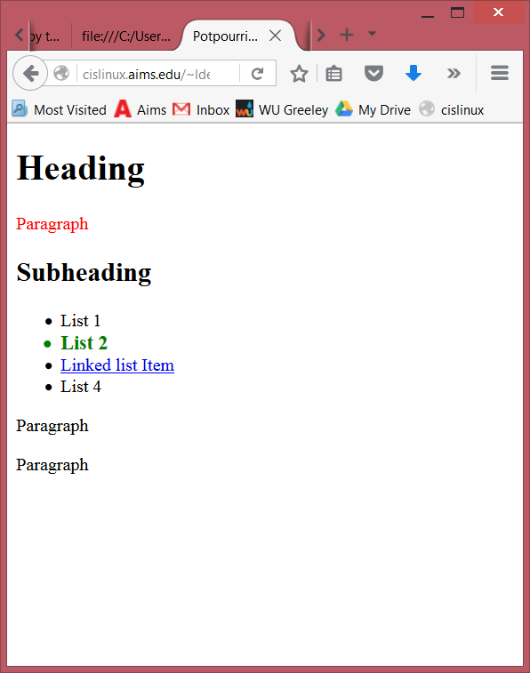

All JavaScript code must reside in the .js file and this script needs to execute when the page has loaded.

Publish your project to your web server account and link to it from your navigation page. . Submit **itsup.txt** to the appropriate Dropbox on the Aims Online location for CWB205 to insure you receive full credit for these projects.