**CWB205 jQuery Pull Quotes**

(10 pts)

Download and extract the files for the Pull Quotes project (pullquotes.zip). The files included are:

* images directory - contains images needed for project
* tempcss directory - contains the style sheet, 205temp.css, for the template page(don’t modify)
* jquery_pullqts.html - the web page you will use for the project.

Additionally, you will need to copy the _**js/jquery-1.11.0.min.js** folder to your working directory. ***Note: This will have to be uploaded to the server along with your completed project when you submit it. This file is included in your tutorial files for the class.***

Using the areas on the web page delineated with <span> tags, create auto pull quotes so that when the page loads, the pull quotes are formatted as shown below. Create a separate style sheet for the project formatting.

**Figure 1:**

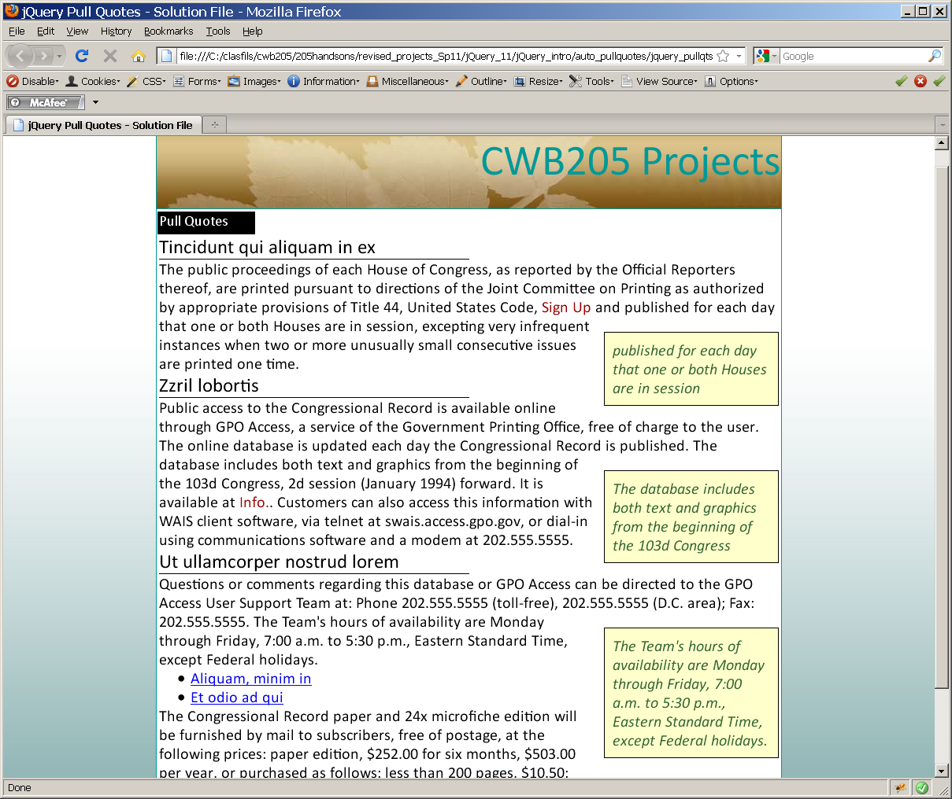

Formatted pull quotes

External hyperlinks formatted uniquely - color is #900 and no underline.

Find all external links (those going out on the web) and format them uniquely as follows. **Figure 2**

* #900 color
* No underline

Format the :hover state of these external links as follows:

* #090 color
* Underlined.

**Figure 2:**

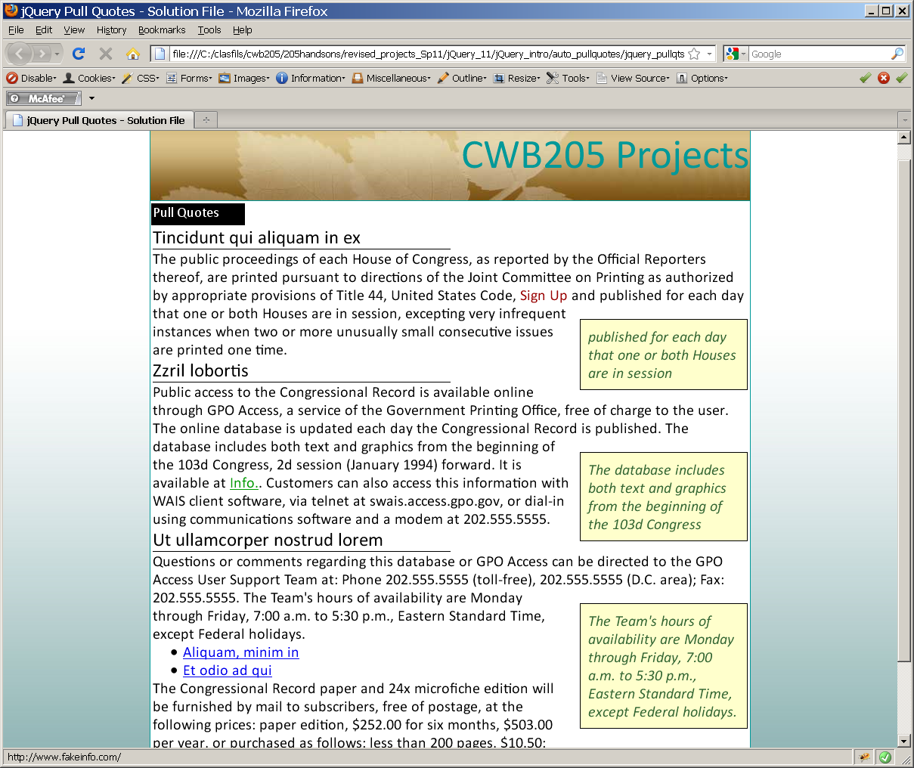

:hover formatting - #090 and underlined for external links.

You must use jQuery structures to complete the project.

1. Upload your project to your web server account on the **cislinux** web server.
2. Test your submission on the server and correct any errors.
3. Modify your navigation page with a link, ***Pull Quotes,*** that will open **jquery_pullqts.html**.
4. Submit the “**itsup.txt**” file to the Aims Online Drop box area for this assignment.

Hints:

Finding the external links with jQuery is covered on page 125 of your book. It's done with a jQuery filter. The code to change a link based on it having an "http://" (which indicates it's an external link) is done with this line of code:

$('a[href^="http://"]').addClass('outLink');

That line of code which will be inside the main jQuery call will find the 2 external hyperlinks starting with http:// and add a class called 'outLink' to them which you will need to add in a CSS file. It will turn the external links red (#900) and then when hovered over, they will turn green (#090). Please note that the 2 local links will remain with the default link behavior.

The PullQuotes tutorial in the book starting on page 141 can be followed nearly exactly to implement this project. The downloadable files for the book, available on Aims online, have a starting file and a working version of this tutorial so that you can see how it works. CSS formatting for the links and pullquote boxes should use this styling:

.outLink{

color:#900;

text-decoration:none;

}

.outLink:hover{

color:#090;

text-decoration:underline;

}

.boxit{

float: right;

clear: right;

display: block;

width: 200px;

border: 1px solid black;

padding: 10px;

font-size: 20px;

background-color:#FFC;

margin: 20px 0 10px 10px;

font-style: italic

color: #363;

}