**CWB205 jQuery Accordion**

(10 pts)

Download and extract the files for the Accordion project (accordion.zip). The files included are:

* images directory - contains images needed for project
  + **bgteal.jpg** - background for the page
  + **header_mod.jpg** - header image
  + **close.png** - image displayed when the content is displayed.
  + **open.png** - image displayed when the content is hidden.
* **tempcss** directory - contains the style sheet, 205temp.css, for the template page(don’t modify)
* **accordion.html** - the web page you will use for the project.

Additionally, you will need to copy the **js/jquery-1.11.0.min.js** folder to your working directory.

***Note: This will have to be uploaded to the server along with your completed project when you submit it.***

Create the script necessary to allow users to click on the main headings to display the hidden content associated with it then click again and hide the displayed content. Save this script as **accordion.js** and link to it from your page…this should follow **jquery-1.11.0.min.js** in the web page.

* You will need to link to the **jquery-1.11.0.min.js** file to make sure you have access to the jQuery structures you will need to complete the project.

**Figure 1.**

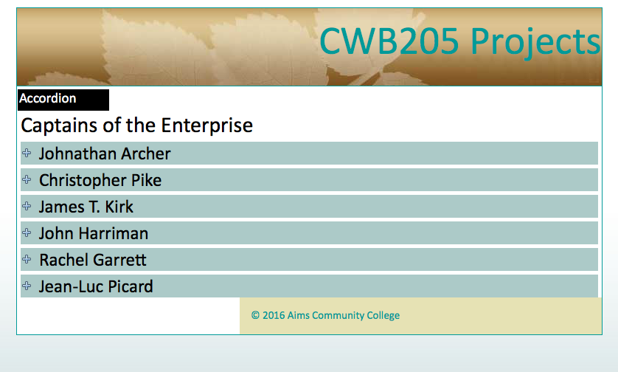

*Note: the '+' sign image showing indicates there is hidden content.

*All sub-content is hidden when the page loads.

**Figure 2.**

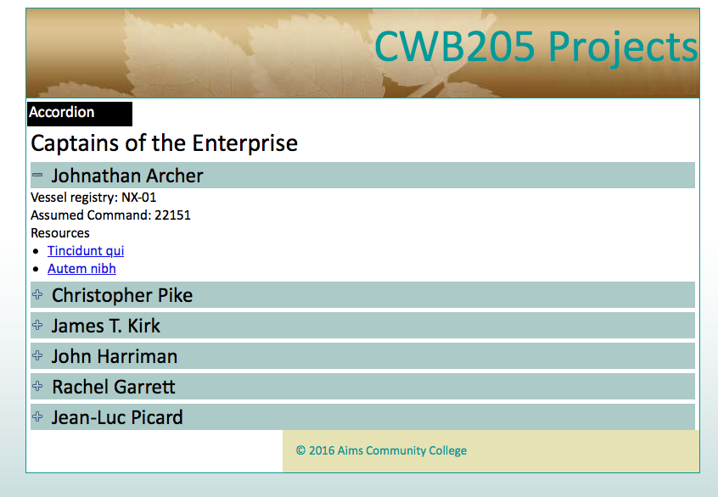

Hidden content displays when the heading is clicked and hides when the heading is clicked again.

Note the '-' sign image showing indicates there is no hidden content.

* You must use **jQuery** structures to complete the project.
* Please see lecture notes for how to toggle content on and off.
* This assignment is closely related to the FAQ tutorial in the book in Chapter 5.
* Upload your project to your web server account on the **cislinux** web server.
* Test your submission on the server and correct any errors.
* Modify your navigation page with a link that will open **accordion.html**.
* Submit the “**itsup.txt**” file to the Aims Online Drop box area for this assignment.