**CWB205 jQuery Shakespeare**

(Swapping images) (10 pts)

Download and extract the files for the Shakespeare Project (**shakespeare.zip**). The files included are:

* images directory - contains most of the images needed for the template page
* images2 directory - contains the rollover menu images needed for the actual project
  + logo.gif - the head image for the main content of the page
  + There are 5 sets of images for the rollover behavior
    - the images with **_ovr** in the name are the rollover images, the images without this are the originally loaded images i.e. **plays.gif** is the originally loaded image and **plays_ovr.gif** is the rollover image appearing when the mouse rolls over the existing image.( ***Hint: think .hover( ) this is based on the rollover tutorial in your book almost exactly. It's in Chapter 7 of the Missing Manual book. Please read that tutorial carefully and experiment with the files that came with the book.***)
* shakesp_student.html - the web page you will use for the project.

You will need to include a link to **jquery-1.11.0.min.js** to include the functionality necessary for the project.

***Note: These will have to be uploaded to the server along with your completed project when you submit it.***

Create the script necessary to create rollover images for the links on **shakesp_student.html**. In addition to coding the rollover behavior, **you need to preload the images** to prevent any performance delays in page function.

**Figure 1:** Shows page as it loads natively with the proper set of images loading.

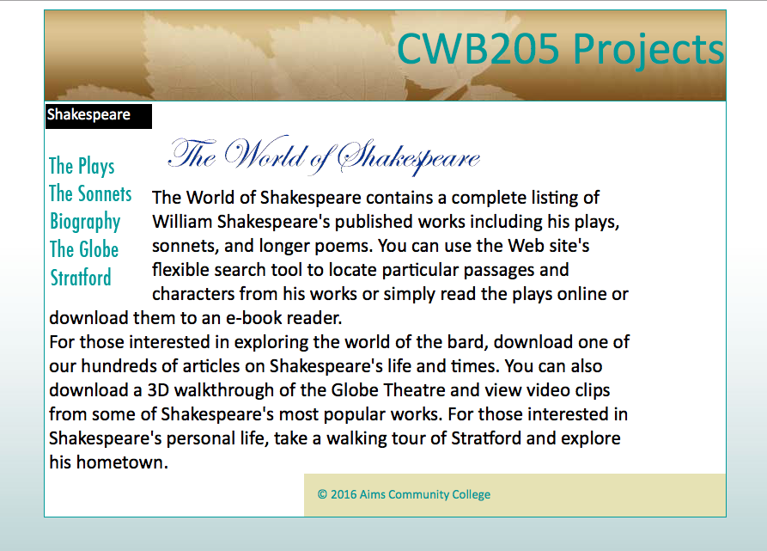

Default images load initially as shown.

**Figure 2:** Shows the first link reacting to the mouse rolling over it.

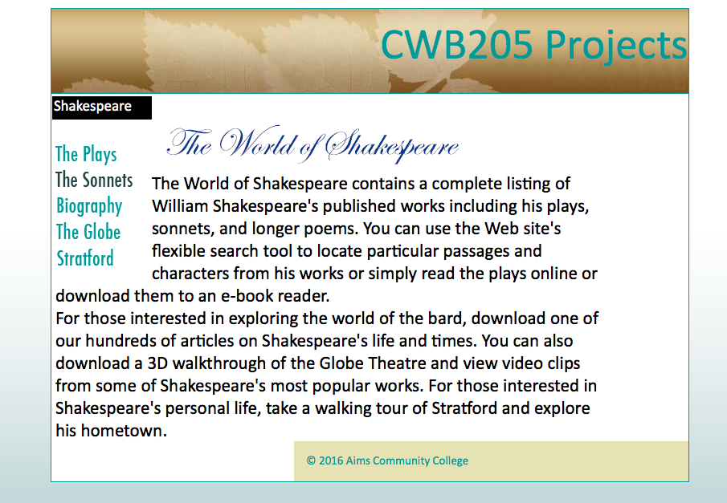

**_ovr.gif** image swaps in when the mouse rolls over the link and returns to the original image when the mouse leaves the link.

* You must use **jQuery** structures to complete the project.
* Submit the completed project to your web server account on cislinux. Be sure to link to **shakesp_student.html** from your navigation page.
* Test your submission on the server and correct any validation or script errors.
* Submit the “**itsup.txt**” file to the Aims Online Drop box area for this assignment.