**CWB205 jQuery FancyBox Advanced Gallery**

(15 pts)

Download and extract the files for the FancyBox Project (fancybox.zip). The files included are:

* images directory - contains most of the images needed for the project
* fancybox_student.html - the web page you will use for the project.

Additionally, you will need to include copies of all necessary jQuery script files and the appropriate jQuery CSS file (the files needed, and how to obtain and use them in your project, are covered in Chapter 7 of the 2nd edition of the Missing Manual textbook which you must download from Aims Online in the Lecture Notes section since the Fancybox plugin is not covered in the third edition of the book). This project has been updated from what is shown in the manual to use version 2 of Fancybox. You can download these files from the same area in the Lecture Notes section. Please also refer to the lecture notes for additional information on this project.

***Note: These files will have to be downloaded from Aims Online and then uploaded to the cislinux server along with your completed project when you submit it. They should be linked like this:***

<script type="text/javascript" src="_js/jquery-1.11.0.min.js"></script>

<script type="text/javascript" src="fancybox2/jquery.fancybox.js"></script>

<link href="fancybox2/jquery.fancybox.css" type="text/css" rel="stylesheet" />

Create a photo gallery and use the jQuery FancyBox plugin to display large versions of the thumbnail images.

* Use the provided external style sheet, **fancybox.css**, to control page formatting. Make sure this file is linked in **fancybox_student.html**.
* The web page is incomplete. You will need to apply HTML such that you can select the images used in your gallery easily. You will also have to add the thumb-nailed images to the page.
* You will need to put in a div with the image links aligned side-by-side. You must also have a rel="gallery" attribute in each image. Note, you should also provide a title attribute for each picture because it needs to show up below the picture as shown in Figure 2. Here's how that section should start:

<div id="gallery">

<a href="images/pinks.jpg" title="A field of pink flowers" rel="gallery"><img src="images/thumbs/pinks_sm.jpg" /></a>

….

</div>

**Figure 1:**

The background color for header and footer - #fc0

The <h3> and footer text color - #099

sans-serif font family is used.

Page is centered using CSS

The page border is #000.

Use appropriate padding/margins to prevent squishing.

No tables allowed ☺

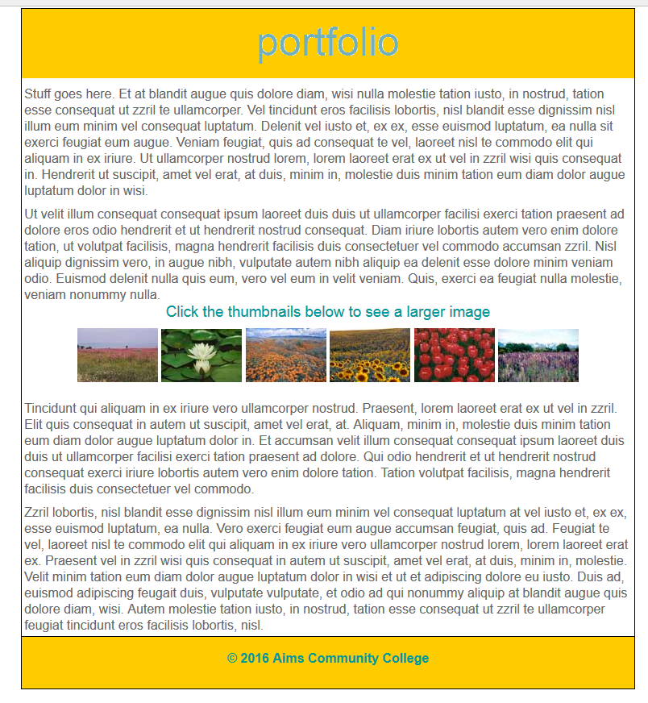

Figure 2 demonstrates the jQuery FancyBox plug-in action- when the thumbnail image is clicked, the page is dimmed and the larger image version is displayed.

**Figure 2:**

*When the thumbnail image is clicked, the page is dimmed and the larger image is displayed.

*The “next” and “prev” indicators should display as shown when the mouse hovers nearby.

*Provide captions for each image using title attribute



Apply the following FancyBox Options to your project:

* Make the overlay #CCC with 50% opacity.
* Use the ***elastic*** transition option for both loading and removing the images.
* Apply code that makes all images part of a group enabling the use of the previous and next graphics to easily move from one image to another.
* Use the default style for the image caption.

Other requirements:

* You must use **jQuery** structures to complete the project.
* Submit the completed project to your web server account on cislinux. Be sure to link to **fancybox_student.html** from your navigation page.
* Test your submission on the server and correct any validation or script errors.
* Submit the “**itsup.txt**” file to the Aims Online Drop box area for this assignment.