**CWB205 JavaScript Basics Project 2**

(5 pts)

After extracting **basics_prj2.zip**, you will find 2 files, **index.html** and **addit_student.html,** in addition to an **images** directory, and **addit.css**.

Modify the web page, **addit_student.html**, so that when loaded, it opens a prompt dialog box that asks the visitor to enter a bid for the vase pictured on the document. An itemized price including the total price, sales tax, and shipping is then communicated to the visitor in the page area of addit.html. Note that **addit_student.html** will be opened when linked to from **index.html**.

* Link both pages to **addit.css**, the style sheet file for the page.
* The JavaScript code used to collect the bid and compute the values should be embedded in the head area of **addit_student.html** which is loaded by linking it to the button in the index.html page.
* The script output should occur in the div with an id set to **bidbox** within the body of the web page using the document.write function. Be sure you use appropriate html tags to format the output as shown in **Figure 1** below.
* Use comments indicating the purpose of the statements in your script.
* Include your name and the Course number in your documentation with an HTML comment.
* Format output to two decimal places – investigate using the toFixed() method to format your output.
* Use 5% for sales tax and 1% for shipping in your script. Recall that all prompt input values are treated as strings unless you convert them to numbers. This can be done with the Number() object.
* If you're having trouble don't forget to use the Console in the Developer Tools and the console.log command to check values of your calculations.
* Publish Project 2 to your cislinux web server account…be sure to test the project and include a link to it from your navigation page. Submit **itsup.txt** to the appropriate Assignment on the Aims Online location for CWB205 to insure you receive full credit for this project.

**Figure 1.**

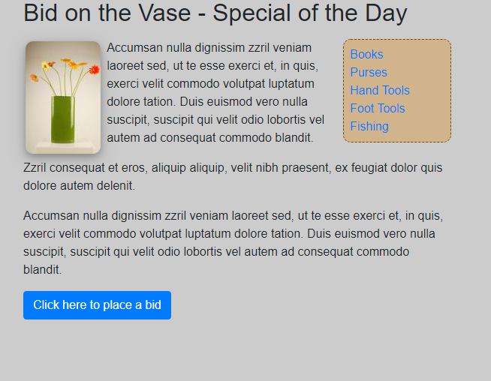

When you click on the button, it will launch the file addit_student.html and the first screen you'll see will look like this:

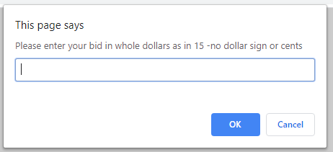

After filling in a number and clicking on the OK, you should see the following page appear:

