**CWB205 JavaScript Basics Project 4**

(5 pts)

Extract the files for Project 4 (basics_prj4.zip).

The files included are:

* **calc_area_student.html** – base page you will use to implement the script
* **calc_area.css** – style sheet - link to web page
* Add the appropriate HTML5 Doctype code to the page to make it W3C compliant (use html5doctype.txt).
* Create a script that will calculate the area of a rectangle given input for width and height then outputs the calculated area to the web page.
* Use 2 separate prompt dialog boxes to receive the width and height from the user as shown in figure 1.
* Create a function passing the two parameters, width and height, that calculates the area of the rectangle then returns the result, i.e., the area. Please note, that the purpose of this assignment is to learn about functions, so don't write the code without using a function that accepts the length and width as inputs and returns the area of the box.
* Output the height, width and area in the appropriate position in the table created for you. See Figure 2. Use the css file provided to match the appearance of this figure. Note, this is how it looks in Chrome. Its appearance will be slightly different in Firefox, but in general, if you don't see the light grey background and show the table as being centered on the page, then you probably did not link the calc_area.css file correctly.
* Create an external file, **calc_area.js**, to hold the bulk of your script code. You should include the code to retrieve user input and your function in this file. The only script code on your web page should be for output of the values to the table. The values in the table elements should be filled in with 3 separate document.write() statements.
* Link your page to calc_area.js
* Publish Project 4 to your web server account…be sure to test the project and include a link to it from your navigation page. Submit **itsup.txt** to the appropriate Assignment on the Aims Online location for CWB205 to insure you receive full credit for this project.

**Figure 1.**

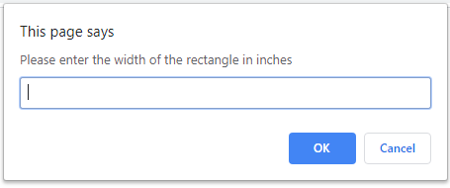

**Then you should send another prompt for the height:**

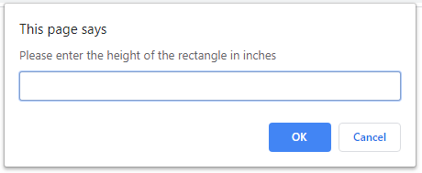

**Figure 2. This should be centered on the page:**

