STREAMING MAP INSTALLATION AND DEMO GUIDE

Contents
1 Scope 3
1.1 Revision History 3
2 Overview 3
2.1 Demo Workflow 4
3 System Requirements 5
3.1 Operating System & Workzone 5
3.2 Hardware Requirements 6
3.3 Software requirements 7
4 Clone the repository 7
4.1 Git installation and repo cloning 7
5 Build 8
5.1 Build Using Visual Studio 8
5.1.1 Installation 8
5.1.2 Build Configuration and rules 10
5.2 Build using batch files 11
6 Running demo in Unity 11
6.1 Installation 11
6.2 Run the Demo 15
7 Troubleshooting 17
8 Recommendations summary 17
9 Open Issues 18

Scope
The scope of this document is to evaluate and execute the Streaming Maps Demo provided through the GizmoSDK. The purpose of this document is to demonstrate existing Generic 3D Map Streaming API, that can be integrated with engines such as Unity, for streaming map data efficiently of any geo-map.
This document provides a step-by-step guide for setting up, building, and running the “CSWUnity Map streamer” project using the GizmoSDK source code and Unity Editor.
This guide is intended for new users/developers who are setting up the project for the first time on a Cloud Development Workstation (CDW).
With the help of this guide, the user will be able to:
- Install and configure the Software/Tools required in CDW.
- Clone the CSWUnity repository.
- Build the required SDK components and generate the required plugin DLLs.
- Run the map streamer demo in Unity.

Revision History
Sno | Revision | Date | Author | Comments
1 | 1.0 | 08-10-2026 | Team Unicorn | First version
2 | 1.1 | 08-25-2026 | Team Unicorn | - Added revision history  - Updated git hub repo links to GHE from OpenSrc. Changed Streaming_map_demo to CSWUnity Map Streamer demo.  - Updated Sec 6.1 Unity Hub installation section with probable errors  - Updated few images to more clear ones  - Removed one open issue (In Open issues section) related to repo in tooltech(opensrc) directory
3 | 1.2 | 09-07-2026 | Team Unicorn | - Address Mikael Comments
4 | 1.3 | 09-10-2026 | Team Unicorn | - Added a table for current software versions used in section 3.3 and corresponding changes
5 | 1.4 |  | Team Unicorn | - Approved by Mikael Erninger  - Removed all comments and tracking changes

Overview
The CSWUnity MapStreamer demo is the SAAB Dynamics demo of the streaming binary data architecture. The repo is available at
https://saab.ghe.com/saab/CSWUnity

The repo consists of two major components:
GizmoSDK Build
Responsible for:
- Downloading NuGet packages
- Building required libraries
- Generating DLL files
- Deploying plugin binaries
Visual studio is used to build the software

Unity Demo
Responsible for:
- Loading generated DLLs
- Initializing the Streaming Engine
- Rendering streamed 3D map data
- Allowing user interaction

Demo Workflow

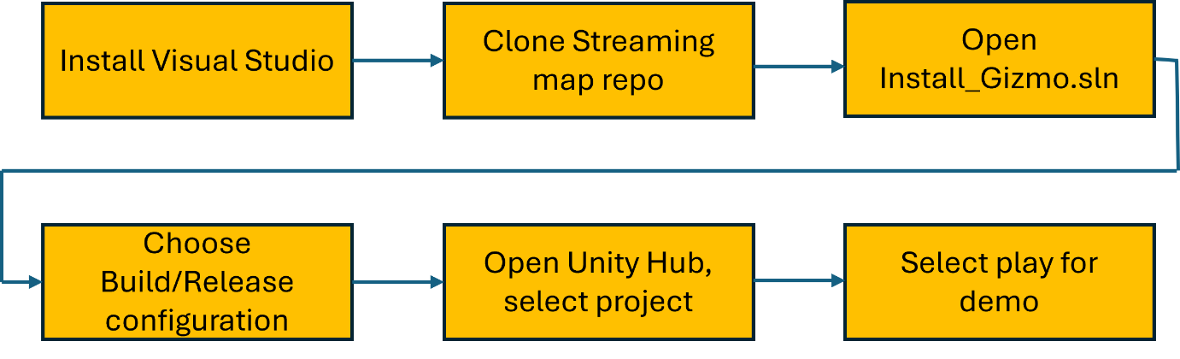

System Requirements

Operating System & Workzone
Work Zone: CDW ( Cloud Development Workstation) (Not Export Controlled)
Refer https://saab-frontrunner-onboarding-guide.pages.saab.ghe.com/generic-onboarding/cdw-setup/ and all the sub-links till step 6
Requesting new CDW
- Raise a request for default config CDW using the following link -
https://servicehub.saabgroup.com/esc?id=sc_cat_item&sys_id=029ce8e41d4c22507d0b1c3769ce7078&table=sc_cat_item&searchTerm=cdw
- Select CDW Non- Export control and respective line-manager name from the drop down for the request approval -> add to cart -> proceed for submitting at view cart.
- Once Modern Workspace Configuration request for CDW is approved, IT Service Desk team will provide initially a default configured CDW with 4 vCPU, 16 GB RAM, and 128 GB storage.
- Raise a GPU-Enabled CDW for the higher configuration.
  - Refer the following link to raise GPU-Enabled CDW
https://servicehub.saabgroup.com/esc?id=sc_cat_item&sys_id=5408c2fbafbf62100f26a2c6512749bc
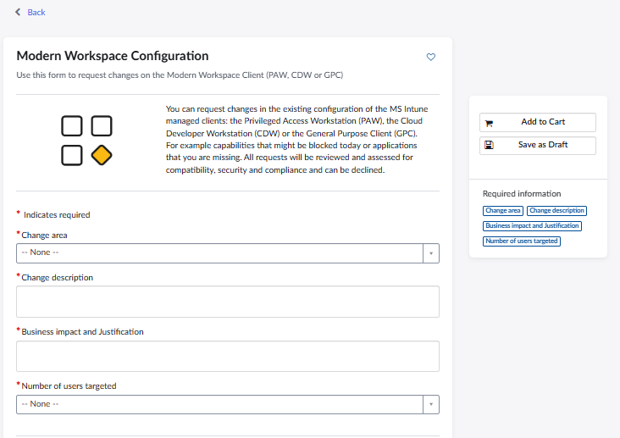

Use the following content in the request page for GPU enabled CDW
- Change area: Cloud Developer Workstation (CDW)
- Change description: Request for “GPU-Enabled CDW”. (New/Replace Existing CDW with GPU-Enabled CDW)
“Add a Graphics Processing Unit (GPU) with at least 4GB to meet our CSW Project tasks and Gizmo works loads using UnityTools & Unreal is the project technical requirements. GPU (Graphics Processing Unit) is minimal essential for the Work Loads.”
- Business impact and Justification:
“Need GPU in CDW, as the CommonTech project requires graphical processing using Unity.”
Note: CDW with GPU has a limitation where in Windows Subsystem Linux is not supported. Currently there is no dependency on WSL.

Hardware Requirements
Component | Comments
Processor | Intel Core i5 / i7 or equivalent
Memory | Minimum 16 GB RAM
Storage | Minimum 70-100 GB free disk space
Graphics | GPU Required
Network | Internet access (for Git and NuGet packages)

Software requirements
Software | Comments
Git Bash | Clone repository
Visual Studio 2022/2026 Professional/Enterprise (see note 1 below) | Build SDK
.NET Core 3.1 Support | Required for Install_Gizmo solution
Unity Hub | Manage Unity projects
Unity Editor (see note 2 below) | Run Demo
Note:
- The recommended version is Visual Studio 2022 Professional or VS 2026 Enterprise
- The version of unity editor where the demo was run originally is 2021.3.17f1 which has a security issue. The security issue is fixed in 2021.3.45f2 version onwards. Recommended version is latest Unity 6000.3.21f1 LTS.
- Currently the following versions are used for software/tools. Latest versions are recommended(refer comment section in the below table)
S No | Software/Tools | Version | Comment
1 | Visual Studio | Professional 2022(v17.14.40) / | Install Latest version available
1 | Visual Studio | Enterprise 2026(v 18.9.2) | Install Latest version available
2 | Git | 2.55.0.5 | Install Latest version available
3 | Unity Hub | 3.20.0 | Install Latest version available
4 | Unity Editor | 6000.3.21f1(LTS) | Install Latest LTS version available

Clone the repository

Git installation and repo cloning
- Download & Install Git on CDW, from “Company Portal application” in CDW. This will install Git Bash and Git CMD applications.
- Open Git Bash, Navigate to your development directory
- Go to https://saab.ghe.com and authenticate(SSO) with GitHub in browser.
- Clone the repository. -
From Saab GHE : : https://saab.ghe.com/saab/CSWUnity
Command: git clone https://saab.ghe.com/saab/CSWUnity.git

- Navigate into the repository (i.e. cd CSWUnity). The repository will contain folders/files as following:
CSWUnity
│
├── Build_x64.bat
├── Build_x64_d.bat
├── README.md
├── projects
├── tutorial
├── vs17
├── com.saab.map-streamer
└── Saab.Foundation.Map.Manager.Test

Build
There are two supported build methods.
- Using Visual Studio (Recommended for developers)
- Using Batch Files (Recommended for quick demo)

Build Using Visual Studio

Installation
- Install Visual Studio from “Company portal App” in CDW (open it in windows/Start apps)
- Select Visual Studio 2022 Professional or 2026 Enterprise and click install. Once installation is completed, restart the CDW.
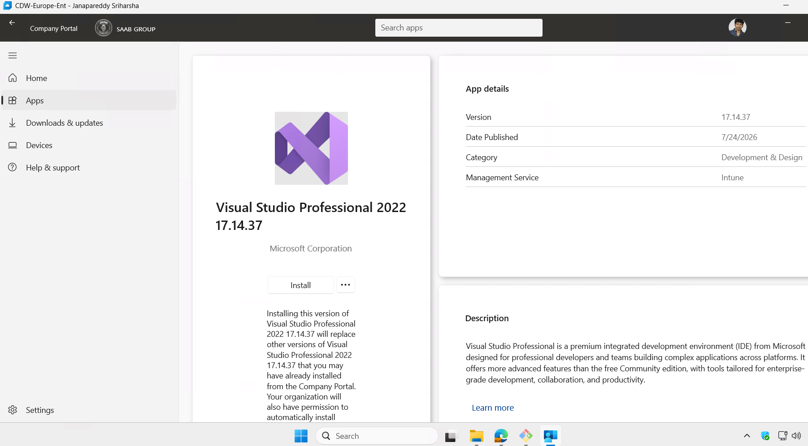
- Open ‘Visual Studio Installer’ from the start menu and select Visual Studio version which was recently installed.
- Click modify button (keep the default selected workloads as it is) in the Workloads select Checkbox ‘.NET desktop development’ And ‘Game development with Unity’ and then select ‘Unity Hub’ in the installation details and click Modify.
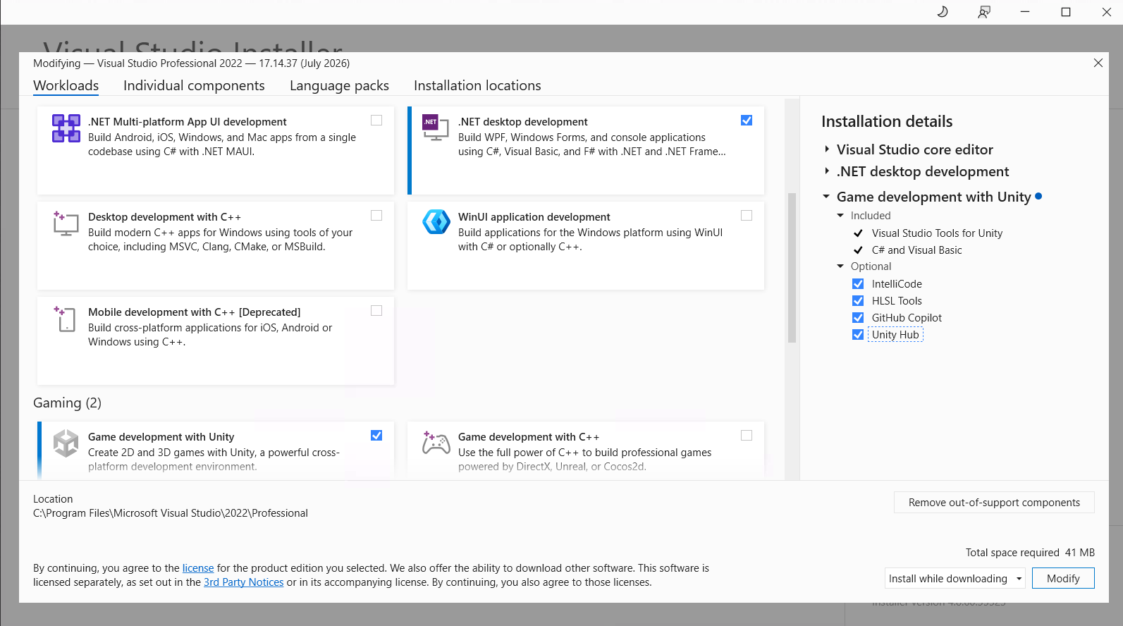
It will allow CDW to install Visual Studio dependencies along with Unity Hub.

- For First time User, Open Visual Studio, select either a Microsoft or GitHub account to sign in.

Open the solution file (from the cloned repo) in Visual Studio from the path below: CSWUnity \vs17\Install_Gizmo\Install_Gizmo.sln

Build Configuration and rules
Building the solution downloads the required NuGet packages, compiles required libraries, creates plugin DLLs, updates the Assets/Plugin folders and prepares the Unity dependencies.
There are two build configurations - Debug | x64 (OR) Release | x64
- Only one should be selected for the build (should not select both i.e. running release and then debug or vice versa). Release is recommended for quick demo and Debug is recommended for developers.
- Select x64 for Windows
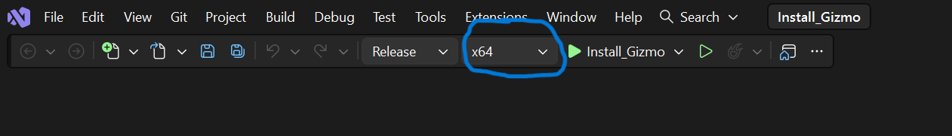
- Build the solution
From menu, select : Build -> Build Solution (or) Press - Ctrl + Shift + B
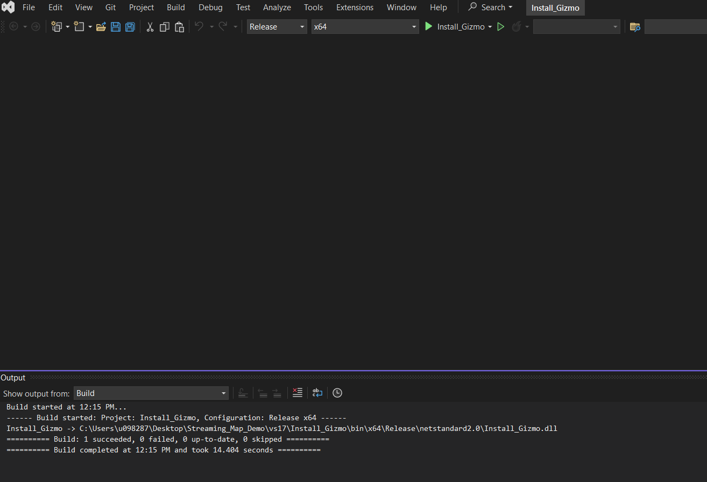

- Switching between the Debug and Release builds (or vice versa)
  - Clear the already generated DLLs using “clean.bat” file located in CSWUnity directory. Double click the file.
  - Reopen “Install_Gizmo.sln” in Visual Studio
  - Select “Release | x64” (or “Debug | x64)
  - Build the solution. This deploys a fresh version of the plugin DLLs.

Build using batch files
Instead of Visual Studio, following batch files can be used for the build.
For Debug: build_x64_d.bat (For developers)
For Release: build_x64.bat (For quick demo)
- These scripts automatically build the SDK and deploy the plugin binaries.
- Switching between the Debug and Release builds (or vice versa)
  - Clear the already generated DLLs using “clean.bat” file. Double click the file to run and it will internally clear the files.
  - Run build_x64.bat / build_x64_d.bat

Running demo in Unity

Installation
- Launch Unity Hub.
  - Ensure Unity Hub is installed on your system (Refer Section 5.1.1). If by chance its not installed, install Unity Hub from internet. Refer https://docs.unity.com/en-us/hub/install-hub-win-mac
  - Open Unity Hub
  - If you do not have a Unity account yet, you can create one during the sign-in process
  - The first time launch may take a little longer because Unity Hub needs to initialize its settings. Following welcome page appears
  - 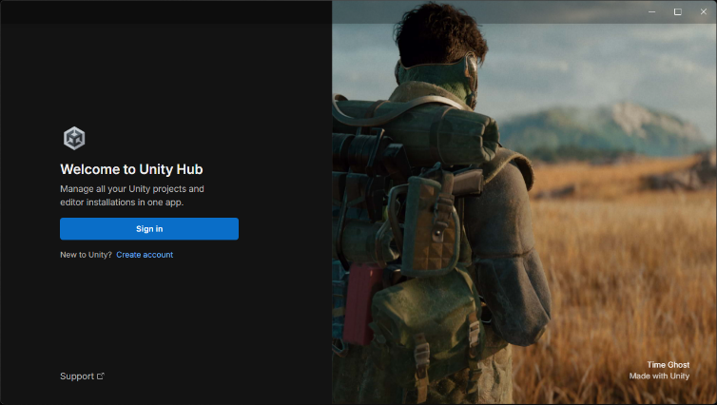
  - Sign in with your existing ID or create a new sign in ID. If Unity asks you to verify your identity, complete the verification steps, for ex:
    - Enter a verification code
    - Approve security request
    - Complete two factor authentication
  - Once login is complete, return to Unity Hub. The top right corner area displays the account information. This confirms that Unity Hub is connected to your Unity account
- Click Projects and then select “Add Project From Disk”. Select CSWUnity /projects/ com.saab.map-streamer folder.
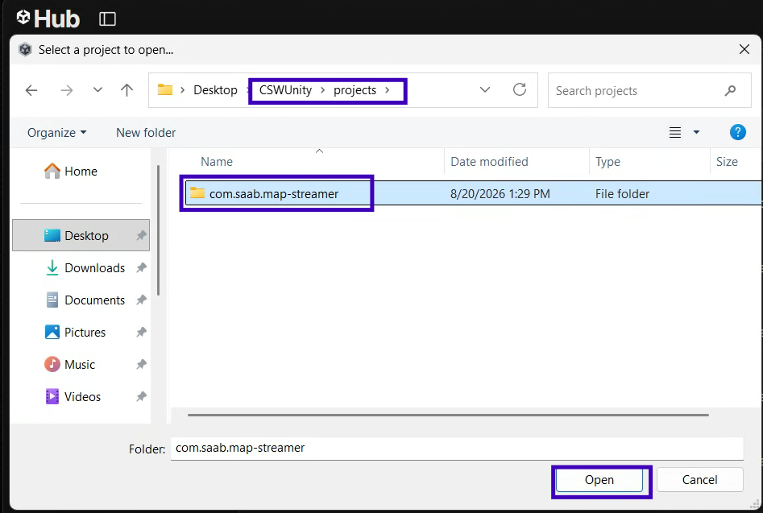
  - Note: Ensure you select the correct unity project directory
  - If you select any other/incorrect directory instead of correct unity project directory. You’ll find no files in unity editor > project > Assets after the project loaded in unity editor. Ex:
  - 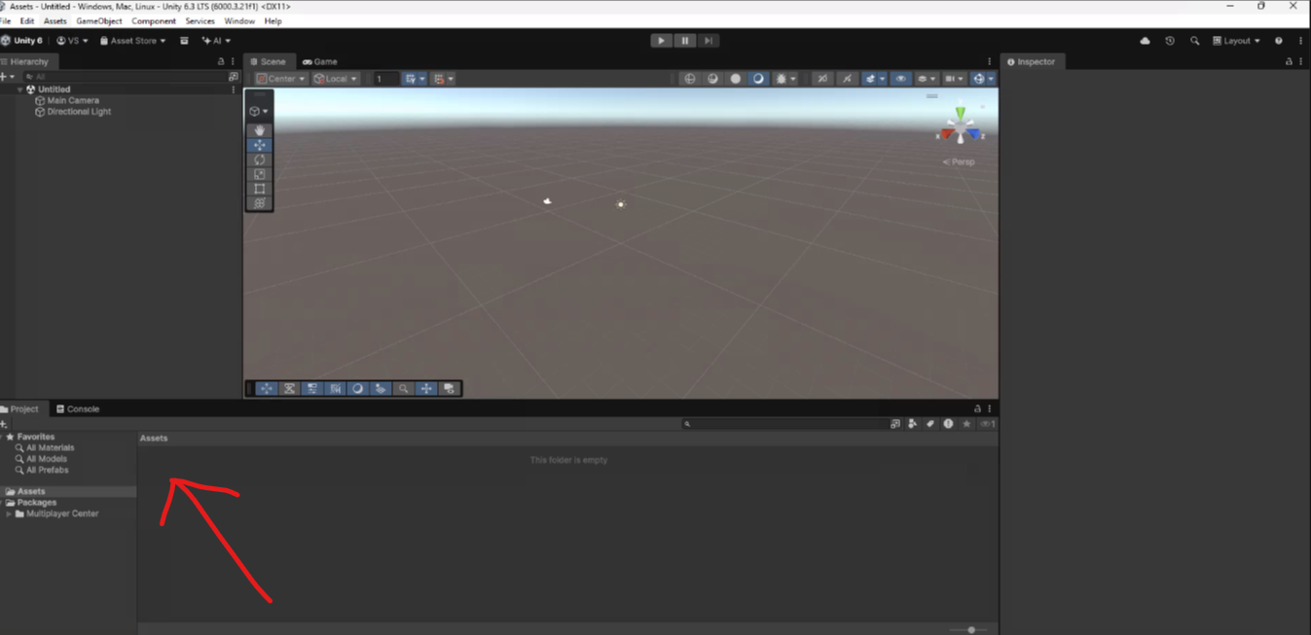
- Click on added project.
  - If Unity Editor is not already installed, a pop-up will appear with recommended version for the project (i.e. 2021.3.17f1) and latest versions also. Select 6.3.21f1 LTS, or latest LTS version.
- Select required build modules for Unity Editor version. For example, if both Linux and Windows are to be supported, select as per the following:
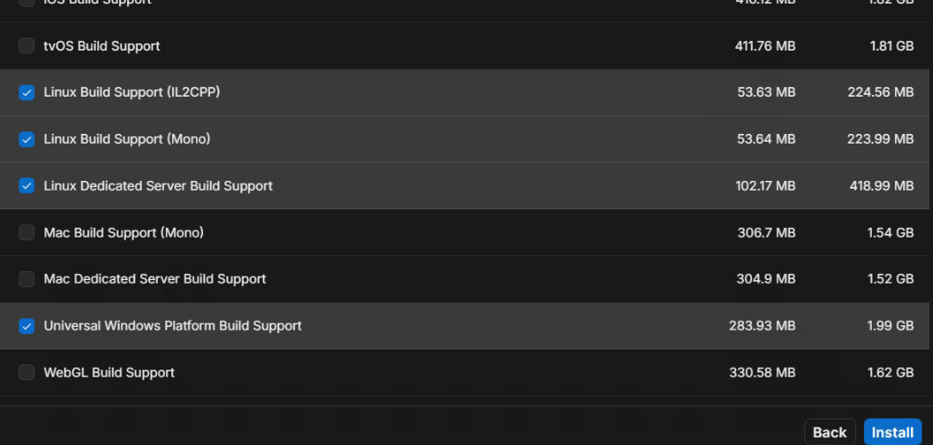
- When running a Unity project for the first time via the Unity Hub, the Unity Editor automatically reads the project's dependency manifest and resolves, downloads and installs all the required registry packages by default.
Note: CDW doesn’t allow a software to further install other software. Once the dependencies/packages are downloaded, to install each registry package manually with “Run with Elevated Access” from the Unity Hub downloads directory i.e.
C:\Users\UserProfile-ID\AppData\Roaming\UnityHub\downloads
Note: App Data Folder is hidden in windows. To view the hidden folder - Click on View Button inside userProfile-ID folder, then click show options and click on Hidden Items. Then App Data folder is visible. Below is a screenshot for a reference.
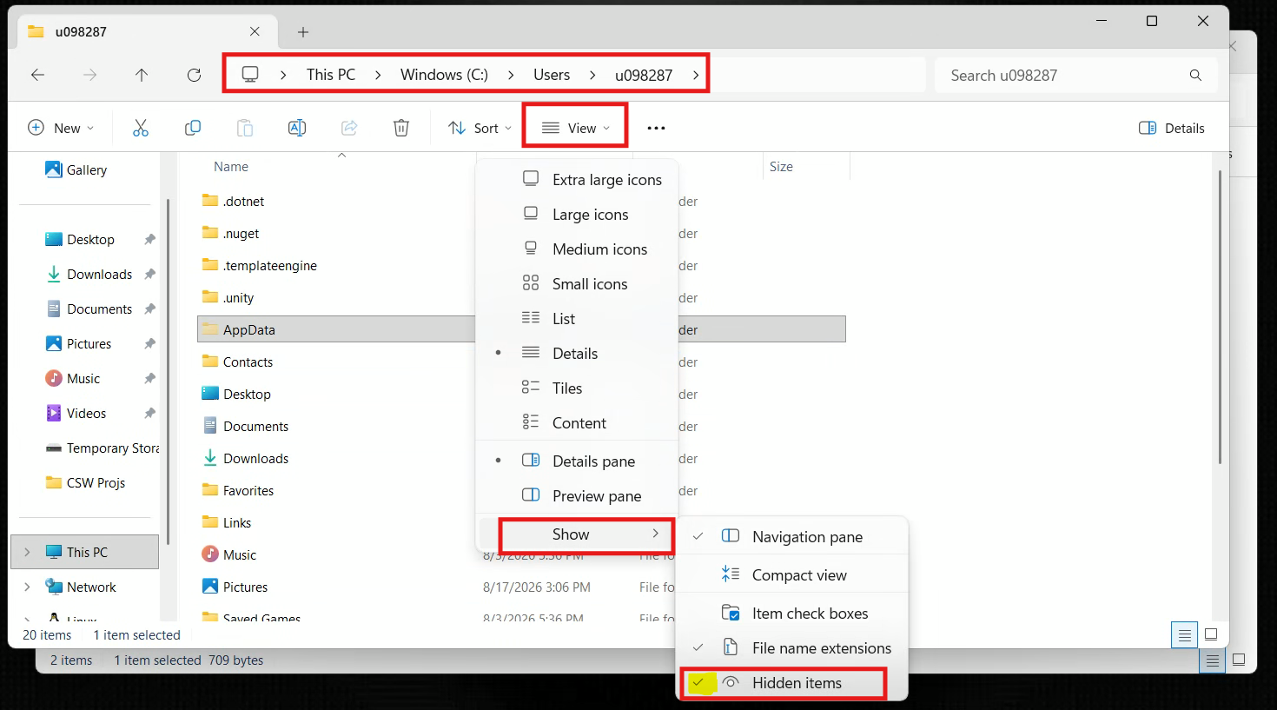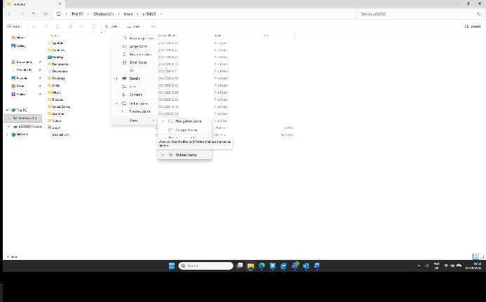

- Ensure to install unity editor “UnitySetup <x.y.z>.exe” file first. Refer picture below. After unity editor gets successfully installed, install unity modules.
- Install each download registry packages by selecting, “Run with elevated access”.
  - Select the package, Right-click the mouse and click 'Show more options.' Then, Left click on 'Run with elevated access' option.
  - Follow the Installation pop-up windows and complete the Installation.
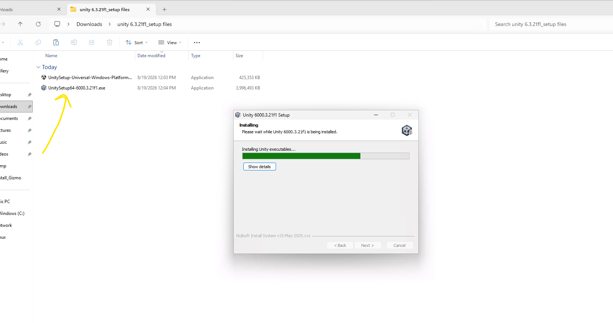
Note: It’s mandatory to install “UnitySetup<x.y.z>.exe” file first. Else unity module won’t find the unity editor install directory path properly and unity editor might not work properly.

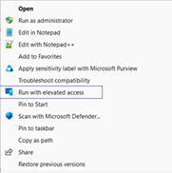

- After Unity Editor successfully installed add editor to Unity Hub
  - Open Unity Hub
  - Click on “Installs” on left side menu
  - Click “Locate” button and select unity editor exe file from the installed location
For Ex: C:\Program Files\Unity 6000.3.21f1\Editor\unity.exe
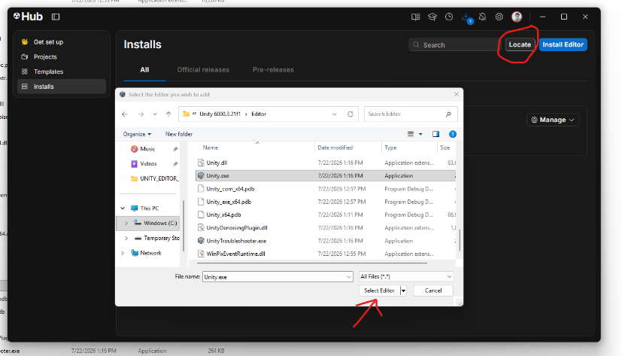

- Open the project
  - Click “Projects” on left side menu
  - Click on “com.saab.map-streamer” project (in the displayed projects list)
  - Wait until Unity editor finishes compiling scripts and importing assets
  - Scene verification: Double Click on “unity project windows -> assets -> Scenes -> Example Scene” to load the example scene

Run the Demo
Press the Play (▶) button at the top of the Unity Editor.
Navigation Controls
Key | Action
W | Move Forward
A | Move Left
S | Move Backward
D | Move Right
Space | Move Up
Ctrl | Move Down
Arrow Keys | Rotate Camera
Shift | Increase Movement Speed
Expected output:
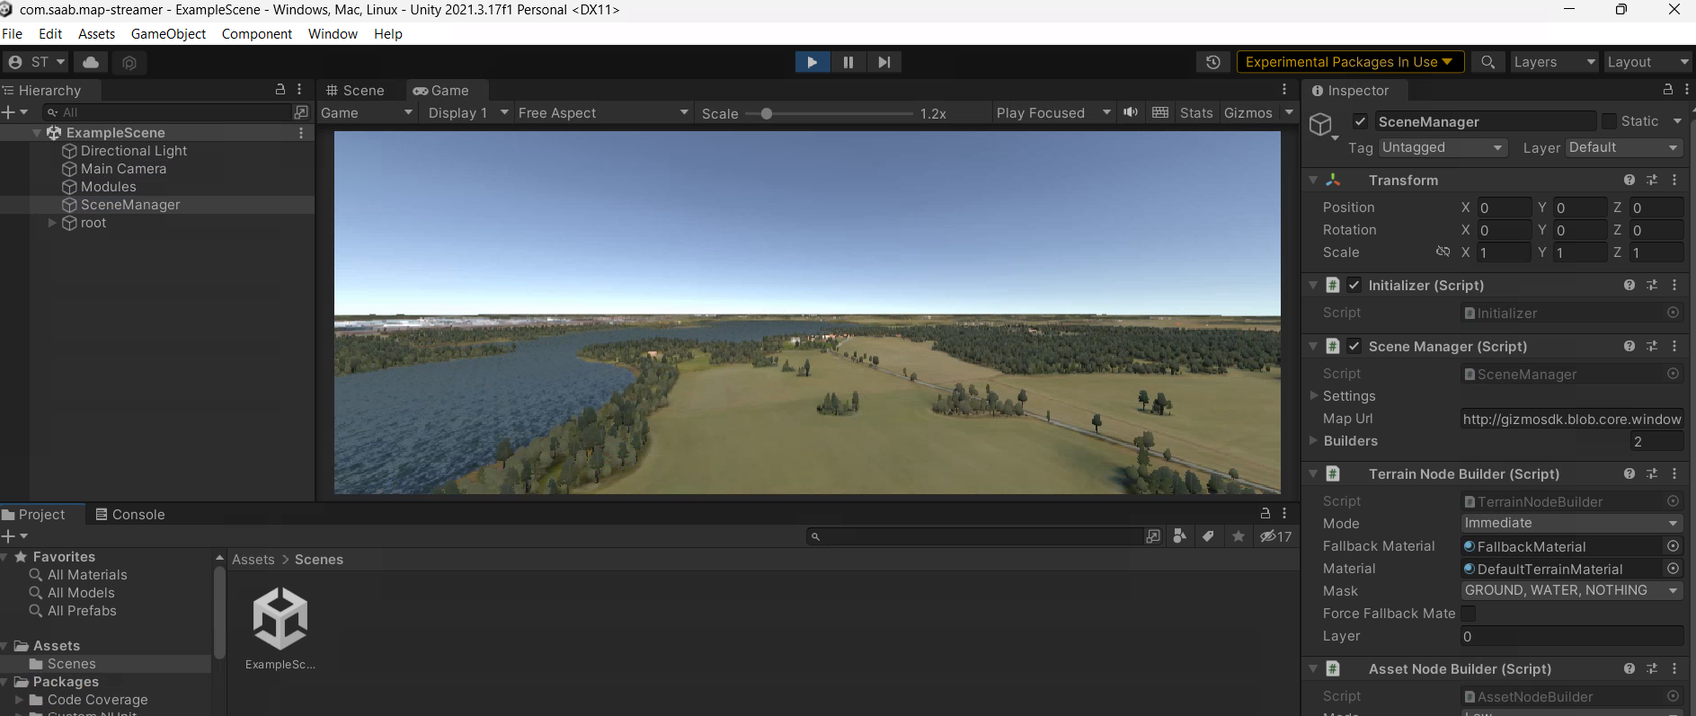

NOTE: If the build is changed from Release to Debug (or) Vice versa (as mentioned in Sec 5.1.2), ensure to close the Unity and open it again.

Troubleshooting
Issue | Resolution
Visual Studio is blank when trying to load .sln file from the downloaded repo | Cache files may be corrupted. Close visual studio, delete the hidden .vs folder (vs17\Install_Gizmo\.vs folder) in the cloned repo and restart Visual Studio
Unity cannot find plugins when builds are switched | Run clean.bat and rebuild.
Camera is in ambiguous reference between GizmoSDK | Run “clean.bat” and then run the build batch file
Warnings in Unity 6.3 project for the first time | While opening the project for the first time in Unity 6.3, there are couple of warnings. Close Unity and reopen, which will resolve the package dependencies. Warnings will go away.
Unity crashes when play button is pressed | It's very likely a native-side mismatch (i.e. Debug DLL + Release Unity player, or vice versa), rebuild cleanly with Clean.bat and one consistent configuration.

Recommendations summary
- CDW with GPU
  - Default CDW doesn’t come with Graphics memory
- Visual Studio 2022 Professional / 2026 Enterprise
  - Original version proposed was VS-2017/2019.
- Unity editor version - Unity 6.3 LTS (6000.3.21f1)
  - Original version where the demo was run is 2021.3.17f1 which has a security issue. The security issue is fixed in 2021.3.45f2 version onwards.
  - As such, unity free/pro will work for the demo. Depending on the user, an edition can be selected for the demo. For commercial deployment, pro version is used.

Open Issues

- WSL limitation on CDW with GPU
  - As per the design, CDW with GPU configured, WSL (Windows Subsystem Linux) will not work anymore. Currently there is no dependency on WSL, but in future if the need arises, need to have a solution.

