**PROGRAM ASSESSMENT REPORT**

Assessment of Student Learning, Annual Program Report 2021-2022

1

Program/Department:

School:

Director/Dean:

Degree:

|  |  |  |
| --- | --- | --- |
| ***Years*** | ***Program Outcomes Assessed for this Academic Year*** | ***Project for the Year*** |
| *Academic Year 0: 2020 - 2021* |  |  |
| Academic Year 1: 2021 - 2022 |  |  |
| Academic Year 2: 2022 - 2023 |  |  |
| Academic Year 3: 2023 - 2024 |  |  |
| Academic Year 4: 2024 - 2025 |  |  |
| Academic Year 5: 2025 - 2026 |  |  |

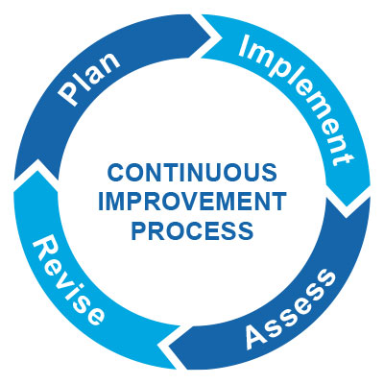

**Section 1: Plan (Please Complete in the Fall)**

1. **What was working for your program last year?**
2. **What was not working for your program last year?**
3. **What kind of project can you work on to improve student performance on your program learning outcomes?**
4. **What program learning outcomes would be the focus of this project?**
5. **Which Institutional Learning Outcome may be tangentially or indirectly involved?**

**Section 2: Implement (Please Complete in the Winter/Spring)**

1. **What evidence will you collect to assess in this project?**



1. **Who is your sample?**
2. **What are some potential biases that could be a part of this assessment project? Are there any ways that we could minimize biases?**
3. **What kind of tool are you using for your assessment (e.g., rubric or scoring guide)? Describe the elements of this tool.**
4. **Will assessment be blind? If not, consider that this may be a weakness.**
5. **Who will be involved in the assessment plan?**

**Section 3: Assess (Suggestion: Winter/Spring)**



1. **What were the results of the academic assessment process?**
2. **What were some strengths? What were some weaknesses?**
3. **What surprised you?**
4. **What were some areas that the program needs to continue to watch?**



**Section 4: Revise (Suggestion: Summer)**

1. **Where are you improving your program?**
2. **What did your adjuncts/faculty/advisory board members think of the results? What were their suggestions?**
3. **How will you use these results to improve your academic program/curriculum?**

.