**Curriculum alignment with Program Outcomes, Institutional Learning Outcomes, and Key Assignments (Insert Year)**

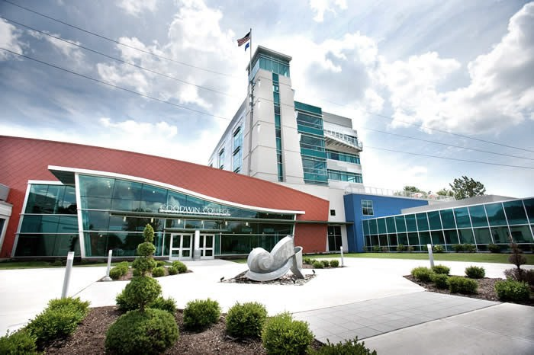

|  |  |  |  |
| --- | --- | --- | --- |
| **Graduate Course** | **Program Outcomes** | **Institutional Learning Outcomes** | **Key Assignment** |
|  |  |  |  |
|  |  |  |  |
|  |  |  |  |
|  |  |  |  |
|  |  |  |  |
|  |  |  |  |
|  |  |  |  |
|  |  |  |  |
|  |  |  |  |
|  |  |  |  |
|  |  |  |  |
|  |  |  |  |
|  |  |  |  |
|  |  |  |  |
|  |  |  |  |
|  |  |  |  |
|  |  |  |  |
|  |  |  |  |



**Student Learning Outcomes and Accreditation Standards used in Assessment**

|  |  |
| --- | --- |
| Program Learning Outcomes | Institutional Learning Outcomes |
|  | 1. **Communication:** Students will be able to effectively express and exchange ideas through various modes of communication including written, oral, and digital. 2. **Information Literacy:** Students will be able to identify relevant information, evaluate alternatives, synthesize findings, and apply solutions. 3. **Career Readiness:** Students will be able to apply their knowledge, skills, and abilities in their chosen field of study. |