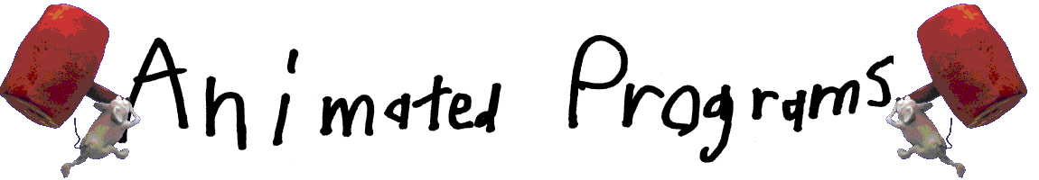
ToonTalk Equivalents

ToonTalk provides graphic representation of typical textual programming commands and constructs.

Computational Abstraction | ToonTalk Concretization
computation | city  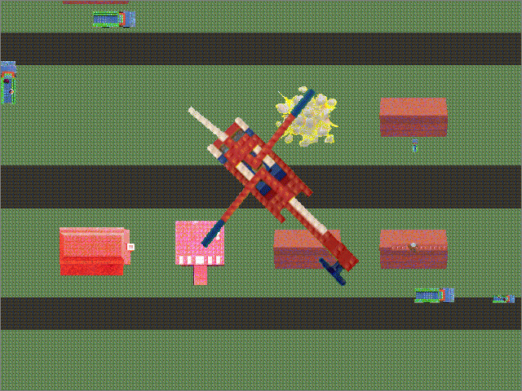
actor  process  concurrent object | house  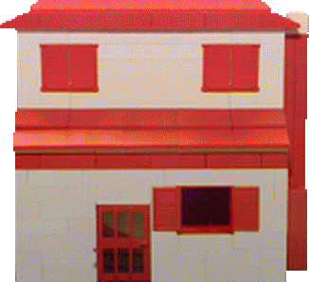
method  clause | robot  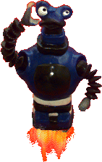
guard  method preconditions | contents of thought bubble  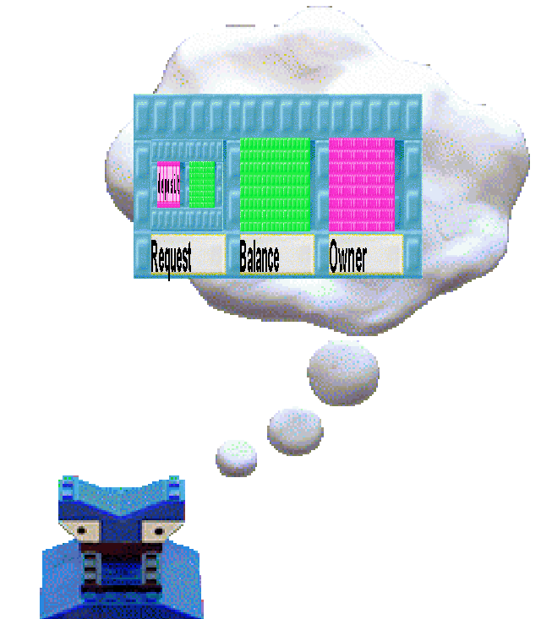
method actions  body | actions taught to a robot
message  array  vector | box  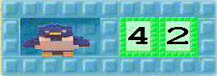
comparison test | set of scales  
process spawning | loaded truck  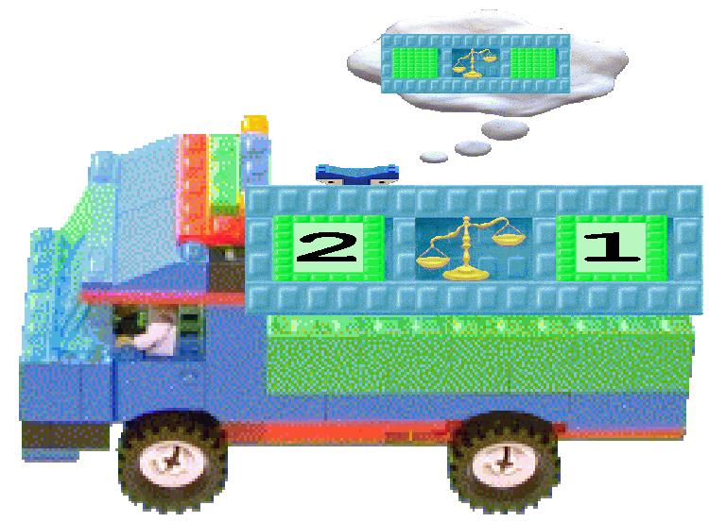
process termination | bomb  

ToonTalk Equivalents Continued

Computational Abstraction | ToonTalk Concretization
constants | numbers, text, pictures, etc.  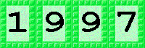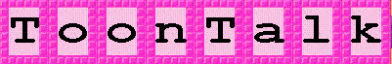
channel transmit capability  message sending | bird  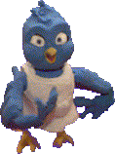
channel receive capability  message receiving | nest  
persistent storage  file | notebook  