Three copies per page – good for laminating.

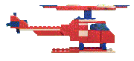 | 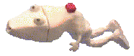 |  | 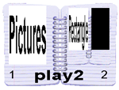 |  |  | 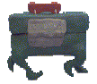 |  | 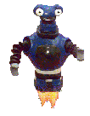 |  |  | 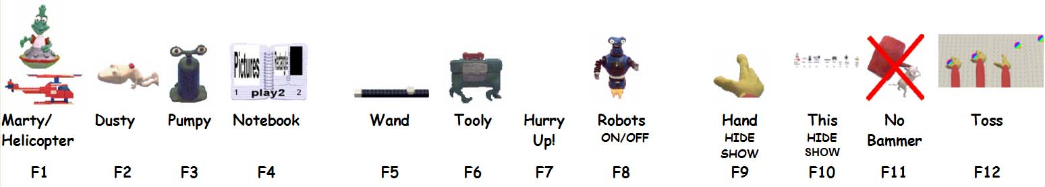 |  | 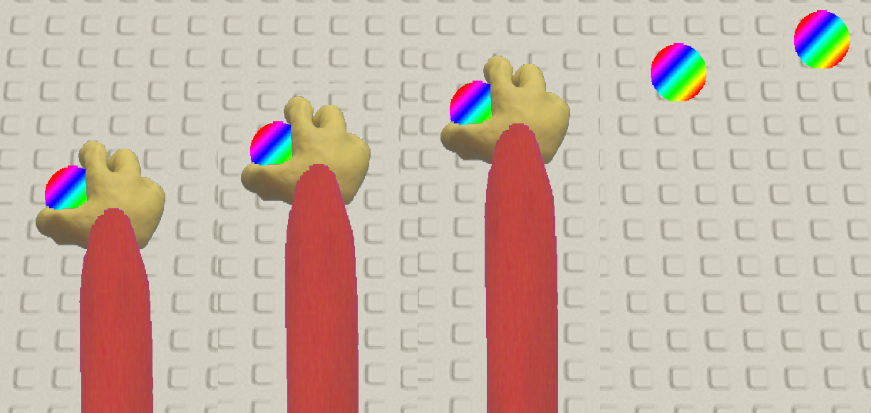
Marty/  Helicopter | Dusty | Pumpy | Notebook |  | Wand | Tooly | Hurry  Up! | Robots  ON/OFF |  | Hand  HIDE  SHOW | This  HIDE  SHOW | No Bammer | Toss
F1 | F2 | F3 | F4 |  | F5 | F6 | F7 | F8 |  | F9 | F10 | F11 | F12

Marty/  Helicopter | Dusty | Pumpy | Notebook |  | Wand | Tooly | Hurry  Up! | Robots  ON/OFF |  | Hand  HIDE  SHOW | This  HIDE  SHOW | No Bammer | Toss
F1 | F2 | F3 | F4 |  | F5 | F6 | F7 | F8 |  | F9 | F10 | F11 | F12

Marty/  Helicopter | Dusty | Pumpy | Notebook |  | Wand | Tooly | Hurry  Up! | Robots  ON/OFF |  | Hand  HIDE  SHOW | This  HIDE  SHOW | No Bammer | Toss
F1 | F2 | F3 | F4 |  | F5 | F6 | F7 | F8 |  | F9 | F10 | F11 | F12

