Activity 5:
Generating a sequence of all rational numbers greater than 1

Pat says: There must be more numbers between 1 and infinity than between 0 and 1. Is Pat right? Explain.

Task A: Think about rational numbers greater than 1

One way to generate the rational numbers greater than 1 is to redo Activity 4 and make a few small changes. But there is a clever way that is much less work.  Rational numbers are all numbers that can be made by dividing two integers. | 

In Activity 4 we made fractions a/b where a is less than b. What kinds of numbers do we get if we had b/a instead?

Explain.

Task B: Programming all rational numbers greater than 1

Train a robot named Divides 1 that takes a number and gives a bird 1 divided by that number. The pictorial instructions are at the end if you need help.

Use the robots from Activity 4 to make all the proper fractions. Run Divides 1 with the nest with all the fractions.

What is the result?

Connect Match Maker with the result. Think about what the robots are producing.

Sally says that something is fishy here. She says:

“There must be the same number of rational numbers from 0 to 1 as there are from 1 to 2. And from 2 to 3. And 3 to 4. So there are an infinite number of intervals of the same size as 0 to 1. So there must be an infinite times more rational numbers greater than 1 than between 0 and 1.”

Do you agree or disagree with Sally? Why?

Activity 5, Task B: Training Divides 1

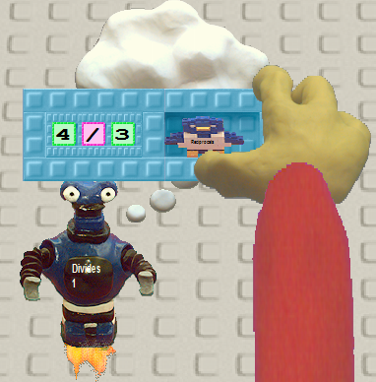 | 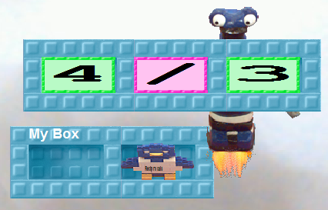
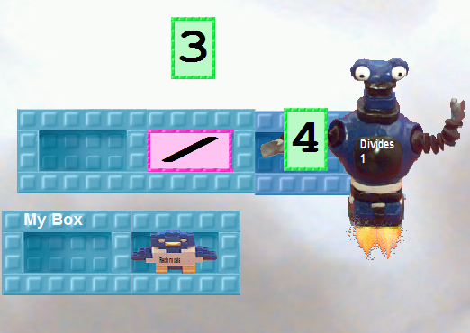 | 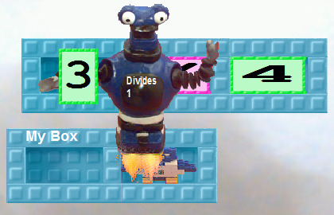
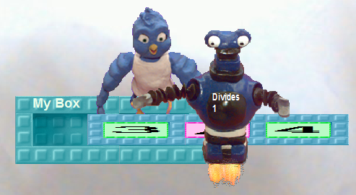 | 

