Activity 8:
Counting Sequences

CHALLENGE
Can we make a sequence of all sequences?

Task A: Exploring the Diagonal team
Load the Diagonal team into ToonTalk. The team should be given a box like



The nest in the Sequences hole will receive a sequence of sequences in boxes. Give the bird a box containing a nest for the first sequence.
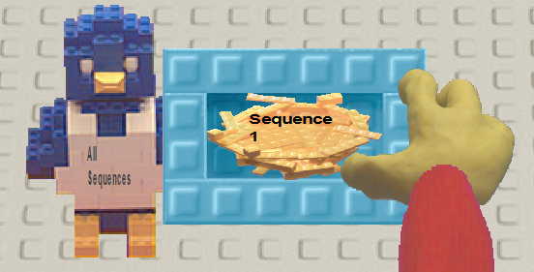

The bird for the Sequence 1 nest should be given the terms of an infinite sequence by the robot of your choice. Then give the All Sequences bird another box with a nest that is the output of another robot (or the same robot with a different box). Repeat this a few times.

Describe how the Diagonal team generates its sequence.

Task B: Changing the Diagonal sequence
Connect the output of the Diagonal sequence to the Add 1 robot.

Is it possible for the resulting sequence to be the same as one of the incoming sequences? (Two sequences are the same if they produce the same numbers in the same order.)

If you used Doubler instead of Add 1 would it change your answer?

Task C: Sequences of Digits

Suppose that all the sequences coming into Diagonal were digits (numbers between 0 and 9). And suppose the output of Diagonal went to a team of robots that when they received a digit and sent out a different digit. (For example, if the incoming digit was 5 they gave the bird a 4. Otherwise they gave the bird a 5.)

Would these changes alter the answers you gave in Task B?

Task D: Counting all the sequences

Suppose you had a robot that took a sequence of digits and produced the decimal number between 0 and 1 with the same digits. For example, if the sequence was 0, 1, 4, 2, 8, 5, 7, 1, 4, 2, 8, 5, 7 … then it would produce .0142857142857… or 1/70.

Write a Web Report answering these questions:

- Is the sequence of all sequences countable?
- Is the sequence of all sequences of digits countable?
- Is the sequence of numbers between 0 and 1 corresponding to sequences of digits countable?
- If the sequence of numbers between 0 and 1 are not countable does that mean there are more numbers between 0 and 1 than rational numbers between 0 and 1?
- Extra credit. Are there numbers between 0 and 1 that cannot be described with a finite number of words?

Read the other Web Reports that answer these questions. If you find reports that give answers different from your report, then add comments to their report.

