 | Activity Sequence 3: Cardinality of Infinite Sequences
Version: 8

Table of Contents
Introduction 1
Knowledge domain 1
Setting 2
General aims of activity sequence 2
Role of collaboration 2
Group work 2
Web Reports 2
Overview of activity sequence 3
Assessment criteria 4
Means of evaluation 4
Description of activities 4
Activity 1: Computing the Even Numbers in Two Ways 4
Activity 2: Combining infinite sequences – part 1 4
Activity 3: Computing a variety of infinite sequences 5
Activity 4: Computing a sequence of all fractions between 0 and 1 5
Activity 5: Computing a sequence of all rational numbers greater than 1 6
Activity 6: Combining infinite sequences – part 2 6
Activity 7: An infinite sequence of rational numbers between any two numbers 6
Activity 8: Counting sequences 7
Tools 8

Introduction

Knowledge domain
- Exploring the cardinality of integers, even numbers, perfect squares, fractions, rational numbers, and real numbers.
- Cardinality of infinite sets is an important part of mathematics. The topic is full of surprises and apparent contradictions that have confused mathematicians and philosophers for millennia.

Related documents
Deliverable 2.1.1 Description of Knowledge Domain (a): Numbers, Big Numbers and Infinity
This lays down the broad aims and discusses common learning obstacles reported in the literature, and positions our work with respect to others.

Related activities
Dependence: This should be after convergence activity sequence since the last activity depends upon having explored the convergence of the sum of inverse powers of 2.

Setting
We tested the initial version of the activity sequence with two girls and two boys in Theydon Bois, England in 2004. They were ten and eleven years old when we started this study. They were selected by the teacher from a class of a little more than 20 students. We worked in the classroom of a local primary school while the teacher taught the rest of the class other subjects. Two of children also installed the software at home. Usually each child had exclusive access to a personal computer for each two hour session. There were 26 sessions where about half the time was focussed on exploring infinity. In only one session did the children work with more than one researcher.
Based upon this testing we made a large number of relatively small revisions to the activity worksheets significantly improving the clarity of the instructions and questions. We tested the second version with two girls and three boys in Oxford, England in 2005. They were twelve and thirteen when we started. The students volunteered and have above average mathematical ability. We met in the school’s computer laboratory after school for 1.5 to 2 hours once a week. Most of the children installed ToonTalk at home. We had only three laptop computers (sometimes only two) without Internet access with ToonTalk installed. There were more computers than children with Internet access but without ToonTalk. There were 18 sessions focussed on the cardinality activity sequence. In only one session did the children work with more than one researcher.

The second version of the activity sequence was tested with five groups in Bulgaria. Two of the groups were in Sofia:
- Group A consists of a boy and two girls aged 12 to 13 years old who met in an office of the Institute of Mathematics and Informatics. The room has black board, 2 PCs and a laptop.
- Group B consists of two boys and a girl aged 13 years old. They worked in a computer lab that included a white board and projection system.

All the students have explicit interests in mathematics and study in specialised classes with emphasis on mathematics and science teaching. Most of them come from families of mathematicians.
For the Sofia A Group there was a call for participation in the Weblabs project among our colleagues from the Faculty and from the Institute of Mathematics and Informatics. Those parents who expressed interest and wish that their children attend the Weblabs classes were invited and explained the goals of the project.
The Sofia B Group consists of children attending extracurricular math classes in the National Mathematics and Science High School, located near the Faculty of Mathematics and Informatics, Sofia University.
The children normally sit one per computer and move freely around the room when they would like to show each other some newly discovered ToonTalk tools, or to demonstrate their programs on an individual computer or by means of the projection system.
The sessions of Sofia groups were once per week for about 90 minutes.
The teachers are George Gachev (a PhD student from Sofia University) and Evgenia Sendova (senior researcher in mathematics and informatics education, Institute of Mathematics and Informatics, Bulgarian Academy of Sciences).
In Plovdiv the Weblabs activities are part of the extracurricular activities for young students with special interests in mathematics, informatics, languages and art organized by the educational centre “Academy 21 century”.
The first year of the Weblabs project we invited students from grades 5 and 6 who had the highest achievements in math contests at regional and national level and had strong interests in working with computers
The computer lab is at the second floor of a modern building. There are six computers, connected in a local net with a cable Internet access and AV devices.
- Group A consists of six boys between 12 and 13 years old. All of them study in a specialized mathematics school and have had during the last 3 years as extracurricular activities courses in programming (Logo, Pascal), web-design and mathematics. They participate in mathematics competitions at regional and national level and are typically among the top 15.
- Group B consists of six boys aged 10 to 11 years old. They attend schools with intensive study of mathematics and English. They have extracurricular activities in informatics and mathematics.
- Group C consists of four boys 9 to 10 years old. They are from a school with intensive study of mathematics and English.
The sessions were once per week for about 90 minutes.
The teacher is Liliana Moneva, is mathematician at the Institute of Mathematics and Informatics, Bulgarian Academy of Sciences, and teaches various courses in programming, web design and computer animation for kids and adults.
In both Bulgarian sites the sessions are planned and the schedule is agreed with the children (and the parents since some of the kids live far away from the place of the classes). The preparation of each class session involved:
- getting familiar with the mathematical topic to be considered in the ToonTalk environment (preparing relevant materials for the teachers and organizing monthly workshops for them),
- studying and adapting the materials developed by the London research group,
- making copies of the adapted materials (in Bulgarian) for every student,
- allowing any topic to take as many classes as necessary to cover it in depth and to provoke discussions on the variety of approaches from mathematical and informatics point of view. Usually the last session was devoted to working in the Weblabs site so as to get familiar with the materials published by the rest of the project participants, to comment on them as well as to publish our own materials on the subject.
- Making efforts to address the needs and interests of the students out of class – by individual sessions or virtually (especially in the cases of students having missed the regular sessions).
The children used ToonTalk at home. They worked on the tasks discussed during the last session and present their solutions during the next one. Some of them published their solutions and posed questions directly to WebLabs web report system. Since many of these students come from families of mathematicians and informaticians they discussed their work with their parents and even grandparents. We have also used the parents’ professional expertise and genuine interest in the project on several occasions.
The children followed an eight-step activity sequence. Each activity was focussed on a particular idea or challenge and consisted of two to five tasks. Some of the tasks were to train robots (i.e. build a program), others were to experiment with previously trained robots (often trying to predict the outcome before trying it), while others were to reflect upon previous activities. The reflective tasks were presented as printed worksheets with open-ended questions for the students to answer. Interviews with a researcher (sometimes individually and sometimes as a group) were conducted aiming to encourage the students to make conjectures, invent definitions, and discuss their current understanding and intuitions. At three points the children were particularly encouraged to write a group report and post it on the project web site.

General aims of activity sequence
The primary aim is to use computational processes, especially infinite (i.e. non-terminating) processes, in exploring and reasoning about the cardinality of sets. Some of the activities involve building processes that compute the same sequence in fundamentally different ways. As the activity sequence progresses the children build infinite sequences of ever more inclusive sets of numbers.
We aim to enable the children to learn to think about infinite sets in new ways:
- To see how a proper subset can have a one-to-one correspondence with the whole set.
- To understand why, for example, the set of every millionth positive integer has the same cardinality as the set of all rational numbers.
- To understand that no sequence can be constructed for the real numbers or for all infinite sequences.
We want to help the children experience infinity in novel ways. They can experience infinity as non-terminating computational processes that they designed, constructed, and observed. They can also experience infinity as tangible computational objects produced by their perpetual processes. These infinite objects the children can experience as things upon which they perform manipulations, operations, and comparisons.
We aim to expose children to a very different kind of mathematics where they need to invent definitions, explore the consequences of their definitions, and reason about novel mathematical situations. We are trying to help the students deepen their understanding of infinity, number, sequences, mappings, sets, countability, and mathematical definitions.

Role of collaboration

Group work
Participants will be instructed to share their work using personal web reports when appropriate. They will also be encouraged to review other's work. Individual work will be presented and inspected in group discussions, to promote a culture of respectfully critical review.

Group discussions will be used as a tool to exemplify the failure of empirical data and “gut feelings” when assessing statements about infinity (or more precisely, about cardinality).

Web Reports
Participants will be prompted to update their personal reports frequently. These reports will allow informal discussion across sites. A structured reflective group report will only be authored at the end of the sequence. The rationale behind this is that we expect students’ perceptions to change as the sequence proceeds, and asking them to record their intermediate thoughts might be confusing both for them and for external readers.

Overview of activity sequence
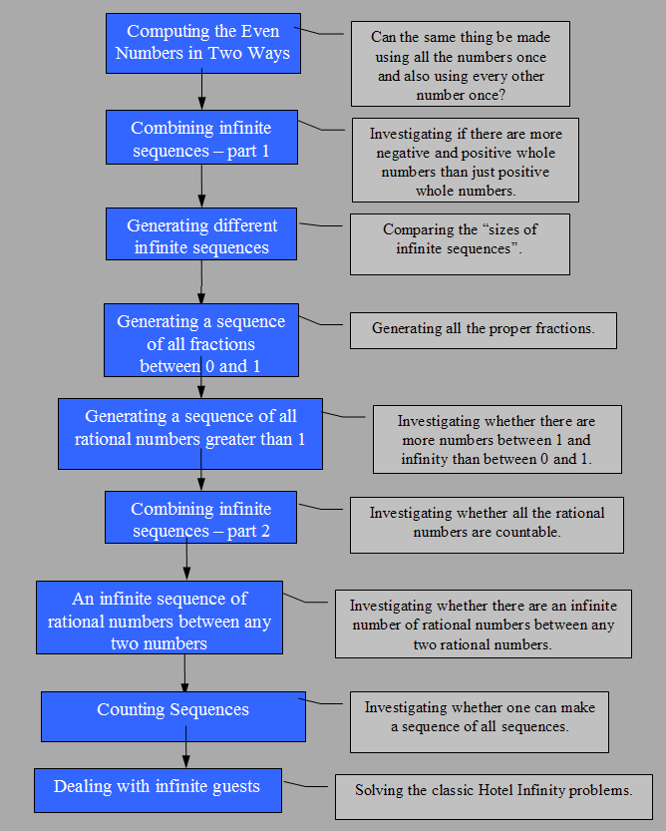

Assessment criteria

That the children can discuss the cardinality of a wide variety of infinite sequences in a way that demonstrates they understand the underlying concepts.

Means of evaluation
Our preliminary plans are to conduct interviews using the questions listed with activities 3, 7, and 8. We will also analyze the programs constructed by the children and their worksheets, and study carefully the web reports and the discussions while the web reports were written.

Description of activities

Activity 1: Computing the Even Numbers in Two Ways

Objectives
To enable the children to explore and understand how the same set can be a proper subset of another and yet be in one-to-one correspondence.

Description
They take the two copies of the stream of natural numbers and give one to a robot that doubles each element and gives the other copy to a robot that throws away every other element.

Collaboration points
This is a great topic for discussion/debate. Normally good methods for determining if some set is larger than another (one-to-one correspondence and part/whole relationship) are in conflict. What does bigger mean?

Activity 2: Combining infinite sequences – part 1

Objectives
See how two infinite sequences can be combined to form a single sequence of the same cardinality. To see that the integers can be placed in one-to-one correspondence with the natural numbers.

Description
A robot is constructed to make the negative integers from the positive integers. Another robot is constructed that takes in two streams and alternately outputs an element from one and then the other. This robot is used to combine the positive and negative integers to generate all the integers.

Collaboration points
Discuss/debate whether the set of all integers really has the same cardinality as the set of natural numbers.

Activity 3: Computing a variety of infinite sequences

Objectives
To discover that all (computable) sequences (that the children invent) are countable and therefore have the same cardinality.

Description
Encourage children to generate infinite sequences that appear to have relatively few elements (e.g. every millionth integer, perfect squares, or the powers of 2) and sequences that seem large (e.g. the sequence whose elements are n/1000000).

Collaboration points
They could share and discuss the cardinality of the sequences made by the different teams, again there is likely to be a range of contradictory responses. A group web report is generated.

Assessment Criteria
Do the students recognize that there is a conflict between the notion of size based upon parts and wholes and the notion of size based upon one-to-one correspondences? Do they understand why they need to abandon the intuitions based upon part/whole relations between finite sets? Do they understand that combining infinite sets does not result in a larger set? Do they understand one can remove an infinite number of elements from a set without changing its cardinality?

Assessment tasks and tools
Individual interviews on the topic: Do all infinite sequences have the same number of terms? The questions to be asked include:

- When you can say two infinite sequences are the same size?
- Can you give an example of two infinite sequences that are different sizes? If not, why not?
- If a sequence includes duplicates is it still countable?
- Can you describe sequences that can’t be programmed?
- Are there infinite sequences that have so many terms they can’t be counted?

Activity 4: Computing a sequence of all fractions between 0 and 1

Objectives
That it is possible to generate a sequence of all proper fractions and that its cardinality is the same as that of the natural numbers.

Description
Eventually the children build a team of two robots to generate 1/2, 1/3, 2/3, 1/4, 2/4, 3/4, 1/5, 2/5 … Note that the more obvious enumerations will fail. E.g. 1/2, 1/3, 1/4, 1/5, 1/6, … 2/3, 2/4, 2/5, 2/6, …

Collaboration points
Discuss/debate whether this really has the same cardinality as the natural numbers (which seems very unlikely but is true!). The simplest robots produce duplicates (e.g. 1/2, 2/4, 3/6 …). Does this matter? Can anyone figure out how to get rid of them?

Activity 5: Computing a sequence of all rational numbers greater than 1

Objectives
To see that it is simple to generate all the rational numbers greater than 1 by taking the reciprocal of each proper fraction.

Description
A simple robot is constructed that takes in a number and puts out its reciprocal. Using this with the robots of activity 4 produces all the rational numbers greater than 1.

Collaboration points
Discuss/debate whether the rational numbers greater than 1 really has the same cardinality as the rational numbers between 0 and 1 (which again, is very surprising and true).

Activity 6: Combining infinite sequences – part 2

Objectives
See how two infinite sequences can be combined to form a single sequence of the same cardinality.

Description
A simple robot is constructed that takes in two streams and alternately outputs an element from one and then the other. This robot is used to combine the rational numbers between 0 and 1 and those greater than 1 to generate the sequence of all positive rational numbers. The positive and negative rational numbers are combined with the same tool.

Collaboration points
Discuss/debate whether all the rational numbers really has the same cardinality as the natural numbers.

Activity 7: An infinite sequence of rational numbers between any two numbers

Objectives
To discover that between any two numbers (even if they are very close) there is not only a rational number but an infinite number of them.

Description
A robot can take each element of the stream of proper fractions and by doing a multiplication and an addition produce all the rational numbers between any two numbers.

Collaboration points
Update/resume the earlier discussion about whether all the rational numbers really has the same cardinality as the natural numbers since the rational numbers are so “dense”. A web report is generated.

Assessment Criteria
Do the students understand that despite the fact that there are an infinite number of rational numbers between any two rational numbers that the entire set is countable?

Assessment tasks and tools
Individual interviews on cardinality of intervals of rational numbers. The questions to be asked include:
- Is there always a number between any two rational numbers?
- How many numbers are there between any two rational numbers?
- Are the rational numbers countable?
- Are all the rational numbers between 0 and 1/1000000 countable?
- Could all the rational numbers “dance” with all the rational numbers between 0 and 1/1000000?

Activity 8: Counting sequences

Objectives
To understand that sequences cannot be counted. And a special case of sequences of digits implies that real numbers can’t be counted.

Description
A team of robots is provided that given a sequence of sequences generates a sequence of the first term of the first sequence, the second term of the second sequences and so on. Then another robot alters every term in the sequence to generate a sequence that wasn’t in the enumeration. Finally a connection to real numbers is made.

Collaboration points
A web report is generated based upon the questions listed below.

Assessment Criteria
Do the students see that not every set is countable. Do they understand that diagonal program they used in this activity means that any attempt to produce a sequence of will fail for uncountable sets. In particular, that the set of all infinite sequences and the real numbers between 0 and 1 are of a different order of infinity.

Assessment tasks and tools
Individual interviews on the cardinality of the set of all infinite sequences and on all the real numbers between 0 and 1. The questions to be asked include:

- Is the sequence of all sequences countable?
- Is the sequence of all sequences of digits countable?
- Is the sequence of numbers between 0 and 1 corresponding to sequences of digits countable?
- If the sequence of numbers between 0 and 1 are not countable does that mean there are more numbers between 0 and 1 than rational numbers between 0 and 1?
- Extra credit. Are there numbers between 0 and 1 that cannot be described with a finite number of words?

Extra Activity: Dealing with Infinite Guests
At the end of the sequence the students build “Resort Infinity” – a mapping of Hilbert’s famous story about Hotel Infinity to ToonTalk. They train robots to solve puzzles involving multiple arrivals of infinite numbers of guests. These robots construct new “cottages” for incoming guests. If the robots ran forever all the incoming guests would be accommodated. The challenges involve handling additional guests after having set in motion an infinite process that is using all available locations.

This activity is “self-accessing” since it is structured as a series of on-line challenges or puzzles. One can inspect the computational world to verify that a correct solution has been applied.

Tools

Tool | Description | Used in | Defined in
Diagonal | Generates a sequence of the first element of the first sequence, the second element of the second sequences and so on | Activity 8: Counting Sequences | New tool
No Copies | Removes duplicates from the fractions between 0 and 1 | Activity 4:  Computing a sequence of all fractions between 0 and 1 | New tool

