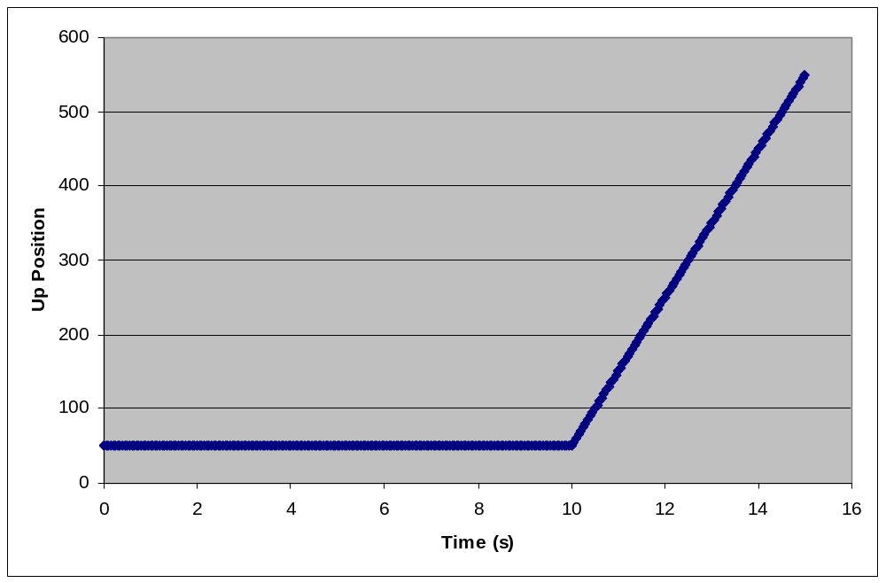
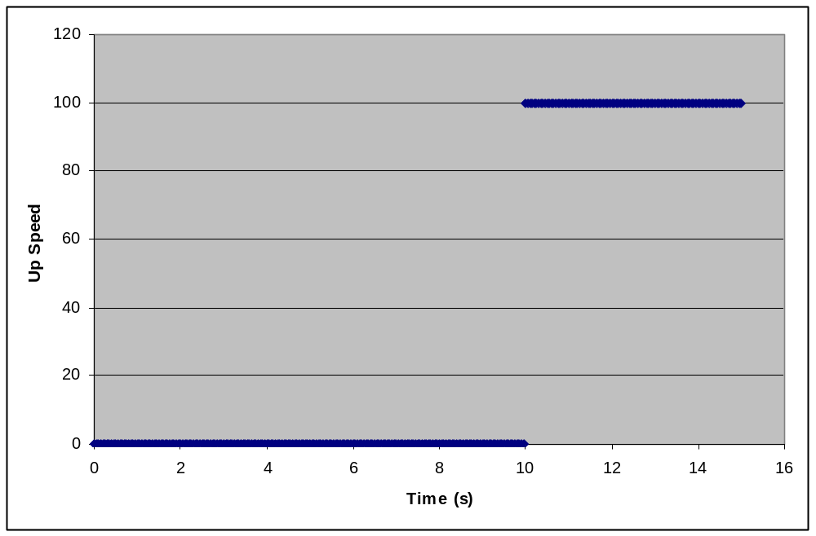
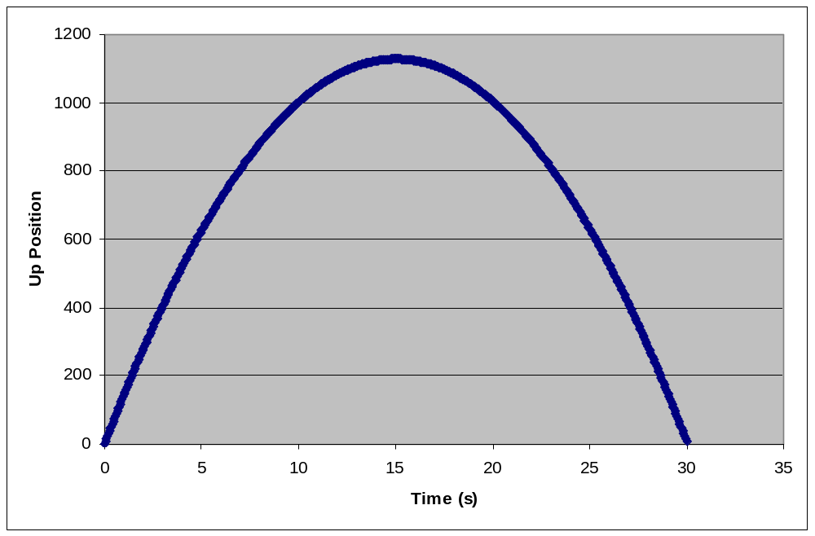
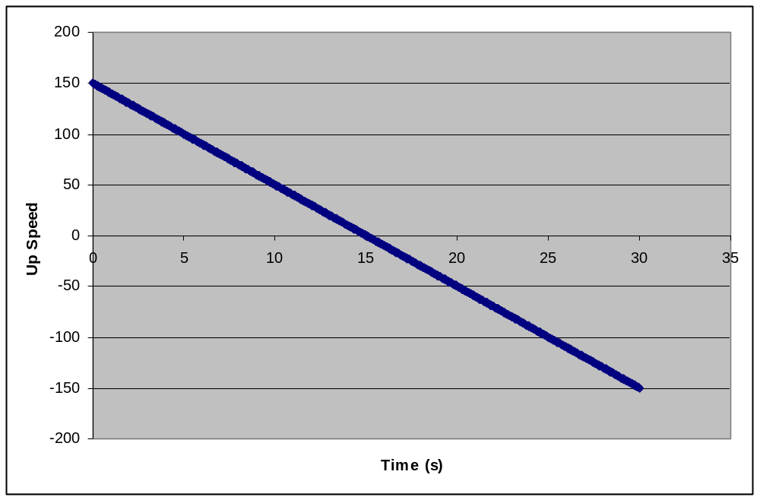
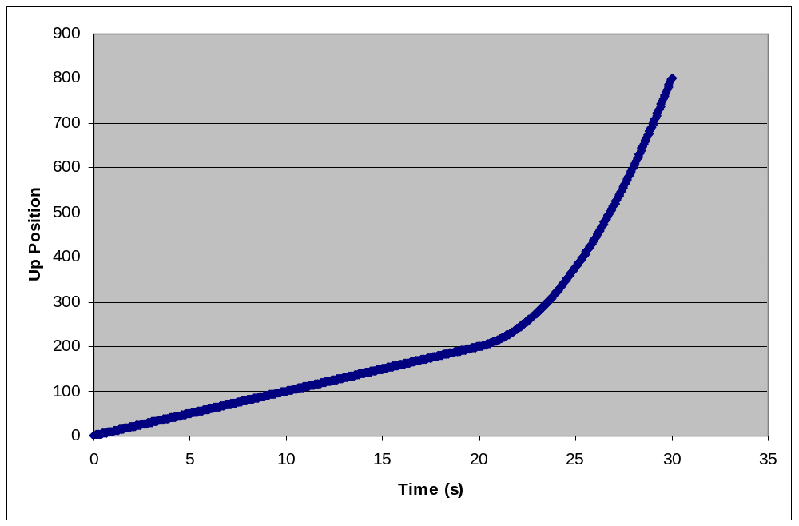
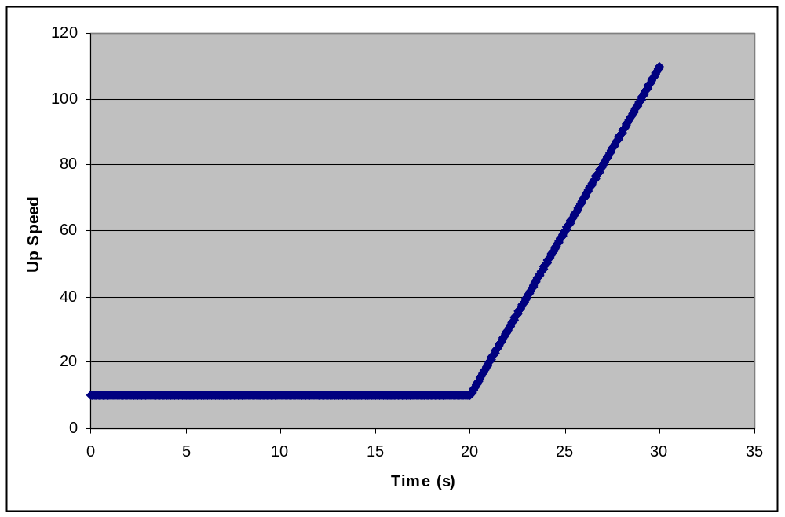
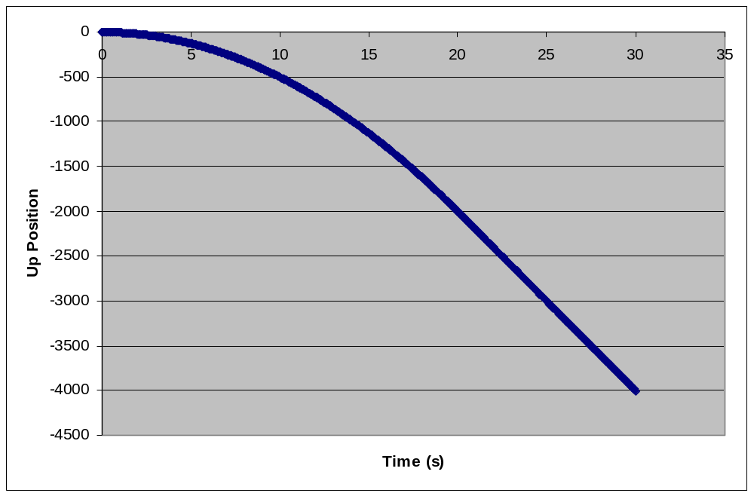
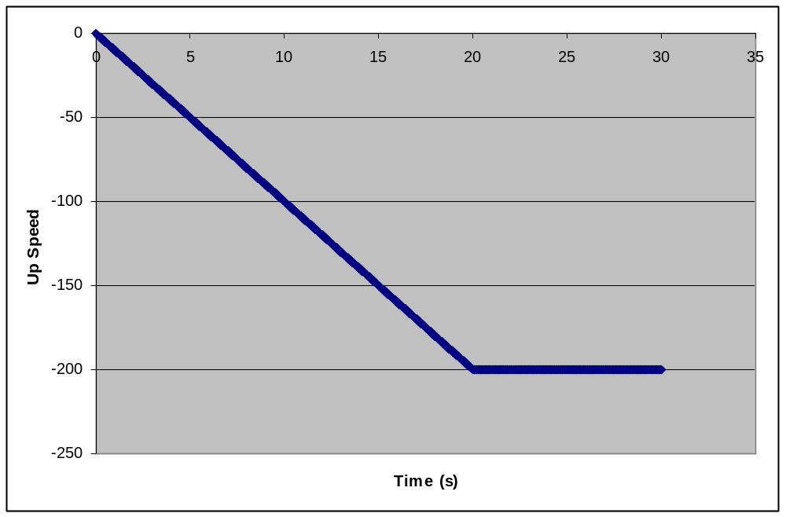
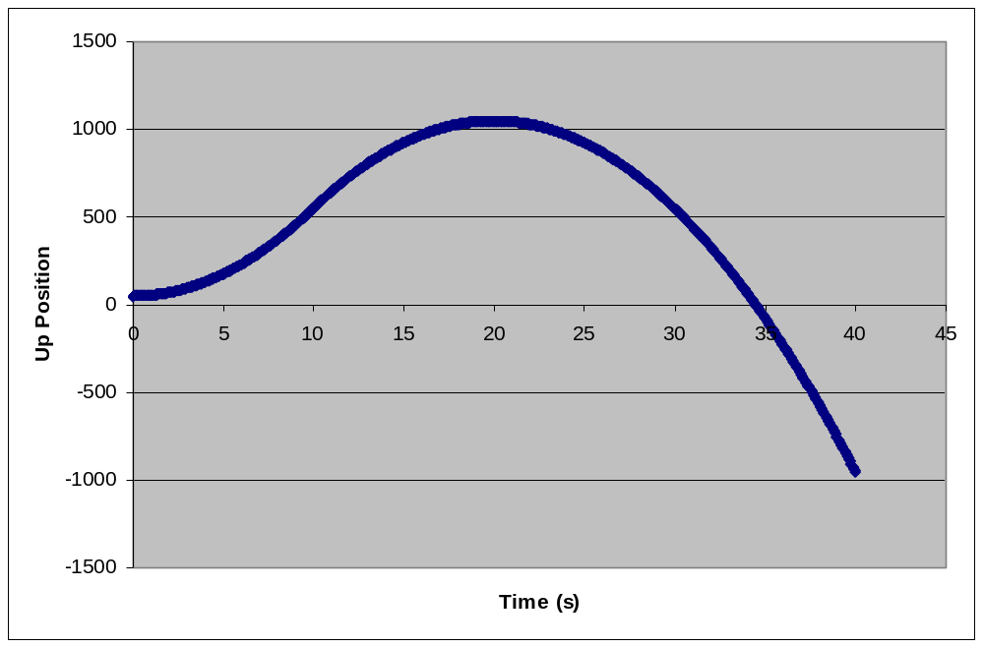
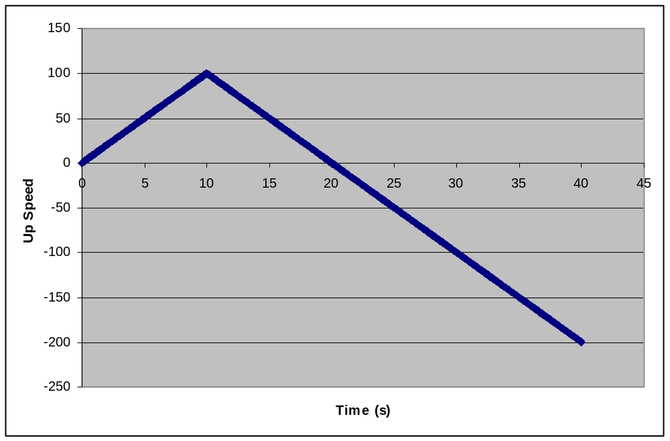
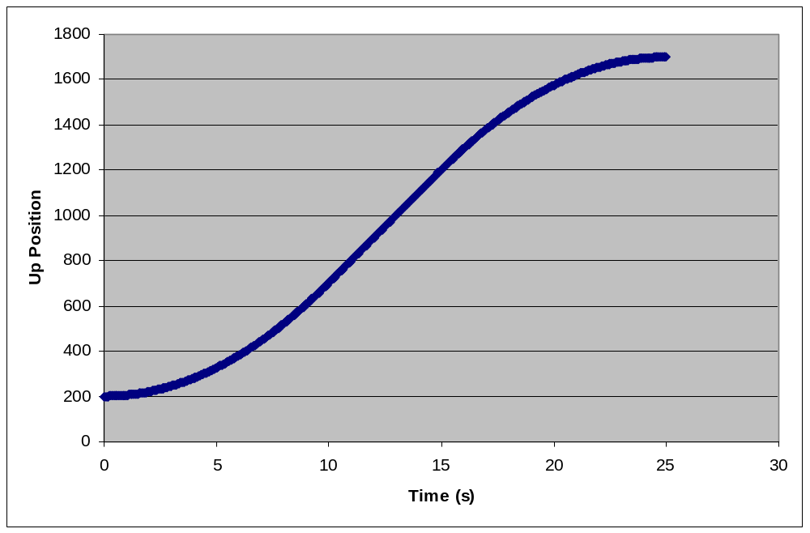
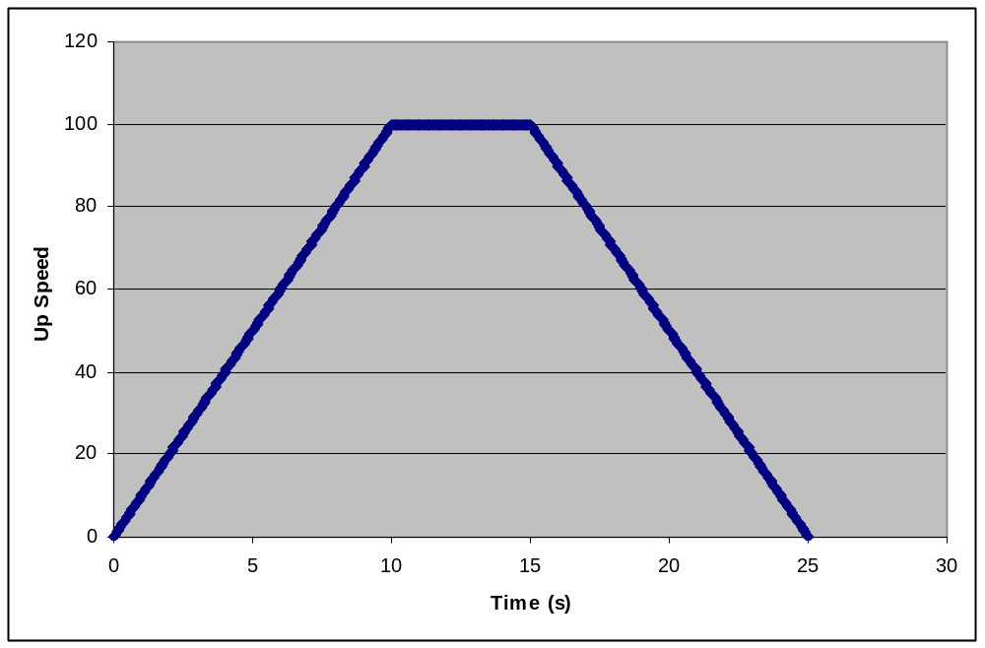
The lander starts at position 50 and does not move for 10 seconds. Then it moves up at a speed of 100.
The lander starts at position 0, and moves up at a decreasing speed. After 15 seconds it reaches its peak height and moves down at an increasing speed.
The lander starts at position 0 and moves up at a speed of 10 for 20 seconds. Then it moves up at an increasing speed.
The lander starts at position 0 and moves down at an increasing speed for 20 seconds. Then it continues at the same speed.
The lander starts at position 50 and moves up at an increasing speed for 10 seconds. Then it begins to slow down. After 20 seconds it reaches its peak height and moves down at an increasing speed.
The lander starts at position 200 and moves up at an increasing speed for 10 seconds. Then it moves at the same speed for 5 seconds. Then it begins to slow down.
