Number Sequences:
design, activities and evaluation

Aims
The aims of these activities are:
- To develop a non-algebraic language for describing, discussing and reasoning about polynomial (and perhaps also some non-polynomial) sequences.
- To develop an understanding of
  - the generation of number sequences,
  - the rules on which sequences rely, and
  - how sequence generation is shaped by the ToonTalk environment
- To gain insight into the relationship between the structure of the programming constructs (e.g. the number of chained robots) and the type and complexity of the corresponding sequence.
- To engage students in a collaborative, semi-structured discourse, both face-to-face and at a distance, about the structure and qualities of number sequences in order to develop students' ability to make conjectures, suggest more than one solution to a problem, and to evaluate arguments and explanations.
It is also intended that the tasks designed to fulfil the above aims will also lead to further activities for addressing some of the main ideas underlying the study of infinite number sequences, which are:
- Expressing and understanding the idea of a series as a sequence of partial sums.
- Reasoning about the limit of a sequence and observing the effects of the rate of convergence or divergence (rate of change).
- Viewing sequence generation as a process and as an object.

Overview of Activities
The activities designed to address these aims are:
- The Add-a-number challenge
- The Add-up challenge
- The Guess my Robot activity
- The Small Change challenge

Overview of Evaluation Methods
In order to assess the ways and extent in which the aims are achieved, we will make use of the following methodological and data-gathering tools:
- Pre- and post-trial evaluations and interviews
- In-action probes or mini-interviews
- Students’ face-to-face discussions
- Students’ WebReports and Task worksheets (students’ answers and contributions)
From an analysis of the data collected during the previous iteration of the activity sequence, we realised that the worksheets could serve as an important means of collecting data to assess students’ evolving conceptions and insights, alongside audio-taping of ongoing transactions. Thus, in order to assess each activity, we have designed a worksheet, in the form of a WebReport template, which serves the two-fold process of directing students’ attention towards the ideas and explorations in which we are interested, as well as providing valuable data through the students’ responses to the questions posed. Analysis of small group discussion alongside individual and group WebReports address in particular the fourth aim above. We will analyze both the products and the arguments the students present. Products will also be analyzed in terms of their adequacy for the task in hand, and their complexity and sophistication. Arguments will be analyzed as situated argumentation: on the one hand, we will apply methods used to analyze classroom mathematical discussion (Yackel & Cobb, 1995; Schwartz, 2002) and on the other hand, we will identify and interpret evidence of situated abstractions (Hoyles & Noss, 1996).
We begin with a description of each activity, how it attempts to address the aims, and how it can be used as an assessment tool.

Activities

I. The Add-a-number challenge:
This activity is a based upon the “Add 1” activity from previous iterations.

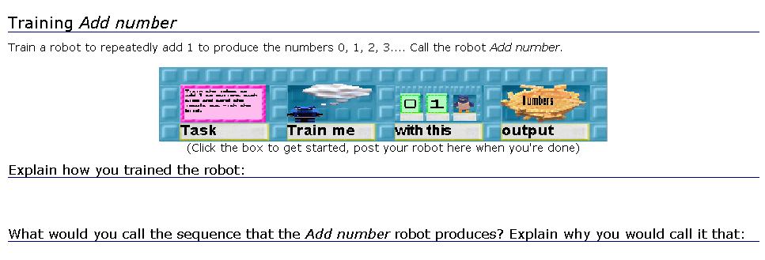
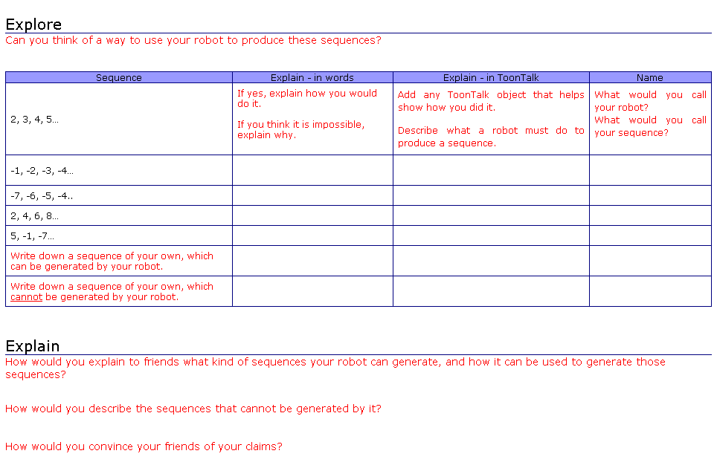
http://www.weblabs.org.uk/wlplone/Members/yish/my_reports/Report.2003-12-18.2548
In this activity, students are asked to train a robot to produce the natural numbers, and to call this robot Add number. This serves as a first introduction to the way in which number sequences are generated (aim 2c) and how this relates to the ToonTalk environment (aim 2c).
In the previous iteration, the activity focused on a robot that could only add 1. For this iteration we have modified the structure of the design of the robot so that the same robot could also be used to generate any arithmetic progression, i.e. where the difference between successive terms of the sequence is a constant number, and could be changed by modifying its input. Using this more general robot makes the activity richer and hopefully will lead students to gain a deeper understanding of the type of rule that generates this kind of sequences (aim 2) and the relationship between the structure of the programming constructs and the type of sequences produced (aim 3).
By asking students if they can use the robot to create other sequences, we aim to encourage exploration and subsequent understanding (within the programming environment) of the generalised rule for an arithmetic progression. Also from the data of the previous iteration, we observed that although some students seemed to be able to explain the rules that would generate other sequences, they were unable to name them correctly. By asking students to name the sequences at the same time as the robot that will produce them, we will gain insight into their understanding of the process.

II. The Add-up challenge
This activity was included in the previous iteration. Its purpose is that students train a robot to add up terms of a sequence (that is produce partial sums). We have redesigned the worksheet so it is similar to the one from the previous activity, with the same objectives; that is both to structure the explorations, and to gather data.

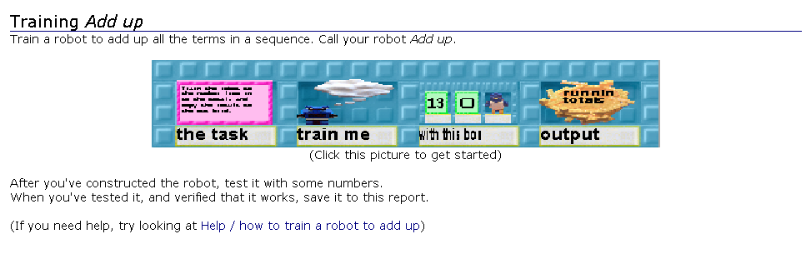
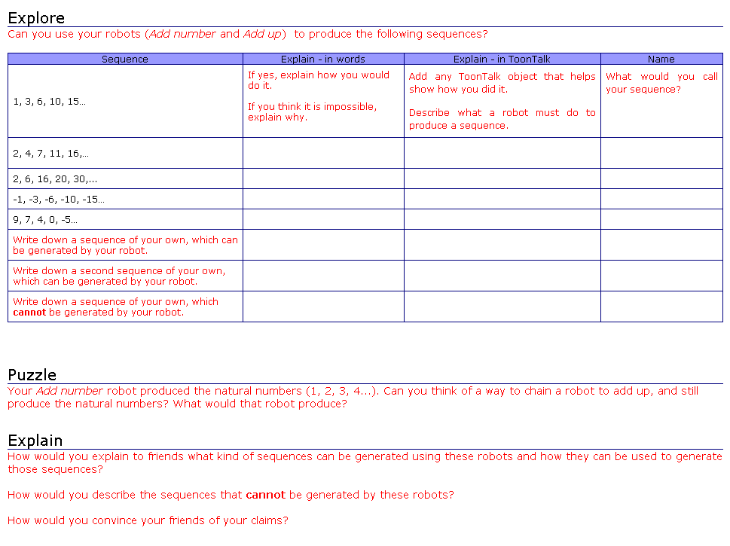
http://www.weblabs.org.uk/wlplone/Members/yish/my_reports/Report.2003-12-18.4817

III. The Guess my Robot activities
- The Guess my Robot game:
This activity focuses on generating and analysing number sequences, through a game of exchanging programmed models of these sequences. In this game, proposers (students) invent a rule for a number sequence. Using the competencies developed through the previous activities, they model it as a ToonTalk robot (procedure) that generates that sequence. They then collect the first few terms of its output in a ToonTalk box and embed it in a web report. Responders can click on the image of the box, and explore its contents in their own ToonTalk environment. They use a variety of tools to uncover the rule of the sequence: ToonTalk programming, Excel and paper and pencil. Once they succeed, they respond to the challenge by posting a comment on the report, which includes a robot they created for generating the same sequence.
This activity is based on the “Guess my rule” game, an activity well-known to many teachers and researchers as a way of encouraging students to discuss and compare the formulation of rules, and in particular the equivalence (or not) of their algebraic symbolism. It has also been employed in the context of Logo and spreadsheets (c.f. Healy & Sutherland, 1990). In its classical form, it has been used as an introduction to functions and to formal algebraic notation. As Carraher and Earnest (2003) have recently reported, even children in younger grades enjoy participating in this game, and can be drawn into a discussion of algebraic nature through using it.
Analyzing and constructing sequences addresses the aim of developing a structural understanding of sequences. The discussion which is triggered by comparing the original robots to those in responses addresses the issue of argumentation. It also serves to establish tools, practices and base knowledge useful for a wide range of subsequent activities such as Convergence and Divergence, Coding and Fibonacci Sequences.
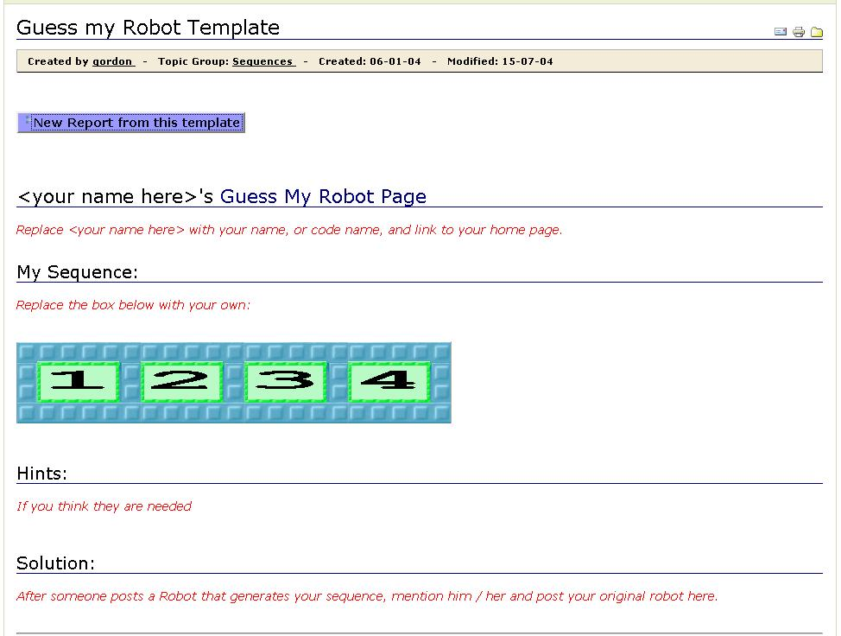
http://www.weblabs.org.uk/wlplone/Members/yish/my_reports/Report.2004-01-06.5051
Several on-line resources are developed to support this activity:
- Rules of the game report for inducting participants in the practice of the game. New players are referred to this page for instructions. In a typical setting, these instructions will be reviewed during a teacher-led group discussion: http://www.weblabs.org.uk/wlplone/Members/yish/my_reports/Report.2004-03-08.1130
- Game page template. Proposers use this template to publish their challenge: http://www.weblabs.org.uk/wlplone/Members/yish/my_reports/Report.2004-01-06.5051
- List of active game pages. Proposers notify the game facilitator when they publish a game page, and she will update this page. Responders use this page to pick a challenge: http://www.weblabs.org.uk/wlplone/Members/yish/my_reports/Report.2004-01-06.5353
- Detailed teacher guide. This is a guidance report, available only to researchers and teachers, which includes teaching hints, references to related readings, issues to note during instruction, etc.:
http://www.weblabs.org.uk/wlplone/Members/yish/my_reports/Report.2004-06-25.4000

Evaluation of Guess my Robot reports
Guess my Robot challenges and responses will be analysed in two levels: product and text.
The “products” are the actual number sequences posted, and their response robots. We also note the form in which these are posted (i.e. compliance with the rules of the game). The sequences and responses are monitored for trajectories in their complexity. The form in which participants post their challenges and responses will be monitored for establishment of norms: do they include a model or just text, do they justify arguments, etc.
A subset of the pages will be examined in greater depth. The text of these pages will be analysed both as argumentation and as narrative. We will monitor it for logical structure of arguments, situated abstractions, situated proofs, reciprocation and author-audience relationship. Conjectures that emerge from this analysis will be validated through stimulated recall interviews.

b) The Guess my Robot tutorial
This is an optional task for students who have completed the Guess my Robot game, and it can be carried out at any point, independently from other activities.
Its purpose is to promote collaboration among the WebLabs participants. It is also designed to help us evaluate students' learning in the Guess my Robot activity, addressing both individual and group learning. It assesses students’ conceptions of number sequences, and their ability to articulate them, in relation to their activity during the Guess my Robot game.
The task consists of asking the children to create a tutorial for new participants. This report should include:
- A set of challenges for new participants.
- A set of hints.
- Example solutions.
- General relevant ToonTalk / math tips.
There are three stages to this task:
- Students start by filling in a personal report on their “favourite sequences”.
- They then compose a tutorial for new players. In the course of writing this tutorial, they discuss:
  - What should be explained in the text of the report?
  - Which challenges should be included as examples, and why?
  - What other tools and examples should be included, and why?
- Finally, they review and comment on similar reports posted by other groups.
A detailed teacher guide is available on-line at:
http://www.weblabs.org.uk/wlplone/Members/yish/my_reports/Report.2004-09-23.0115

As an evaluation tool, this task differs from traditional means of learning evaluation in two ways:
- It is weaved into the activity, rather than being extrinsically imposed on it.
- Students are active partners in the evaluation process.
The philosophy behind this tool stems from the communities of practice framework, but the detailed design is embedded in the specifics of the activity and the domain knowledge.
The central theme of this set of tasks is that students are asked to produce materials for introducing newcomers to the game. The rationales for this approach are:
- It provides a joint enterprise, which is a strong motivation for collaborative work.
- It invokes a mechanism of apprenticeship.

IV. The Small Change challenge
This aim of this activity is to generate the factorial number sequence, but is also used as a means to carry out an overall evaluation of students’ learning. It consists of four parts:
Part 1. Individual work on a programming challenge.
Part 2. Individual work on a response worksheet
Part 3. Individual work on a paper task (see Appendix 3).
Part 4. Group discussion about the factorial function and the Small Change programming challenge.
(Note: Because we would like to use students’ responses for assessment purposes, it is important that parts 2 and 3 are conducted without teacher intervention.)

Part 1. In the first part, the programming challenge, students are given a chain of robots that generate the sequence of the sum of natural numbers:
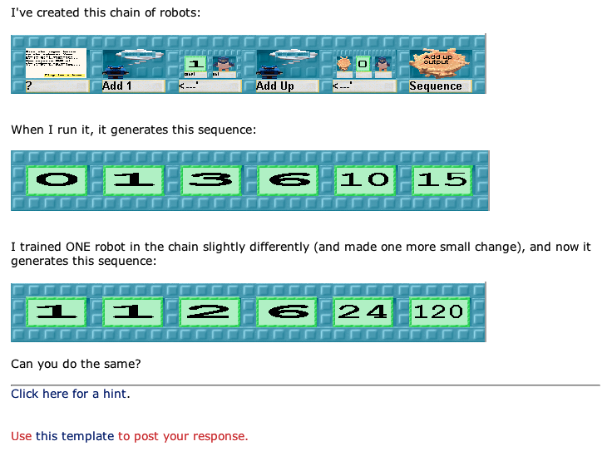
http://www.weblabs.org.uk/wlplone/Members/yish/my_reports/Report.2004-10-04.3852

The first robot, Add 1, generates the natural numbers; the second, Add up, adds them up as they come along and sends out the sequence of partial sums.
The idea is to use this first chain of robots as a model to create the factorial sequence. This will require an understanding of what the given chain of robots does, and an analysis of the factorial sequence (how it is generated). It is intended that students will realise that they only need to change the add operation (represented by the Add Up robot) by a multiplying operation (a new Multiply – or whatever name they wish to give it – robot).
However, an interesting additional challenge in this activity is that the initial value (the number in the middle hole of the input box) also needs to be changed: If they leave 0 as first term of the sequence, when multiplying, they will get a sequence of only zeros. They therefore need to change the initial value to 1 (a hint for this is provided in the back of the instructions square in the box). It is hoped that this additional difficulty will stimulate reflection and further understanding of the way the sequence-generating process works.
Part 2. In order to assess the understandings developed during this activity, we provide students with a separate worksheet template. In this worksheet, we ask the following questions:
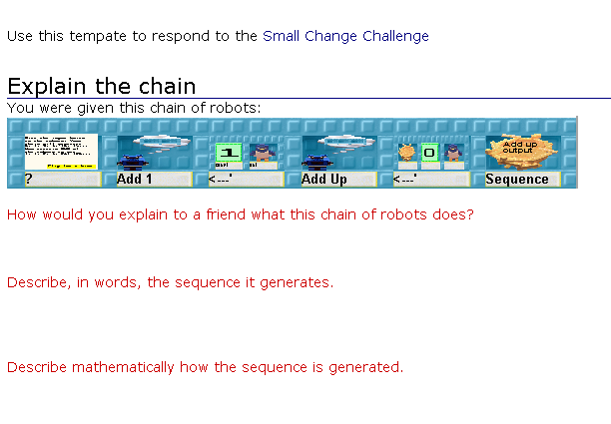
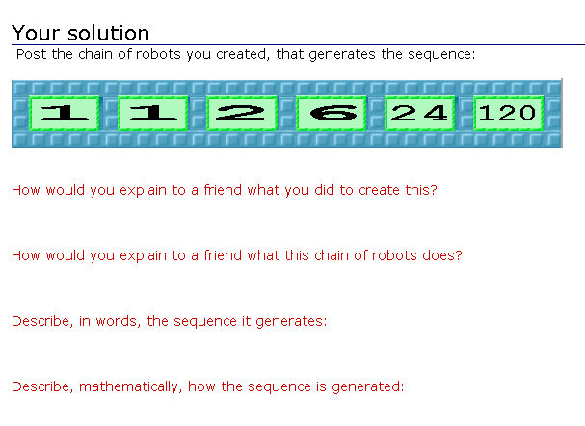
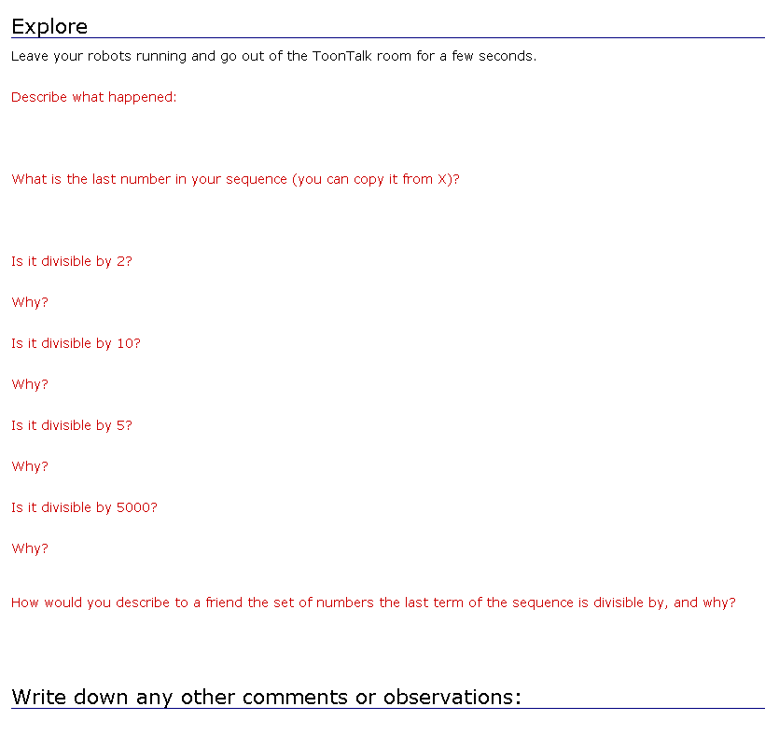
http://www.weblabs.org.uk/wlplone/Members/asacrist/my_reports/Report.2004-11-04.0752

The first set of questions is designed to assess students’ understandings of the given sequence and how it is generated within the ToonTalk environment as well as mathematically.
The second set of questions has the same purpose as the first for the factorial sequence, but it also assesses how students relate (if at all) the two sequences and the way in which they are generated (similar recursive processes).
The third set of questions aims to assess their understanding of the factorial. It is related to the written task (see below) that will be given as a post-activity question, with the intent of comparing how answers are shaped by the situation and context presented (what kind of situated abstractions are generated).
Part 3. Written task:
a) 4! means 4 x 3 x 2 x 1.
5! means 5 x 4 x 3 x 2 x 1.

Is 5! exactly divisible by 3?
Explain your answer.

b) What does 50! mean?

c) Is 50! exactly divisible by 19?
Explain your answer.
These questions were given in a questionnaire as part of a 4-year longitudinal study of mathematical reasoning among students of years 8 and 9, conducted in the UK (the Proof Project). These questions ask students about the divisibility of n! by numbers smaller than n. Only a small percentage of the students in the original study answered this question correctly. The question, as used in the Proof Project, can be found in Küchemann & Hoyles (2003d). The coding frequencies can be found in Küchemann & Hoyles (2003a; 2003b; 2003c).
Part 4. Group Discussion: the Factorial function. The teacher builds on the previous activities to introduce the formal definition of factorial, and an example application. The questions from the written task are discussed, and if time permits students post a consensus response group report.

Description of Evaluation Methods

Pre-trial evaluation of students’ knowledge
We will use two procedures for evaluating students’ knowledge of a number sequence prior to the activities: a short questionnaire and a task-based interview.
The questionnaire will be administered to all students, and if possible to students’ classmates who do not participate in the activities. The questionnaire is designed to assess students’ perception of the complexity of sequences, and at the same time monitor their argumentation skills. If possible, this questionnaire will be administered again, after the four activities, as a post-test.
The interview aims to capture students’ initial intuitions of the concept of a sequence. It incorporates a question widely tested in the UK educational system, to calibrate the range of our students’ responses against the results of prior research.
- How would you explain to a younger student what a number sequence is?
- Look at the following number sequence: 2, 4, 6, 8, …
  - What is the 1st term?
  - What is the term after 8?
  - What is the 10th term?
  - What is the 100th term?
  - How did you work out the 100th term?
  - Describe this sequence in words.
  - Describe this sequence mathematically.
- Give an example of what you would describe as a simple number sequence.
  - Describe this sequence in words.
  - Explain why you think this sequence is simple.
- Give an example of what you would describe as a complicated number sequence.
  - Explain why you think this sequence is complicated.
  - Describe this sequence in words.

Pre-trial questionnaire

This questionnaire is aimed at providing a baseline view of the students’:
- Initial concept of sequence.
- View of complexity.
- Argumentation skills, regarding sequences.
Questions 1 and 2 assess the students’ initial idea of a sequence and how it is generated; the vocabulary of sequences, and the ability to generalise the process to generate terms. It looks at the initial concept of sequence via a direct probe, while questions 3a and 4b look at it through the verbal structures used to describe specific sequences. Questions 3 and 4 look at the students’ notion of complexity through products (sequence examples chosen by students), and through interpretation of the accompanying narrative. The range of examples chosen in these responses is also indicative of students’ initial concept of sequence, e.g. if all examples are arithmetic progressions, we can speculate that students are not aware of other types. These will be particularly useful when compared to the examples given in the post-trial evaluation.

Questionnaire coding (to be completed)
- Constant rule
- Understand ‘term’
- Ability to generalize
- Ability to describe in words
- Ability to describe mathematically
- All sequences = arithmetic

Pre-trial interview
A. The first part of the interview is a stimulated-recall interview based on the questionnaire above.
B. In the second part, students are given a few minutes to answer the following task, and are interviewed about their responses (task-based interview):

The rule of this sequence is ‘Add 3 each time’.
1 4 7 10 13 16 …
The sequence continues in the same way.
Mary says:
“No matter how far you go, there will never be a multiple of three in the sequence”
Is she correct?
Explain how you know

This task was used in a national assessment test in the UK (QCA 2002). Evens & Houssart (2004) carried out a follow-up study, analysing the argumentation of a subset of responses. We will use this task to calibrate our results against the wider study, and to observe argumentation patterns in our subject group, using Evans and Houssart’s framework, as well as that of Schwartz et al (2002). We will compare the findings from this task to the post-trial results.
Evens & Houssart claim that students have deeper understandings than are reflected in formal assessment of their answers. As well as noting the percentage of correct responses and explanations in the paper and pencil responses, we will also examine this claim further in the interview that follows the task. In particular we will code how far their explanations show signs of process knowledge expressed by reference to the ToonTalk environment.

In-action probes and mini-interviews
During the student activity sessions, we will conduct short (1-3 minute) mini-interviews with the students while they work. These interviews will hinge on the task on which they are working at that moment, and focus on probing students’:
- choice of task, when relevant.
- solution strategy.
- reflections on the task and its implications.
The reflections will touch on questions such as:
- The relationship between the initial input, computational process and resulting sequence.
- The mathematical properties of the generated sequences (e.g. “will it ever have a term that is divisible by 7?”).
- The algebraic representations of the sequences (recursive or closed form), and their relationship to the computational construct.

Mid-trial evaluation
Students’ web reports from the add-a-number and add-up tasks will be used as a basis for simulated recall interviews. These interviews will take place during a full day workshop, which will take place at the end of the activity sequence, while the group also works on the Guess my Robot activity.

Post-trial evaluation
The Small Change challenge and Guess my Robot tutorial tasks are designed to evaluate our success with respect the aims proposed at the top of this document. Although they were conceived primarily as evaluation tasks, they have been integrated into the design of activities, in a way that strives to offer pedagogical value.

Discussion
The analysis of previous iterations of this activity sequence suggests several issues which we intend to track more rigorously this year. This section lists those issues, and then discusses how we will refer to them as we evaluate the evolution of students’ knowledge.

Complexity and difficulty
We have noted that some types of sequences are considered “harder” or more “advanced” than others. We would like to track students’ progression from simple to complex sequences. But how do we quantify a sequence’s complexity?
There are two measures we should look at: objective complexity and perceived complexity. The former is derived from the computer science notions of Kolmogorov complexity (Li & Vitányi, 1997) and minimal description length. The later is a cognitive measure, based on what students see as more or less complex. The objective complexity remains fixed, whereas the perceived complexity changes throughout the activity. We expect students to refine their concepts of complexity through the activity. Such refinement is indicative of an evolution in their concepts of number. For example, our evidence shows that students see sequences with negative numbers as more complex. Abandoning this conception signifies students’ acknowledgment of the homogeneity of the number line. Of course, it is hardly ever possible to say with certainty whether a subject holds any particular conception or not. We will discuss this issue further in the methods section below.
A second notion we’re interested in is difficulty. Complexity refers to how hard it is to generate a sequence; difficulty – how hard it is to solve it (i.e. uncover its rule). In this case there are three parameters we can look at: objective, perceived and contextualized difficulty. Perceived difficulty refers to what students see as a difficult problem. Contextualized difficulty is our assessment of the minimal effort required to solve a problem, given the tools available to students. Objective difficulty is measure of the minimal effort in an abstract computational model.
Objective difficulty is hard to compute, and has little significance to our research. However, the convergence of perceived to contextualized difficulty is a significant indicator of situated abstraction. It shows that students are learning to master the tools at their disposal – but not only in a technical manner: they are acknowledging the mathematical meanings embodied in these tools. For example, in previous iterations students suggested using Excel to look at the differences between terms, as a strategy for finding the sequence rule. Such an initiative demonstrates students’ appropriation of tools, but it also suggests that they see some connection between the sequence structure and its derivative sequence.

Argumentation
This issue refers to students’ ability to articulate observations about number sequences, their ability to support claims about these sequences with sound and well-formed mathematical arguments, and their awareness of the structure, qualities and behaviour of sequences.
Previous iterations have shown that students’ initial argumentation is fragmented, ambiguous and sometimes self-contradictory. These observations agree with the literature; Evens & Houssart (2004) use Toulmin’s framework to analyse over 400 responses to a task involving reasoning about number sequence, and categorize students’ arguments. They found about a quarter of the arguments were wrong or irrelevant, 17% were restatement of the question, 9% provided examples and 42% gave some level of justification – which in most cases was incomplete.
In our experiment we noticed that students’ argumentation was influenced by two factors. On the one hand, their explorations with ToonTalk and Excel provide them with a new vocabulary for expressing their ideas. On the other, the collaborative aspects of the activity encourage students to refine their arguments.
One of the most challenging issues in this context is to trace the connections between the situated and generalized elements in students’ discourse. Quite often, the two are tightly intertwined. Even when not, when a subject provides a medium-bound description, how do we know if she intended to convey a more general message? On the other hand, when students provide a formal mathematical knowledge, how can we know if they constructed it from a situated metaphor?

Methods
We can observe student’s actions, register their words, but how can why probe their knowledge? How can we say, with any degree of confidence, anything meaningful about the concepts and meanings they possess? This question spans across the social sciences. There are two main approaches to it:
- Positivist: focus on students’ actions, and the products of these actions, as the main evidence to their mental states.
- Interpretist: focus on students’ articulation of their knowledge.
Both approaches have their strengths and weaknesses. If we focus on students’ products, we have unified and seemingly objective criteria. However, we can never know how these products were obtained: do they reflect deep understandings or technical rote learning? Yet when we rely on students’ articulations, we assume that they will express everything they know in words. However, people often have intuitions which they find hard to verbalize. Do we discard these? On the other hand, we are exposed to many extrinsic disturbances, such as students’ tendency to please their interviewer.
Our approach is to try and triangulate and synthesize data from both approaches. We will look at:
- The products of students’ work, as published in WebReports.
- The accompanying text in these WebReports.
- Field notes noting students’ work process, leading to these products.
- In-action interviews, aiming to illuminate the thought process accompanying the work process.
- Stimulated recall interviews, in which we will provoke students to share their reflections on the activities and their products, and express the conceptualizations they have developed through them.

References
Carraher, D. & Earnest, D. (2003) Guess My Rule Revisited in Proceedings of 27th International Conference for the Psychology of Mathematics Education, 2003: Honolulu
Evens, H. & Houssart, J. (2004) Categorizing pupils’ written answers to a mathematics test question: ‘I know but I can’t explain’, Educational Research, 46(3), pp. 269-282.
Healy, L. & Sutherland, R. (1990) Exploring Mathematics with Spreadsheets (Hemel Hempstead, Simon & Schuster).
Küchemann, D. & Hoyles, C. (2003a) Technical Report for Longitudinal Proof Project Year 8 Survey 2000: Technical Report Institute of Education http://www.ioe.ac.uk/proof/Y8TecRepMain.pdf
Küchemann, D. & Hoyles, C. (2003b) Technical Report for Longitudinal Proof Project Year 9 Survey 2001 Volume 1: Technical Report Institute of Education http://www.ioe.ac.uk/proof/Y9TecRepMain.pdf
Küchemann, D. & Hoyles, C. (2003c) Technical Report for Longitudinal Proof Project Year 10 Survey 2002 Volume 1: Technical Report Institute of Education http://www.ioe.ac.uk/proof/Y10TecRepMain.pdf
Küchemann, D. & Hoyles, C. (2003d) Technical Report for Longitudinal Proof Project Year 8 Survey 2000, APPENDIX A: The Baseline Mathematics Test: Technical Report Institute of Education http://www.ioe.ac.uk/proof/Y8TecRepAppend.pdf
Qualifications and Curriculum Authority (2002) Standards at key stage 2, English, mathematics and science: a report for headteachers, class teachers and assessment coordinators on the 2001 National Curriculum assessments for 11-year-olds (Sudbury: QCA).
Schwarz, B.B., Neuman, Y., Gil, J. & Ilya, M. (2002) Construction of Collective and Individual Knowledge in Argumentative Activity, The Journal of the Learning Sciences, 12(2).
- How would you explain to a younger student what a number sequence is?

- Look at the following number sequence: 2, 4, 6, 8, …
  - What is the 1st term? __________
  - What is the term after 8? __________
  - What is the 10th term? __________
  - What is the 100th term? __________
  - How did you work out the 100th term?

  - Describe this sequence in words:

  - Describe this sequence mathematically:

- Give an example of what you would describe as a simple number sequence:

  - Describe this sequence in words:

  - Explain why you think this sequence is simple:

- Give an example of what you would describe as a complicated number sequence:

  - Explain why you think this sequence is complicated:

  - Describe this sequence in words:

The rule of this sequence is ‘add 3 each time’.
1 4 7 10 13 16 …

The sequence continues in the same way.

Mary says:
“No matter how far you go, there will never be a multiple of three in the sequence”

Is she correct?  Yes / No
Circle Yes or No

Explain how you know

 ………………………………………………………
……………………………………………………………
……………………………………………………………
……………………………………………………………

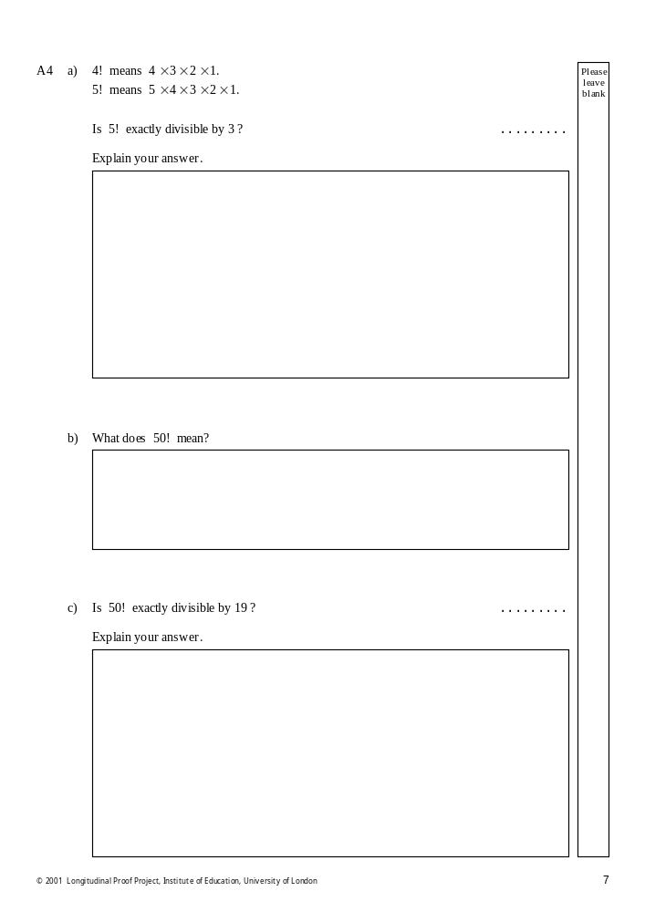

See Appendix 3.
See Appendix 1.
It may be worth noting that in question 4 we changed the order of the questions, asking first about the complexity, and later about the description. This is because a more complicated sequence can be much harder to describe in words.
See Appendix 2.

