TTRcx rel 0.3 – 9 Apr. 03
This release of the TTRcx.dll addresses a number of optimization issues:
- It does no longer spawn a separate nqc process. All the relevant code is embedded in the dll. As a consequence, it allows working with TT at full screen.
- The communication between TT and the RCX is fairly optimized. One can poll a value from the RCX at a rate as low as 1/10 sec. Given the nature of the packet-based communication protocol that uses the infrared link running at 2400 Baud, this seems quite a good result.
- The dll is significantly smaller (68 KByte).
The API is unchanged, so you can still refer to the old documentation.

Installation
Unpack the TTRcx.zip file and copy the TTRcx.dll file into the TT root directory (usually C:\Program Files\Animated Programs\ToonTalk\)

Testing of the dll
- Make sure that the RCX is switched on and within reach of the IR tower.
- If you haven’t yet downloaded the firmware (or you’ve changed the batteries in your RCX):
  - Download the firmware file from ftp://weblabs.eu.com/toontalk/TTRCX/LEGO firmware/firm0328.lgo
  - Download the nqc program from ftp://weblabs.eu.com/toontalk/TTRCX/LEGO firmware/nqc.exe
  - Put both files in the same folder
  - Run a command shell and cd into this folder
  - Type the command
nqc –Scom1 –firmware firm0328.lgo
If your IR tower is connected to a different port, change the –S option accordingly: -Scom2 or –SUSB etc.
The firmware download takes a few minutes to complete.
- Download and unpack the file ftp://weblabs.eu.com/toontalk/TTRCX/release03/notebooks.zip
- Import into TT the TTRcxSampleCode.tt notebook that contains the RCX foreign bird and the syntax of all available commands. A warning message appears saying that you’re about to load an external dll, unless you have disabled it. Click on “Yes”.
- Set the tower port to the proper value. In the following, we’ll assume your IR tower is connected on port com1. See fig. 1.
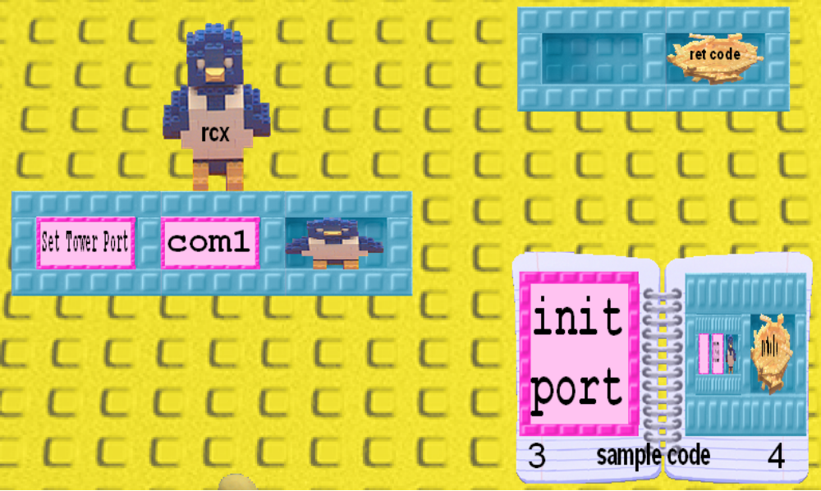
Fig. 1: Setting tower port.

If everything is working correctly, you will hear a sound from the RCX and the foreign bird will return the string “OK” to its nest (“ret code”).

What you can do with the RCX foreign bird
- Play a sound
- Control motors
- Set the RCX display to a sensor, message or variable value.
- Send a message
- Set sensor type (the RCX has no plug-and-play support, you should always tell it what kind of sensors you’ve attached)
- Get a sensor value
- Set and get a variable

Extending TT with an RCX sensor
- Import into TT the TTRcxSensor.tt notebook that contains an abstraction layer offering robots that encapsulate the low level API.
- Hit F8 to stop all robots
- Extract from the notebook the “Poll sensor1” box, and unpack it as in fig. 2.
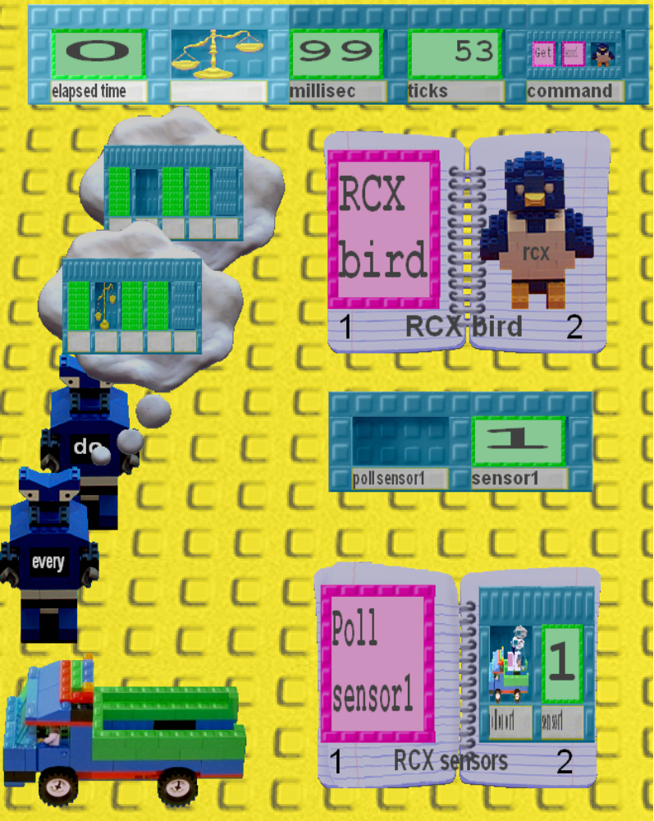
Fig. 2: The “Poll sensor1” box unpacked. The truck is loaded with a robot team that executes the “Get sensor1” command every 100 millisecond (i.e. when the elapsed time is greater than 99 msec.). The object in the box labeled “sensor1” receives the return value from the RCX bird.

You can change the sampling rate and the sensor you’re monitoring. To launch the process, load the truck with the robots, the 5-hole-box on top of the figure and the “RCX bird” notebook. Hit f8 again to restart the robots and watch how the “sensor1” value changes.

Adding a notebook to a truck is a useful packaging technique. The robot that executes the LEGO brick commands needs the RCX foreign file. When you build the robot the RCX bird ought to be found in your personal notebook. However, assuming that all users should include that bird in their personal notebook is too error prone.

The “sensor1” is a number with robots on the back that receive the value read from the RCX sensor and update its “look”.

The remaining of the “RCX sensors” notebook contains the various pieces of code used by this example.

We have tested this code with two sensors (for example, start two trucks on “senor1” and “sensor3”). It works, but the performance is degraded.

Our next task is to start implementing some of the examples described in the “One dimensional motion experiments” section of our tangibles report.

Since the RCX sensors monitoring is handled by robots running in a separate house it would be nice to decorate its roof with an image of that sensor. The last page of the notebook contains a sample file for the touch sensor. To use it, Copy the htRCXtouch.GIF file into the
C:\Program Files\Animated Programs\ToonTalk\Downloads\
folder.

Ken, when we tried to decorate the roof using the provided sensor TT (ver. 2.88) displays it slightly off the actual roof involved.

