ToonTalk Evaluation Report (6)
Date : January 7, 2000
To : Ken Kahn
From: T. Matsuzawa / JEI

- Environment
PC IBM PC/AT Compatible
OS Windows 98
Application ToonTalk Beta 221299

- Details of Problem
  - Common
- Japanese text in talk balloon
Its position is too lower as a whole.
Fixed 260100 – thanks.
- Japanese text in talk balloon(2)
Text in talk balloon are still broken in the middle of words though subtitles are shown properly.
Fixed 270100 – thanks. It still will break words if there are no spaces indicating words breaks and no punctuation on the line. Japan.rc needs to be updated to indicate word breaks using space if it hasn’t been already updated.
Also fixed a problem where if no breaks of any kind were found that the text was sometimes too long for the talk balloon.

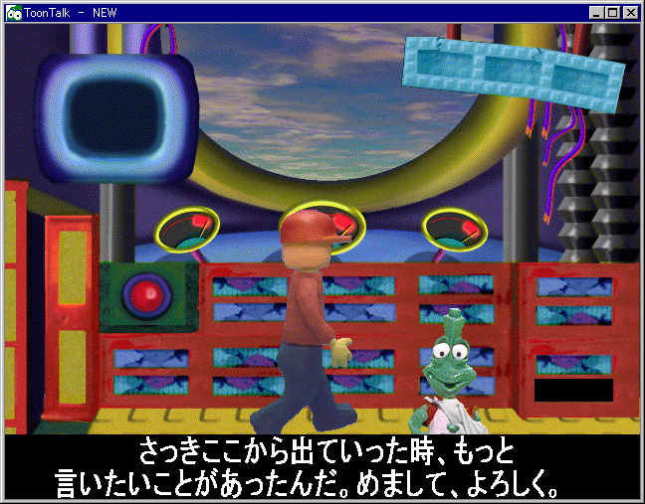
  - Play Game
[P1] 1) If I get out the ship and come
into the ship again when
Marty is speaking the
introductory text, then broken
or missing text is shown on
subtitle.
It seems the garbage is
remaining.
Fixed 270100 –thanks.
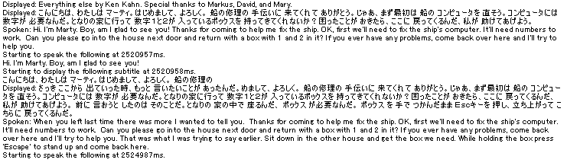
“Boy, am I glad to see you” is never repeated. But a part of Japanese subtitle is displayed again like a garbage.

- If I bring back a bomb instead of a box, then some hints are displayed.
“We need a box with 2 holes. “ is one of them. But Japanese text is wrong. It seems that the order of entries are as follows;

IDS_HOLES + IDS_HOLES0 + 2

I tried to edit japan.rc and string.h to change IDS_HOLES0 to IDS_HOLES2, but
result was same.
The code produces IDS_BOX_WITH + IDS_HOLES0 + 2 + IDS_HOLES + IDS_BOX_WITH2. So as I understand Japanese you’ll want to make IDS_BOX_WITH and IDS_HOLES0 be empty and give entries to the others.
[P2]
- If I bring back ‘2’ instead of ‘4’, then Marty speaks only “Noop.”. He does not speak anything else after that.
- The rules are a bit complicated here. This should only have happened if you got a hint on the previous puzzle and was told about how to use bombs. I’ve fixed it so that the first time that Marty has nothing to say he explains how to come over to him and he’ll give a hint. The rules are that if you come back with the wrong thing for the first time you might not want a hint since you may enjoy the challenge of figuring it out. But if you come back empty handed or come back twice with the same wrong answer then you get a hint even if you don’t “collide” with Marty.

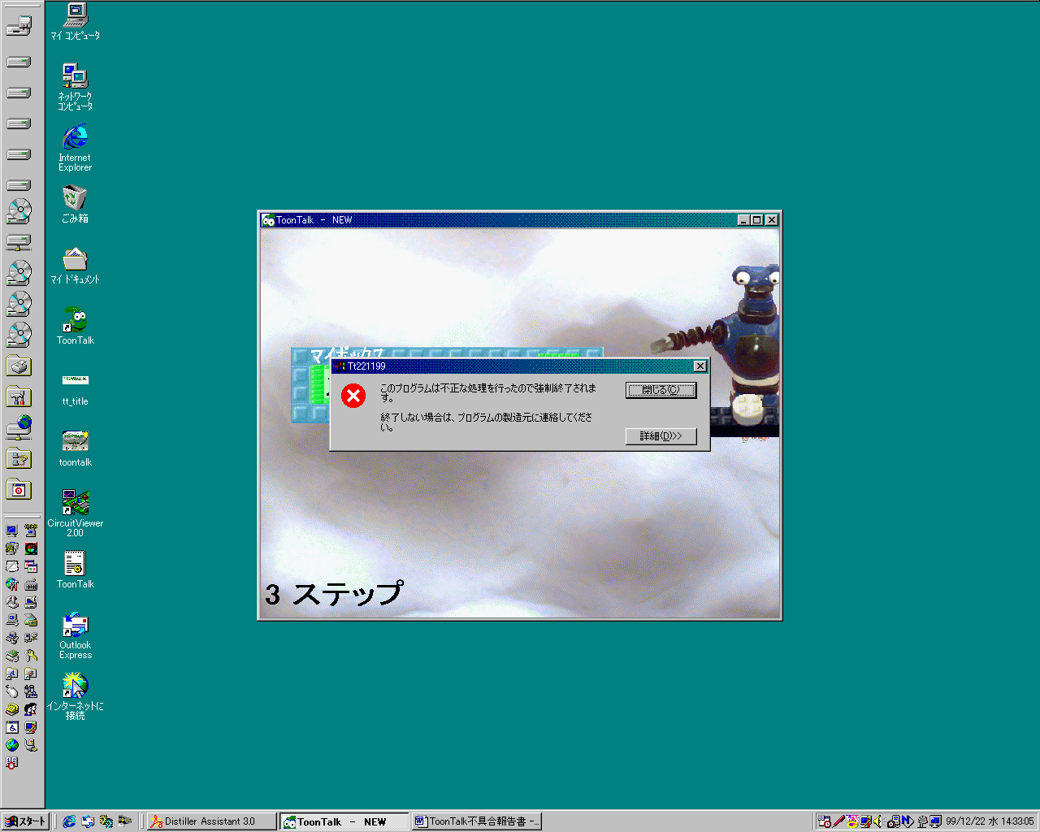
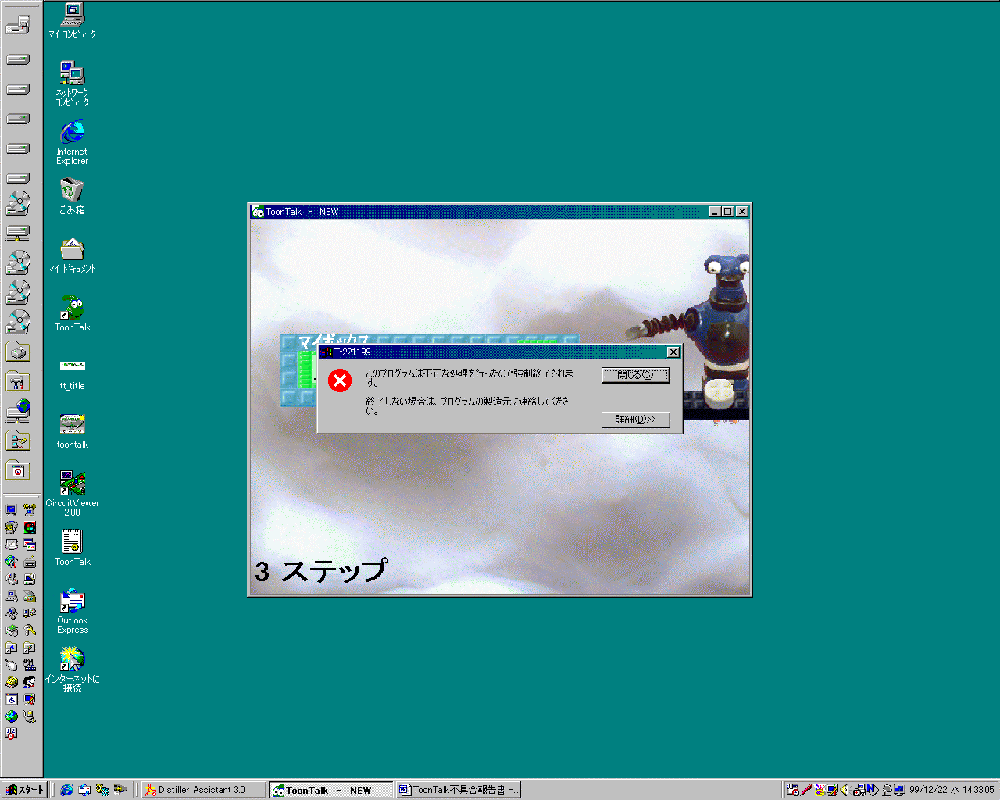[P42] Micronet reports this puzzle is not solved because of GPF or something. Unfortunately,
I cannot duplicate here. Do you have any good ideas to trace this problem.
I couldn’t duplicate it either. I tried to train the robot to copy many incorrect things but couldn’t cause an error. It would help to know if anything unusual was done before this and whether anything special was happening when the error occurred.
  - See Demos
I am waiting for new version of demos.
Puzzle #42 problem at Micronet.
Making very good progress on the new system for demos. Creating the new demos should be easy once it is working well.

  - Free Play
- As I said at the meeting in Japan, there are some entries that are better to break into two or three In the resource files. Please refer to another document. (“ToonTalk_IDS.xls”)
- Done – thanks for your help here. IDS_VACUUM_RESTORE_HELP4 isn’t needed anymore – it is obsolete. Also I added IDS_MAKE_THINGS2 in case that is useful. See new strings.h file for details.
- The following entries are not displayed.
IDS_PICK_UP_HLP3
IDS_PICK_UP_HELP3 should work – let me know if there are problems.

- Requests
  - Common
- Number of lines in subtitles
Micronet does not prefer that several lines are show as subtitles, because the Marty is hidden by them.
I don't care it, but please consider if it is possible to change the subtitles to display only one line.
I’ll consider changing it. I understand that long subtitles are not common and might be too much for children to read. But it is nearly impossible to keep a good synchronization between the spoken and displayed text and keep the subtitles to one line.

  - Play Game
- In the old version, I can play the specific puzzle by double-clicking the PZL file.
But in the new version, it is impossible with the following error message.

could not open the file : JaTT32.DLL

This is very useful for debugging.
I’ve updated starttt.exe so that it works as the associated application for PZL (and DMO, CTY, and USR) files. The advantage of this is that starttt can look in toontalk.ini to find the current ToonTalk executable and run it (using the ToonTalk32= entry). The newest installation makes this association. For now you can use regedit or another tool to change the association of PZL to be “<path name>\starttt.exe”. The new starttt.exe is included here.

  - Set options
1) Please consider the following combinations regarding how Marty talk.
Marty talk yes / no
Text Talk balloon / Subtitle / no
speed 10 years kid / adult / PgDn key

